EAST HOATHLY WITH HALLAND

NEIGHBOURHOOD PLAN

CHARACTER APPRAISAL

Supporting Document for Submission Plan (Regulation 15)

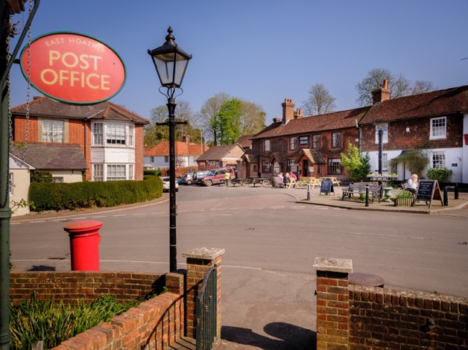

East Hoathly Village Corner

Version 6 – 20 August 2023
Contents

Page

Introduction 3

Character Areas 9

Criteria affecting all Character Areas 13

Character Area Appraisal 32

Character Area 1 – Spur Area 33

Character Area 2 – River Uck Catchment Area 43

Character Area 3 – River Cuckmere Catchment Area 47

Character Area 4 – Halland Area 52

Character Area 5 – Conservation Area 61

Character Area 6 – Church Marks Lane Area 65

Character Area 7 – Rectory Close Area 72

Character Area 8 – Susan’s Close Area 78

Character Area 9 – Thomas Turner Drive Area 82

Character Area 10 – Linear Development Area 94

Character Area 11 – South Street Area 106

Character Area 12 – The Mews Area 110

Character Area 13 – Juziers Area 115

Character Area 14 – Nightingales Area 123

Character Area 15 – Amenity Area 128

Summary 134

Recommendations 138

Conclusion 140

List of Annexes and Figures 140

Introduction

1. This Character Appraisal is a supporting paper for the East Hoathly with Halland Neighbourhood Plan (EHHNP). A character appraisal is a document that describes the distinct appearance and feel of a settlement or an area. It communicates the key physical features and characteristics that combine to give a particular settlement or an area its local distinctiveness and unique identity.

2. The Parish of East Hoathly with Halland comprises the Village of East Hoathly and the smaller settlement of Halland 2 Km to the West of East Hoathly. The Parish also includes the smaller hamlets of Barham, Davis Town and Graywood. East Hoathly is a village located on the old route of the A22, but now benefits from a bypass opened in 1992. Halland is a small, linear settlement bisected by the A22 and the B2192. The rural hinterland of the Parish is scattered with farmstead developments and associated rural cottages.
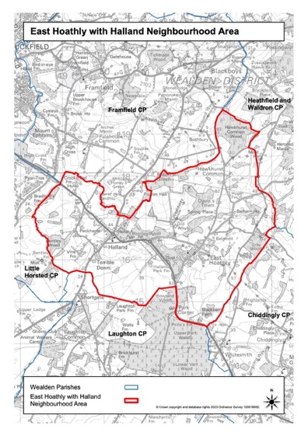
Figure 1 - Map showing East Hoathly with Halland Neighbourhood Area
3. The Parish is located 6 Km South East of Uckfield and 10 Km North West of Hailsham that are both market towns connected by the A22. It is located in the Low Weald landscape which is between the High Weald Area of Outstanding Natural Beauty (AONB) to the North and the South Downs to the South. Its slightly elevated position affords wide ranging views southwards to the South Downs National Park.

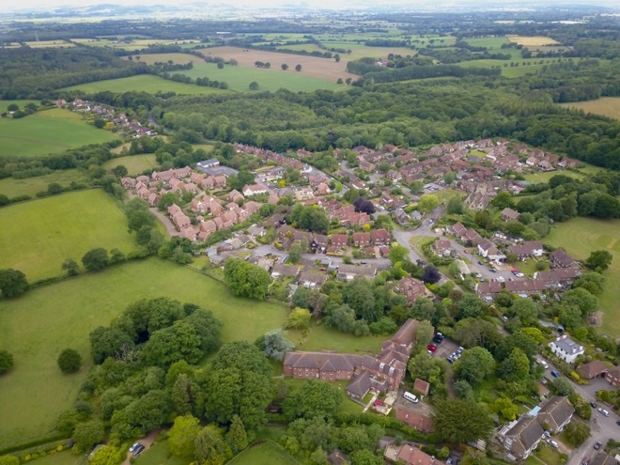
Aerial View of woodland and farmland surrounding East Hoathly

4. The Parish is a rural, largely agricultural landscape with several historic farmsteads. The farmland is liberally scattered with woodland which accounts for 22% of the area of the Parish. A significant proportion of this woodland is designated as Ancient Woodland and this makes up 72% of all the woodland in the Parish. There is also a large network of hedgerows over 50% of which are recorded as Species Rich. There are many large woods, but also many very important Ghyll and Shaw woodlands that are in particular need of protection. The Parish contains many historic field systems and a network of ponds and streams that add to the landscape value of the area.

Historic Context

5. There has only been limited archaeological investigation in the Parish which means that prehistoric and early historic activity is not fully understood, although there is evidence of early activity in the area. Mesolithic sites have been recorded in Halland Park to the West of the Parish and several finds of Mesolithic flints have been recorded in Halland Park. A Bronze Age axe was found on the Eastern side of South Street. Roman occupation of the wider area commenced in A.D.43, after the Roman conquest. The Roman fort of Anderida lies approximately 13 miles to the South East at Pevensey, with the Roman road from the fort extending westwards from Pevensey to Lewes, 9 miles to the South West and a Roman villa in Laughton. There are limited records of Roman finds in the Parish but a Roman bloomery has been found in Halland.

6. The Parish has an important historic past dating back to Norman times:

a. The name of East Hoathly may have been derived from the De Hodleigh family who owned land in the area from 1296. Another possibility is a variation of Hothly or hath leah - an Old English term for a forest clearing. The hamlet/settlement/village of Halland was originally known as the Nursery/Nurseries in recognition of its cluster of horticultural nurseries. Its name was changed to Halland in 1891 which was taken from the nearby Halland Park Farm. The name of Halland derives from the Hall family, former owners of the land for which the earliest reference appears to be in 1533.

b. The Pelham family bought the land from the Halls and Sir Thomas Pelham built Halland House in 1594. A later Thomas Pelham with his brother Henry raised troops to fight against the Jacobite Rising of 1715 and was rewarded by being created Duke of Newcastle. Both Henry and Thomas went on to become British Prime Ministers residing in Halland House throughout. The house went into decline and was demolished in 1788.

c. Historic landscape characteristics of the Parish include:

(1) An extensive area of cohesive assarts ancient fieldscapes.

(2) Remnant ancient landscape surrounding East Hoathly and Halland.

(3) Areas of regular piecemeal enclosure.

(4) Linear belts of Ancient Woodland lining stream corridors and marking some field boundaries, with several large areas of Ancient Woodland.

(5) Ponds and streams located throughout the landscape.

(6) Many places have views of the Lewes Downs, South Downs and High Weald AONB.

(7) A good network of footpaths linking the settlements to the wider landscape, including the Wealdway and Vanguard Way.

d. The settlements of Halland and East Hoathly both exhibit linear historic development extending along their original roads:

(1) For Halland this was the crossroads of the road from Uckfield to East Hoathly and the road from Ringmer to Blackboys.

(2) For East Hoathly this was the junction of Waldron Road, London Road, High Street and Mill Lane.

e. The area of Halland was administered by three parishes until 1990 when the whole of its area was absorbed with East Hoathly to become East Hoathly with Halland Parish.

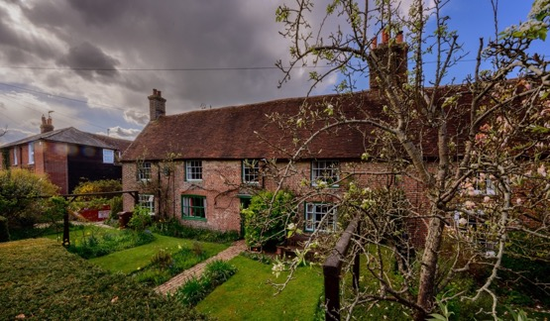

Thomas Turner’s House, East Hoathly

f. The Diaries of Thomas Turner recorded Georgian rural life from 1754 to 1765.

g. The Cricket Club was founded in 1759.

h. There has been a school in East Hoathly since at least 1755 with the current building dating to 1865.

i. The Parish Church was rebuilt in 1855 although the tower is believed to be circa 1500 and evidence was found during the rebuilding in 1855 of a 12th Century Norman Pillar Piscina and Norman windows.

j. East Hoathly has a history of torchlit bonfire parades and celebrations dating back to 1870 and the 1918 armistice saw the creation of the Carnival Society in commemoration of the dead of the First World War and subsequently the Second World War.

k. Within Moat Wood there is a moated site, designated a Scheduled Monument. The site was probably set within a medieval landscape of dispersed settlement, comprising farmsteads, cottages and hamlets surrounded by fields and woodland.

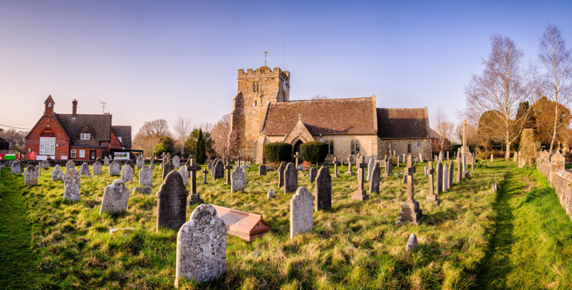

East Hoathly School and Church

7. The Parish has 34 Listed Buildings and a single Scheduled Monument. The Scheduled Monument is located near the centre of Moat Wood, East Hoathly. The majority of the Listed Buildings are within the designated East Hoathly Conservation Area (The Conservation Area was originally designated in 1995 but was reviewed and re-designated in 2017 and a larger part of the village was included). The designation of the Conservation Area introduces a general control over the demolition of unlisted buildings and provides a basis for planning policies to promote the conservation of all aspects of character or appearance that define an area’s special interest, including landscape and public spaces. The designation is supported by a draft Character Appraisal from 2021 that sets out the distinctive character and sense of place that create the area’s special interest, and considers the location and landscape setting of the area; Historic development; The character of the area in detail; Building materials and details: The contribution of the natural environment; and Issues having a negative impact on the character and appearance of the area. This should lead to a Management Plan for the Conservation Area.

Character Areas

8. Wealden District Council (WDC) approved the whole of the Parish area to be designated as the East Hoathly with Halland Neighbourhood Development Area on 7 August 2017.

9. A map analysis was carried out to determine the primary geographic features of the Parish and the general nature of the built environments. Following this analysis, the Parish has been divided into 15 character areas:

a. Character Area 1 – Spur Area.

b. Character Area 2 – River Uck Catchment Area.

c. Character Area 3 – River Cuckmere Catchment Area.

d. Character Area 4 – Halland.

e. Character Areas 5 to 15 – East Hoathly.

10. Each character area is described using the relevant criteria from the following list (Criteria 6.a to 6.h are taken from the Royal Town Planning Institute guide.)

a. Topography – landscape setting and description.

b. Land Use – housing, commercial, agricultural, amenity or natural.

c. Access – vehicle, cycle, bridleway and pedestrian routes.

d. Landmarks – man-made or natural features of the landscape.

e. Views – into and out of the area.

f. Buildings – design, materials, layout and character including heritage assets and buildings that might be suitable for consideration as non-designated heritage assets in the future.

g. Streetscape – lighting, utilities, open space, greenspace, amenities.

h. Layout – relationship between spaces and routes, open and public spaces, housing density.

i. Dark Skies – lighting, lighting controls and design.

11. Having identified the character areas and the criteria to be assessed, the appraisal was conducted by a preliminary walk/drive around the character areas noting the characteristics of each area against the criteria specified at Paragraph 10. The work was carried out by the EHHNP Steering Group during early 2022. The team included an architect and an engineer. The initial findings were circulated to the remainder of the Steering Group for input and discussion. Further visits to the character areas followed in which a photographic record was made. Public consultation was carried out as part of the Regulation 14 Consultation.

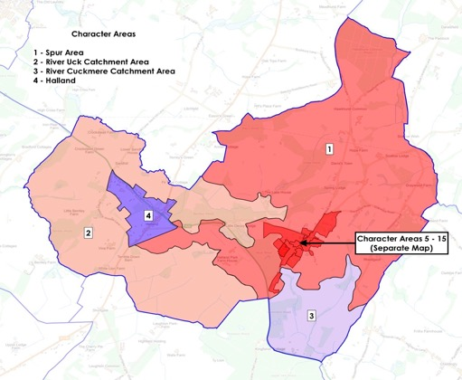
Parish Character Areas

Figure 2 - Map showing Parish Character Areas

12. The village of East Hoathly is divided into 11 Character Areas of which the two largest are the Conservation Area - Character Area 5 (described in its own Draft Character Appraisal) and an Amenity Area - Character Area 15, comprising the Sports Ground, School Field and Garden Plots. The areas of housing in the village have been defined by their grouping and the period in which they were generally developed. They are colour coded as follows:

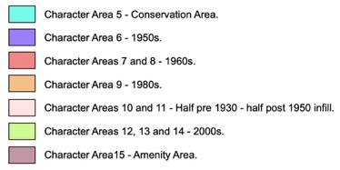

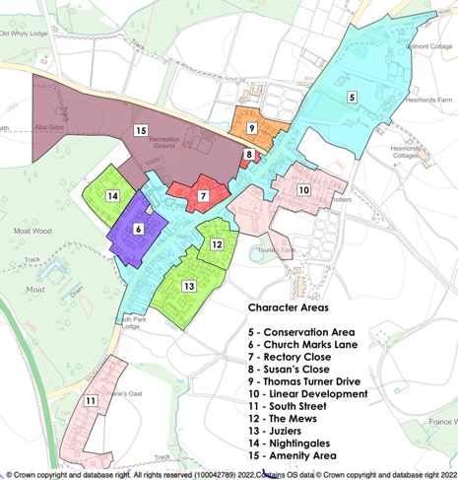

Figure 3 - Map showing East Hoathly Character Areas

13. Part of the function of this Character Appraisal is to note where there are things that detract from the character of the Parish. As such, following each character area appraisal, a list of detractors is produced. Whenever there is the opportunity to remove detractors, these should be taken to enhance the character areas. New housing development should seek to avoid the detractors already identified. These are design features that should be avoided in new developments or factors to which designers should be sensitive.

Criteria affecting the Whole Parish

14. Some aspects of the character of the Parish apply to the whole Parish so they are discussed separately this first part of this appraisal.

Layout - Housing Density

15. Housing Density is one aspect of the layout of built areas. This has been measured in terms of the number of dwellings per hectare (dph). The character area housing densities are detailed in the Parish Statistics on the EHHNP Website.

16. Historic rural housing density levels were low with generally well separated homes with large gardens. Infill development and modern housing developments have increased the housing density and this changes the character and rural nature of the settlements. New developments should seek to reflect the character of rural settlements and their historic development. The housing density of rural villages is historically very low and that is true of East Hoathly and, in particular, its Conservation Area. Post 1950s developments have had much higher housing densities and the character of the village has been changed. Whilst the need to make the best use of available land is understood, new development should not be allowed to radically change the character of the village or the Conservation Area. The cumulative size of the Character Areas 5 to 14 is 26.34 ha and the number of homes in them is 360 giving an average housing density for East Hoathly village of 14 dwellings per hectare (dph). This is considered to be modest in modern planning terms which is an important indicator of the rural character of the village with open spaces and relatively large gardens.

17. This is recognized in the WDC Landscape Character Assessment 2022 as one of the guidelines to recommend how the landscape can be managed to ensure future change respects local character: “Limit the amount and scale of development in rural areas, protecting the existing low-density settlement pattern of dispersed rural villages, hamlets, and scattered farms, and the separation between these different settlement types”.

Layout – Cul-de-sacs

18. Many of the housing developments in the Parish are cul-de-sacs. People like to walk around their community and this helps social cohesion and a sense of belonging. Cul-de-sacs inhibit this and can create a sense of exclusion. Unless you live in the cul-de-sac, or are visiting someone, you have no reason to enter. New developments should avoid cul-de-sacs where possible and be designed to allow paths through developments connecting to other parts of the community and the countryside beyond. The connections within existing settlements of paths, lanes and twittens are all well used and much valued.

a. In East Hoathly the cul-de-sacs range in size from 5 dwellings to larger estates, for example, Susan’s Close, Carpenters Croft, Thomas Turner Drive, Rectory Close, The Mews, Nightingales and Trug Close.

b. In Halland, housing growth has largely been by infill of the linear development along the A22 and B2192. The small housing developments within Halland have been small cul-de-sacs. It has six: Wenham Gardens, Old Heath Close, Old Hartfield, Willow Field and the private un-named roads serving cul-de-sacs such as The Old Sawmill, The Mill House, and Chestnuts and finally, Poppy Fields, Nova Cottage and Broadgate. The houses of Kinver, Yarrow Bank, Ramblers and North View also form a cul-de-sac but this was not built as one development.

19. It is important that developments are designed to encourage opportunities for people to meet each other. This social interaction can have hugely beneficial effects on Health and Wellbeing. Cul-de-sacs with no through routes are less useful in creating opportunities for people to meet each other. The incorporation of seating areas into developments that are on the main through routes is another important consideration to improve the potential for meeting people.

Topography

20. The WDC Green Infrastructure Study 2017 sets out a potential green infrastructure network for Wealden, based on an analysis of the District’s green and blue assets, where there are deficiencies and where there are opportunities for improvements/enhancements/provision. Whilst not an adopted strategy for the District, the potential Green Infrastructure Network provides a framework for the delivery of Green Infrastructure to support the planning of sustainable development. WDC are reviewing this study to inform the new draft WLP.
21. Our Parish is part of one of the Strategic Green Access Links in this Network. This connects the communities and facilities of the Parish via a range of Public Rights of Ways (PROWs) and principally, the Wealdway and Vanguard Way. It proposes that these links are protected and enhanced for pedestrians and cyclists and connections to public transport links improved. The proposal notes that it is important that the network is not compromised by inappropriate development and/or land management. It states: “Where development is planned within or in close proximity to Green Infrastructure assets, it should become an integral feature to the design and ‘identity’ of the development site to ensure that the connectivity of the network for both public benefit and biodiversity is retained and enhanced”.

22. The WDC Landscape Character Assessment 2022 categorized the Parish in 3 parts as shown in Figure 4:

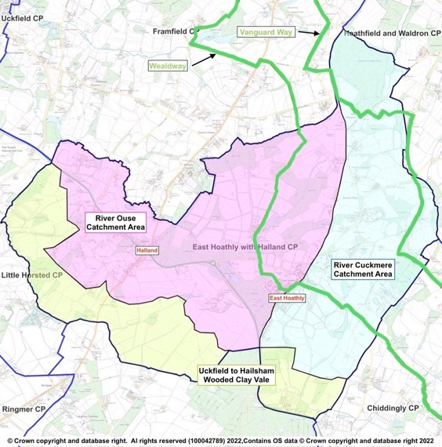

Figure 4 – WDC Landscape Character Assessment 2022 - Characterization of Parish

a. Wooded Clay Vale (Zone 3)

The Landscape Character Assessment describes this area as a low-lying landscape, crossed by the narrow river valleys of the Uck and its tributaries in the west and the Cuckmere in the east. The landscape supports a patchwork of arable and pastoral fields, interspersed with areas of woodland, much of ancient origin, and more extensive mixed plantations. Scattered linear settlements and farmsteads are strung along the rural road network.

b. High Weald – Ouse Catchment (Zone 6D)

The Landscape Character Assessment describes this area as a rolling landscape of ridges and valleys containing the River Ouse and its tributaries that drain south-westwards from Ashdown Forest and the Central High Weald into Lewes District. A wooded landscape with an intricate pattern of small irregular fields, streams and small, historic ridge-top settlements. This categorization is slightly confused. Within the Parish, the watercourses that drain to the North East and along the northern boundary of the Parish, all flow into the River Uck rather than directly into the River Ouse and the Landscape Character Assessment describes the River Uck Catchment area as being in Zone 3.

c. High Weald – Cuckmere Catchment (Zone 6E)

The Landscape Character Assessment describes this area as a rolling landscape of ridges and valleys containing the River Cuckmere and its tributaries that drain south from the Central High Weald into the Low Weald. A wooded landscape with a pattern of small-scale irregular fields, streams and historic ridge-top villages.

23. The Landscape Character Assessment produced guidelines for each Zone to recommend how the landscape can be managed to ensure future change respects local character. Any proposed development should conform to all the guidelines specified in the Landscape Character Assessment but the key guidelines relating to the Parish landscape are:

a. Wooded Clay Vale (Zone 3)

Retain and enhance the biodiversity of watercourses and their associated wetland habitats by minimising water pollution from agriculture through sensitive land management practices, including restoration of buffer strips along watercourses to minimise run off.

Conserve and manage the streamside woodlands and copses, conserving and restoring riverside vegetation and wetland habitats, to ‘slow the flow’ and increase biodiversity.

Improve the connectivity of woodlands across the area through tree planting and hedgerow corridors.

Protect and manage the existing hedgerow network, and plan for restoration and linkages between hedgerows, including planting hedgerow trees to increase biodiversity and connectivity. Encourage the conservation of historic field patterns and boundary features.

Conserve the dispersed rural settlement pattern, encouraging the use of local materials, to maintain a strong local identity. Use woodland or tree planting to screen development on the edge of settlements.

Ensure existing public rights of way and public access within woodlands are maintained and explore opportunities for new pathways extending from urban areas. Plant wooded corridors along footpaths, such as the Vanguard Way and the Wealdway.

Maintain the rural character of the landscape away from the large urban areas, retaining tranquillity and dark skies where present.

Retain and where possible enhance long views to the South Downs and High Weald, which form a strong backdrop to the landscape and provide a sense of place in the landscape. Any new developments should consider intervisibility with the South Downs and High Weald.

b. High Weald – Ouse Catchment (Zone 6D)

Monitor water quality in the rivers and streams. Minimise water pollution from agriculture through sensitive land management practices, including regenerative agricultural systems such as no or minimal till, holistic grazing, reduction or removal of chemical inputs, cover crops and restoration of buffer strips along watercourses and field ponds, to minimise run off in order to maintain the biodiversity of wetland habitats.

Protect and manage the existing hedgerow network, and plan for the restoration of, and linkages between, hedgerows, including establishing hedgerow oaks, to maintain habitats.

Maintain and restore links between the numerous woodlands in the area, other woodland habitats (such as hedgerows and parkland), and species-rich habitats such as wet meadows, unimproved grassland and heathland to create a robust network of woodland and open semi-natural habitats.

Limit the amount and scale of development in rural areas, protecting the existing low-density settlement pattern of dispersed rural villages, hamlets, and scattered farms, and the separation between these different settlement types.

Extend woodland around settlements and infrastructure development to filter light pollution and soften the visual impact of further urbanization.

Protect long views to the wooded Central High Weald to the North and east and to the distinctive ridge of the South Downs to the South.

Maintain the strong scenic qualities of the landscape and its sense of remoteness, tranquillity and experience of dark skies.

c. High Weald – Cuckmere Catchment (Zone 6E)

Safeguard ancient woodland and protect and enhance vulnerable woodland habitats including gill woodlands and wet woodlands for the benefit of biodiversity and the landscape structure.

Protect and manage the existing hedgerow network, and plan for the restoration of, and linkages between, hedgerows, including establishing hedgerow oaks, to maintain habitats.

Maintain and restore links between the numerous woodlands in the area, other woodland habitats (such as hedgerows and parkland) and species-rich habitats such as wet meadows and unimproved grasslands, to create a robust network of woodland and open semi-natural habitats for the benefit of biodiversity and to contribute to an integrated green infrastructure network.

Limit the amount and scale development in rural areas, protecting the existing settlement pattern of dispersed rural villages, hamlets and scattered farmsteads, and the separation of these different settlement types.

Retain the characteristic contrast between areas of enclosed character and long open views to the Pevensey Levels, South Downs and landmark church towers.

Maintain the strong scenic qualities of the landscape and its sense of remoteness, tranquillity and experience of dark skies.

24. The close proximity of open fields and ancient woodland to the very heart of our villages provides a strong sense of connection to nature and the wider landscape of this part of East Sussex, including unspoilt long-distance views to the South Downs. The roads entering East Hoathly have attractive wide and open verges that creates a sense of anticipation as the village is approached.

25. Parish Surveys and the Consultation Process of this Plan have identified a strong feeling within the Parish to preserve the rural village character and setting. It is the principal reason why people have enjoyed living in the village for so long and is why many came to live here in the first place.

26. Much of the Parish is agricultural farmland. Much of this is registered as part of Countryside Stewardship Scheme, Environmental Stewardship Scheme and the Organic Farming Scheme. These schemes are designed to enhance the environment and biodiversity and the current land under these schemes is shown at Annex B.

27. The Natural Environment surrounding the built areas is a mix of woodland, hedgerows, agricultural fields all interwoven with a network of waterways and ponds that provide a rich haven for biodiversity and is a constant reminder that this is a rural village.

28. The topography of the Parish shows how East Hoathly was built along the ridge of a spur coming from the higher ground to the North East.

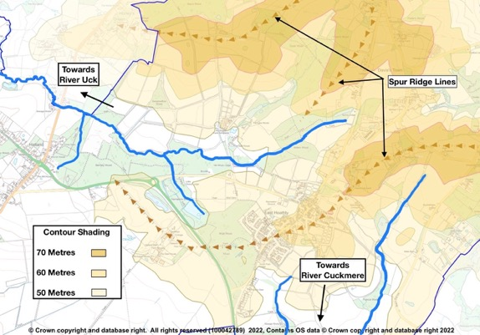
Figure 5 - Topography of Parish

Woodlands, Trees and Hedgerows

29. The Parish is liberally scattered with woodland which accounts for 22% of the area of the Parish. A significant proportion of this woodland is designated as Ancient Woodland and this makes up 72% of all the woodland in the Parish. In addition to the large amount of woodland, there is also a large network of hedgerows that have still not been fully surveyed. Many of those that have been surveyed are recorded as Species Rich. The most important of these hedgerows are those that connect with Ancient Woodland as they provide vital transit corridors for wildlife. There are many large woodlands in the Parish, but also many of the very important smaller Ghyll and Shaw woodlands that are in particular need of protection. The Ancient Woodland, Ghyll Woodland, Orchards, Veteran Trees and trees protected by Tree Preservation Orders are shown at Annex C. The surveyed hedgerows in the Parish are recorded at Annex D. It is intended to continue the hedgerow surveys.

30. Trees and hedgerows should be incorporated into all development proposals to create a rural and peaceful ambience and to allow the development to blend into its surroundings. Trees provide Climate Change mitigation and new developments should consider tree lined streets, parks and community orchards in their planning (National Planning Policy Framework (NPPF) 2021, Paragraph 131). Care should be taken when using tree and hedgerow planting as screening, that it does not detract from skyline or distant views both into and out of the development site.

Waterways and Ponds

31. The waterways, ponds and ditches in the Parish feed the River Cuckmere to the South and River Uck to the North. This complex network is vitally important in draining the agricultural land to make it workable and to prevent the flooding of the built environment. It is also a haven for wildlife and provides habitats for a wide range of plants.

32. The WDC Landscape Character Assessment 2022 identifies the importance of maintaining the water quality in ponds and watercourses in the differing landscapes of this Parish. It is important that development in the Parish does not damage the quality of water in these important river catchment areas.

33. The discharge of sewage into watercourses is a particular concern in this Parish. Figures from the Rivers Trust in Table 1 show the very high frequency and duration of storm overflows. The Government Storm Overflow Evidence Project states in the Executive Summary Background Section that “overflows are designed to operate infrequently and as the result of heavy rainfall and this is the basis of their environmental permits”. The report fails to define what heavy rainfall is. Many people believe that the environmental permits should not allow water companies to continue with this practice.

34. The Meteorological Office does not define what amounts to “heavy rainfall”. However, it does record data for days when rainfall exceeds 1mm, these are defined as a “wet day” as opposed to a “dry day” when less than 1mm rainfall occurs. The wettest days recorded in South East England were 2020 – 43mm, 2012 – 24mm and 2022 – 28mm. A conservative assumption might be to consider “heavy rainfall” as exceeding 8mm in 24 hours. This is also shown in Table 1 in order to contrast the sewage discharges against days that could be regarded as “heavy rainfall”. This clearly shows that sewage is being discharged at both Treatment Plants far more often than when “heavy rainfall” occurs.

35. These figures are shocking and new development should not be allowed to make this situation worse. New developments should calculate the expected outflow to the Sewage Plants and show evidence to indicate that the Sewage Plant and connecting sewers can cope with the additional load without increasing the number of storm overflows.

Table 1 - Sewage Discharges into Watercourses
Sewage Treatment Plant | Year | Halland | East Hoathly | Days in year where rainfall exceeded 1mm | Days in year where rainfall exceeded 8mm
Settled Storm Overflows | 2020 | 112 | 41 | 132 | 32
 | 2021 | 119 | 46 | 122 | 23
 | 2022 | 97 | 35 | 108 | 26
Hours Overflowing | 2020 | 2045 | 416
 | 2021 | 1906 | 593
 | 2022 | 1712 | 416

Biodiversity

36. The Sussex Biodiversity Record Centre has recorded 51 species that are red listed (in England or Great Britain) indicating that they are under threat of extinction and one species of rabbit that is on the global red list. In addition, 32 species are identified as Priority Species in the UK Biodiversity Action Plan. In total there are 26 internationally designated species, 86 nationally designated species and 175 species with some other designation, mostly indicating that they are scarce in England or Rare in Sussex.

37. Some of the rare and protected species that live in this area are skylark, nightingale, 15 species of bats, water vole, common toad, great crested newt, pearl-bordered fritillary butterfly, wasp spider, brilliant emerald dragonfly, dormouse, polecat, adder, grass snake and slow worms. There are several Badger setts recorded in the Parish. Badgers and deer regularly visit local gardens and in recent years, Buzzards and Red Kites are frequently seen in the skies above the Parish.

38. One of the protected species present in our Parish is the Barn Owl with 5 nesting sites currently known. The mix of woodland, hedgerows and open countryside is the perfect environment for these endangered birds and all planning applications must ensure that they will not cause harm to the Barn Owls, their eggs or nests. This is particularly important during the nesting period when it is an offence to disturb them whilst they are nesting, building a nest, or to disturb them whilst they are in or near a nest that contains their young or to disturb their dependent young.

39. The following sites have been recorded with special biodiversity significance:

a. Park Corner Heath - A Site of Special Scientific Interest which is adjacent to the southern border of the Parish.

b. Moat Wood - An area of Ancient Woodland and a Medieval Moat which is a Scheduled Monument. Part of this land was purchased by the Parish Council and the management of the land passed to the Woodland Trust.

c. Croom Cottage Meadow is a designated Local Wildlife Site (LWS) with rare wild flowers and orchids.

d. Halland - Wildlife Verge with orchids and wildflowers (ESCC Wildlife Verge Ref 2/46/30).

e. Long Pond is a breeding pond for Great Crested Newts.

40. The Consultation Process of this Plan identified a strong feeling within the Parish to preserve and enhance our existing biodiversity. The loss of open fields and hedgerows that provide foraging areas and transit routes between habitats is a particularly sensitive issue. The creation of new development places greater pressure on publicly accessible areas of wildlife and natural habitats. This can lead to increased disturbance of wildlife by residents, visitors and pets, which can lead to deterioration and habitat loss.

Dark Skies

41. NPPF 2021 (Paragraph 185c) requires that new development should “limit the impact of light pollution from artificial light on local amenity, intrinsically dark landscapes and nature conservation”. Wealden District has the darkest skies in the South East of England and this should be preserved. Dark skies are hugely beneficial to nocturnal wildlife and of significant importance to those people who enjoy the night sky. The Neighbourhood Plan consultation process recorded the desire of many people to maintain the existing benefits of the Dark Skies of the Parish. It reflects the rural nature of the Parish and is something that should be protected as much as possible. When new developments are created, the issue of light pollution should be a careful consideration. The poor use of lighting in existing built areas can detract from the Dark Skies character that currently exists in the Parish. The importance of Dark Skies in the differing character areas of this Parish was identified in the WDC Landscape Character Assessment 2022.

42. The primary source of light pollution within the Parish is from the lights on the A22 at the Halland roundabout, Shaw roundabout and the junction of the A22/South Street.

43. Some general issues with light pollution apply across the Parish and it would be beneficial to produce some guidance for residents. It is recommended that a wider survey is carried out but some ideas for this guidance might be:

a. Lights inside buildings are often left on unnecessarily at night. If this is considered essential, they should be low intensity lights and positioned/shrouded to prevent radiation into the sky. Consideration should be given to using timing devices to switch them off from midnight to 5 am.

b. Lights in gardens or on the exterior of buildings should be on timing devices to switch them off from midnight to 5 am.

c. Security lights using motion detectors should be aligned so that they do not illuminate when people pass on public paths or roadways.

d. All outside lights should be positioned/shrouded to prevent radiation into the sky.

e. All outside lights should use the minimum effective intensity of lamp.

House Designs

44. The design of homes is clearly critical to the Character of settlements and how all homes sit in the landscape and impact on its Character. Designs are normally chosen to reflect the local Sussex vernacular in design style, materials and colours. Most modern housing developments, particularly in isolated rural locations, are dominated by the car. This includes garages, forecourt parking, parking bays on streets and now the advent of Electric Vehicle (EV) Charging Points (and associated trailing cables). New housing developments are also likely to have mandatory use of such things as Air Source Heat Pumps and renewable energy systems such as built in Solar Panels. The impact of cars, EVs and new energy systems will have a significant impact on house designs and thereby the Character of future developments:

Garages

a. Car Parking is a problem in most of the Parish housing developments. Older developments were built in an era when car ownership was limited and the size of vehicles was much smaller than the modern vehicles now available. Many of these older developments were allocated communal garage areas but the size of these garages is now too small for many modern vehicles and the access is often narrow with very tight turning areas. The vehicles that should be garaged in them are therefore generally parked in other places. These vehicles are generally parked in front of the garages, forecourts to homes and on the streets. This view is supported by the WDC Design Guide. This adds to the clutter of vehicles and car dominated landscape in areas of housing, causes access issues on narrow streets an adversely affects the beauty and character of the housing areas. These areas of garaging that are mostly not now used for vehicle storage form part of the character of the area. They are sometimes poorly maintained and unsightly.

b. Garages are included in all new developments but are often too small to accommodate some modern vehicles. The ESCC Guidance for Parking at New Residential Development 2017 recognises the increasing trend in car ownership. It acknowledges that poor parking design and inadequate space for maneuvering can exacerbate parking issues. It recognises that tandem parking is rarely effective and leads to on-street parking. It states that only 33% of garages in East Sussex are used for cars. All of this leads to new developments that have garages not used for cars and significant levels of on-street parking.

c. It seems bizarre that new homes are designed with garages that the designers, ESCC and occupants will mostly use for something other than car storage. If the garages are expected to be used as part of the home, then they should be built to the same specification, not that of a garage. The whole appearance of a home should be radically different if it is designed without a garage. Homes should be designed as they are to be used and not with garages that will not be used to store vehicles.

EV Charging

d. EV Charging Points will need to be provided in new garages and on forecourts for most new homes. Existing homes will need to have EV Charging Points installed; often where on-street parking is the only option. Visitor parking spaces will need access to EV Charging Points.

e. The coming ubiquity of these EV Charging Points and their associated trailing cables is something that needs to be designed into new developments with great care. Equal care needs to be taken with existing homes, particularly in the Conservation Area and with Heritage Assets. If great care is not taken over this matter, it will cause great harm to the Character of the built environment.

New Energy Systems

f. Heat Pumps and Renewable Energy devices will become the norm on all new homes and are likely to be retrofitted to a large proportion of the existing housing stock. It will be particularly important to design new homes with this in mind and not simply bolt them onto existing house designs. House Designs that have not been designed to include these systems from the beginning will detrimentally affect the Character of the built environment.

Landmarks

45. There are various roadside landmarks in the Parish that add considerably to the rural character and heritage of the area:

Pelham Buckle Milepost Markers

a. Bow Bells milestones extend along the A22 between Horsebridge and East Grinstead. This is the longest sequence of milestones in the country. The iron milestones were erected in the 18th century and feature a string of five bells below a bow of ribbon. The bells were a reference to Bow Bells Church in the City of London from where most roads heading south were measured. The milestones were erected by the Turnpike Trusts along this turnpike route in the 18th century, with the Uckfield to Horsebridge turnpike (via East Hoathly) completed by 1768. Between Uckfield and Horsebridge the Pelham Buckle is shown above the mile mark, denoting the Pelham landowners along this stretch of the turnpike. Four Pelham Buckle Mileposts survive within the Parish and can be seen at Annex E.

Fingerpost Direction Signs

b. Fingerpost Direction Signs mark many of the junctions of minor roads in the Parish and are an example of the special rural nature and heritage value of the area. They have age and charm and remind people that they are on a quiet country lane and not a major highway. Many of these Fingerposts have been lost in recent years and this Parish will seek to retain all the remaining ones and reinstate some of the lost Fingerposts. These are shown at Annex F.

Post Boxes

c. Post Boxes are also a reminder of the rural setting for our Parish and this Parish currently has eight remaining. They help with sustainability preventing the need to get into a car and drive to post a letter. This Parish will strive to retain the remaining Post Boxes. These are shown at Annex F.

Views and Settings

46. Views are important to people, whether this is the view from their home, or the views within, into or out of the area in which they live. The right to an existing view is not protected in planning law but, it is something that has great value to the community. The setting of a building, settlement or conservation area is also an important element in the enjoyment and relationship of people and places. Views and setting are important factors in the character of places and this was identified in the WDC Landscape Character Assessment 2022.

47. All views are important but those which affect Heritage Assets have a greater significance. The following is a precis of Section 5.5 of the draft East Hoathly Conservation Area Character Appraisal:

a. The most important views looking into, out of and through the Conservation Area contribute to the character and setting of the Conservation area and care needs to be taken to ensure that they are not lost or compromised by future development or poorly sited services.

b. Consideration should also be made to the seasonal changes in the landscape and that views may more easily be gained into, out of and through the Conservation Area during certain times of the year, and particularly in the winter and early spring when the trees are without full leaf.

c. Views through the Conservation Area are generally to the church and along the roads extending through the village. From the northern part of the Conservation Area there are views along the road back to the village core, across the fields to the west, and views to the large houses set back to the eastern side of the road, which are often glimpsed through trees.

d. Views across the wider countryside are also important, with views in and out of the Conservation Area providing a strong sense of place and affording strong inter-visibility with historic buildings in the historic core. From Waldron Road the fields to the west allow views in and out of the Conservation Area and to the large area of woodland beyond and from South Road there are views across the fields adjacent to the Conservation Area to the west and views southwards towards the South Downs.

48. The following is an extract of Paragraph 2.2.2 of the WDC draft East Hoathly Conservation Area Character Appraisal: “The setting of a heritage asset, including a conservation area, includes the surroundings in which it is experienced. Its extent is not fixed and may change seasonally, throughout the day and over time. It is not restricted to public views and one may not need to see a heritage asset to be within its setting”.

49. The Conservation Area Character Appraisal also considers the landscape setting of the Conservation Area, including important views into and out of the defined area. One of the particularly important aspects of this are the distant views to places such as the Lewes Downs, High Weald AONB or South Downs National Park, all of which contribute to a recognizable sense of place.

50. When the East Hoathly Conservation Area was first designated in 1995, a significant amount of post 1950s development had already been carried out in what would now be regarded as the setting of the Conservation Area. It is important that the remaining views within, into and out of the Conservation Area and the setting of the Conservation Area are preserved and enhanced whenever possible.

51. The WDC Landscape Character Assessment 2022 makes the following specific guidelines for how views within the Parish landscape can be managed to ensure future change respects local character:

“Retain and where possible enhance long views to the South Downs and High Weald, which form a strong backdrop to the landscape and provide a sense of place in the landscape. Any new developments should consider intervisibility with the South Downs and High Weald”.

“Protect long views to the wooded Central High Weald to the North and east and to the distinctive ridge of the South Downs to the South”.

“Retain the characteristic contrast between areas of enclosed character and long open views to the Pevensey Levels, South Downs and landmark church towers”.

Detractors

52. Detractors are noted at the end of the appraisal of each character area. However, the following detractors affect all the whole Parish:

a. Urbanization of PROWs.

b. Historic rural housing density levels were low with generally well separated homes with large gardens. Infill development and modern housing developments have increased the housing density and this changes the character and rural nature of the settlements. New developments should reflect the character of rural settlements and their historic development.

c. Erosion of the views into and out of the settlements and the settings of Heritage Assets.

d. Erosion of the rural setting for the settlements.

e. The existing sewage system is often overloaded causing sewage surges into resident’s properties. The Parish suffers a substantial level of sewage overflows into the river catchment systems. These overflows damage the watercourses, ancient woodland and biodiversity. They have an adverse effect on the natural landscape and its character.

f. Reduction in remaining woodland, trees and hedgerows and increased pressure on accessible woodland.

g. Reduction in biodiversity by the isolation of habitats and removal of foraging areas and transit routes and increased pressure on accessible biodiversity by residents, visitors and pets.

h. Light Pollution producing pressure on Dark Skies by increased urbanization, poor design and poor control. This includes residential properties with internal lights radiating into the night sky unnecessarily or external garden/security lighting that radiates upwards, are on unnecessarily or poorly controlled.

i. Garages that are too small and not used for vehicles which then displaces vehicles to park elsewhere and add to the clutter of parked cars and a car dominated landscape and which often become unused and poorly maintained and unsightly.

j. Loss of remaining landmarks such as Pelham Buckle Milepost Markers, Fingerpost Direction Signs and Post Boxes.

k. Cul-de-sac development that inhibits permeability, reduces opportunities for residents to meet each other and can create a sense of exclusion.

l. Renewable energy systems added onto existing house designs rather than being integral to the design.

m. Electric vehicle charging systems added onto existing house designs rather than being integral to the design.

Character Area Appraisal

53. Each character area will now be described against the criteria outlined in Paragraph 10 above and any specific detractors will be noted at the end of each description. It should be noted that those criteria affecting the whole Parish and covered in Paragraphs 14 to 51 will not be repeated unless specifically required.

Character Area 1 - Spur Area

Topography

54. The Spur Area is the higher ground in the Parish where a spur of land slopes down from the High Weald Fringes area. The villages of East Hoathly and Halland broadly follow the ridge line of the main spur.

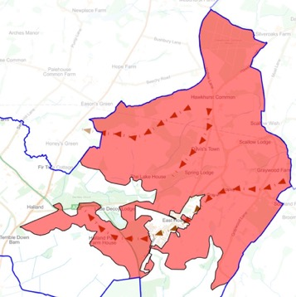
Figure 6 – Map of Character Area 1 – Spur Area

55. The land is gently undulating with low ridges and open valleys. In addition to the village of East Hoathly there are also many scattered rural dwellings. This includes the small hamlets of Davis Town, Barham and Graywood. Some of the farms have converted redundant buildings into commercial use

Land Use

56. The land is mostly agricultural with one dairy farm remaining, a horse stud farm and the remainder being mixed agriculture. The farmland retains most of its ancient field boundaries as can be seen on the 1778-1783 Yeakell and Gardner Map and the 1839 Tithe Map, both shown below, when compared with a modern map of the same area. The area is liberally scattered with woodland much of which is designated Ancient Woodland and a large network of hedgerows over 50% of which are recorded as Species Rich. There are many large woods but also a significant number of important Ghyll and Shaw woodlands.
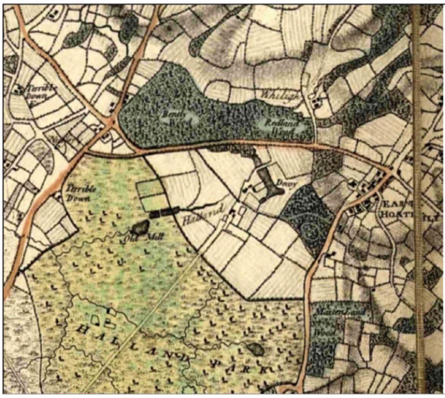
Figure 7 - Yeakell and Gardner Map 1778-83

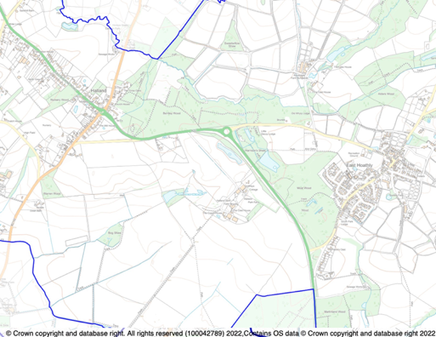

Figure 8 - Ordnance Survey Map showing comparative area of Parish
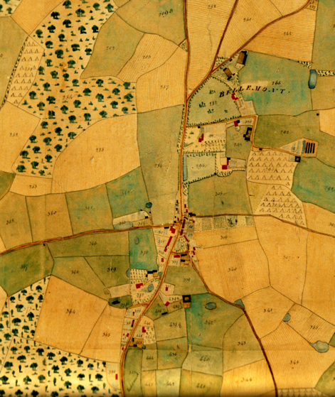

Figure 9 - East Hoathly Tithe Map 1840

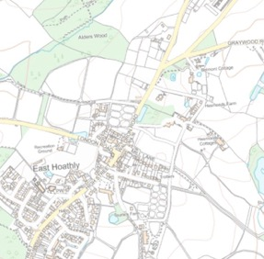

Figure 10 – Ordnance Survey map showing comparative area of Parish
Access

57. The area is bisected by the A22 and B2192 and a number of small roads. The A22 Bypass was completed in 1993 and removed the bulk of North - South traffic from the centre of East Hoathly.

58. Traffic in the narrow rural lanes has increased because of vehicles using back roads to avoid congestion on the A22, the creation of many more farm based rural business and the growing number of home deliveries now drawing large delivery vehicles into the settlements and narrow lanes. The speed of vehicles is usually too high, verges are being damaged by large vehicles and these lanes are increasingly unsafe and unpleasant for people trying to walk or cycle.

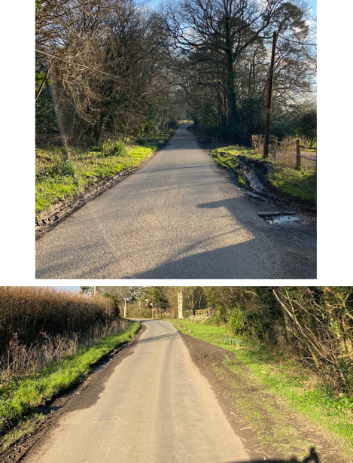
Examples of Damage to Verges
59. The area has a well-used network of Footpaths allowing residents and visitors to enjoy the local countryside. In contrast there is only one Bridleway in whole of the Parish. This begins on Mill Lane and proceeds to Ailies Lane.

60. Parts of the Wealdway and Vanguard Way pass through the area. The Wealdway is an important PROW running from The Thames Estuary to Eastbourne via East Hoathly. The Vanguard Way is an important PROW running from East Croydon via East Hoathly to Newhaven. Parts of both of these paths were included in the circular Wealden Millennium Walk in 2000. These important public footpath routes are significant attractions to our Parish and bring many visitors to the area. The existing PROWs and our only bridleway are shown at Annex G.

61. The footpath which connects East Hoathly to Halland is through woodland and fields in one of the lowest lying parts of the Parish. The route is an attractive country walk but is often muddy and waterlogged. It is very enclosed in parts and is not an easily usable route connecting our communities. It is unsuitable for cycles or child buggies.

Buildings

62. This area has several Heritage Assets:

a. Godfreys, Halland - Grade II.

b. Piper’s Farmhouse, Hollow Lane - Grade II.

c. The Ruins of the old house known as Halland House in the grounds of Halland Park House, Shortgate - Grade II.

d. Halland Park Farmhouse, Shortgate - Grade II.

e. Barn at Halland Park Farm to South West of the Farmhouse, Shortgate - Grade II*.

f. Scheduled Monument - Moated site in Moat Wood.

63. This area includes the small hamlets of Davis Town and Graywood in addition to many farmsteads and isolated rural dwellings. Many former agricultural buildings have been converted into other businesses.

Landmarks

64. This area retains four of its Fingerpost Direction Signs marking rural road junctions. These add greatly to the rural character and heritage of the area. It has also lost three of these Fingerposts in the past few decades.

65. This area benefits from having four rural Post Boxes. These add character to the rural environment and help with sustainability preventing the need to get into a car and drive to post a letter.

Views

66. The area has several important views which display the vistas from the elevated position of the spur. These views are a very important feature of the area and significant factor in the beauty of the area and the enjoyment derived from it. It is a significant element in the character of the Low Weald and High Weald Fringes:

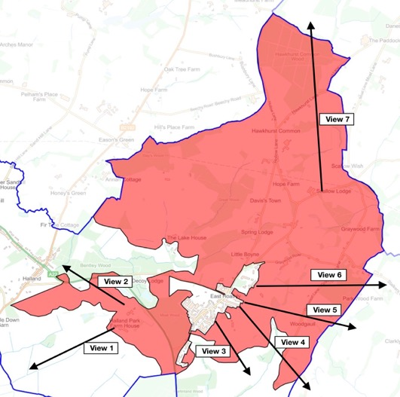

Figure 11 - Map showing Views out of Character Area 1 - Spur Area

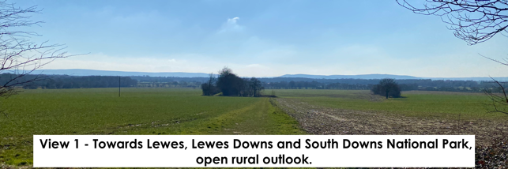
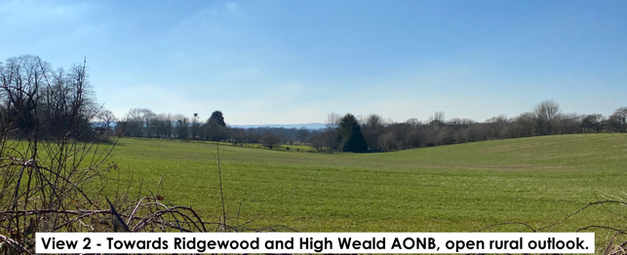
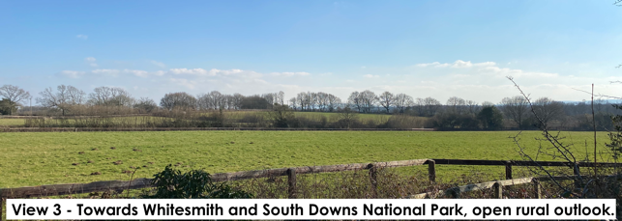
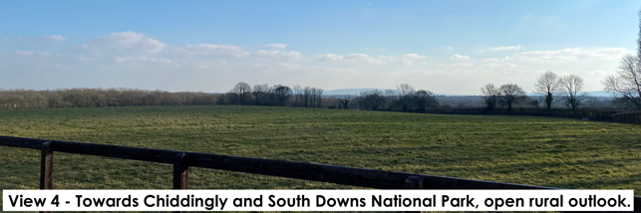

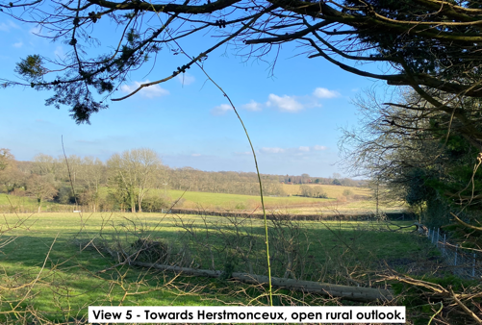

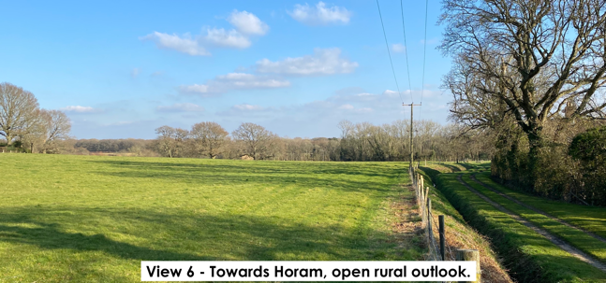

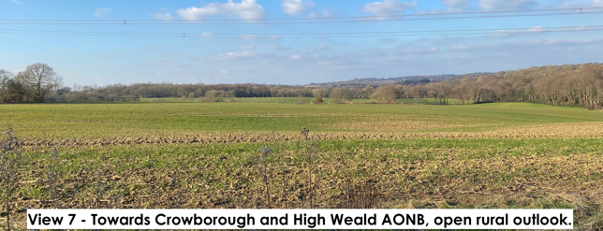

Detractors

67. In this Character Area, the following detractors are noted:

a. Urbanization of PROWs.

b. Erosion of the views into and out of the area.

c. Erosion of the rural setting for the settlements of East Hoathly and Halland.

d. Erosion of architectural detail. This can be caused by older buildings being modernised and having such things as chimney pots removed/replaced, double glazing, plastic rainwater fittings and modern extensions.

e. Reduction in remaining woodland, trees and hedgerows and increased pressure on accessible woodland.

f. Reduction in Biodiversity by the isolation of habitats and removal of foraging areas and transit routes and increased pressure on accessible biodiversity by residents, visitors and pets.

g. Loss of remaining Fingerpost Direction Signs and Post Boxes.

h. Safety on rural roads where traffic flows and speeds are increasing, making use by pedestrians, cyclists and horse riders more challenging. This affects the sense of security, calm and enjoyment to the detriment of the rural character.

i. Damage to road verges in part caused be an increase in large vehicles using the narrow rural lanes.

j. Poor Quality of the Halland to East Hoathly footpath/cycle route.

Character Area 2 - River Uck Catchment Area

Topography

68. The River Uck Catchment Area is the lowest ground in the West of the Parish where a spur of land slopes down from the High Weald Fringes area. The village of Halland broadly follows the end of the ridge line of the spur.

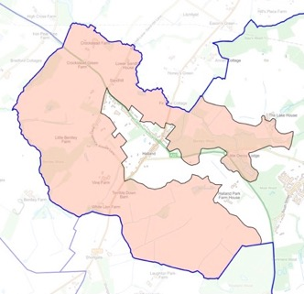

Figure 12 – Map of Character Area 2 – River Uck Catchment Area

69. The land is low lying and interspersed with ponds waterways and ditches. The watercourses are under significant pressure as a result of sewage overflows (See Paragraphs 31 to 35).

Land Use

70. The land is mostly mixed agricultural land. The farmland retains most of its ancient field boundaries as can be seen on the 1778-1783 Yeakell and Gardner Map, when compared with a modern map of the same area (See Page 34). The area is liberally scattered with woodland much of which is designated Ancient Woodland and a network of hedgerows. There are many large woods but also several important Ghyll and Shaw woodlands.

Access

71. The area is bisected by the A22 and B2192 with Knowle Lane cutting across the North West quadrant. In recent years the amount of traffic on the A22 passing through Halland has increased considerably. Traffic on Knowle Lane has increased because of vehicles using it to avoid congestion on the A22. This increase is also the result of the creation of many more farm based rural business and the growing number of home deliveries now drawing large delivery vehicles into settlements and narrow lanes. The speed of vehicles is usually too high, verges are being damaged by large vehicles and these lanes are increasingly unsafe and unpleasant for people trying to walk or cycle.

72. The area has a well-used network of Footpaths allowing residents and visitors to enjoy the local countryside. There are no bridleways.

73. A small section of the circular Wealden Millennium Walk passes through this area (See Paragraph 60). This important public footpath route is a significant attraction for our Parish and brings many visitors to the area.

Buildings

74. This area has several Heritage Assets:

a. Old Whyly, East Hoathly - Grade II.

b. Lower Sandhill House, Easons Green - Grade II.

c. Peckhams, Knowle Lane - Grade II.

d. Bentley Wood, Knowle Lane - Grade II.

e. Vine Cottage, Terrible Down - Grade II.

75. The area also has 2 properties of interest that may have the potential to be non-designated heritage assets:

a. Old Whyly Cottage.

b. Old Whyly Oast House.

76. This area includes several farmsteads and isolated rural dwellings. One former farmstead has been converted into the Bar/Restaurant and Wedding/Function venue. Many former agricultural buildings have been converted into other businesses.

Landmarks

77. This Character Area has two Pelham Buckle Milepost Markers and the Parish Council is considering applying to get them designated as Heritage Assets but not as part of this plan (See Paragraph 45a for description):

a. Milepost 46 - A22 Near Crockstead.

b. Milepost 47 - A22 South of Halland.

Detractors

78. In this Character Area, the following detractors are noted:

a. Urbanization of PROWs.

b. Erosion of the views into and out of the area.

c. Erosion of the rural setting for the settlements.

d. Erosion of architectural detail. This can be caused by older buildings being modernized and having such things as chimney pots removed/replaced, double glazing, plastic rainwater fittings and modern extensions.

e. Reduction in remaining woodland, trees and hedgerows and increased pressure on accessible woodland.

f. Reduction in Biodiversity by the isolation of habitats and removal of foraging areas and transit routes and increased pressure on accessible biodiversity by residents, visitors and pets.

g. Loss of remaining Pelham Buckle Milepost Markers.

h. Safety and Congestion on A22 and B192. Traffic queues and congestion are not conducive to peaceful rural life. It detracts from the appearance and identity of rural settlements, adversely affecting their character.

i. Safety on rural roads (Knowle Lane in particular) where traffic flows and speeds are increasing making use by pedestrians, cyclists and horse riders more challenging. This affects the sense of security, calm and enjoyment to the detriment of the rural character.

j. Damage to road verges in part caused be an increase in large vehicles using the narrow rural lanes.

k. Sewage overflows into the river catchment system. These overflows damage the watercourses, ancient woodland and biodiversity. They have an adverse effect on the natural landscape including its appearance and character.

Character Area 3 - River Cuckmere Catchment Area

Topography

79. The River Cuckmere Catchment Area is the lowest ground in the South of the Parish where a spur of land slopes down from the High Weald Fringes area.

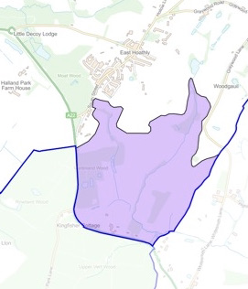

Figure 13 – Map of Character Area 3 – River Cuckmere Catchment Area

80. The land is low lying and interspersed with ponds, waterways and ditches. The watercourses are under significant pressure as a result of sewage overflows (See Paragraphs 31 to 35).

Land Use

81. The land is mostly mixed agricultural land and also includes part of a horse stud farm. The farmland retains most of its ancient field boundaries as can be seen on the 1778-1783 Yeakell and Gardner Map and the 1839 Tithe Map, when compared with a modern map of the same area (See Pages 34 -35). The area is liberally scattered with woodland much of which is designated Ancient Woodland and a network of hedgerows. There are many large woods but also several important Ghyll and Shaw woodlands.
82. The area includes Blackberry Farm which is a farm run as a family attraction with farm animals, outdoor play areas, rides and food outlets.

Access

83. The Southern boundary of the area is the A22 and this is the only road in the area.

84. The area has two well-used footpaths allowing residents and visitors to enjoy the local countryside. There are no bridleways.

Buildings

85. This area has one Heritage Asset named Price’s Cottages, Whitesmith - Grade II.

86. This area includes several isolated rural dwellings and one former farmstead that has been converted to a Children’s Farm Park.

Landmarks

87. This Character Area has Pelham Buckle Milepost Marker 49 on the A22 at Park Lane Corner and the Parish Council is considering applying to get it designated as a Heritage Asset but not as part of this plan (See Paragraph 45a for description).

88. This area benefits from having a single rural Post Box. This adds character to the rural environment and helps with sustainability preventing the need to get into a car and drive to post a letter.

Views

89. The area has several important views which display the vistas of open countryside within the area. These views are a very important feature of the area and a significant factor in the beauty of the area and the enjoyment derived from it. It is a significant element in the character of the rural Low Weald:

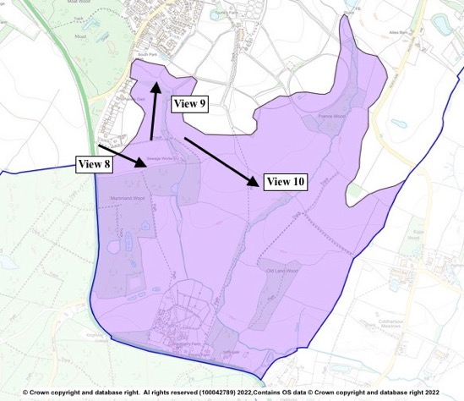

Figure 14 - Map showing Views out of Character Area 3 - River Cuckmere Catchment Area

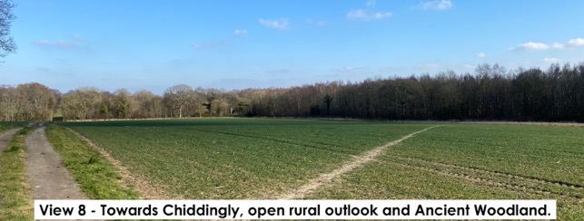

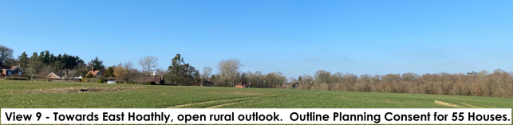

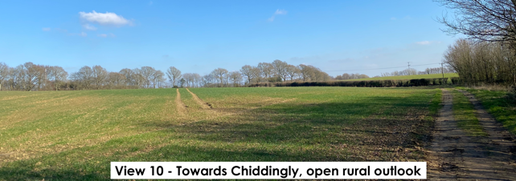

Detractors

90. In this Character Area, the following detractors are noted:

a. Urbanization of PROWs.

b. Erosion of the views into and out of the area.

c. Erosion of the rural setting for East Hoathly.

d. Erosion of architectural detail. This can be caused by older buildings being modernised and having such things as chimney pots removed/replaced, double glazing, plastic rainwater fittings and modern extensions.

e. Reduction in remaining woodland, trees and hedgerows and increased pressure on accessible woodland.

f. Reduction in Biodiversity by the isolation of habitats and removal of foraging areas and transit routes and increased pressure on accessible biodiversity by residents, visitors and pets.

g. Loss of remaining Pelham Buckle Milepost Markers.

h. Sewage overflows into the river catchment system. These overflows damage the watercourses, ancient woodland and biodiversity. They have an adverse effect on the natural landscape including its appearance and character.

Character Area 4 - Halland Area

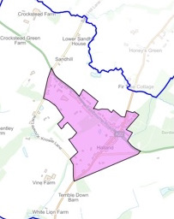

Figure 15 – Map of Character Area 4 – Halland Area

91. Halland is a small settlement, but it lacks any community facilities. There are no community buildings, open space, green space or play areas.

Layout

92. The Halland Character Area is a mixed commercial and residential area. It is essentially formed in linear development around the Halland roundabout on the A22/B2192. The majority of the development is in the Western quadrant where the linear development has extended to Knowle Lane in both directions. Knowle Lane has some housing but retains gaps between the housing.

93. Housing growth has largely been by infill of the linear development along the A22 and B2192. The small housing developments within Halland have been small cul-de-sacs. It has six: Wenham Gardens, Old Heath Close, Old Hartfield, Willow Field and the private un-named roads serving cul-de-sacs such as The Old Sawmill, The Mill House, and Chestnuts and finally, Poppy Fields, Nova Cottage and Broadgate. The houses of Kinver, Yarrow Bank, Ramblers and North View also form a cul-de-sac but this was not built as one development.
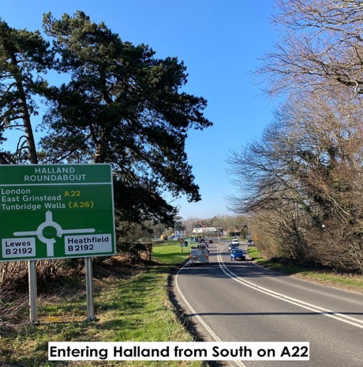

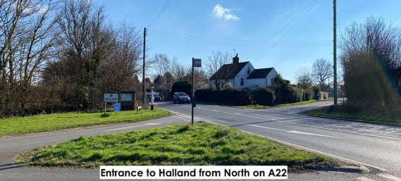

94. Almost all the homes have adequate off-street parking and large gardens.

95. The area includes:

a. Halland House Care Home.

b. Garage.

c. Halland Chapel and burial ground - Proposed for application to list as an Asset of Community Value with WDC.

d. Buffalo Bill’s (hotel/restaurant).

e. Blacksmith’s Arms Public House - Asset of Community Value listed with WDC.

f. Staverton Nursery and Shop.

Topography

96. The area is the very end of a gently sloping spur of land coming out of the High Weald Fringes area.

97. Because of the linear nature of the development and elevated position, almost all the homes have views from the rear onto open countryside or woodland.

98. The area contains a parcel of Ancient Woodland called Nursery Wood.

Land Use

99. The area was formerly known as The Nurseries before the name Halland was adopted. The area to the rear of the housing along the roads is open agricultural land and is a legacy of these former nurseries. Some of it is still under cultivation for Staverton Nursery, the only remnant of the earlier businesses.

100. The bulk of the land is residential housing interspersed with commercial businesses and Halland Chapel with its burial ground.

Access

101. The area is bisected by the A22 and B2192. The intersection of these roads at the Halland roundabout is a busy junction particularly at peak periods. The congestion at this roundabout often leads to traffic seeking alternative routes on the smaller surrounding roads, especially Knowle Lane.

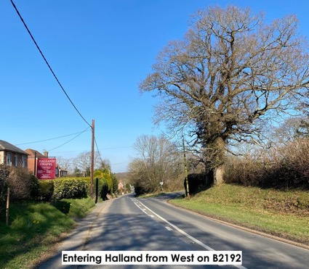

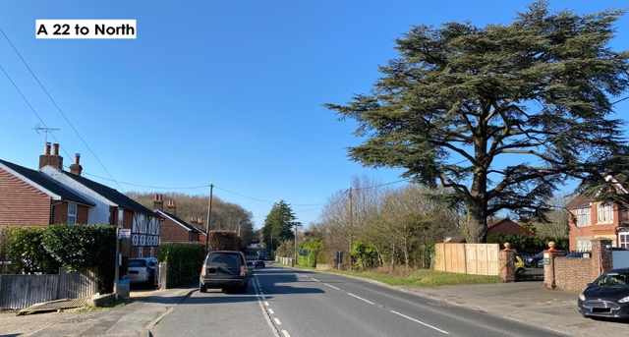

102. The only other road is a narrow road called Back Lane, which cuts across the Southern quadrant. This is also used to avoid the roundabout and can cause traffic issues when vehicles are trying right to rejoin the main routes, particularly when trying to turn across the oncoming A22 traffic.

103. The area has three short sections of PROW leading out of the village.

Buildings

104. The buildings are a mix of periods and architectural styles.

a. The earliest building, Hartfield Farmhouse is a Grade II Heritage Asset. It is a seventeenth century timber framed building with red brick infilling and curved braces to the first floor.

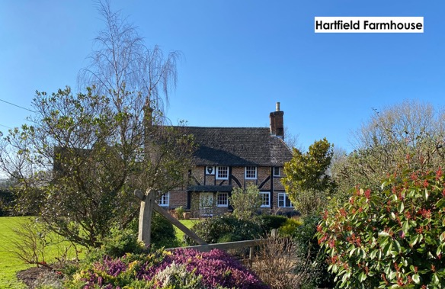

B2192/Lewes Road

b. The majority of the houses on the Lewes Road and in the vicinity of the roundabout are late eighteenth century. Many of these properties may be of historic interest and may have the potential to be non-designated heritage assets. This area of Halland has great character despite the proximity to the noise, smells and disturbance of the busy road.

c. The dwellings are predominantly brick built, two storey homes of varying sizes. The roofs are a mix of slate and plain tiles. There are some decorative hung tiles, decorative ridge tiles and some decorative brickwork designs using grey headers to create diamond patterns. Some of the more modern in-fill houses have flint walls with brick framing or faux wood frames.

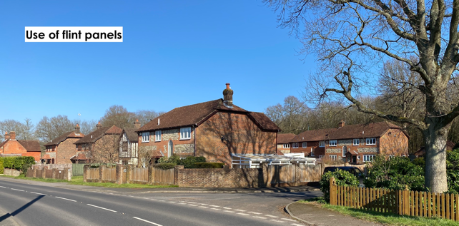

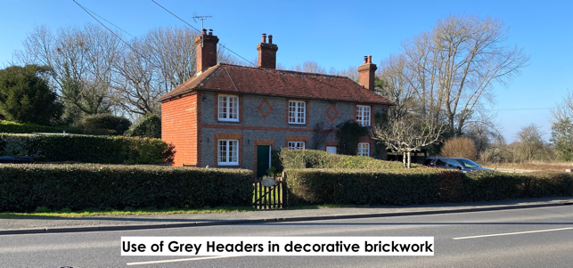

d. The Lewes Road has several examples of homes with stone window surrounds and the building corners are made in decorative stone.

A22/Eastbourne Road

e. Some of the properties on this road are of historic interest that may have the potential to be non-designated heritage assets. This would include The Blacksmiths Arms, Weavers Cottage, Ivy Cottages and Lower Ivy Cottage, Dunster Lodge and White Lodge.

f. Halland House Care Home was a large Victorian home that retains many of its original features but has had significant modern additions to the rear. It is a brick built, three storey building under a plain tile roof with several gable and decorative ridge tiles. The gables have decorative hung tiles. The window surrounds are stone with stone mullions.

Streetscape

105. The area is strewn with many utility poles providing power and telephone cables. There is lighting at the roundabout and its approaches but no other street lighting. The roundabout lighting is on all night and very bright. This detracts from the otherwise dark skies in the area and may be unnecessary from midnight to 5 am.

106. The main roads are heavily marked with warning and restriction signs. The roads have many speed-limit signs, roundabout approach signs and direction signs. There are also some traffic calming measures built into the A22 in the vicinity of Staverton Nursery, however these are not fully effective as evidenced by the speed camera being rated number seven in the UK’s Top 10 Highest Earning Speed Cameras in 2015.

107. The area has three bus stops with wooden shelters.

108. This area retains one of its Fingerpost Direction Signs marking a rural road junction. This adds greatly to the rural character and heritage of the area. The area has also lost four of these Fingerposts in the past few decades.

109. This area benefits from having two rural Post Boxes. These add character to the rural environment and help with sustainability preventing the need to get into a car and drive to post a letter.

110. Parked vehicles on the B2192 to the West of the roundabout cause issues with visibility for traffic and a restriction to traffic flow.

Views

111. The area has two important views, which display the vistas from the slightly elevated position of the area. These views are a very important feature of the area and significant factor in the beauty of the area and the enjoyment derived from it. It is a significant element in the character of the Low Weald and High Weald Fringes:

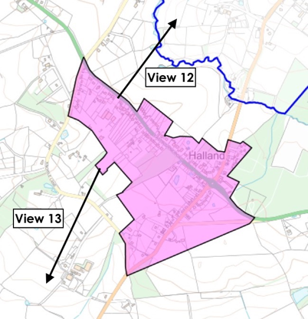

Figure 16 – Map showing Views out of Character Area 4 - Halland Area

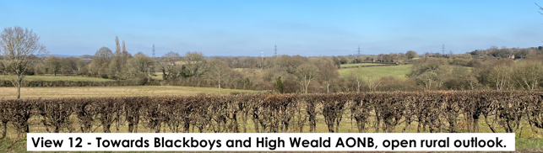

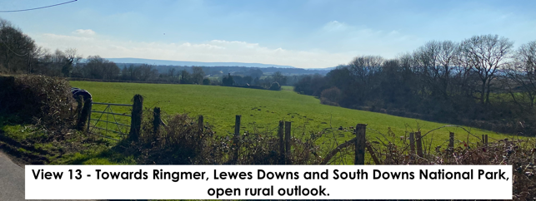

Detractors

112. In this Character Area, the following detractors are noted:

a. Urbanization of PROWs.

b. Erosion of the views into and out of the area.

c. Erosion of the rural setting for Halland.

d. Erosion of architectural detail. This can be caused by older buildings being modernised and having such things as chimney pots removed/replaced, double glazing, plastic rainwater fittings and modern extensions.

e. Reduction in remaining woodland, trees and hedgerows and increased pressure on accessible woodland.

f. Reduction in Biodiversity by the isolation of habitats and removal of foraging areas and transit routes and increased pressure on accessible biodiversity by residents, visitors and pets.

g. Increase in housing density changing the rural nature of the settlement.

h. Loss of remaining landmarks such as Fingerpost Direction Signs and Post Boxes.

i. Noise, smells and disturbance of the busy roads, particularly the A22.

j. Cul-de-sac development that inhibits permeability, reduces opportunities for residents to meet each other and can create a sense of exclusion.

k. Lighting at roundabout is on all night and very bright.

Character Area 5 - Conservation Area

113. The Conservation Character Area is fully described in its own Draft Conservation Area Character Appraisal. The Conservation Area is the heart of East Hoathly village and is critical to the character of the Parish; its importance cannot be over-stated.

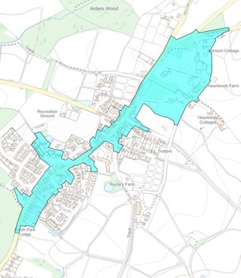

Figure 17 – Map of Character Area 5 – Conservation Area

114. It is not intended to repeat the information contained in the Wealden draft Conservation Area Character Appraisal 2021 in this document but the two documents should be considered together. Since it was published several matters have changed. Some of the changes and additional information worthy of mention is as follows:

a. The area measures 13.35 ha and includes 90 dwellings giving the area an approximate density of 7 dph. The Northern part of the Conservation Area includes 11 houses, 3 of which have large gardens, making the area particularly open. Nevertheless, this area is part of the Conservation Area and an integral part of its character and layout.

b. The heritage street lamps are currently illuminated all night. Use of a timer to control illumination during the early morning hours would benefit the Dark Skies within the area and thereby benefit biodiversity.

c. The former Foresters Public House is now a Grade II Listed Heitage Asset. The post and frame for its hanging advertising sign remains in place but the sign has been removed.

d. The Kings Head Pub is an Asset of Community Value listed with WDC.

e. The Village Hall - proposed for application to list as an Asset of Community Value with WDC.

f. This area retains two of its Fingerpost Direction Signs marking rural road junctions. These add greatly to the rural character and heritage of the area.

g. This area benefits from having two rural Post Boxes. These add character to the rural environment and help with sustainability preventing the need to get into a car and drive to post a letter.

h. The bypassing of the A22 to take traffic away from the centre of East Hoathly undoubtedly improved the quality of life for everyone in the village and allowed the atmosphere of a rural village to return. However, in recent years the amount of traffic on the A22 passing through Halland has considerably increased. More traffic now comes into the centre of East Hoathly to avoid the congestion on the A22 at peak times. This traffic comes into the centre of the Village and has to navigate the sharp and hazardous Post Office bend. Pedestrian safety has become an issue once again.

i. The Doctor’s Surgery and car park (built in 2009) were added to the Conservation Area in 2017 but are not mentioned in the 2021 Draft Conservation Area Character Appraisal. The WDC Issues, Options and Recommendations Consultation that considered the changes to the Conservation Area does not make any reference to the Doctor’s Surgery or the reasons for its inclusion.

Guiding Principles for any changes in the Conservation Area

115. The Wealden draft Conservation Area Character Appraisal 2021 noted several guiding principles for any changes in the Conservation Area:

a. Preserve and enhance the character and appearance of the Conservation Area.

b. Understand and respond to significance.

c. Respond to historic pattern of development.

d. Retain historic features that contribute to the character of the Conservation Area.

e. Retain architectural detailing.

f. Ensure consistency and quality in design, materials and finishes.

g. Retain landscape features, open spaces and boundary treatments that contribute to the character of the conservation area.

h. Avoid visual clutter.

i. Ensure the conservation area is not harmed by inappropriate change within its setting.

j. Preserve and enhance views into and out of the Conservation Area.

Detractors

116. The Wealden draft Conservation Area Character Appraisal 2021 noted the following detractors:

a. Erosion of architectural detail.

b. Inappropriately detailed window replacement.

c. Scale, design and location of new development, including infill development and outbuildings.

d. Light pollution.

e. Loss of traditional boundary treatments.

f. Wirescape.
g. Parking.
h. Road signage and highways works.

117. The following additional detractors are noted:

a. Erosion of views into and out of the Conservation Area.

b. Urbanization of PROWs.

c. Erosion of the rural setting for the settlement.

d. Reduction in remaining woodland, trees and hedgerows and increased pressure on accessible woodland.

e. Reduction in Biodiversity by the isolation of habitats and removal of foraging areas and transit routes and increased pressure on remaining accessible biodiversity by residents, visitors and pets. Rural gardens such as those in the Conservation Area, are regularly visited be a wide range of biodiversity. As the housing surrounding the Conservation Area grows, the proximity of the Conservation Area to open countryside diminishes another notch. The level of biodiversity visiting the Conservation Area will decrease as habitats and transit routes are lost and the volume of residents, visitors and pets increases. This damages the character of a rural Conservation Area.

f. Increase in housing density changing the rural nature of the settlement.

g. Garages that are too small and not used for vehicles which then displaces vehicles to park elsewhere and adds to the clutter of parked cars and a car dominated landscape and which often become unused and poorly maintained and unsightly.

h. Loss of remaining landmarks such as Fingerpost Direction Signs and Post Boxes.

i. Paving over of front gardens to create vehicle parking.

j. Lack of refuse bin storage.

Character Area 6 - Church Marks Lane Area

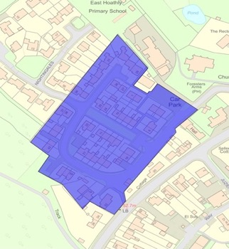

Figure 18 – Map of Character Area 6 – Church Marks Lane Area

118. The Church Marks Lane Area was built in the 1950s on the former site of the village allotments. The buildings were completed in at least 2 phases and it is believed that some of the plots were self-build projects. It also includes a small public car park.

Layout

119. Church Marks Lane is a residential estate. The building plots vary in size but are generally small with small front and rear gardens. Most plots are divided by hedges, fences and some walls. The area is generally open and welcoming with a wide lawn separating the central section of housing. The central area comprises three short terraces of homes surrounded by the access road along which the detached and semi-detached homes sit. The houses are a mix of medium sized, detached, two storey homes, medium sized, semi-detached, two storey homes, three bungalows and several blocks each containing four flats. The orientation is varied.

120. The terraced houses all have small front and rear gardens. The remainder of the housing is generally set back about 6 metres from the access road. They have small front and rear gardens generally with most of the front given over to parking forecourts.
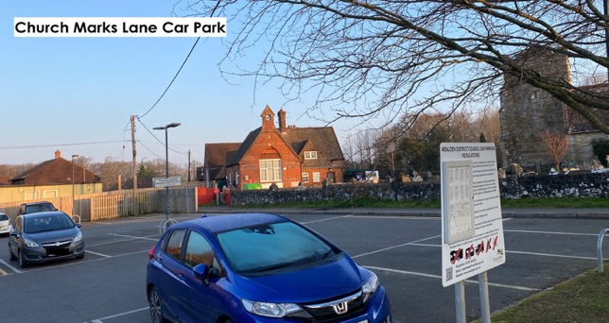

121. The entrance to the area includes a free public car park owned and operated by WDC. This has 20 parking bays and is situated adjacent to the Village School, Church and Village Hall. This car park is primarily used by the School, Village Hall and Church. It is not for the regular use of the residents of Church Marks Lane. It is not intended for the use of visitors to the residents of Church Marks Lane. It is perfectly understandable that the residents and their visitors do sometimes make use of the car park because of the lack of parking space elsewhere. It should be noted that overnight parking is not allowed so cannot be used by residents overnight or visitors who stay the night. The principal need of residents to park vehicles is to park for long periods and almost always to park overnight. The public car park is therefore of little use to residents.

122. There is some off-street parking in forecourts and some homes have attached garages. To the East of the area, there are marked parking bays and a few garages.

123. The area measures 1.77 ha and includes 56 dwellings giving the area an approximate density of 32 dph. This is high compared with the settlement when it was built in the 1950s and remains so now when the housing density for the village is 14 dph.

Topography

124. The land slopes slightly down, away from the entrance, towards Moat Wood.

125. Some of the houses have views towards the School and Church and some houses have views to the rear into Moat Wood. Mostly the views are onto other housing.

Access

126. The road is asphalt, with some asphalt pavements and grass verges. There are pedestrian through routes within the area connecting it to South Street, the Sports Ground and via Nightingales to Moat Wood.

127. The condition of some of the pavements is poor.

Buildings

128. The architecture of the terraced housing is simple and uniform. Brick built, small sized homes with hung clay tiles. Roofs are medium pitched clay tiles with gabled ends. Each entrance has a flat roofed porch. The bricks and tiles in some places are overly regular in colour and manufacture which creates a utilitarian feel and does not reflect the character of the traditional hand-made tiles of Sussex vernacular. Windows are generally UPVC with clear glass. Window sizes are large on some properties but others have small windows, the general categorization within the whole area is good.

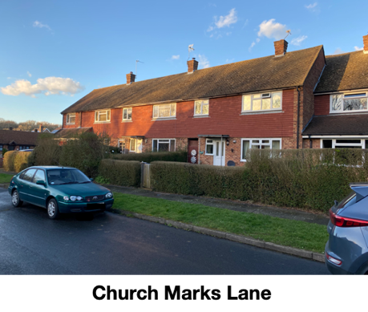

129. The houses to the West of the site were a later addition and are generally semi-detached, brick built medium sized homes with clay tile hanging to the first floor. Roofs are medium pitched roman style tiles with gabled ends. Each entrance is gabled and has an enclosed porch. Windows are small with brown frames and leaded glass designs. The unusual style of these windows is not reflected anywhere else in the Parish and does not fit with the vernacular of the settlement.

130. The flats have the appearance of semi-detached houses with two upper flats and two lower flats accessed from a communal entrance.

131. The remainder of the housing is a variety of detached individual designs and some chalet bungalows.

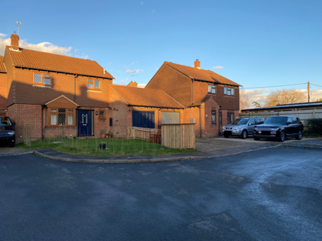

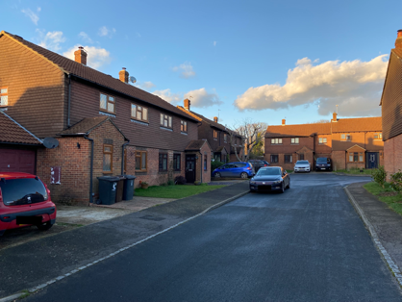

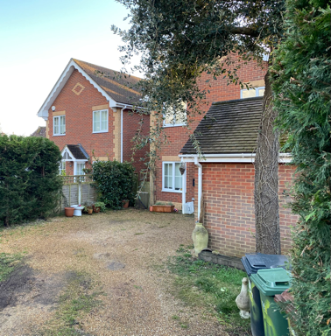

Three examples of later additions to Church Marks Lane

Streetscape

132. Parking is an issue, with on-street parking visible. Some vehicles park in the public car park thereby taking up space from visitors to the School, Church and Village Hall.

133. Bins are stored out of sight and there is no street lighting. Utility poles provide power and telephone cables for the area.

134. The central pair of terraced houses is separated by a wide area of lawn which provides an attractive open green space. This area has some tree planting but nothing elsewhere in the area. The Eastern side of the area has some grass verges.

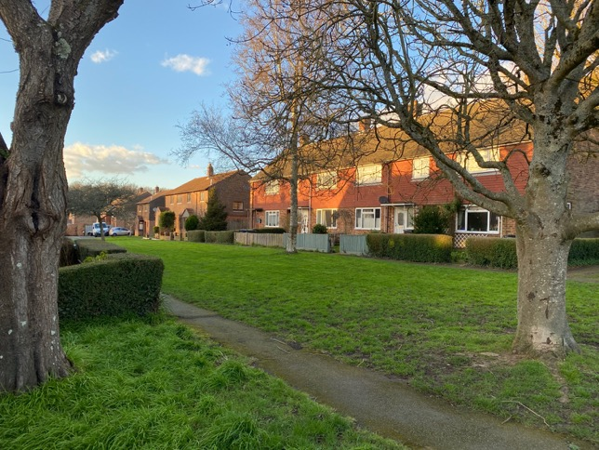

Church Marks Lawn

135. The public car park has an adjacent footpath, an access roadway for the School. There is no formal drop off point for the school and the layout does not make the best use of the available space and has inadequate landscaping.

Dark Skies

136. The lights in the public car park are very bright and radiate in all directions. They illuminate a wider area than the car park. A reduction in the intensity of the lights, shrouding to prevent upward radiation and use of a timer to control illumination during the early morning hours would benefit the Dark Skies within the area and thereby benefit biodiversity.

Detractors

137. In this Character Area, the following detractors are noted:

a. Inappropriate choice of materials and finishes. The use of machine cut tiles, roman roof tiles, brown window frames with leaded windows and the use of colours that do not fit with the vernacular of the Parish.

b. Failure to respond to historic pattern of development.

c. Inadequate parking for residents and visitors. It is noted that the area contains a public car park but see Paragraph 121 for explanation of why this of little use to residents or people visiting residents.

d. Visual clutter of parked cars and a car dominated landscape.

e. Density not reflecting existing settlement particularly at the time the development was built, and this remains so now, in comparison with the village as a whole.

f. Light Pollution in Car Park.

g. Narrow roadways vulnerable to blockage by parked or large vehicles.

h. Wirescape.

Character Area 7 - Rectory Close Area

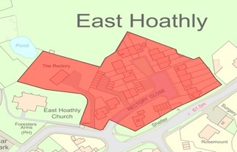

Figure 19 – Map of Character Area 7 – Rectory Close Area

138. The Rectory Close Area was built in the 1960s on the site of the former East Hoathly Rectory.

Layout

139. Rectory Close is a residential cul-de-sac. The building plots are relatively small, with small front and rear gardens. The plots are not generally divided at the front. The houses are all two storeys and a mixture of detached, semi-detached and terraced dwellings. The orientation is varied with the houses set back around 5 metres from the road or communal green. There are four blocks of flat roofed garaging and a few houses have their own garages within their curtilage. There are some unmarked on-street parking spaces but there is also on-street parking outside these designated spaces and parking in front of garages.

140. The area measures 0.96 ha and includes 23 dwellings giving the area an approximate density of 24 dph. This is high compared with the settlement when it was built in the 1960s and remains so now when the housing density for the village is 14 dph.

141. A private drive just in front of the entrance to Rectory Close leads to the current Rectory.

Topography

142. The land is level. Eight of the houses are have views onto the Sports Ground from the rear. The remainder of the views are inward onto housing, the High Street or in the rear onto garaging.
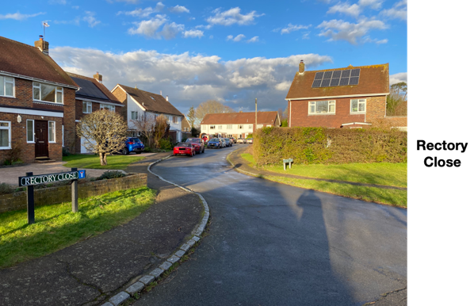

Access

143. The road is asphalt with asphalt pavement on both sides. The areas in front of the garaging are concrete and are in a poor state of repair.

144. There is one pedestrian though route connecting to the Sports Ground.

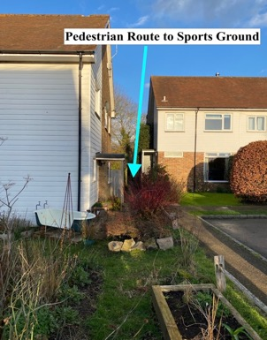

Buildings

145. The architecture is simple and relatively uniform in design. There are slight variations in design but the general impression is of utilitarian style of limited character. Brick built medium sized homes with clay tile hanging or shiplap UPVC weatherboarding to the first floor. Roofs are medium pitched plain clay tiles with gable ends. The bricks and tiles in some places are overly regular in colour and manufacture which creates a utilitarian feel and does not reflect the character of the traditional hand-made tiles of Sussex vernacular.

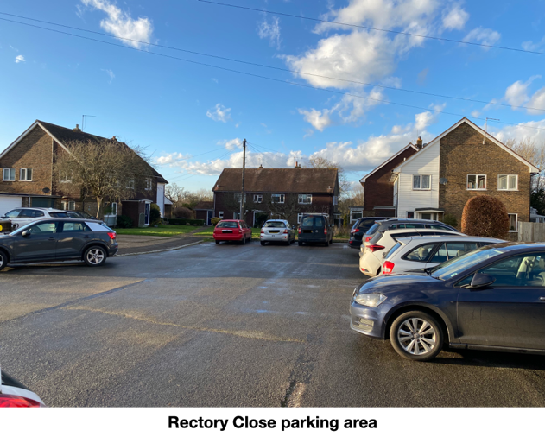

146. Windows are a variety of UPVC plain glass designs, with one house with leaded glass. Window size is variable with some well sized and some small.

147. The new Rectory is a large detached two storey house. It is a large brick-built house with clay tile hanging to the first floor and a gable ended roman style clay tile roof.

Streetscape

148. On-street parking was visible and the tight space suggests that maneuvering vehicles is an issue. Bins are stored out of sight or in the garaging areas. There is no street lighting. There are two utility poles providing telephone cables.

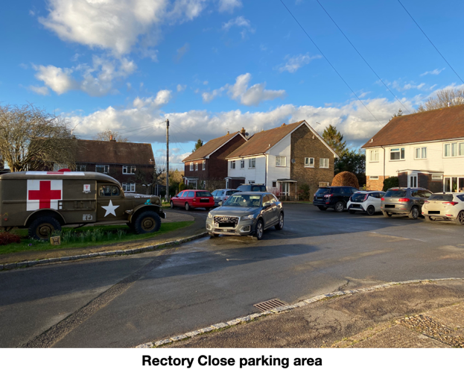

149. The garaging areas were clear and appeared to be used but most residents report that they are not used for vehicle storage. The concrete forecourts of the garaging areas were in variable condition with cracks and weed growth evident. The garage doors are of varying designs.

150. There is a small communal lawn at the head of the cul-de-sac.

151. There are no trees within the area.

152. Rectory Close benefits from a Calor Gas supply to the houses from a pair of storage tanks.
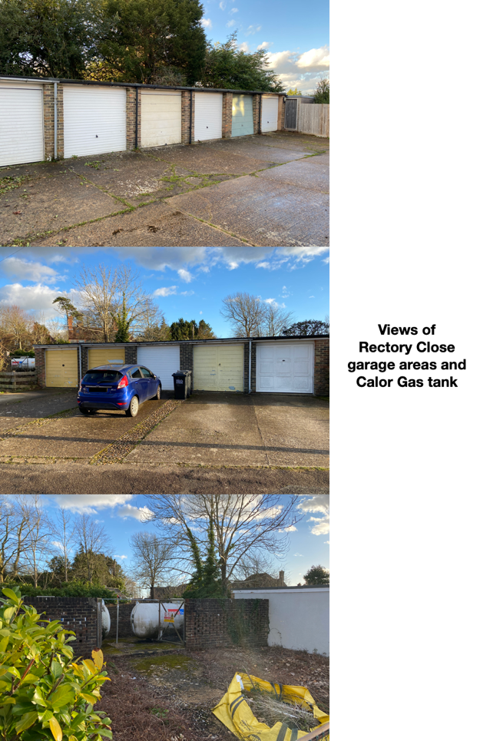

Detractors

153. In this Character Area, the following detractors are noted:

a. Inappropriate choice of materials and finishes. The use of machine cut tiles, and the use of colours that do not fit with the vernacular of the Parish.

b. Failure to respond to historic pattern of development.

c. Inadequate parking for residents and visitors.

d. Visual clutter of parked cars and a car dominated landscape.

e. Density not reflecting existing settlement particularly at the time the development was built, and this remains so now, in comparison with the village as a whole.

f. Narrow roadway vulnerable to blockage by parked or large vehicles.

g. Garages that are too small and not used for vehicles which then displaces vehicles to park elsewhere and add to the clutter of parked cars and a car dominated landscape and which often become unused and poorly maintained and unsightly. This includes poorly maintained forecourts in front of garages.

h. Wirescape.

Character Area 8 - Susan’s Close Area

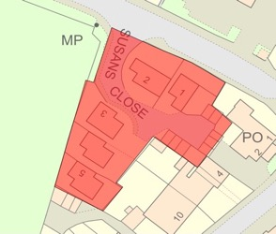

Figure 20 – Map of Character Area 8 – Susan’s Close Area

154. The Susan’s Close Area was built in the 1960s on the site of a Workshop and Garden.

Layout

155. Susan’s Close is a residential cul-de-sac. The building plots are of small size with small front and rear gardens. The plots are not generally divided on their boundaries facing into the site. The houses are comprised of five detached two storey homes. The orientation is varied with the houses set back from the road between 3 and 12 metres. The development has a cramped feel with houses squeezed into the site rather than creating a pleasing layout. There is an area of garaging and limited off-street parking but on-street parking is also visible.

156. The area measures 0.19 ha and includes five dwellings giving the area an approximate density of 26 dph. This is high compared with the settlement when it was built in the 1960s and remains so now when the housing density for the village is 14 dph.

Topography

157. The land is level. Four of the houses have views onto the Sports Ground. Two of the houses have views onto London Road, Village Works and the Village Pump. The remainder of the views are onto garaging and the rear of houses on the High Street.

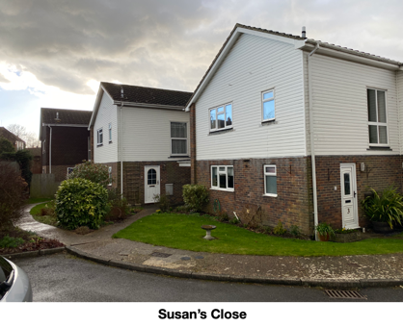

Access

158. The road is asphalt, with one concrete pavement (in poor condition). The cul-de-sac arrangement means that no though route exists.

Buildings

159. The architecture is simple and each house has slight variations in design. They are largely brick built, medium sized homes with clay tile hanging or shiplap UPVC weatherboarding to the first floor. Roofs are shallow pitched, low profile concrete tiles with gable ends. The hung clay tiles are darker than the traditional Sussex tile and do not blend easily with surrounding examples.

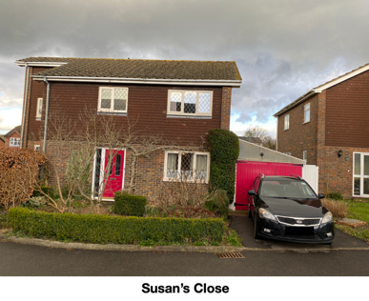
160. Windows are a variety of UPVC plain glass designs and one house with leaded glass. Window sizes are relatively small.

Streetscape

161. On-street parking was visible and the tight space suggests that maneuvering vehicles may be an issue. Bins are stored out of sight. There is no street lighting or utility poles.

162. The area has three small flat roofed garage blocks, some of which are allocated to houses on the High Street.

163. There are no communal spaces, green spaces or trees.

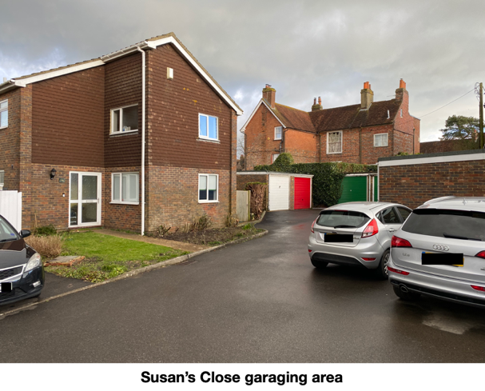

Detractors

164. In this Character Area, the following detractors are noted:

a. Inappropriate choice of materials and finishes. The use of machine cut tiles, and the use of colours that do not fit with the vernacular of the Parish.

b. Failure to respond to historic pattern of development.

c. Inadequate parking for residents and visitors creating a visual clutter of parked cars and a car dominated landscape.

d. Density not reflecting existing settlement particularly at the time the development was built, and this remains so now, in comparison with the village as a whole.

e. Narrow roadway vulnerable to blockage by parked or large vehicles.

f. Garages that are too small and not used for vehicles which then displaces vehicles to park elsewhere and add to the clutter of parked cars and a car dominated landscape.

g. There are no communal spaces, green spaces or trees.

h. Cul-de-sac development that inhibits permeability, reduces opportunities for residents to meet each other and can create a sense of exclusion.

Character Area 9 - Thomas Turner Drive Area

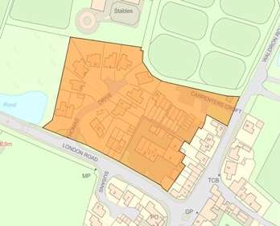

Figure 21 – Map of Character Area 9 – Thomas Turner Drive Area

165. The Thomas Turner Drive Area includes Thomas Turner Drive, Carpenters Croft and the Village Works mixed commercial and residential area. Each of the three elements will be described separately as part of Character Area 9. Carpenters Croft was built around 1988. Thomas Turner Drive was built in two phases with the final phase completed around 1988. Village Works was a former Garage and Filling Station. It was adapted into a mix of residential flats and commercial spaces in the 1980s.

Thomas Turner Drive within Character Area 9

Layout

166. Thomas Turner Drive is part of Character Area 9 and is an attractive residential cul-de-sac. The building plots are of medium size with front and rear gardens. Some plots are divided by hedges and fences, but the area is generally open and welcoming. The houses are a mix of two storey homes with large detached homes, semi-detached homes and a terrace of three homes facing onto London Road. The orientation is varied with the houses set back from the road around 6 metres, focusing into the centre of the cul-de-sac. They mostly have off-street parking and integral or attached garages. The houses facing onto London Road have a separate garage block to the rear.
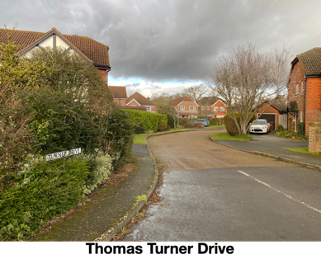

167. The area measures 0.63 ha and includes 16 dwellings giving the area an approximate density of 25 dph. This is high compared with the settlement when it was built in the 1980s and remains so now when the housing density for the village is 14 dph.

Topography

168. The land slopes slightly down, away from the London Road.

169. Houses to the West of the area have views towards Long Pond but these are generally limited by vegetation. Views to the North, onto the equestrian facilities and open paddocks of Hesmond’s Stud are generally screened by hedges. The views to the East are onto the rear of properties in Carpenters Croft and Village Works. The views to the South are onto London Road, with some views of the Sports Ground beyond.

Access

170. The road is block paved with no pavements. The cul-de-sac arrangement means that no through route exists.

Buildings

171. The architecture has used some elements of Sussex historic building design, with hung tiles and some faux timber framing to the upper floor. The houses are generally, brick built, medium and large sized homes with decorative hung clay tiles on the earlier properties and machine-made tiles on the later ones. Roofs incorporate Roman style tiles with a mix of gable ends, half hips and facing gables. Individual designs have been used for the earlier homes, but the later ones are identical.

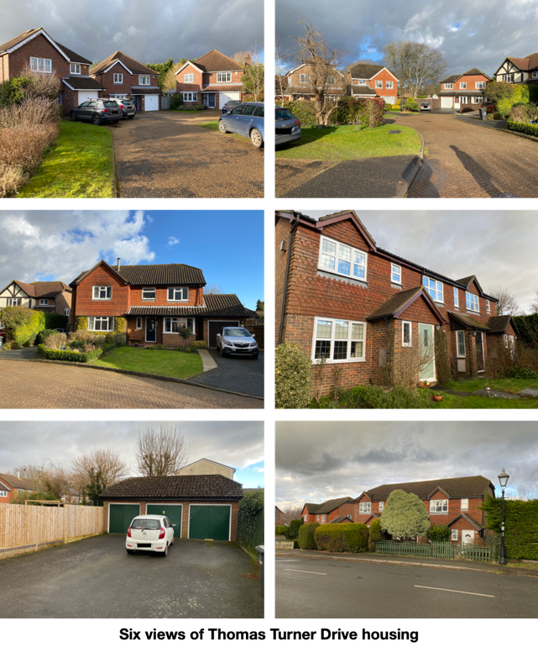

172. The windows all have UPVC frames with a mix of leaded light designs. Window sizes are good.

Streetscape

173. Parking is reasonable with no on-street parking visible. Vehicles are parked on forecourts in front of each house. Bins are stored out of sight. There is no street lighting in the cul-de-sac but there is a heritage street light on London Road. There are no utility poles.

174. There are no public communal spaces, greenspaces or trees. All greenery and trees are part of private gardens.

Dark Skies

175. The heritage street lamp on London Road uses a low intensity bulb, which limits its light emission. It is currently illuminated all night. Installing a timer system would enable its use to be controlled from midnight to 5 am.

Carpenters Croft within Character Area 9

Layout

176. Carpenters Croft is part of Character Area 9 and is a residential cul-de-sac. The building plots are of a relatively small size with small front and rear gardens. The plots are not generally divided on their boundaries at the front. The houses are comprised of two, four house terraces each of two storey homes. The orientation is uniformly North facing with the houses set back from the road by around 3 metres. There are limited on-street parking bays, but each house has a garage in a separate area near the entrance to the development.

177. The area measures 0.24 ha and includes 8 dwellings giving the area an approximate density of 33 dph. This is high compared with the settlement when it was built and remains so now when the housing density for the village is 14 dph.

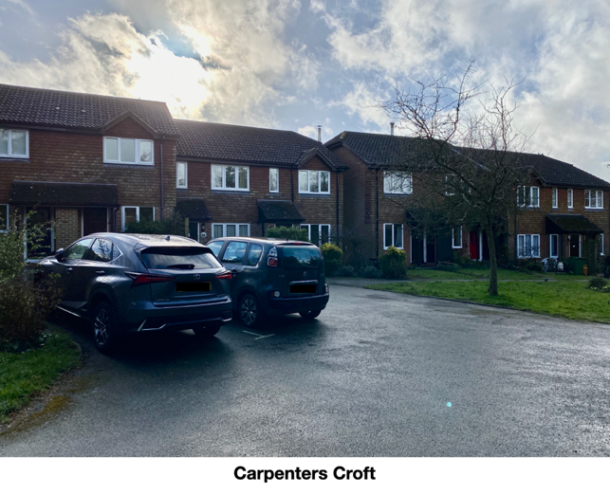

Topography

178. The land slopes slightly down, away from the Waldron Road.

179. The houses are screened to the North by vegetation, which restricts views onto the equestrian facilities and open paddocks of Hesmond’s Stud. The views to the South, West and East are onto the rear of properties in Thomas Turner Drive and Village Works.

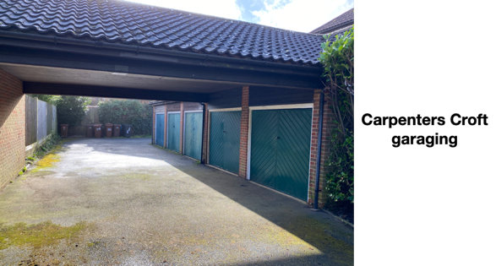

Access

180. The road is a mix of block paving and asphalt with no pavements. The cul-de-sac arrangement means that no though route exists.

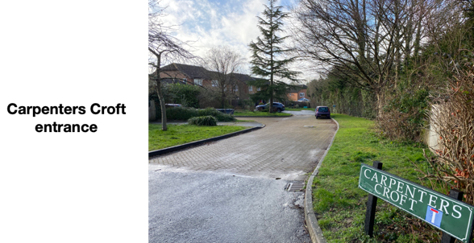

Buildings

181. The architecture is simple and uniform. The houses are generally brick built, small sized homes with clay tile hanging to the upper floor. Roofs are shallow pitched, with interlocking Roman style tiles with half hipped gable ends. Each entrance has a lean-to porch.

182. Steel chimney vents are visible on some properties.

183. The windows all have UPVC frames with plain glass designs. Window sizes are good.

Streetscape

184. Parking is reasonable with only limited on-street parking visible. Bins are visible but stored in the garage area and therefore in a utility area. There is no street lighting or utility poles.

185. The development benefits hugely from a garage area with a wide access route. This area also provides a covered space for unloading.

186. There are three small communal green spaces and a wide green verge in the development with several trees planted.

187. There is a small electrical sub-station at the entrance to the development.

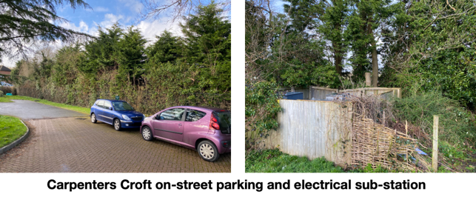

Village Works within Character Area 9

Layout

188. Village Works is part of Character Area 9 and is a repurposed site with primarily commercial units and two residential flats. The commercial units occupy the buildings of a former Filling Station and Garage. Two residential flats are situated above the commercial units in the main part of the building. The current businesses are:

a. Wellbeing Space.

b. Dot to Dot.

c. Osteopathy for All.

d. Jim Holden Photography Studio.

e. Keith Pettit Sculpture/Engraving.

f. Holistic Veterinary Surgery.

g. Health House.

h. Georgie’s Groom Room.

189. The buildings are set well back from the road with parking for staff and clients in the front and to the rear of the buildings.

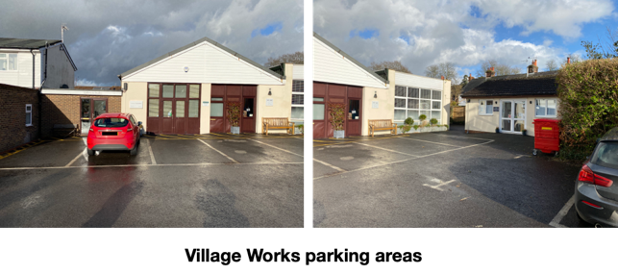

Access

190. The access is a wide asphalt entrance onto an asphalt forecourt with marked parking bays and pedestrian walking areas marked with hazard warnings. The self-contained arrangement means that no through route exists.

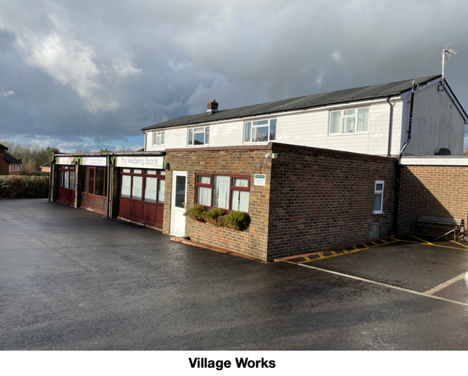

Buildings

191. The architecture is a mixture of styles and periods, with some brick construction, some rendered finishes, UPVC weatherboarding and a wide variety of windows and frontages to the commercial units. Roofs are a mix of concrete tiles and felt with some roofs pitched and some flat.

Streetscape

192. Parking is adequate. Bins are stored in a utility area to the rear of the buildings. There is no street lighting or utility poles. There is one bench available.

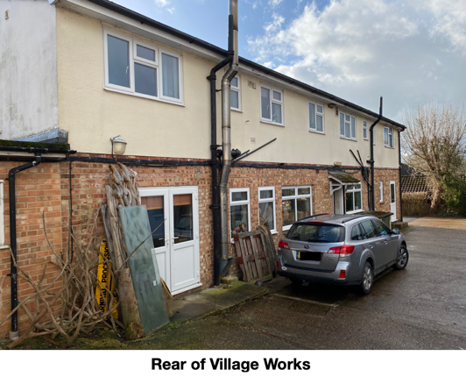

193. There is a raised bed of shrubs and trees at the entrance, which also contains a wooden sculpture.

194. A square oak framed structure with a clay tiled roof stands at the entrance to Village Works. Inside the structure is the historic village water pump. This feature is surrounded by a hedge and other planting.

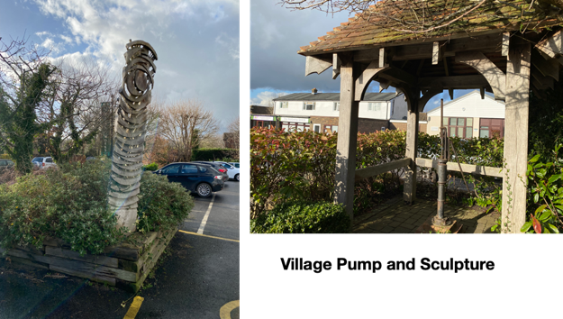

195. A Village Works sign marks the entrance to the site and each business also has its own sign. The signs are not overly large and each is discreet and does not intrude on the character of the site.

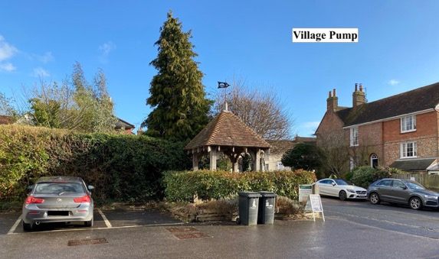

Detractors

196. In this Character Area, the following detractors are noted:

a. Inappropriate choice of materials and finishes. The use of machine cut tiles, and the use of colours that do not fit with the vernacular of the Parish.

b. Failure to respond to historic pattern of development.

c. Inadequate parking for residents and visitors in the Carpenters Croft part of the Character Area.

d. Visual clutter of parked cars and a car dominated landscape.

e. Density not reflecting existing settlement particularly at the time the development was built, and this remains so now, in comparison with the village as a whole.

g. Narrow roadways vulnerable to blockage by parked or large vehicles.

h. Garages that are too small and not used for vehicles which then displaces vehicles to park elsewhere and add to the clutter of parked cars and a car dominated landscape.

i. Cul-de-sac development that inhibits permeability, reduces opportunities for residents to meet each other and can create a sense of exclusion.

Character Area 10 - Linear Development Area

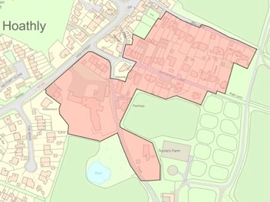

Figure 22 – Map of Character Area 10 – Linear Development Area

197. The Linear Development Area is made up of three lanes radiating out of the Conservation Area and comprises Mill Lane, Buttsfield Lane and Old Lane which leads to Tourles Farm. Linear Development has been a common form of growth for many villages. An initial cluster of properties, often sited at a crossroads or clearing becomes the nucleus for a settlement. Growth then spreads along the lanes leading out of such an emerging settlement. Originally, the buildings would have been of mixed use and often separated along the lanes. Over time, the working buildings such as blacksmiths, shops and businesses have been converted to housing and the gaps filled in and most of these are within the Conservation Area. Where Mill Lane, Buttsfield Lane and Old Lane leave the Conservation Area they have been gradually developed in a linear form since the 1960s.

198. The area (excluding Lydfords and the old Surgery) measures 2.5 ha and includes 44 dwellings giving the area an approximate density of 18 dph. This is comparable with the settlement when these homes were built and remains so now when the housing density for the village is 14 dph.

Mill Lane within Character Area 10

Layout

199. Part of Character Area 10 is Mill Lane from where it leaves the Conservation Area, at the site of the former Blacksmiths, to the elevated position where East Hoathly windmill formerly stood. The buildings are all on the Southern side of the Lane. The plots are generally large with generous front and rear gardens. The plots are generally divided on their boundaries with hedging and fences. The houses are a mixture of detached, two storey homes, semi-detached, two storey homes and one chalet bungalow. The orientation is all North facing with the houses set back around 20 metres from the Lane.

200. Most of the houses have adequate forecourt parking and separate or attached garages.

Topography

201. The land slopes gently upward from Waldron Road to the ridge of a spur at the top of the Lane.

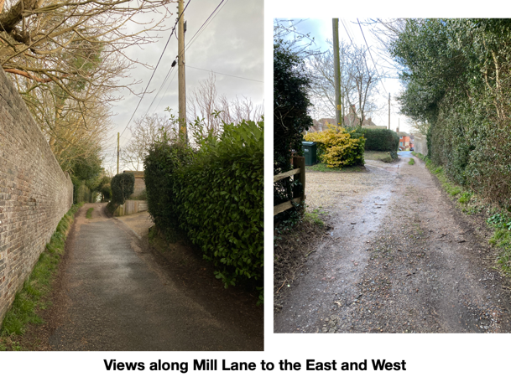

202. The views from the houses to the North is screened by the high brick wall with trees emerging above it on the boundary with Hesmond’s House. This wall gives way to a very tall hedge about half way along the lane. Views to the South are onto the housing on Buttsfield Lane.

Access

203. The road has an unmade surface with no pavement. The uneven surface can be problematic for some users, but is generally welcomed as retaining the feel of a village lane and the rural setting.

204. There is pedestrian access to paths at the top of the Lane. The path connecting to the top of Buttsfield Lane is not a PROW but is commonly used by the public. A bridleway begins on Mill Lane and connects with the Wealdway PROW towards Chiddingly.

Buildings

205. The architecture varies significantly and gives a distinctive feel to the area. Most of the houses have used some elements of Sussex historic building design comprising brick built medium and large sized homes with tile hung or timber boarded upper floors. Some have been more successful than others. The roofs are a mix of styles with plain tiles, slate, many gables and some hips with bonnets. The homes are generally brick built, medium and large sized homes with hung clay tiles or wooden weatherboarding. One house is of contemporary design with horizontal wooden boarding. It is the only example of contemporary design in the village. It has strong design integrity and sits well alongside the more traditional designs.

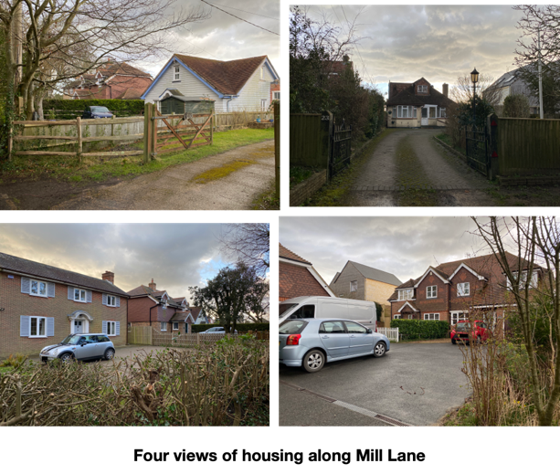
206. Windows are a mixture of wooden and UPVC plain glass designs. Window size is variable with some well sized and some small.

Streetscape

207. On-street parking is not possible because the Lane is too narrow. Bins are generally stored out of sight from the Lane. There is no street lighting. There are utility poles providing power and telephone cables along the length of the Lane.

208. There are no communal spaces, green spaces or trees.

Buttsfield Lane within Character Area 10

Layout

209. Part of Character Area 10 is Buttsfield Lane (an unadopted road) from where it leaves the Conservation Area where the former Post Office was sited to an elevated position following the route of the Wealdway PROW to Chiddingly. The buildings are sited on both sides of the Lane. The plots are generally large with generous front and rear gardens. The plots are generally divided on their boundaries with hedging and fences. The houses are a mix of detached 2 storey homes, semi-detached, two storey homes, some chalet bungalows and two terraces, one of three and one of four homes. The orientation is either North or South facing with the houses set back between 6 and 12 metres from the Lane.

210. Some of the houses have forecourt parking and separate or attached garages. There are some unmarked parking spaces on the Lane and two areas of flat roofed garage blocks on the North side of the Lane. These are discreetly located to the rear of the properties and have narrow access roads.

Topography

211. The land slopes gently upward from Waldron Road to the ridge of a spur at the top of the Lane.

212. The views from the houses to the South are onto Hesmond’s Stud land and open countryside. Views to the North are onto the housing on Mill Lane.

Access

213. The road has a partial asphalt surface, but is poorly maintained and there are significant potholes and cracks in the surface. There is generally no pavement other than a small asphalted section around the outside of a parking area. The top of the Lane has a gateway and reduces to a footpath. The uneven surface can be problematic for some users but is generally welcomed as retaining the feel of a village lane and the rural setting.

214. There is pedestrian access to paths at the top of the Lane. The path connecting to the top of Mill Lane is not a PROW but is often used by the public. The main path is the Wealdway PROW, which leads towards Chiddingly.

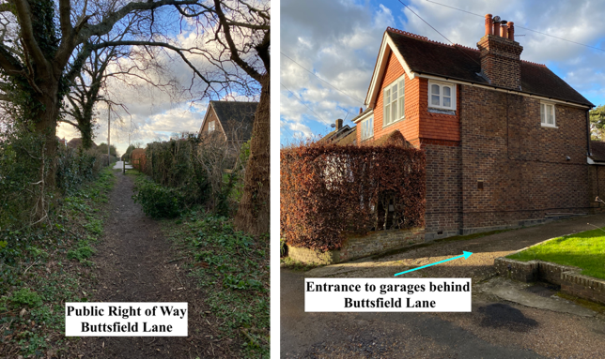

Buildings

215. The architecture varies significantly and gives a distinctive feel to the area. Some of the houses have used some elements of Sussex historic building design with hung tiles and some faux timber framing. The roofs are a mix of styles with plain tiles, slate, many gables and half hips with bonnets. The homes are generally brick built, medium and large sized homes with hung clay tiles (some decorative) or wooden weatherboarding. There are three pairs of two storey semi-detached homes with distinctive hipped roofs extending down to the lower storey.

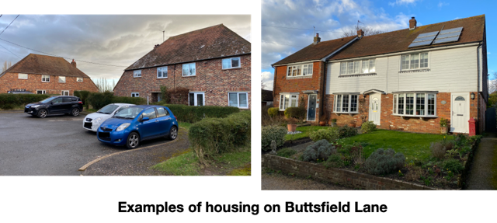

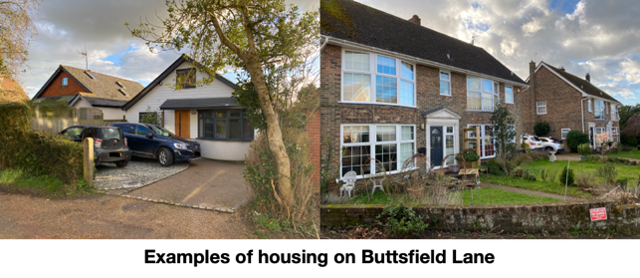

216. Windows are a mixture of wooden and UPVC frames with plain glass designs. Window size is variable with some well sized and some small.

Streetscape

217. On-street parking is generally not possible because the Lane is too narrow but it does occur. The access to the garage areas to the rear of the houses is narrow and maneuvering is an issue. Bins are generally stored out of sight from the Lane. There is no street lighting. There are utility poles providing power and telephone cables along the length of the Lane.

218. There are no communal spaces, green spaces or trees until the road reduces to a footpath at the top end.

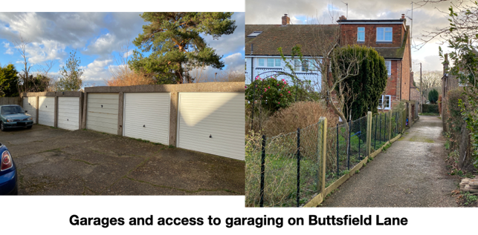

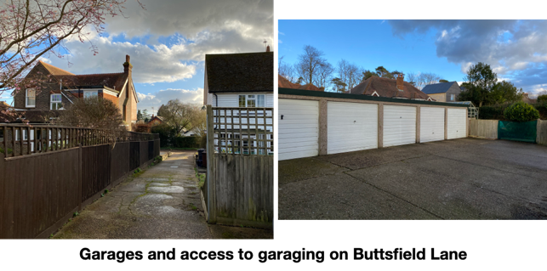

Old Lane within Character Area 10

Layout

219. Old Lane is part of Character Area 10. It leads from the Conservation Area where the former Post Office was sited, to Tourles Farm (a red brick bungalow constructed in 1948) and continues as a farm track/footpath to Tourles Yard, which is part of Hesmond’s Stud. There are only four houses on this Lane. Three of the plots are small and one is substantial. The orientation is varied and the properties are set back by varying amounts from 3 to 25 metres from the Lane.

220. Most of the houses have forecourt parking and separate or attached garages.

221. The area also includes Lydfords Care Home and the former Doctor’s Surgery. Neither of these have access onto the Lane, although Lydfords did until very recently (their access is now solely onto South Street). Lydfords is a residential Care Home converted from what was originally a large victorian house and is now much extended.

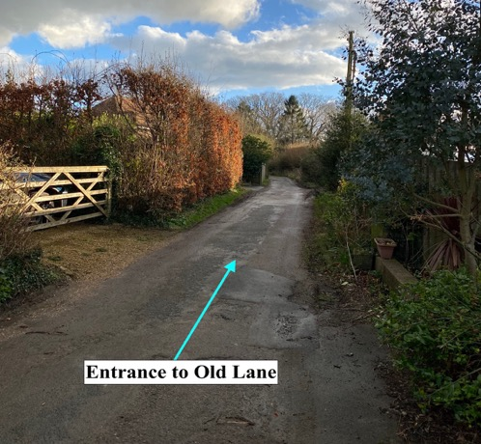

Topography

222. The land slopes gently downward from Buttsfield Lane towards Tourles Farm.

223. The views of final two houses on the Lane are onto Hesmond’s Stud land and the open countryside that has distant views towards the South Downs.

Access

224. The road has an unmade surface with no pavement. The uneven surface can be problematic for some users but is generally welcomed as retaining the feel of a village lane and the rural setting.

225. The Lane is a PROW that leads into open countryside and towards Prices Farm and Whitesmith.

Buildings

226. The houses are detached chalet bungalows styled with significant additions and extensions. The roofs are a mix of styles with plain tiles, many gables and some hips with bonnets. The houses are generally brick built, medium sized homes.

227. Windows are a mixture of wooden and UPVC frames with plain glass and leaded glass designs. Window size is variable with some well sized and some small.
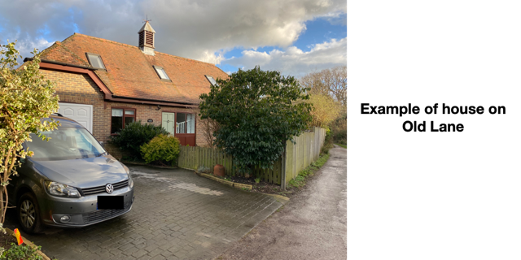

228. The original Lydfords building was a fine Victorian mansion and elements of its brickwork are still evident but the building has been much extended. It is roofed with plain tiles, decorative ridge tiles and there are a mix of gables and hips with bonnets. The windows are all UPVC framed with plain glass in a mixture of styles.

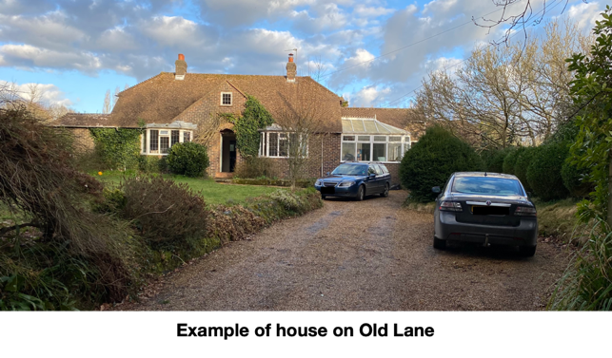

Streetscape

229. On-street parking is not possible because the Lane is too narrow. Bins are generally stored out of sight from the Lane. There is no street lighting. There are utility poles providing power along the length of the Lane with and telephone cables via poles in the gardens to the East of the Lane.

230. The lighting of Lydfords Care Home is bright and abundant and in contrast to the surrounding buildings and the village generally. It is currently illuminated all night. Use of a timer to control illumination during the early morning hours would benefit the Dark Skies within the area and thereby benefit biodiversity.

231. There are no communal spaces, green spaces or trees. However, there is a significant area of private woodland, which overhangs the West side of the lane, South of Lydfords, opposite Tourles Farm.

Detractors

232. In this Character Area, the following detractors are noted:

a. Erosion of architectural detail. This can be caused by older buildings being modernized and having such things as chimney pots removed/replaced, double glazing, plastic rainwater fittings and modern extensions.

b. Inappropriate choice of materials and finishes on some properties. The use of machine cut tiles, and the use of colours that do not fit with the vernacular of the Parish.

c. Light Pollution.

d. Narrow roadways vulnerable to blockage by parked or large vehicles.

e. Wirescape.

f. Traditional boundary treatments such as hedges, brick walls, iron railings or picket fencing being replaced with close boarded fencing.

Character Area 11 - South Street Area

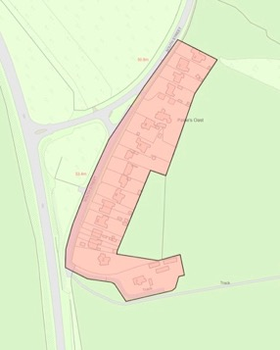

Figure 23 – Map of Character Area 11 – South Street Area

Layout

233. The South Street Area is a linear development that has always been separate from the village. It follows the original line of the A22 prior to the construction of the by-pass and the southern end is now a cul-de-sac. Around half of the homes are pre 1930 and the remainder are post 1950 infill.

234. The building plots are of a large size with deep front and rear gardens. All plots are divided by hedges, fences or walls. The houses are mostly large detached, two storey homes with some chalet bungalows, one semi-detached bungalow and one converted Oast House. The orientation is West facing, with the houses set back from the road around 20 metres. They mostly have off-street parking and a few have integral or separate garages.

235. The area measures 2.3 ha and includes 20 dwellings giving the area an approximate density of 9 dph. This is low compared with the settlement when these homes were built and remains so now when the housing density for the village is 14 dph.

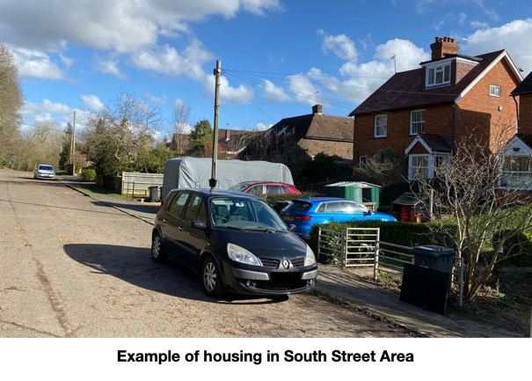

Topography

236. The land rises from the Northern part of the area towards the South. The houses in the Northern part are below the level of the roadway but at the Southern end, they are elevated above the roadway.

237. The houses generally have views to the West onto the woodland of Moat Wood or onto a wooded screen blocking the A22. Views to the East are onto open farmland and the countryside beyond (however, this farmland was granted outline planning consent in 2021 and will become a housing estate).

Access

238. The road is asphalt, with an asphalt pavement along one side of the road. The cul-de-sac arrangement means that no though route exists for vehicles but pedestrians can access a PROW to Blackberry Farm.

Buildings

239. The architecture is mixed. The houses are predominantly brick built with small, medium and a few large sized homes with some hung clay tiles and wooden weatherboarding. Roofs are generally plain tiles with a mix of gable ends, hips, half hips and facing gables. Many of the roofs have dormer windows or Velux additions. The nature of the in-fill development has led to a variety of design ideas and sizes.

240. Windows are wooden or UPVC frames with a mix designs. Window sizes are generally good.

241. There are several properties of historic interest that may have the potential to be non-designated heritage assets:

a. The house at 115 South Street was built in 1908 as Park View Nurse’s Home. It is a large detached, two storey brick building with decorative bands of horizontal brickwork and some decorative hung tiles in the gables. The high-pitched roof is plain tiled but with bands of decorative tiles that are repeated in lower lean-to roofs. The ridge tiles are decorative, as are the finials at the ridge ends. The wooden sash windows are plain glass with each upper sash being divided into four or six separate lights.

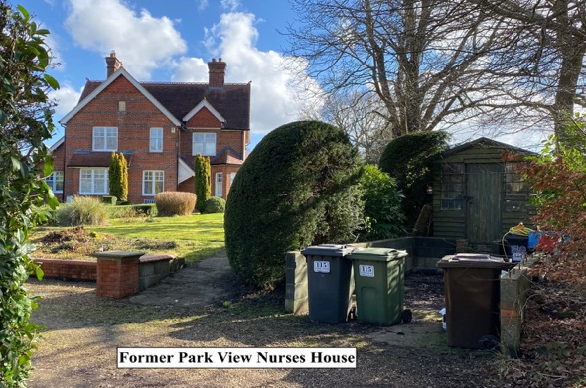

b. There are two sets of brick built, semi-detached cottages (Numbers 107 - 113). These were built as farm workers cottages for soldiers returning from WW1 and are named Paine’s Cottages 1 to 4.

c. Paine’s Farmhouse and Paines Oast both have architectural merit. Buildings are shown on this site of Paine’s Farmhouse from as early as the Yeakell and Gardener Map 1778 - 1783 (See Page 34).

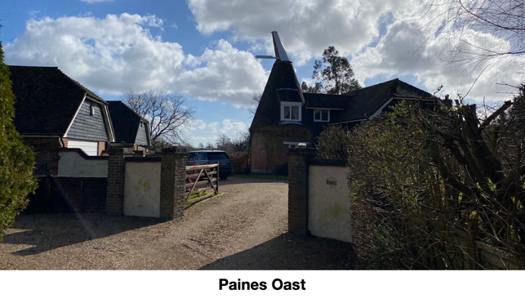

Streetscape

242. Parking is reasonable with only limited on-street parking visible. Bins are stored out of sight. There is no street lighting. There are utility poles for telephone and power along the length of the area.

243. There are no communal spaces or green spaces. A mature tree line buffer exists between the road and the A22.

Detractors

244. In this Character Area, the following detractors are noted:

a. Erosion of architectural detail. This can be caused by older buildings being modernised and having such things as chimney pots removed/replaced, double glazing, plastic rainwater fittings and modern extensions.

b. Inappropriate choice of materials and finishes on some properties. The use of machine cut tiles, and the use of colours that do not fit with the vernacular of the Parish.

c. Wirescape.

Character Area 12 - The Mews Area

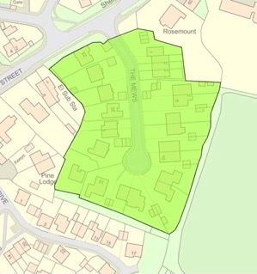

Figure 24 – Map of Character Area 12 – The Mews Area

245. The Mews Area was built in 2 phases with the final phase completed around 2001. The site was a former mansion house and industrial unit.

Layout

246. The Mews area is a linear residential cul-de-sac with a small turning circle at the end. The building plots are generally of large size with front and rear gardens. Most plots are open, but a few are divided by hedges and fences. The first phase of houses was single storey, semi-detached, chalet bungalows with one off-set terrace of four, two storey houses. The orientation is varied with the homes set back from the road by 6 to 20 metres. The second phase of houses was large sized detached, two storey homes.

247. They mostly have off-street parking and separate garages. The bungalow’s garaging is arranged in pairs to the rear of the properties and is accessed by roadways between each set of semi-detached bungalows.

248. The area measures 1.07 ha and includes 24 dwellings giving the area an approximate density of 22 dph. This is high compared with the settlement when it was built and remains so now when the housing density for the village is 14 dph.

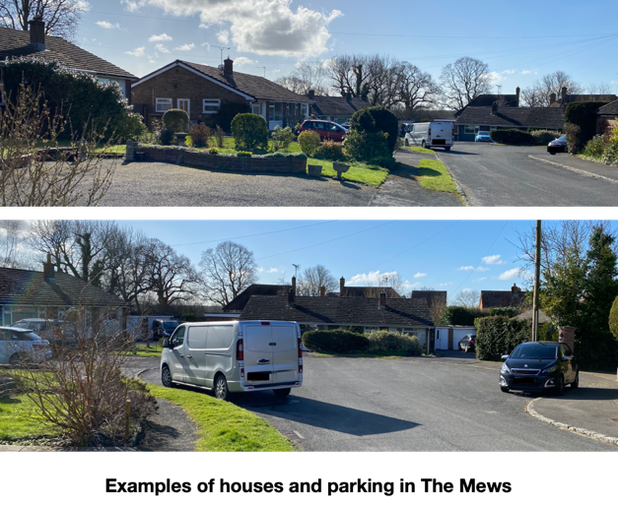

Topography

249. The land is generally flat. Houses on the East side of the area mostly have views onto open countryside that reach towards the South Downs. The remaining views are onto the rear of other properties or South Street.

Access

250. The road is asphalt, with asphalt pavements on both sides. The cul-de-sac arrangement means that no through route exists.

Buildings

251. The architecture is mixed and does not reflect the local vernacular. The houses are generally brick built, medium and large sized homes. The bungalows have rendered panels painted white. The roof’s of the terrace and bungalows are shallow pitched concrete tiles. The detached houses have some hung tiling and higher pitched roofs with gable ends. Some of these roofs use roman style tiles and some plain tiles. Some of the brick and tile-work is decorative and some of the garages have hipped roofs with bonnets.

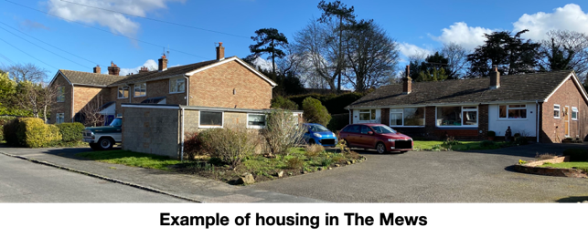

252. Windows are UPVC frames with a variety of clear glass designs. Window sizes are good.

Streetscape

253. Parking is reasonable for the houses, but no visitor parking is identified or available. On-street parking is visible and causes a significant problem on the narrow roadways or blocks pavements. It has the appearance of forecourts cluttered with parking. Bins are stored out of sight. There is no street lighting. There is one telephone pole at the entrance to the area.

254. There are no communal spaces, green spaces or trees.

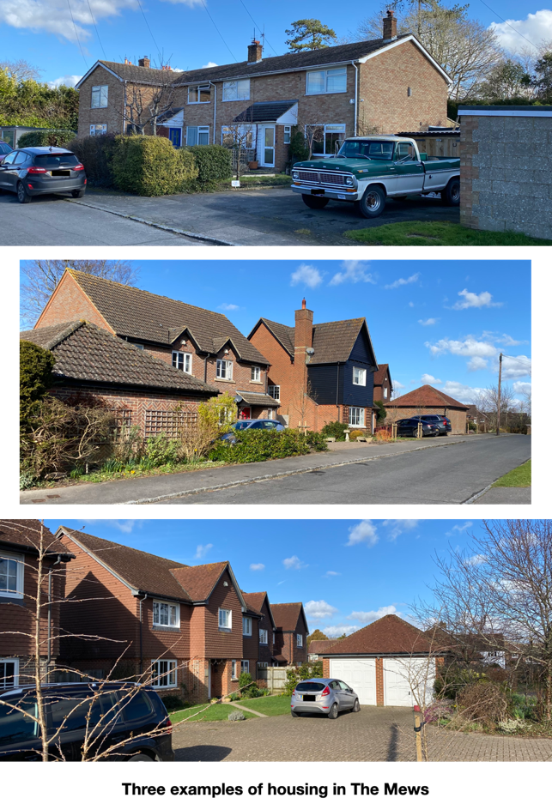

Detractors

255. In this Character Area the following detractors are noted:

a. Inappropriate choice of materials and finishes. The use of machine cut tiles, and the use of colours that do not fit with the vernacular of the Parish.

b. Failure to respond to historic pattern of development.

c. Inadequate parking for residents and visitors.

d. Visual clutter of parked cars and a car dominated landscape.

e. Density not reflecting existing settlement particularly at the time the development was built, and this remains so now, in comparison with the village as a whole.

f. Narrow roadways vulnerable to blockage by parked or large vehicles.

g. Garages that are too small and not used for vehicles which then displaces vehicles to park elsewhere and add to the clutter of parked cars and a car dominated landscape and which often become unused and poorly maintained and unsightly.

h. Wirescape.

i. There are no communal spaces, green spaces or trees.

j. Cul-de-sac development that inhibits permeability, reduces opportunities for residents to meet each other and can create a sense of exclusion.

Character Area 13 - Juziers Drive Area

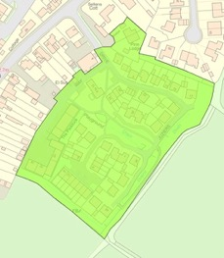

Figure 25 – Map of Character Area 13 – Juziers Drive Area

256. The Juziers Drive Area includes Juziers Drive, Trug Close and an area of commercial businesses on Carriers Way (these roads are unadopted). The development was built in 2009 on the site of the former E&A Carriers and PB Fencing. Part of the development was the construction of a new Doctors Surgery and car park at the entrance to the site. The Doctors Surgery and car park were added to the Conservation Area in 2017 but are not mentioned in the 2021 Character Appraisal. The WDC Issues, Options and Recommendations Consultation that considered the changes to the Conservation Area does not make any reference to the Doctors Surgery or the reasons for its inclusion.

Layout

257. Juziers Drive Area is a mixed-use cul-de-sac. The house plots are of small and medium size. Most of the plots have small forecourts at the front and gardens at the rear. None of the plots are divided by hedges or fences so the area is generally open; however, the lack of set-back for the properties has created a slightly crowded feel on the entrance road. All the houses are close together and this gives a rather cramped feel to the development. The houses are mostly large detached and semi-detached two storey homes with an area of terraced homes around Trug Close. The orientation is varied.

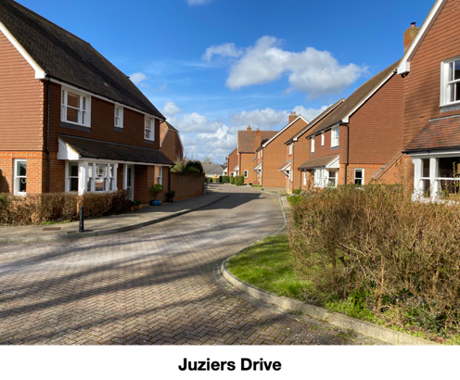
258. In the centre of the development the houses are arranged around a lawn/drain which has created a pleasant open aspect.

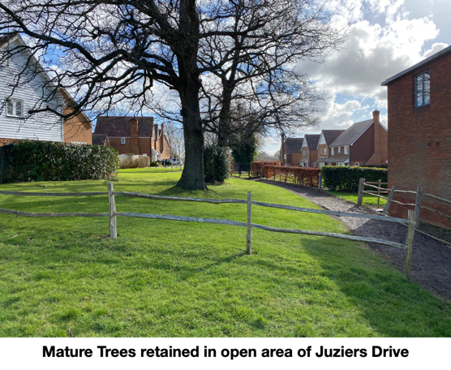

259. The houses mostly have off-street parking and integral or attached garages.

260. The area of housing (excluding the commercial area) measures 2.0 ha and includes 44 dwellings giving the area an approximate density of 22 dph. This is high compared with the settlement when it was built, and remains so now, when housing density for the village is 14 dph.

261. The commercial area has a mixed range of businesses. Currently these are:

a. Electrical Contractors.

b. Freedom Leisure Offices.

c. Oncology Imaging.

d. Tuff Trek Manufacturing.

e. Office Planters.

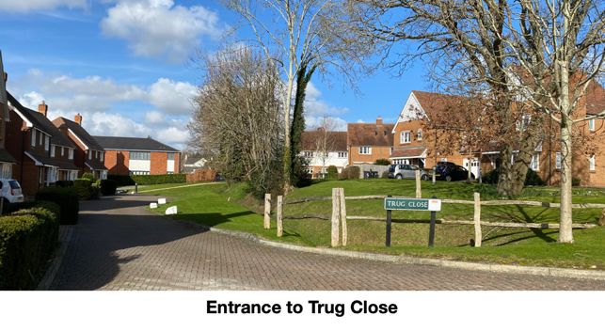

Topography

262. The land slopes gently down, away from the entrance towards the South.

263. Houses on the East of the area have views onto open countryside with distant views of the South Downs. Houses to the South of the area have views onto the open fields of The Circle of Oaks and beyond. The remainder of views are onto housing or commercial premises.

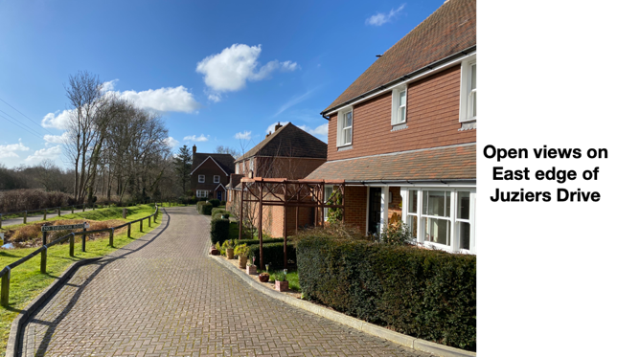

Access

264. The road is block paved. A pavement is provided on one side of the entrance road from South Street to the rear of the development. Paths are provided within the open space in the centre of the development and connecting different parts of the site. Although a cul-de-sac for vehicles, the development has a link to a PROW into the countryside beyond the village and an alternative route back onto South Street.

265. The connection to the PROW at the South East corner is at the lowest point of the site where the SUDS system discharges into a watercourse. Since the development of this site, the PROW now regularly floods. The footpath is often boggy and occasionally impassable.

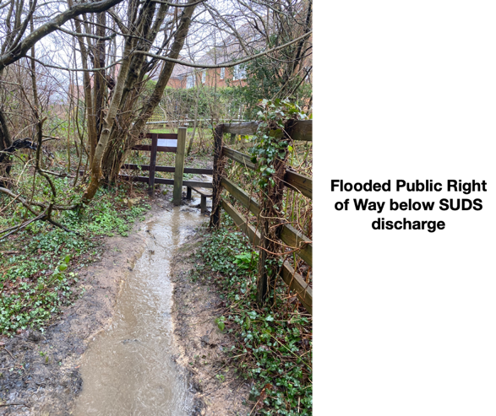

Buildings

266. The architecture has used some elements of Sussex historic building design with hung tiles and weatherboarding. The houses are generally brick built, small, medium and large sized homes. The homes have lean-to style porches, some with a gabled entrance, and all of which extend over a lower storey bay window. Roofs are plain tiles with a mix of gable ends, hips with bonnets, half-hips and facing gables. The designs vary but the size of each component tends to be the same and there is a feel of repetition and uniformity despite the varying designs.

267. Windows are wooden framed with plain glass. There is some variation in the window designs but these are repeated throughout the development giving a feel of uniformity. Window sizes are adequate.

Streetscape

268. Parking is inadequate for the houses and no visitor parking is identified or available. On-street parking is visible and causes a significant problem on the narrow roadways or blocks pavements. It gives the appearance of forecourts cluttered with parking and cars are known to park in the commercial area and surgery car park. Bins are stored out of sight. There are no utility poles. Some areas lack footpaths, thereby forcing pedestrians to use the roadways. There is low level lighting of the roadways.

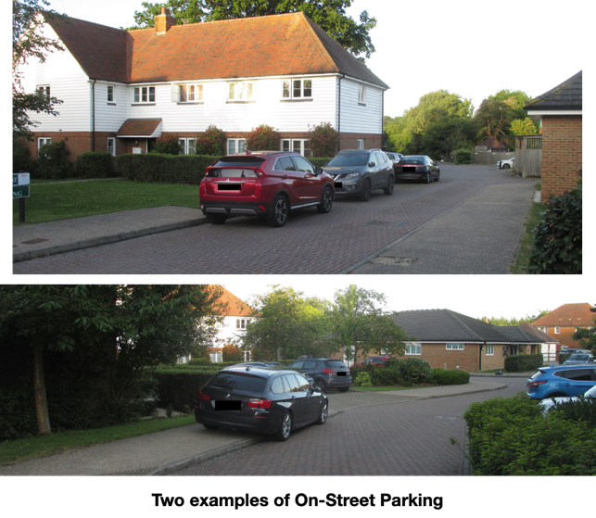
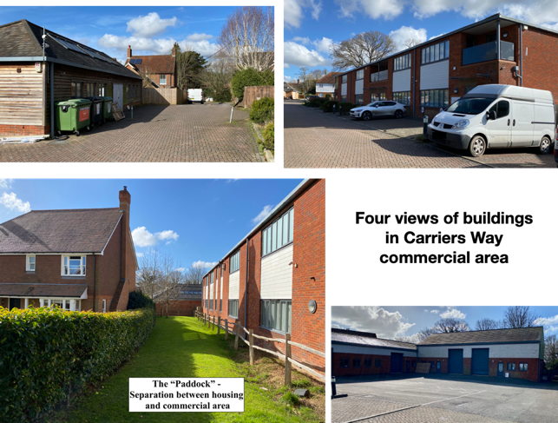

269. There are several strips of green space to accommodate the surface water drainage system and these incorporate some mature trees. There are also other small areas of grass, one named the “paddock”. There is also a fenced lawn that was originally the site of a children’s play area.

Commercial Area

270. There is an electrical substation in Carriers Way.

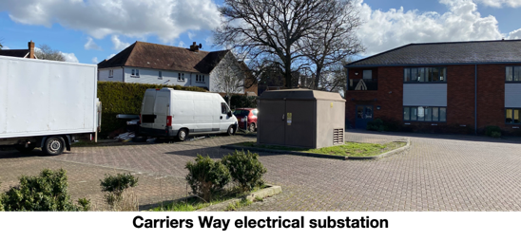

271. The buildings in the commercial area are brick built with wooden or
UPVC weatherboarding and slate or artificial slate roofs. The main two storey building has recessed balconies on the first floor.

Dark Skies

272. The street lighting in this development is the only such lighting in the Parish. The only other street lighting is the very limited number of heritage street lamps on East Hoathly High Street and lighting on A22 roundabouts/junctions. Use of a timer to control illumination during the early morning hours would benefit the Dark Skies within the area and thereby benefit biodiversity.

Detractors

273. In this Character Area, the following detractors are noted:

a. Inappropriate choice of materials and finishes. The use of machine cut tiles, and the use of colours that do not fit with the vernacular of the Parish.

b. Failure to respond to historic pattern of development.

c. Inadequate parking for residents and visitors.

d. Visual clutter of parked cars and a car dominated landscape.

e. Density not reflecting existing settlement particularly at the time the development was built, and this remains so now, in comparison with the village as a whole.

f. Light Pollution.

g. Narrow roadways vulnerable to blockage by parked or large vehicles.

h. Garages that are too small and not used for vehicles which then displaces vehicles to park elsewhere and add to the clutter of parked cars and a car dominated landscape.

i. Areas with no pavements forcing pedestrians into roadways.

Character Area 14 - Nightingales Area

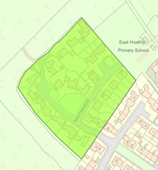

Figure 26 – Map of Character Area 14 – Nightingales Area

274. The Nightingales Area is a residential area cul-de-sac. It was built in 2009 on a greenfield site.

Layout

275. Nightingales is an attractive residential cul-de-sac. The building plots are of medium and large size, with small front and larger rear gardens. The plots are generally not divided at the front and the area is generally open and welcoming with the majority of the housing being arranged around a lawned area and children’s play area. The houses are two storey homes, mostly large and detached but with some medium sized, semi-detached homes and one bungalow. The orientation is varied with the houses generally positioned at the front of each plot with a set-back of only around 2 metres. The homes have off-street parking and integral or attached garages.

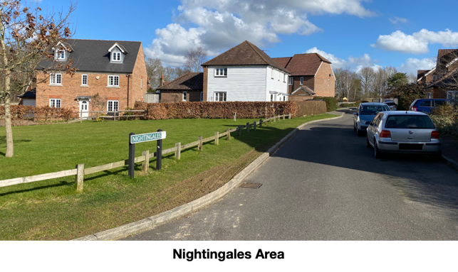

276. The area measures 1.33 ha and includes 30 dwellings giving the area an approximate density of 23 dph. This is high compared with the settlement when it was built, and remains so now, when the housing density for the village is 14 dph.

Topography

277. The land slopes slightly down, away from the Eastern corner of the area to the Western corner.

278. Houses on the Western half of the area have views into Moat Wood. The School Field sits to the North of the site but is fenced off. The views to the East are onto housing.

Access

279. The road is asphalt (with a small area of block paving), with asphalt pavements on both sides of most roads. The cul-de-sac arrangement means that there is no though route for vehicles, but pedestrians can access Moat Wood.

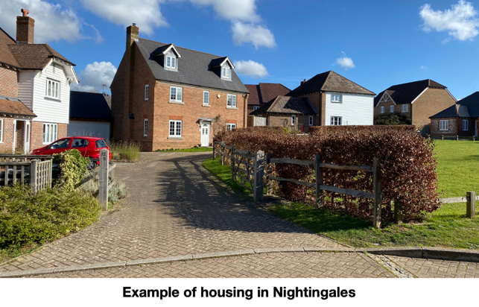

Buildings

280. The architecture has used some elements of Sussex historic building design with hung tiles, weatherboarding, flint walls and some faux timber framing. The houses are generally brick built, medium and large sized homes. Roofs are generally plain tiles with a few slate and some Roman style tiles. The roofs have a mix of gable ends, hips with bonnets, half hips and facing gables. Individual designs have been used and the varied sizes, orientation and grouping around central open spaces has created a pleasing feel to the development.

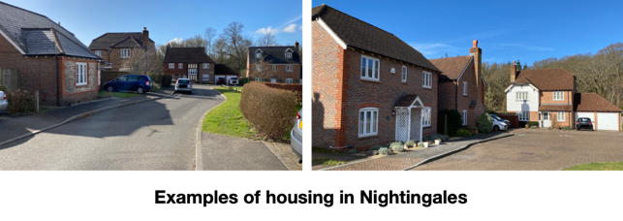

281. Windows are UPVC frames with plain glass. The window design is varied. Window size appears to be too small for the size of the buildings.

Streetscape

282. Parking space is inadequate and on-street parking visible. Bins are stored out of sight or in fenced and concealed areas. There is no street lighting or utility poles.

283. There is a communal lawn with one tree and some grass verges. There is a fenced and well-maintained children’s play area. A buffer strip of grass is positioned on the Western side of the development towards Moat Wood and is known as Church Marks Green.

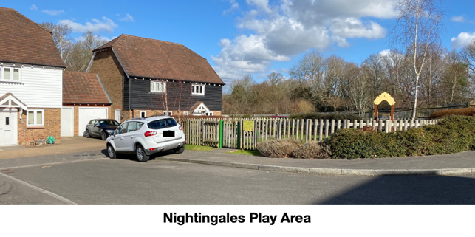

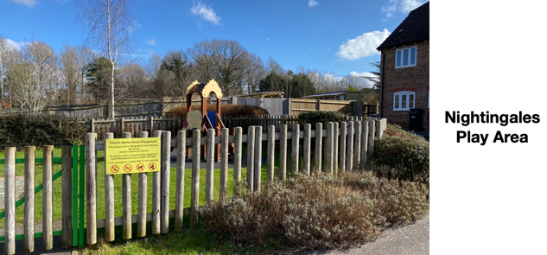

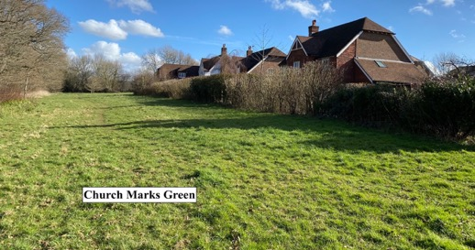

Detractors

284. In this Character Area, the following detractors are noted:

a. Failure to respond to historic pattern of development.

b. Inadequate parking for visitors.

c. Visual clutter of parked cars and a car dominated landscape.

d. Density not reflecting existing settlement particularly at the time the development was built, and this remains so now, in comparison with the village as a whole.

e. Narrow roadways vulnerable to blockage by parked or large vehicles.

f. Garages that are too small and not used for vehicles which then displaces vehicles to park elsewhere and add to the clutter of parked cars and a car dominated landscape.

Character Area 15 - Amenity Area

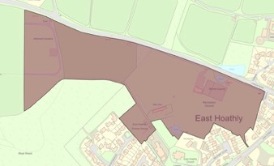

Figure 27 – Map of Character Area 15 – Amenity Area

285. The Amenity Area includes the War Memorial Sports Ground, Broomy Lodge, the Garden Plots and School Field. This area is very important for the health and wellbeing of the Parish. It provides places for exercise, food production and meeting spaces, which all adds to community cohesion.

Topography

286. The land slopes gently down from East to West.

287. The area is generally open space comprising allotments, agricultural land and sports pitches.

Access

288. There are three PROWs in the area. The main path is the Wealdway PROW which leads from Old Whyly, into the Conservation Area and on to Chiddingly.

War Memorial Sports Ground within Character Area 15

289. The War Memorial Sports Ground Trust was established in 1947 after purchase of the 4 Hectare site with the proceeds of a War Memorial Fund. The Conveyance stipulates that the land must not be used for any other purpose than as a sports and recreation ground for the benefit and use of the Parish. The East Hoathly Parish Council became the Trustees in 1952 and the Trust was registered as a charity in 1963. The Sports Ground is central to the sporting life of our community and also for many recreational activities including annual events such as Midsummer Magic and Carnival Night. It has also been the venue for Dog Shows, Fetes and Flower Shows. It is currently home to:

a. East Hoathly Cricket Club.

b. East Hoathly Rifle Club.

c. East Hoathly Tennis Club (Three floodlit courts).

d. Children’s Play Area.

e. Occasional use by visiting Cycle Club.

f. Basketball Hoop.

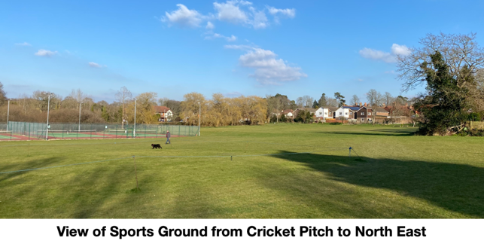

290. The Sports Ground is badly drained and often waterlogged in Winter conditions. The lack of playable conditions led to the demise of the East Hoathly Football Club and it is unlikely that this will start again without improvements to the drainage. The possibility of the level of the football pitch area being raised by infilling the area with waste soil has been examined.

291. This Character Area has Pelham Buckle Milepost Marker 48 at the pedestrian entrance to the Sports Ground on London Road and the Parish Council is considering applying to get it designated as a Heritage Asset but not as part of this plan (See Paragraph 45a for description).

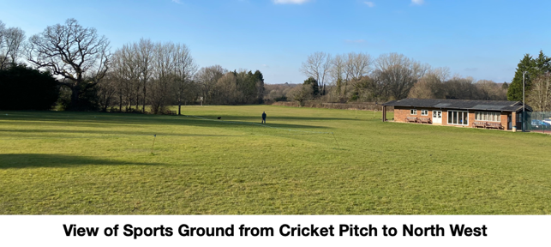

292. The Pavilion is situated on the War Memorial Sports Ground and is part of the War Memorial Sports Ground Trust. The Pavilion was built in 1980 and is of simple brick construction within a steel utilitarian style framework with an asbestos roof. It is now in poor condition, energy inefficient, with inadequate shower and changing facilities for players, officials, women and the disabled. The Pavilion has been identified as having the potential to be nominated as an Asset of Community Value with WDC and the Parish Council are considering this.

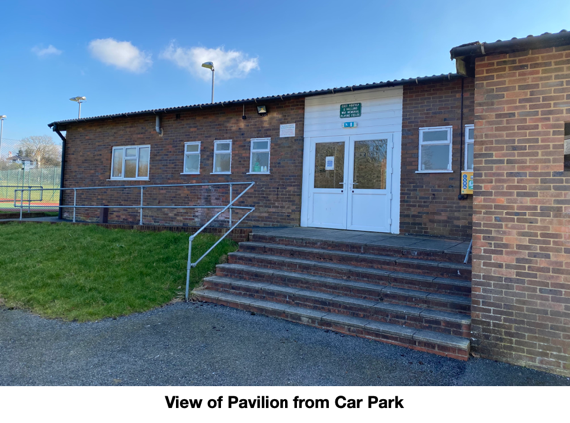
293. The Parish Council has had a long running aspiration to provide a new Pavilion in combination with improvements to the drainage of the Sports Ground. It has been suggested that one option is to replace the Pavilion with a new facility that incorporates the functions of the Village Hall. The Consultation Process of the Neighbourhood Plan and the Parish Survey sought the opinions of parishioners on the future of these facilities.

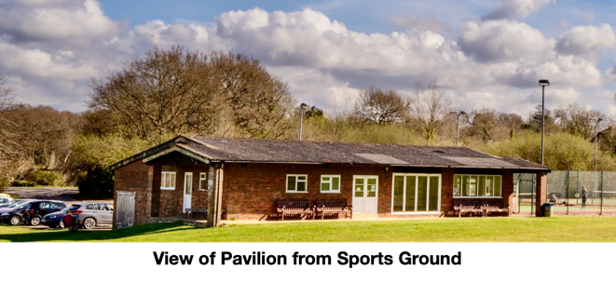

Garden Plots within Character Area 15

294. East Hoathly Garden Plots are located on the South side of the London Road opposite the turning to Old Whyly. They were created in 2013 to replace the original much-loved Allotments at Church Marks Lane that were turned into housing in the 1950s. They are highly valued by Parish residents. The Garden Plots are an Asset of Community Value listed with WDC.

295. The Garden Plots provide recreational benefits and the opportunity for people to grow their own food. The people doing so have formed their own supportive community aiding their health and wellbeing. There is also a separate organisation, which runs a Community Garden and Community Orchard. The Community Garden is a Community Interest Company that started in 2015 to provide a safe and nurturing space for local people, who are challenged by mental health and physical disabilities. Further details can be found at: https://www.ourcommunitygarden.org.uk/

296. The Garden Plots are often bustling with activity, yet they also provide a quiet place to enjoy healthy activity surrounded by the natural world.

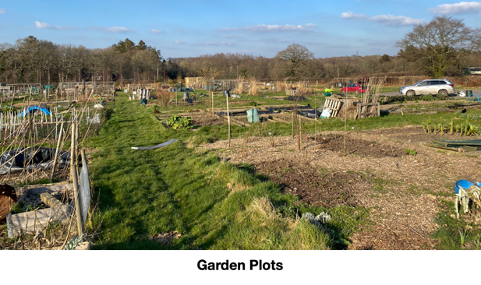

Broomy Lodge within Character Area 15

297. Broomy Lodge is an agricultural field between the Garden Plots and Sports Ground. It contains the Carnival Society Hut which is used for the storage and preparations for the village Carnival. It also has a large pond surrounded by trees, which is an important part of the drainage for the Sports Ground. In recent years, Broomy Lodge has been planted with herbal lays including sunflowers and chicory, which has been of great value to wildlife and much enjoyed by residents.

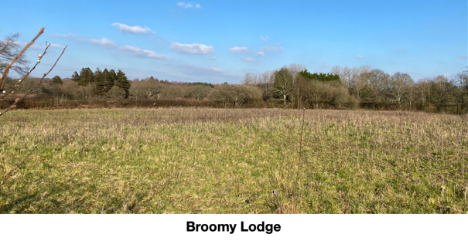

School Field within Character Area 15

298. The School Field was given to the School as part of a Section 106 Legal Agreement when the Nightingales development was approved in 2009. It provides an open play space for the School.

Detractors

299. In this Character Area, the following detractors are noted:

a. Light pollution from Tennis Courts.

b. Pavilion is poorly designed and has used inappropriate materials and finishes. Its facilities are very limited, dated and in poor repair.

c. The drainage of the Sports Ground is ineffective. This might not normally be considered an issue that would affect the character of this area; however, the appearance and identity of a football pitch would normally be expected to be one of activity and football, not inactivity and standing water. It is therefore considered to be a character detractor.

Summary

300. This Character Appraisal defined 15 Character Areas within this Parish and examined them against criteria identified as being relevant to this Parish. Criteria that affect the whole of the Parish were examined initially and then each Character Area was assessed separately. Things that detract from the character of the Parish were identified throughout this process and are summarized below:

Detractors

301. A summary of the detractors noted in this Character Appraisal are:

Topography

a. Erosion of the rural setting for the settlements.

Land Use

b. Reduction in remaining woodland, trees and hedgerows and increased pressure on accessible woodland.

c. Reduction in Biodiversity by the isolation of habitats, reduction of foraging areas, reduction of transit routes and increased pressure on accessible biodiversity by residents, visitors and pets.

d. Damage to watercourses, ancient woodland and biodiversity caused by sewage overflows that have an adverse effect on the natural landscape and its character.

e. Pavilion is poorly designed and has used inappropriate materials and finishes. Its facilities are very limited, dated and in poor repair.

f. The drainage of the Sports Ground is ineffective. This might not normally be considered an issue that would affect the character of this area; however, the appearance and identity of a football pitch would normally be expected to be one of activity and football, not inactivity and standing water. It is therefore considered to be a character detractor.

Access

g. Urbanization of PROWs.

h. Safety on rural roads where traffic flows and speeds are increasing, making use by pedestrians, cyclists and horse riders more challenging. This affects the sense of security, calm and enjoyment to the detriment of the rural character.

i. Safety and Congestion on A22 and B192. Traffic queues and congestion are not conducive to peaceful rural life or the safety of pedestrians.

j. Damage to road verges in part caused be an increase in large vehicles using the narrow rural lanes. This adversely affects the appearance of rural lanes and the ease with which pedestrians can use them.

k. Noise, smells and disturbance of the busy roads, particularly the A22.

l. Poor Quality of the Halland to East Hoathly footpath/cycle route.

Landmarks

m. Loss of remaining landmarks such as Pelham Buckle Milepost Markers, Fingerpost Direction Signs and Post Boxes.

Views

n. Erosion of the views into and out of the settlements and the Parish generally. Particular focus on the erosion of views into and out of the settings for heritage assets and the Conservation Area.

Buildings

o. Erosion of Architectural Detail - many modern house designs seek to use some elements of Sussex historic building design with hung tiles and weatherboarding. Often these attempts to mimic historic architectural detail fail because the dimensions are wrong, inferior quality materials are used or colour schemes are not local vernacular. The designs are often limited to these basic ideas of weatherboarding and hung tiles and do not take on other ideas such as decorative ridge tiles, decorative hung tile patterns and decorative brickwork. Limiting the design details on larger developments creates a repetitive feel that is out of keeping with the original character of the settlements. The same considerations should also apply to extensions and alterations to existing buildings in the Parish.

p. Poor choice of building materials. Materials are sometimes not well chosen to match the vernacular that they are trying to imitate in colour, texture, size, shape, quality and design. Colours that do not replicate the original character of the settlements and machine-made bricks and tiles that lack the irregularity to reflect the original character of the settlements. Roman style interlocking roof tiles are not part of the traditional Sussex vernacular and create roofs with jarring straight lines.

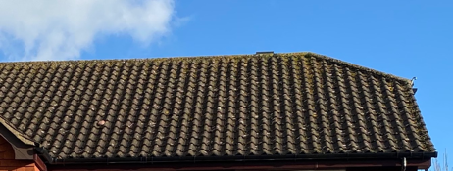
Roman Style Roof Tiles

q. Renewable energy systems added onto existing house designs rather than being integral to the design.

r. Electric vehicle charging systems added onto existing house designs rather than being integral to the design.

Streetscape

s. Lack of car parking space which leads to on-street parking, cluttered forecourts and a car dominated landscape. Rural car dependent homes require car parking space in addition to the statutory minimum. New developments provide no parking space for the increasing number of self-employed (often large) work vehicles.

t. Visitor parking spaces not clearly identifiable in new housing developments for visitors or delivery vehicles.

u. Garages should be large enough for the largest domestic vehicles and, if they are not intended to be used for vehicles, the design of the home should be changed.

v. Vehicle dominated layouts. New developments should be designed to avoid vehicle dominated layouts. Paths through developments should be provided and they should have pavements to protect pedestrians. The paths should connect the new development to the wider settlement, enhancing social integration and cohesion by preventing the creation of pedestrian cul-de-sacs.

w. Many existing housing developments have narrow roads that a vulnerable to blockages when vehicles are parked on them.

x. Many existing housing developments have no greenspaces, open spaces or trees.

y. Most existing housing has overhead wiring on utility poles. This should be removed whenever possible and not used for new developments.

z. Traditional boundary treatments should be provided for new developments and these should be varied to prevent the uniformity of a new estate. Close boarded fencing should be avoided in preference to hedgerows, walls, railings or picket fencing.

Layout

aa. The layout and design and of new housing development, including outbuildings, is often contrary to the historic pattern of development. New developments should seek to create a sense of space with well-proportioned generous plot sizes and varying set-backs that include space for front and back gardens. Whilst it is accepted that there must be flexibility, it is preferable that new developments look as if they have grown organically and not merely been placed alongside an historic settlement (existing post 1950 developments that may have done this should not be used as a justification for future designs).

bb. The historic housing density of rural villages is very low and that is true of East Hoathly (14 dph) and, in particular, its Conservation Area. Post 1950s developments have had much higher housing densities and the character of the village has been changed. Whilst the need to make the best use of available land is understood, new development should not be allowed to detrimentally affect the character of the village or the Conservation Area.

cc. Cul-de-sac development that inhibits permeability, reduces opportunities for residents to meet each other and can create a sense of exclusion.

Dark Skies

dd. Light Pollution producing pressure on Dark Skies by increased urbanization, poor design and poor control.

Recommendations

302. The detractors that have been identified are all features that add little to or detract from the character of the Parish. They are features that can be found in many parishes and do not reflect the character and history of East Hoathly with Halland. It is recommended that whenever there is the opportunity to remedy detractors that already exist, these should be taken to enhance the character of the Parish. It is also recommended that these design features should be avoided in new developments or be factors to which designers should be sensitive. The following specific recommendations are made:

a. Designs should reflect the traditional layout of rural settlements avoiding cul-de-sacs where possible. If cul-de-sacs are proposed, they should reflect the best examples of the Parish with permeability and access to allow pedestrians and cyclists to have connections through the cul-de-sac to the remainder of the settlement and its surroundings.

b. The architecture, materials and density of any development should be compatible with the local vernacular in the Parish and make a positive contribution to local character and distinctiveness.

c. Provision for electrical supply, telephone cable and fibre-optic cable should, whenever possible, all be underground from the entrance to the development.

d. Designs should seek to avoid road layouts where the width of the road, or curves in the road, create a situation that is vulnerable to the road being blocked by parked vehicles.

e. Designs and layouts should achieve a sense of place by protecting and enhancing the quality, distinctiveness and character of the existing settlement. Respecting or enhancing the character of the site and its surroundings in terms of its proportion, form, massing, density, height, size, scale, materials and detailed design features.

f. Designs and layouts for new development should, where possible, seek to avoid uniformity. Designs and layouts should seek to reflect the range and variety of buildings that have already been established in the settlement and maintain the character and charm of existing historic rural developments. Whenever possible, gaps in the built environment should be maintained and infill development resisted if it damages the character and appearance of the settlement.

g. Designs should ensure development of land in proximity to heritage assets and their settings, conserves, preserves, reflects and enhances the heritage asset and the historic environment in accordance with their significance.
h. Designs should ensure development safeguards, respects and enhances the natural environment, the biodiversity, landscape and wildlife corridors and the countryside. Incorporating where appropriate, biodiversity, trees, landscaping and public and private open spaces and supports the creation of wildlife corridors.

i. Designs should ensure the layout and the design takes account of the potential users of the development to promote active travel and provide safe, convenient and attractive links within the development and to existing networks for people with disabilities and restricted mobility, pedestrians, cyclists and public transport users.

j. Designs should ensure that the development does not cause an unacceptable adverse impact on the amenities of occupiers of existing or proposed nearby properties. Wherever possible, the significant views into and out of settlements should be preserved.

k. Boundary treatments should be varied, incorporating a mix of such things as walls, hedgerows, post and rail fencing, picket fencing and railings. Close boarded fencing should be avoided.

l. Designs should ensure that adequate infrastructure, services and community facilities are, or will be, made available to serve the development.

m. Ensure that site layout and building design helps to provide a safe and secure environment which promotes the health and wellbeing of residents, reduces social isolation, supports healthy lifestyles and improves social cohesion by providing places for people to meet and sit in open spaces and greenspaces.

Conclusion

303. Based on the analysis of the Character Areas, it is important that future developments in the Parish respond positively to local features and avoid the identified detractors to the character of the Parish. New development should demonstrate how the proposals respond to the existing character and avoid the detractors identified. Where mistakes have been made in earlier developments, this should not be used as justification for future designs. New development should seek to enhance the lives of the existing community not merely satisfy the needs of those wishing to join it.

Annexes:

A. Listed Buildings in East Hoathly with Halland Parish.
B. Land Stewardship Schemes in East Hoathly with Halland Parish.
C. Ancient Woodland and Tree Preservation Orders in East Hoathly with Halland Parish.
D. Hedgerows in East Hoathly with Halland Parish.
E. Pelham Buckle Milepost Markers in East Hoathly with Halland Parish.
F. Fingerpost Signs and Post Boxes in East Hoathly with Halland Parish.
G. Public Rights of Way and Bridleways in East Hoathly with Halland Parish.

Figures:
Page

1 Map showing East Hoathly with Halland Neighbourhood Area. 3
2 Map showing Parish Character Areas. 10
3 Map showing East Hoathly Character Areas. 11
4 WDC Landscape Character Assessment 2022 –
Characterization of Parish. 16
5 Topography of Parish. 20
6 Map of Character Area 1 – Spur Area. 33
7 Yeakell and Gardner Map 1778-83. 34
8 Ordnance Survey Map showing comparative area of Parish. 34
9 East Hoathly Tithe Map 1840. 35
10 Ordnance Survey map showing comparative area of Parish. 35
11 Map showing Views out of Character Area 1 - Spur Area. 38
12 Map of Character Area 2 – River Uck Catchment Area. 43
13 Map of Character Area 3 – River Cuckmere Catchment Area. 47
14 Map showing Views out of Character Area 3 - River Cuckmere Catchment Area. 49
15 Map of Character Area 4 – Halland Area. 52
16 Map showing Views out of Character Area 4 - Halland Area. 59
17 Map of Character Area 5 – Conservation Area. 61
18 Map of Character Area 6 – Church Marks Lane Area. 65
19 Map of Character Area 7 – Rectory Close Area. 72
20 Map of Character Area 8 – Susan’s Close Area. 78
21 Map of Character Area 9 – Thomas Turner Drive Area. 82
22 Map of Character Area 10 – Linear Development Area. 94
23 Map of Character Area 11 – South Street Area. 106
24 Map of Character Area 12 – The Mews Area. 110
25 Map of Character Area 13 – Juziers Drive Area. 115
26 Map of Character Area 14 – Nightingales Area. 123
27 Map of Character Area 15 – Amenity Area. 128

Annex A

LISTED BUILDINGS

IN EAST HOATHLY WITH HALLAND PARISH

Serial | Listing Number | Grade | Description
1 | 1043288 | II | East Hoathly Stores, 9, 11 and 13 High Street, East Hoathly, BN8 6DR
2 | 1353330 | II | East Hoathly Post Office and House Attached, 2 High Street, East Hoathly, BN8 6EB
3 | 1043286 | II | Godfreys, Halland, BN8 6RB
4 | 1193320 | II | Whyly, East Hoathly, BN8 6EL
5 | 1043251 | II | Yew Tree Cottage, 20 South Street, East Hoathly, BN8 6DS
6 | 1353331 | II | Price’s Cottages, Whitesmith, BN8 6JD
7 | 1353332 | II | Sellens Cottages, 7, 9 and 11 South Street, East Hoathly, BN8 6DS
8 | 1043249 | II | The White House, 20 High Street, East Hoathly, BN8 6PS
9 | 1043250 | II | Jasmine Cottages, 2 and 4 Mill Lane, East Hoathly, BN8 6QB
10 | 1043254 | II | The Mill House, 2 Waldron Road, East Hoathly, BN8 6DP
11 | 1043285 | II* | The Parish Church, Church Marks Lane, East Hoathly
12 | 1043287 | II | Hartfield Farmhouse, Halland, BN8 6PW
13 | 1286188 | II | Fern Cottage, 4 Waldron Road, East Hoathly, BN8 6DP
14 | 1353293 | II | Cherry Tree Cottages, 24 and 26 South Street, East Hoathly, BN8 6DS
15 | 1353294 | II | Lavender Cottage, 15 Waldron Road, East Hoathly, BN8 6PW
16 | 1193427 | II | The Gate House, Waldron Road, East Hoathly, BN8 6QH
17 | 1043253 | II | 5, 7 and 9 Waldron Road, East Hoathly, BN8 6DP
18 | 1043289 | II | Rosemount, High Street, East Hoathly, BN8 6DR
19 | 1286184 | II | Piper’s Farmhouse, Hollow Lane, East Hoathly, BN8 6RA
20 | 1353295 | II | Hesmonds, Waldron Road, East Hoathly, BN8 6QH
21 | 1193327 | II | The Ruins of the old house known as Halland House in the grounds of Halland Park House, Shortgate, BN8 6RB
22 | 1043248 | II | 6,8 and 10 High Street, East Hoathly, BN8 6EB
23 | 1043252 | II | Spring Cottage, 1 and 3 Waldron Road, East Hoathly, BN8 6DP
24 | 1043255 | II* | Belmont, Waldron Road, East Hoathly, BN8 6QJ
25 | 1286193 | II | Aberdeen House, 5 High Street, 7 High Street, The King’s Head Inn, 1 and 3 High Street, East Hoathly, BN8 6DR
26 | 1028363 | II | Vine Cottage, Terrible Down, Halland,
27 | 1028388 | II | Lower Sandhill House, Easons Green,
28 | 1028391 | II | Peckhams, Knowle Lane, Halland, BN8 6PR
29 | 1286218 | II | Old Post Office Cottage, Buttsfield Lane, East Hoathly, BN8 6EF
30 | 1444079 | II | Telephone Kiosk, Mill Lane/Waldron Road, East Hoathly
31 | 1043102 | II | Halland Park Farmhouse, Shortgate, BN8 6RB
32 | 1353376 | II* | Barn at Halland Park Farm to South West of the Farmhouse, Shortgate, BN8 6RB
33 | 1452099 | 2 | Foresters Arms, 6 South Street, East Hoathly, BN8 6DS
34 | 1468363 | II | Bentley Wood, Knowle Lane, Halland, BN8 6PR
35 | 1020515 |  | Scheduled Monument - Moated site in Moat Wood, 580 m East of Halland Park Farm, East Hoathly

Description of Scheduled Monument

The peak period for moated sites was about 1250 to 1350 and the majority were prestigious residences where the moat was generally intended as a status symbol rather than for practical military defence. This monument includes a medieval moated site, situated on the south western outskirts of East Hoathly village, on low lying ground which forms part of the Sussex Weald. The roughly north west-south east aligned moated site survives in the form of earthworks and associated buried remains. The square, central island measures around 35m across and is surrounded by a ditch, up to 19m wide and 1.3m deep. The north western and north eastern arms of the moat remain partly water- filled. Elsewhere, the ditch has become partly infilled over the years, and contains a low, central bank in the south east, about 4m wide and 0.3m high. The ditch was in turn surrounded by an outer bank, and sections of the bank, measuring up to 6m wide and 1m high, survive around the western corner of the moat and along its north eastern side. The eastern corner of the moat has been partly disturbed by past modern drainage operations, and the outer bank has been partly levelled by other activities, including the construction and use of the footpaths on the north western and south western sides of the moat. Although no upstanding remains of former buildings have been identified, traces of buildings can be expected to survive as buried features beneath the present ground surface of the central island.

Annex B

LAND STEWARDSHIP SCHEMES

IN EAST HOATHLY WITH HALLAND PARISH

1. The Countryside Stewardship Scheme provides financial incentives for farmers, woodland owners, foresters and land managers to look after and improve the environment.

2. The Environmental Stewardship Scheme is a land management scheme that provides funding to farmers and other land managers in England to deliver effective environmental management

3. The Organic Farming Scheme aims to encourage the expansion of organic production. Under the scheme, farmers moving from conventional to organic farming methods receive financial help during the conversion process.

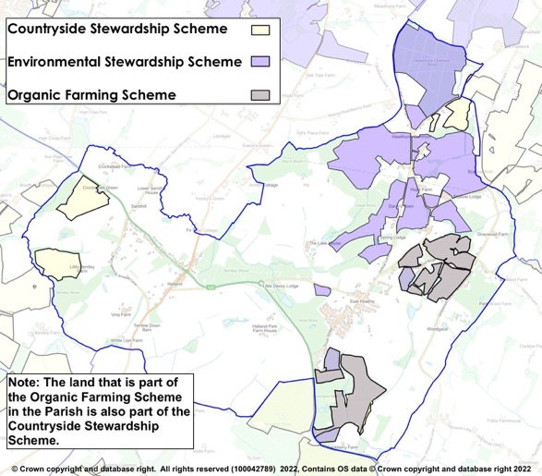
Figure 25 – Land Stewardship Schemes

Annex C

ANCIENT WOODLAND AND

TREE PRESERVATION ORDERS

IN EAST HOATHLY WITH HALLAND PARISH

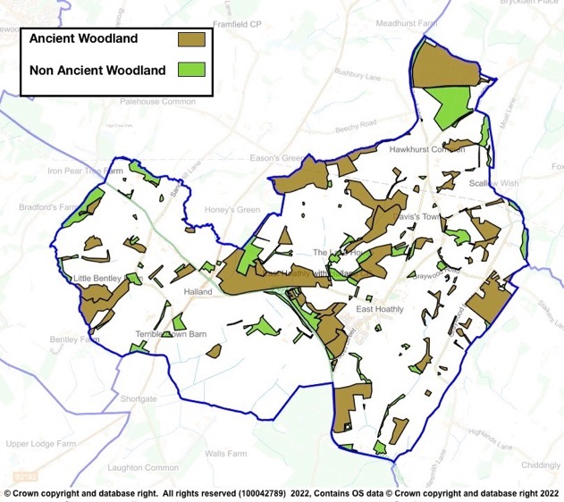

Parish Woodland

Table 2 - Tree Preservation Orders

Serial | TPO Number | Location | Species | Confirm-ation Date | Grid Ref
1 | HRDC 1973 (3) | Land Adj Cherry Tree Cottage, South St | T1 - Yew |  | 551936  116004
2 | 14 1998 | Land at Slays Wood, Adj Annan Court, Easons Green | W1 & W2 - Woodland consisting mainly of Silver Birch, Sweet Chestnut, Hornbeam and Oak. |  | 551205  117796
3 | 22 1978 | Land at Upper Hook Fd, Waldron Rd | T1 Oak | 23/1/80 | 552480  116590
4 | 22 1991 | Engineering Works, The Mews | T1 - Scots Pine  G1 - Group of 3 Cherry Laurel, 11 Portugal Laurel, 2 Hawthorn, 1 Holly, 2 Variegated Holly, 1 Western Red Cedar | 16/5/91 | 5213  1606
5 |  |  | T1 Scots Pine presumed to be felled - noted on land parcel for 16 The Mews - 17/11/08
6 | 23 1997 | Land at Slays Wood, Adj Annan Court, Easons Green | W1 - Woodland comprised predominantly Oak, Silver Birch, Hornbeam and Sweet Chestnut | 12/5/98 | 551115  117788
7 | 25 1981 | Land between Gables and Myrtle View, A22 | T1 - Holly, T2 - Ash, T3 - Oak, T4 - Oak, T5 - Oak, T6 - Oak, G1 - Group of 40 Aspen | 14/10/81 | 550130  116730
8 | 26 2004 | Graywood N of Quadrangle | W1 - Woodland maily Hornbearm, Ash, Oak, Sweet Chestnut, W2 - Woodland mainly Hornbeam, Ash, Oak, Sweet Chestnut, W3 - Woodland mainly Hornbeam, Ash, Oak and Sweet Chestnut | 8/7/91 | 5365  1654
9 | 26 2004 | Crockstead Farm | A1 - Area of Misc deciduous and coniferous trees | 23/12/04 | 549440  117941
10 | 29 2004 | Downs Cottage, 31 Mill Lane | T1 - Horse Chestnut | 14/12/04 | 552466  116194
11 | 30 2002 | Moat Wood | W1 - Mixed deciduous Ancient Semi-Natural woodland consisting mainly of Ash, Birch, Cherry, Douglas Fir, Hazel, Hornbeam, Oak, Sweet Chestnut, Sycamore and Willow. Note - 5 Oak, 1 Willow, 1 Poplar, 2 Birch and 4 Sweet Chestnut removed from TPO - felled 13/10/2015 | 20/12/02 | 551567  116128
12 | 36 1996 | Great Ailies Farm | W1 - mainly Oak, Hornbeam, Ash, Holly and Field Maple | 18/4/97 | 5334  1602
13 | 46 1986 | Harrisons Shaw | W1 - Woodland mainly Oak, Sweet Chestnut and Ash | 31/1/87 | 5128  1643
14 | 48 2006 | Martinland Wood | W1 - Woodland consisting of all deciduous and coniferous trees incl Birch, Ash, Sycamore and Native species | 3/10/06 | 551941  115118
15 | 5 1990 | Rear of 22 South St | T1 - Holm Oak, T2 - Sweet Chestnut, T3 - Ash, G1 Group of 3 Ash, G2 - Group of 2 Ash and 2 Oak | 2/4/90 | 5190  1600
16 | 56 2004 | Safir Works, South St | T1 - Common Oak, T2 - Common Oak, G1 - Group of 7 Ash, 4 Common Oak, 1 Horse Chestnut | 13/5/05 | 552090  115920
17 | 58 1990 | Nursery Wood | W1 - Woodland mixed hardwoods mainly Oak, Sweet Chestnut, Hornbeam, Holly, Birch and Gean | 3/9/90 | 5000  1676
18 | 71 1991 | Rear of Yew Tree Cottage, Halland | T1, T2 and T3 English Oak | 3/2/92 | 5035  1677
19 | 99 1990 | N of Belmont - Supersedes 16 1986 | W1 - Woodland mainly Oak, Sycamore, Ash, Holly, Hornbeam, Beech, Birch, Sweet Chestnut | 20/11/90 | 552667  116679
20 | 2018/0008 | Adj to Park Lodge | G1 - 7 Common Oak | 11/6/19 | 551952  115840

Annex D

HEDGEROWS

IN EAST HOATHLY WITH HALLAND PARISH

1. A countryside hedgerow is a boundary line of bushes, which can include trees. A hedgerow is protected, meaning it cannot be removed, if it meets the following criteria for length, location and importance:

Length

a. If it is more than 20m long with gaps of 20m or less in its length; or

b. If it is less than 20m long, but meets another hedge at each end.

Location

c. A hedgerow is protected if it is on or next to land used for agriculture or forestry, land used for breeding or keeping horses, ponies or donkeys, common land.

Importance

d. A hedgerow is important and is protected if it is at least 30 years old and marks all or part of the parish boundary, is part of a field system that existed before 1845, contains protected species, contains species that are endangered, vulnerable or rare, includes woody species as specified in Hedgerow Regulations.

2. Hedgerows are surveyed and assessed in accordance with the Hedgerow Regulations 1997 and the findings recorded by the Sussex Biodiversity Trust. This was part of the Sussex Hedgerow Project under the control of the Sussex Biodiversity Records Centre in which they provided training for Parish volunteers to carry out the surveys. The hedgerow is recorded for its length, width and the presence of associated ditches, walls or banks. The woody species and herb layer are separately listed and assessed for their quality and variety. Native species and alien species are recorded. Following the survey, the Hedgerow is graded and recorded. The hedgerows that have been surveyed in the Parish are shown below:

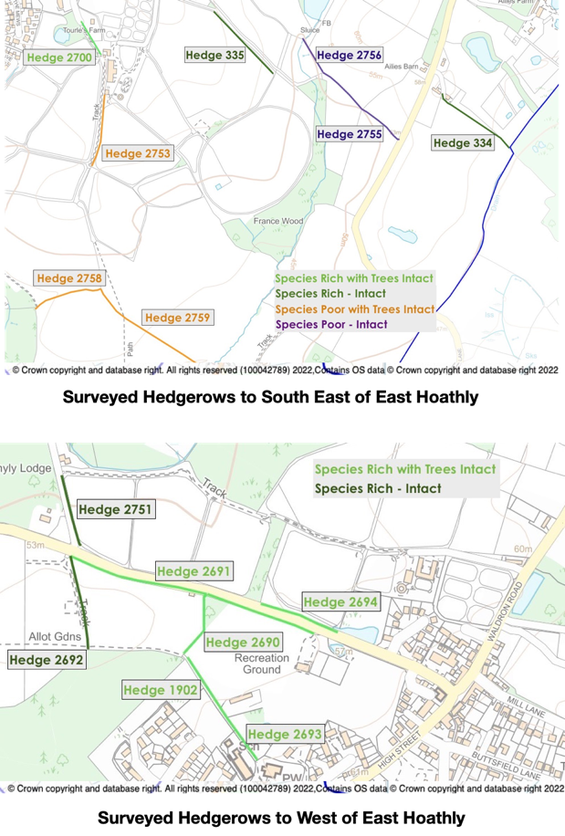
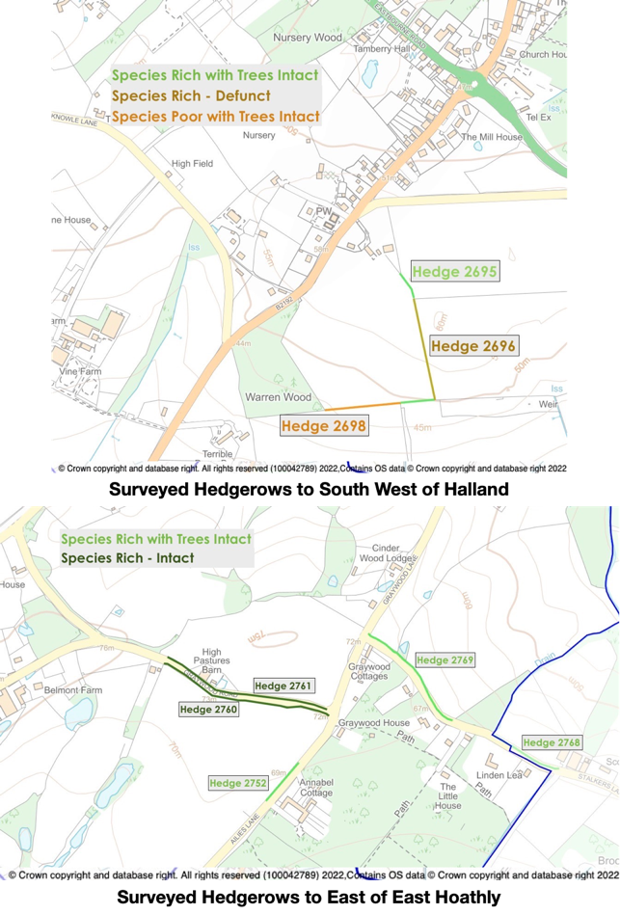
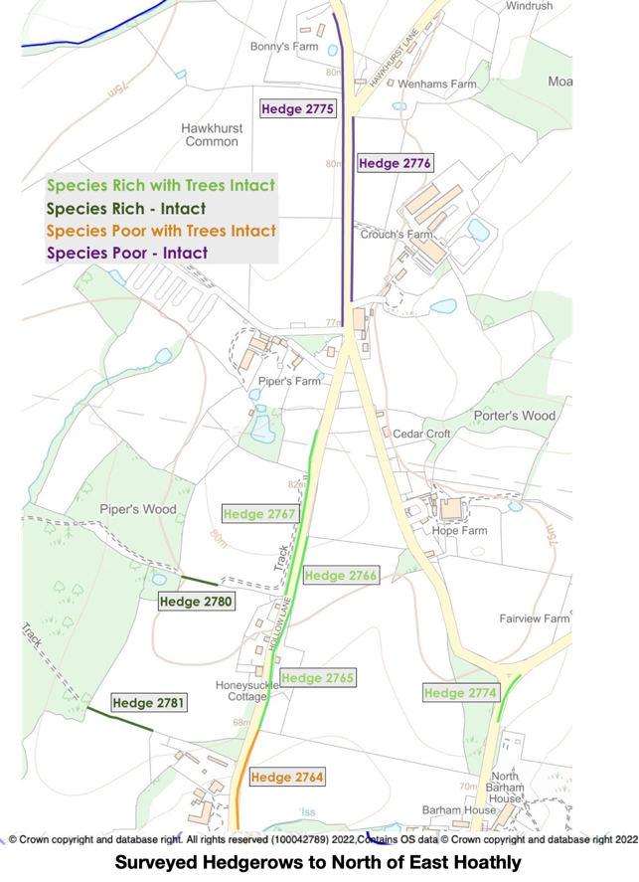

Annex E

PELHAM BUCKLE MILEPOST MARKERS

IN EAST HOATHLY WITH HALLAND PARISH

Milepost 46 A22 Near Crockstead MES 21804

Milepost 47 A22 South of Halland MES 21803

Milepost 48 London Road, East Hoathly MES 33241

Milepost 49 A22 Park Lane Corner MES 21802

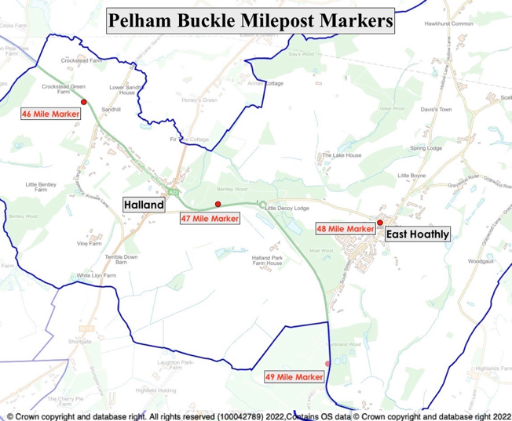

Annex F

FINGERPOST SIGNS AND POST BOXES

IN EAST HOATHLY WITH HALLAND PARISH

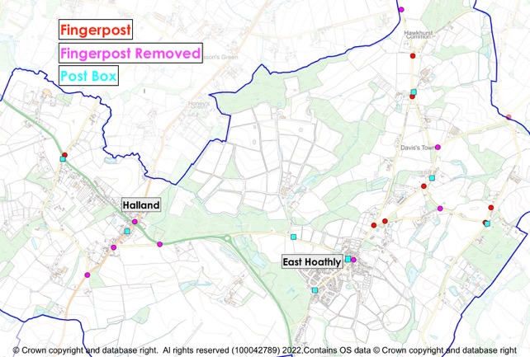

Annex G

PUBLIC RIGHTS OF WAY AND BRIDLEWAYS

IN EAST HOATHLY WITH HALLAND PARISH

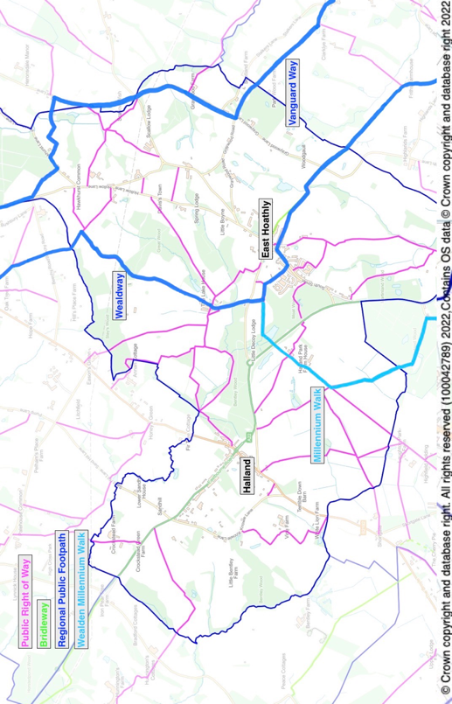

Wealden Landscape Study 2014 - The Low Weald Landscape.
Parish Online Mapping Extract shown at EHHNP Website - Parish Statistics.
Parish Online Mapping Extract shown at EHHNP Website - Parish Statistics.
ESHER Reference: MES 15563 and MES 21353.
ESHER Reference: MES 15564, MES 15565, MES 3113, MES 23121, MES 23122 and MES 21352.
ESHER Reference: MES 3114.
The History, Antiquities and Topography of the County of Sussex Thomas Walker Horsfield FSA, page 358.
WDC Draft East Hoathly Conservation Area Character Appraisal 2021, Paragraph 2.3.8.
WDC Draft East Hoathly Conservation Area Character Appraisal 2021, Paragraph 2.5.22.
https://historicengland.org.uk/sitesearch?searchType=site&search=East+Hoathly+with+Halland+Parish (also shown in Annex A).
WDC Draft East Hoathly Conservation Area Character Appraisal 2021.
RTPI Guide: How to prepare a character assessment to support design policy within a Neighbourhood Plan.
Wealden Draft Conservation Area Character Appraisal - East Hoathly dated January 2021.
EHHNP Website - Parish Statistics.
This excludes anomalies such as Character Area 15, Lydfords Care Home and flats above commercial premises.
WDC Landscape Character Assessment 2022 page 173.
WDC Green Infrastructure Study 2017, Paragraph 5.2.5.
GI Network Plan provides a strategic framework for the delivery of GI. It is only illustrative and does not necessarily indicate a constraint on development.
WDC Landscape Character Assessment 2022: https://www.wealden.gov.uk/UploadedFiles/Wealden-LCA.pdf
WDC Landscape Character Assessment 2022 pages 84, 172 and 185.
Rivers Trust Website - https://experience.arcgis.com/experience/e834e261b53740eba2fe6736e37bbc7b/page/Map/?data_id=dataSource_4-1788e0d0481-layer-54%3A16460&org=theriverstrust
Stantec/Water UK - Storm Overflow Evidence Project - Nov 2021.
Met Office – Southern England: Climate - https://www.metoffice.gov.uk/binaries/content/assets/metofficegovuk/pdf/weather/learn-about/uk-past-events/regional-climates/southern-england_-climate---met-office.pdf
Met Office Data - https://www.metoffice.gov.uk/hadobs/hadukp/data/daily/HadSEEP_daily_totals.txt
Met Office Data - https://www.metoffice.gov.uk/pub/data/weather/uk/climate/datasets/Raindays1mm/date/England_SE_and_Central_S.txt
Met Office Data - https://www.metoffice.gov.uk/hadobs/hadukp/data/daily/HadSEEP_daily_totals.txt
Sussex Biodiversity Record Centre - Report SxBRC/21/1019 dated 21 Mar 2022.
Parish Online Mapping – ESCC Shared Data, Wildlife Verges.
WDC Landscape Character Assessment 2022 pages 85, 173 and 186.
WDC Design Guide, Part 1, Figure 10.21.
ESCC Guidance for Parking at New Residential Development 2017.
WDC Landscape Character Assessment 2022 pages 85, 173 and 186.
WDC Landscape Character Assessment 2022 pages 85, 173 and 186.
Wealden Draft Conservation Area Character Appraisal - East Hoathly dated January 2021.
ESCC Traffic Data 2000 to 2021
East Hoathly with Halland Parish Survey 2016 Results Summary and Feria Interim Report see EHHNP website.
https://www.wealden.gov.uk/UploadedFiles/WLP_IOR_CA_October2015-1.pdf
https://www.wealden.gov.uk/UploadedFiles/WLP_IOR_CA_October2015-1.pdf
See EHHNP website.
Sussex Biodiversity Records Centre (Contact Andrew Lawson).
East SussexHistoric Environment Record reference.

