EAST HOATHLY WITH HALLAND
NEIGHBOURHOOD PLAN

Plan Period 2022 to 2039

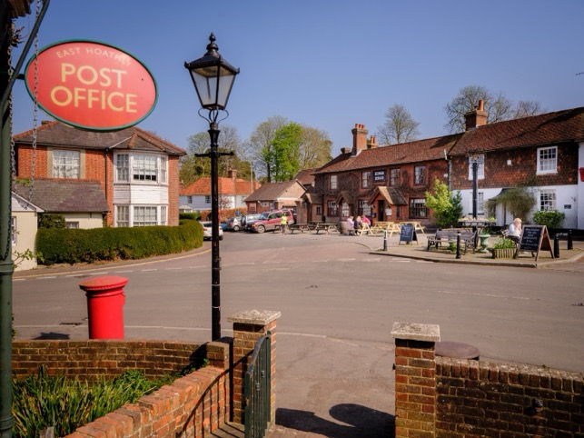
East Hoathly Village Corner

Referendum Version. June 2024

Version 20
CONTENTS

LIST OF SECTIONS

Page

- Introduction. 4

2. Context. 9

3. Vision and Objectives. 20

4. Housing and Housing Design. 24

5. Conservation. 42

6. Natural Environment. 52

7. Health and Wellbeing. 78

8. Business. 90

9. Accessibility and Connectivity. 96

10. Community Infrastructure Levy. 111

List of Annexes, Tables and Figures. 113

POLICY LIST

Policy 1 Housing 36

Policy 2 Housing Design – Resource Efficiency 40

Policy 3 Housing Design – Layout and Materials 41

Policy 4 Conservation of Historic Environment 51

Policy 5 Natural Environment 68

Policy 6 Dark Skies 72

Policy 7 Local Green Space 76

Policy 8 Business 93

Policy 9 Communications 99

ASPIRATION LIST

Aspiration 1 Community Land Trust 36

Aspiration 2 Conservation of Historic Environment 51

Aspiration 3 Conservation of Community Assets 52

Aspiration 4 Dark Skies 72

Aspiration 5 Health and Wellbeing 89

Aspiration 6 Broadband 99

Aspiration 7 Accessibility 110

SECTION 1 - INTRODUCTION

1. This is the East Hoathly with Halland Submission Neighbourhood Plan (EHHNP) for the parish of East Hoathly with Halland. It sets out the community’s aspirations for our Parish over the period to 2039 and establishes policies in relation to land use and development. Once the plan has a positive referendum the plan will become part of the Local Development Plan and applications for planning permission must be determined in accordance with the development plan, unless material considerations indicate otherwise.

2. Wealden District Council (WDC) approved the whole of the Parish area to be designated as the East Hoathly with Halland Neighbourhood Development Area on 7 August 2017. The Plan Period will be 2022 to 2039.
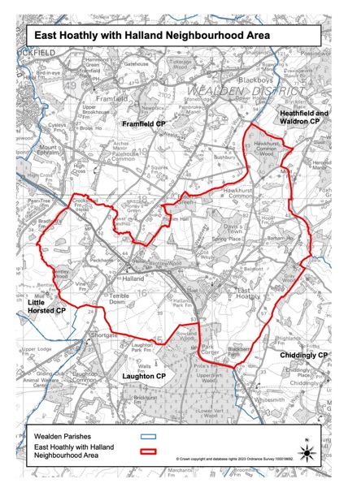
Figure 1 – East Hoathly with Halland Neighbourhood Area
3. The purpose of neighbourhood planning is to give local people and businesses a voice in how the places they live, work and play should change and develop over time. This can shape the future of our greenspaces, housing and business developments, enhance the protection of our environmental and heritage assets, protect the health of residents and enhance community wellbeing.

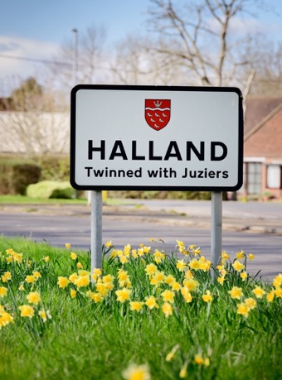

Halland Signpost

Structure of Neighbourhood Plan

4. The Plan comprises ten sections. These are as follows:

a. Section 1 - Introduction. This Section outlines how the Neighbourhood Plan (NP) area was designated and the setting up of a Steering Group to carry out the work.

b. Section 2 - Context. This Section gives a brief description of the Parish and its setting, the history of the area and the community. It describes the current position with regard to WDC’s adopted Local Plan (LP) policies.

c. Section 3 - Vision and Objectives. This Section presents the Vision and Objectives for our Parish as well as the overarching principles guiding sustainable development.

d. Sections 4 to 10. These Sections present the policies, associated projects and ambitions for our Parish. They are as follows:

(1) Section 4 - Housing Development and Design. The first part of this Section addresses Housing Development with an examination of housing stock and housing issues in the Parish. The second part examines matters of design and leads to Design Policies which focus on Resource Efficiency and the Layout and Construction of developments.

(2) Section 5 - Conservation. This Section examines matters relating to the conservation of buildings, landscape, the setting of heritage assets and character of the Parish.

(3) Section 6 - Natural Environment. This Section examines the Landscape, Woodlands, Trees, Hedgerows, Ponds, Waterways and biodiversity in the Parish. It proposes policy to protect and enhance the Natural Environment including the designation of thirteen Local Green Spaces.

(4) Section 7 - Health and Wellbeing. This Section considers the opportunities for living, working and playing in the parish, tackling health inequalities and improving life expectancy. It examines facilities such as the Sports Ground, Pavilion, Village Hall, Places of Worship, Doctors Surgery and the Arts and Crafts community.

(5) Section 8 - Business. This Section covers business matters.

(6) Section 9 – Accessibility and Connectivity. This Section covers matters related to access to Broadband provision, Mobile telephone coverage, Bus Services, Footpaths and Cycleways.

(7) Section 10 - Community Infrastructure Levy. This Section explains the Community Infrastructure Levy and how the Parish Council propose to make use of it.

5. Within Sections 4 – 10 each subject includes some introductory and explanatory text followed by one or both of the following:

Policy Box

This Neighbourhood Plan establishes land use and development management policies for the Parish. These are contained in policy boxes, like this one.

Projects / Aspirations Box

This Neighbourhood Plan covers more than just traditional planning matters as it presents the community’s vision for the area. Items that the community are seeking, but that cannot be delivered through planning policy, are identified and contained in project / aspiration boxes, like this one.

It is important to note that these Projects / Aspirations will not form part of the Statutory NP and will not be subject to the Independent Examination.

6. The plan will become part of the Local Development Plan and therefore all local and neighbourhood plan policies should be read as a whole.

7. The Neighbourhood Plan does not allocate sites for development. It is anticipated that WDC will allocate land for development in the District as part of its new Local Plan process. In accordance with the NPPF, WDC may also provide a planning policy in its emerging Local Plan to provide a housing figure for future neighbourhood plans to consider delivering through a neighbourhood plan. However, this has not yet been confirmed but will be considered as part of the production of the emerging Local Plan.

Steering Group

8. The Parish Council established a Steering Group to carry out the work of creating a Neighbourhood Plan. This Steering Group comprises some members of the Parish Council and other members of the community. The Parish Council issued Terms of Reference for the Steering Group and has regularly overseen the work of the Steering Group. The Steering Group has endeavoured to engage, enthuse and energise residents and the wider community, including businesses and other stakeholders and organisations, to have their say on the Parish’s future and help shape the Neighbourhood Plan. In addition, the Steering Group have sought the expertise of an experienced firm of consultants during the process and in particular to run some of the formal Consultation events.

Policies Governing Neighbourhood Plans

9. The Localism Act 2011 defined the current concept of Neighbourhood Planning and this has been incorporated into the Government’s National Planning Policy Framework (NPPF) since 2012, with the latest version published in December 2023. WDC is the Planning Authority for this Parish. For clarity, direct extracts from WDC planning documents are shown in blue text.

10. Once adopted, the Neighbourhood Plan has legal status and will become part of the statutory development plan.

WDC’s Neighbourhood Plan Guide

11. This NP has been prepared using the Wealden Guide to Neighbourhood Planning - November 2018 which is guidance provided by WDC based on Neighbourhood Planning (General) Regulations 2012 and the Neighbourhood Planning (Referendums) Regulations 2012 (as amended). Use has also been made of the guides published by Locality.

12. A request for a Screening Opinion on the Draft NP was submitted to WDC on 25 Oct 2021. WDC (after consultation with Historic England, Environment Agency and Natural England) concluded that a Strategic Environment Assessment (SEA) would not be required for the EHHNP. WDC (after consultation with Natural England) concluded that an Appropriate Assessment under the Conservation of Habitats and Species Regulations 2017 would not be required for the EHHNP.

SECTION 2 - CONTEXT

13. This Section contains information about the Parish and how it fits into WDC’s plans. The size and status of the Parish has changed significantly in the last 30 years.

The Parish of East Hoathly with Halland

14. The Parish of East Hoathly with Halland comprises the Village of East Hoathly and the smaller settlement of Halland 2 Km to the West of East Hoathly. The Parish also includes the smaller hamlets of Barham, Davis Town and Graywood. East Hoathly is a village located on the old route of the A22, but now benefits from a bypass opened in 1992. Halland is a small, linear settlement bisected by the A22 and the B2192. The rural hinterland of the Parish is scattered with farmstead developments and associated rural cottages.

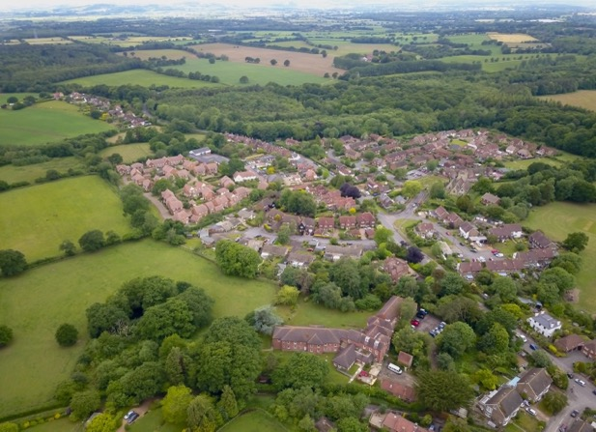

Aerial View of woodland and farmland surrounding East Hoathly

15. The Parish is located 6 Km South East of Uckfield and 10 Km North West of Hailsham that are both market towns connected by the A22. It is located in the Low Weald landscape which is between the High Weald National Landscape to the North and the South Downs to the South. Its slightly elevated position affords wide ranging views southwards to the South Downs National Park.

Setting

16. The Parish is a rural, largely agricultural landscape with several historic farmsteads. The farmland is liberally scattered with woodland much of which is designated as Ancient Woodland and a large network of hedgerows over 50% of which are recorded as Species Rich. There are many large woods, but also many very important Ghyll and Shaw woodlands that are in particular need of protection. The Parish contains many historic field systems and a network of ponds and streams that add to the landscape value of the area.

17. East Hoathly has significant and attractive green approaches. The three roads entering the Village are generally tree lined with green verges and open vistas across pasture and into woodland. This is particularly so on the London Road. Halland also sits in a rural setting with attractive green approaches.

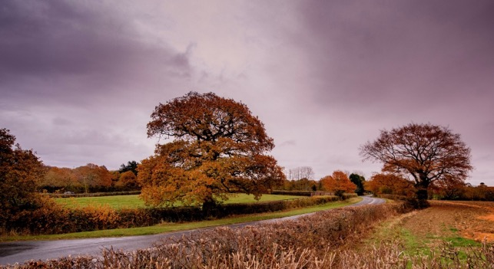

Approach to East Hoathly on London Road

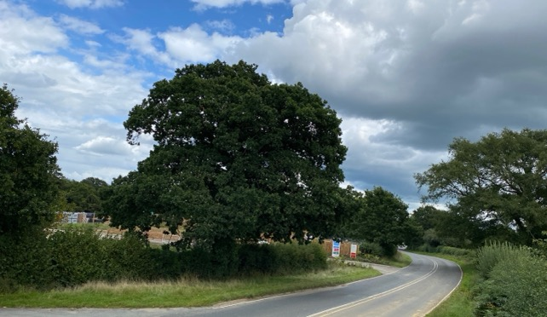
The Changing Face of the Approach to East Hoathly on London Road

18. The environment is rich with biodiversity all supported by a considerable number of ponds, ditches and streams which feed the River Cuckmere to the South and River Uck to the North. The most notable biodiversity features within or adjacent to the NP boundary are:

a. Park Corner Heath - A Site of Special Scientific Interest which is adjacent to the southern border of the Parish.

b. Moat Wood - An area of Ancient Woodland and a Medieval Moat which is a Scheduled Monument. Part of this land was purchased by the Parish Council and the management of the land passed to the Woodland Trust.

c. Croom Cottage Meadow - A Local Wildlife Site (LWS) with rare wild flowers and orchids.

d. Wildlife Verges on B2192 Lewes Road in Halland (ESCC Ref 2/46/30).

e. Long Pond - A breeding pond for Great Crested Newts.

19. The Sussex Biodiversity Record Centre has recorded 51 species that are red listed (in England or Great Britain) indicating that they are under threat of extinction and one species of rabbit that is on the global red list. In addition, 32 species are identified as Priority Species in the UK Biodiversity Action Plan. In total there are 26 internationally designated species, 86 nationally designated species and 175 species with some other designation, mostly indicating that they are scarce in England or rare in Sussex.

Community

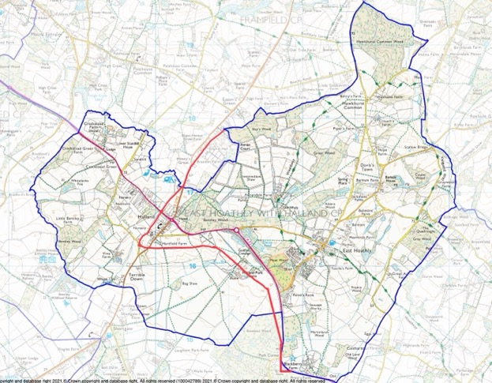

Figure 2 - The Parish Boundary shown in Blue was enlarged to the West of the Red line in 1990 to incorporate the whole of the Settlement of Halland (Prior to this, Halland had been administered by the Parishes of Laughton, Framfield and East Hoathly).

20. The Parish of East Hoathly with Halland is an open inclusive community that has seen significant expansion since the 1950s. The community has grown from 701 people in 1951 to 1,530 people in 2021. East Hoathly village has seen significant growth in the last 22 years and is destined to grow further. In the first decade of this period, housing in the village of East Hoathly increased from 294 to 377 which represents a 27% increase in the number of homes. Most of the building in East Hoathly has been on the sites of former businesses and this has significantly changed the balance of the living and working community. Most residents now travel out of the Parish (almost exclusively by car) to work, for shopping and leisure.

Historic Context

21. There has only been limited archaeological investigation in the Parish which means that prehistoric and early historic activity is not fully understood, although there is evidence of early activity in the area. Mesolithic sites have been recorded in Halland Park to the West of the Parish and several finds of Mesolithic flints have been recorded in Halland Park. A Bronze Age axe was found on the Eastern side of South Street. Roman occupation of the wider area commenced in A.D.43, after the Roman conquest. The Roman fort of Anderida lies approximately 13 miles to the South East at Pevensey, with the Roman road from the fort extending westwards from Pevensey to Lewes, 9 miles to the South West and a Roman villa in Laughton. There are limited records of Roman finds in the Parish but a Roman bloomery has been found in Halland.

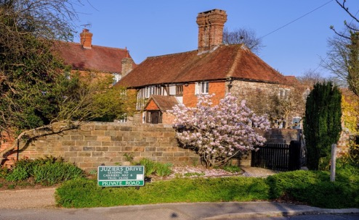

Sellens Cottage - Probable 15th Century Medieval Hall with floor and chimney added in 16th Century.

22. The Parish has an important historic past dating back to Norman times:

a. The name of East Hoathly may have been derived from the De Hodleigh family who owned land in the area from 1296. Another possibility is a variation of Hothly or hath leah - an Old English term for a forest clearing. The hamlet/settlement/village of Halland was originally known as the Nursery/Nurseries in recognition of its cluster of horticultural nurseries. Its name was changed to Halland in 1891 which was taken from the nearby Halland Park Farm. The name of Halland derives from the Hall family, former owners of the land for which the earliest reference appears to be in 1533.

b. The Pelham family bought the land from the Halls and Sir Thomas Pelham built Halland House in 1594. A later Thomas Pelham with his brother Henry raised troops to fight against the Jacobite Rising of 1715 and was rewarded by being created Duke of Newcastle. Both Henry and Thomas went on to become British Prime Ministers residing in Halland House throughout. The house went into decline and was demolished in 1788.

c. Historic landscape characteristics of the Parish include:

(1) An extensive area of cohesive assarts ancient fieldscapes.

(2) Remnant ancient landscape surrounding East Hoathly and Halland.

(3) Areas of regular piecemeal enclosure.

(4) Linear belts of Ancient Woodland lining stream corridors and marking some field boundaries, with several large areas of Ancient Woodland.

(5) Ponds and streams located throughout the landscape.

(6) Many places have views of the Lewes Downs, South Downs and High Weald National Landscape.

(7) A good network of footpaths linking the settlements to the wider landscape, including the Wealdway and Vanguard Way.

d. The settlements of Halland and East Hoathly both exhibit linear historic development extending along their original roads:

(1) For Halland this was the crossroads of the road from Uckfield to East Hoathly and the road from Ringmer to Blackboys.

(2) For East Hoathly this was the junction of Waldron Road, London Road, High Street and Mill Lane. The Parish has an important historic past dating back to Norman times:

e. The area of Halland was administered by three parishes until 1990 when the whole of its area was absorbed with East Hoathly to become East Hoathly with Halland Parish.

f. The Diaries of Thomas Turner recorded Georgian rural life from 1754 to 1765.

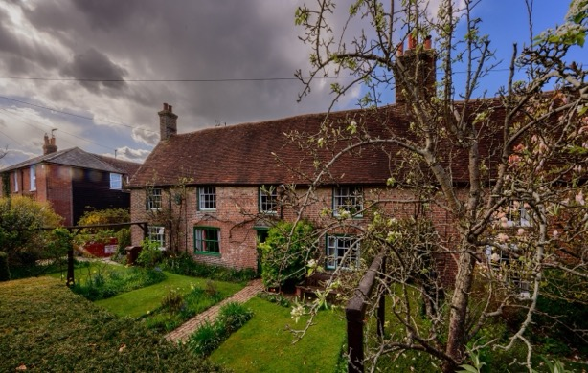

Thomas Turner’s House, East Hoathly

g. The Cricket Club was founded in 1759.

h. There has been a school in East Hoathly since at least 1755 with the current building dating to 1865.

i. The Parish Church was rebuilt in 1855 although the tower is believed to be circa 1500 and evidence was found during the rebuilding in 1855 of a 12th Century Norman Pillar Piscina and Norman windows.

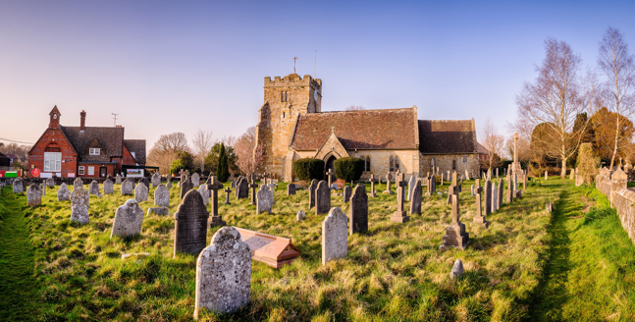

East Hoathly School and Church

j. Within Moat Wood there is a moated site, designated a Scheduled Monument. The site was probably set within a medieval landscape of dispersed settlement, comprising farmsteads, cottages and hamlets surrounded by fields and woodland.

k. East Hoathly has a history of torchlit bonfire parades and celebrations dating back to 1870 and the 1918 armistice saw the creation of the Carnival Society in commemoration of the dead of the First World War and subsequently the Second World War.

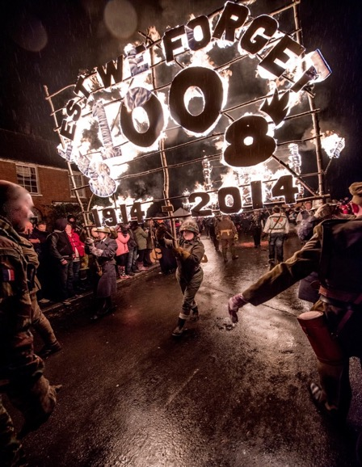

East Hoathly Carnival Parade

23. The Parish has 34 Listed Buildings and a single Scheduled Monument (full details can be found in Annex D). The Scheduled Monument is located near the centre of Moat Wood, East Hoathly. The majority of the Listed Buildings are within the designated East Hoathly Conservation Area (The Conservation Area was originally designated in 1995 but was reviewed and re-designated in 2017 and a larger part of the village was included). The designation of the Conservation Area introduces a general control over the demolition of unlisted buildings and provides a basis for planning policies to promote the conservation of all aspects of character or appearance that define an area’s special interest, including landscape and public spaces. The designation is supported by a draft Character Appraisal from 2021 that sets out the distinctive character and sense of place that create the area’s special interest, and considers the location and landscape setting of the area; Historic development; The character of the area in detail; Building materials and details: The contribution of the natural environment; and Issues having a negative impact on the character and appearance of the area. This should lead to a Management Plan for the Conservation Area.

Position within the WDC Planning Policies

24. WDC currently has three adopted planning documents.

a. Wealden LP 1998 - This covered the period 1994 to 2004. WDC has saved (meaning that this was approved by the Secretary of State in September 2007 and therefore remain valid policy) some of the policies from this plan and these are also available to view on the WDC Website. In the Wealden LP 1998, Halland and East Hoathly had Development Boundaries but no allocation of housing.

b. Wealden Core Strategy LP 2013 - This covered the period 2013 to 2027. The Wealden Core Strategy LP 2013 removed the Development Boundaries and allocated no housing allocation for the Parish.

c. Wealden Affordable Housing Delivery LP 2016 - This had no time period specified and is only related to the provision of Affordable Housing. This policy superseded WDC8 in the Wealden Core Strategy LP 2013. No allocations of housing were included.

SECTION 3 - VISION AND OBJECTIVES

Vision

VISION FOR EAST HOATHLY WITH HALLAND IN 2039

Our Vision is that in 2039, East Hoathly with Halland will remain a thriving, healthy, safe and caring community that has met its changing needs and which caters for the health and wellbeing of residents of all ages. It will be less car dependent with more residents working in the parish. It will have preserved the distinctive character that has evolved over eight centuries.

It will have ensured the protection of its Heritage Assets and Green Spaces.

It will have accommodated housing developments to meet the needs of local people and supported a Community Land Trust (CLT) to provide affordable rented homes. It will have improved the balance of housing stock available and ensured that new homes are sympathetic to the distinctive nature of the Parish.

It will have sought to enhance its sustainability by supporting remaining and new businesses, improving accessibility and supporting improvements to utilities and services. It will have promoted and enabled healthier lifestyles.

It will have improved its contribution to a Carbon Neutral future and to achieving Climate Emergency targets.

Objectives

25. The Objectives are specific statements that set out what the community wants to achieve in realizing its Vision. The Objectives are separated into the categories of Development, Conservation, Environment, Health and Leisure, Business and Accessibility.

Development

a. Objective 1 To accommodate new housing development in accordance with WDCs emerging LP and to ensure that the Parish has an improved balance of housing stock to provide both smaller dwellings and retirement living accommodation.

b. Objective 2 To support the delivery of affordable rented homes for local working people.

c. Objective 3 To support the development of high quality, beautiful and sustainable homes that ensure that future developments will make a positive contribution to local character and distinctiveness.

d. Objective 4 To support development that promotes sustainable transport use by improving access to sustainable transport including walking, cycling, wheeling and bus services and the provision of sufficient EV charging points for residents and visitors.

e. Objective 5 To support the creation of resource efficient homes including net zero residential and non-residential development within the Parish.

Conservation

f. Objective 6 To preserve Listed Buildings in the Parish and their setting and any features of special architectural or historic interest; to protect the Scheduled Monument from damage; identify additional buildings suitable for statutory protection.

g. Objective 7 To preserve and enhance the Conservation Area.

h. Objective 8 To identify potential Assets of Community Value.

Environment

i. Objective 9 To protect and enhance the existing Ancient Woodland in the Parish and protect other important woodland and trees.

j. Objective 10 To protect and enhance the existing green infrastructure, and in particular the Hedgerows in the Parish (excluding private gardens).

k. Objective 11 To protect and enhance ponds and other waterways in the Parish (excluding private gardens) as habitats and to protect their role in the drainage system.

l. Objective 12 To identify Local Green Spaces to be designated within the Parish.

m. Objective 13 To protect and enhance the biodiversity in the Parish.

Health and Leisure

m. Objective 14 To improve the facilities for Leisure and Recreation in the Parish and in particular to improve the drainage of the East Hoathly War Memorial Sports Ground.

n. Objective 15 To maintain and improve access to nature and to play and recreation, increasing physical activity and providing health and wellbeing benefits such as positive mental health.

o. Objective 16 To maintain and improve social cohesion and reduce social isolation and loneliness.

p. Objective 17 To maintain and enhance opportunities for growing healthy food.

q. Objective 18 To provide lifetime and adaptable homes that meet the needs of an aging population.

r. Objective 19 To maximize opportunities for healthy design principles including active travel.

s. Objective 20 To identify a potential community open/greenspace and play area in Halland.

Business

t. Objective 21 To support local employers and agricultural/rural businesses within the Parish.

Accessibility

u. Objective 22 To improve access to key services and amenities within the Parish by protecting and enhancing Parish Footpaths and the single Bridleway, and to pursue opportunities for improved walking, cycling and wheeling infrastructure.

v. Objective 23 To support the improvement of bus services in the Parish.

w. Objective 24 To support the improvement of Mobile and Broadband services for domestic and business users and encourage the growth of people using Broadband to work from home.

Policies

26. The EHHNP objectives lead to the creation of policies and aspirations which aim to achieve the community’s vision for the Parish in the period 2022 – 2039.

27. The EHHNP must conform with the strategic policies of the WDC development plan, and this currently includes the saved policies of the Wealden LP 1998, the Wealden Core Strategy LP 2013 and Wealden Affordable Housing Delivery LP 2016. It must also have regard to national policies contained within the NPPF (December 2023). The EHHNP policies alongside policies set out in the development plan will be used by WDC as the local planning authority to consider and determine planning applications. If WDC’s policies or the NPPF changes during the adoption process or subsequently, then any policy changes relevant to the EHHNP will be reviewed as part of the EHHNP Review Process and the latest policies to be adopted will take precedence if there is a conflict between policies.

28. The Parish is aware that the NPPF 2023 has a presumption in favour of sustainable development and that any plan and decision must take a positive approach in considering sustainable development.

SECTION 4 - HOUSING AND HOUSING DESIGN

29. Annex A provides background evidence on Sustainability and Infrastructure.

Housing

Demography

30. The demography of the Parish shows that the population is ageing, with those aged over 45 increasing from 47% in 2001 to 53% in 2011 with the trend expected to be confirmed when the 2021 census data is available. The WDC Local Housing Needs Assessment 2021 projects that in the plan period, there will be a 56% increase in the population aged over 65. This therefore increases the need for homes suitable for retirement. The ageing population brings with it a greater need for homes suitable for those with mobility problems, wheelchair users and those requiring accessible and adaptable dwellings.

31. The current state pension age is 66 (due to begin increasing again from 2026) and this is generally taken as retirement age. The Government Response to Planning for the Right Homes in the Right Places Consultation proposed to widen the definition of retirement, in respect of accommodation, to include people approaching retirement. Older persons accommodation needs range from those who might be aged 55 and older who are active elderly but do not require support or care services, to those who require residential care homes or nursing homes. Older people may be completely independent but just want to downsize as they retire, or approach retirement. This can then transition into requiring some support or care to help them remain in their own home which might need adaptions and accessibility changes. Irrespective of the level of support or care the elderly need, the need for more retirement homes has been a constant comment in surveys and discussions on housing. In this Parish it has identified a need for 1 and 2 bedroom homes for retirement and downsizing.

32. Levels of diversity in this rural parish are extremely low with only 3% of the population in 2011 being from an ethnic background other than white and 3.2% in 2021.

33. Data for the health of the population show that in 2011, 84% were in good health with 12% described as fair health and 4% in bad health. Dementia in the aging population is a factor that will become increasing significant in coming decades. Creating a built environment that enables older people to live well and cope with illnesses such as dementia will become ever more important. Developers should be encouraged to follow the guidance of the Royal Town Planning Institute on dementia, the East Sussex Dementia Joint Strategic Needs Assessment and the Housing our Aging Population Panel for Innovation (HAPPI) guidelines.

Housing in the Parish

34. The Housing in the Parish is mostly concentrated in the villages of East Hoathly and Halland with some smaller hamlets and a significant number of isolated rural dwellings. This Parish is conscious of the changing needs of the local community and the housing stock. This Plan seeks to redress the imbalance in the Parish housing stock and to provide smaller homes for local people to downsize and for local people to access the housing market. The following tables show data from the 2011 Census comparing the Parish with Wealden and the South East region and England. In some cases, data is also available for East Hoathly village.

35. Table 1 shows the different forms of housing available. The highlighted text shows the significant imbalance in the housing stock with fewer flats compared with a larger proportion of detached homes.

Table 1 - Housing Type

Area | All Dwellings | Detached | Semi-Detached | Terraced | Flat
South East | 3,694,388 | 1,037,388 | 1,022,394 | 829,923 | 788,570
 |  | 28.1% | 27.7% | 22.5% | 21.3%
Wealden | 65,159 | 29,030 | 19,581 | 8,289 | 7,532
 |  | 44.6% | 30.1% | 12.7% | 11.6%
East Hoathly with Halland | 639 | 322 | 190 | 87 | 34
 |  | 50.4% | 29.7% | 13.6% | 5.3%

36. Table 2 shows the different forms of housing available. The highlighted text shows the significant imbalance in the housing stock, with fewer homes with one bedroom when compared with a larger proportion of houses with four or more bedrooms.

Table 2 - Housing - Number of Bedrooms

Area | Total | No Bedrooms | 1  Bedroom | 2  Bedrooms | 3  Bedrooms | 4+ Bedrooms
South East | 3,555,463 | 8,531 | 413,761 | 932,994 | 1,383,662 | 816,515
 |  | 0.2% | 11.6% | 26.2% | 38.9% | 23.0%
Wealden | 62,676 | 94 | 4,783 | 17,670 | 22,213 | 17,916
 |  | 0.1% | 7.6% | 28.2% | 35.4% | 28.6%
East Hoathly with Halland | 620 | 1 | 28 | 128 | 224 | 239
 |  | 0.2% | 4.5% | 20.6% | 36.1% | 38.5%

37. Table 3 repeats some of the data from Table 2 but adds a comparison with the Rented sector. The highlighted text shows the significant imbalance in the housing stock with fewer homes with one bedroom when compared with a larger proportion of houses with three or more bedrooms. Data for the rented sector in the Parish is not available but it might be that a similar trend is followed in the highlighted text for One Bed Social Rented homes.

Table 3 - Housing - By Number of Bedrooms and Tenure

Area | One Bed  All Sectors | Two Bed  All Sectors | Three + Bed All Sectors | One Bed  Social Rented | Two Bed Social Rented | Three + Bed Social Rented
England | 12.0% | 27.9% | 60.1% | 30.8% | 34.4% | 34.8%
South East | 11.9% | 26.2% | 26.2% | 32.4% | 33.0% | 34.6%
East Sussex | 12.7% | 30.9% | 56.4% | 32.8% | 32.4% | 63.5%
Wealden | 7.8% | 28.2% | 64.0% | 24.1% | 44.5% | 42.2%
East Hoathly with Halland | 4.7% | 20.6% | 74.7% | Data not available | Data not available | Data not available

38. Table 4 shows data from the 2011 Census comparing the Parish with Wealden District, the South East region and England. The highlighted text shows the significant imbalance in the forms of tenure in the Parish and the significant lack of rented accommodation in comparison to the rest of England and the South East region.

Table 4 - Housing - Tenure/Ownership

Area | All Tenures | Owned | Social Rented | Private Rented | Rent Free
England | 22,063,368 | 13,945,024 | 3,903,550 | 3,401,675 | 295,110
 |  | 63.3% | 17.7% | 15.4% | 1.3%
South East | 3,555,463 | 2,404,517 | 487,473 | 578,592 | 45,601
 |  | 67.6% | 13.7% | 16.3% | 1.3%
Wealden | 62,676 | 49,355 | 4,808 | 6,973 | 1,037
 |  | 78.7% | 7.7% | 11.1% | 1.7%
East Hoathly with Halland | 620 | 480 | 53 | 64 | 15
 |  | 77.4% | 8.5% | 10.3% | 2.4%

39. Table 5 shows the Housing Mix by bedroom types recommended in the WDC Housing Needs Assessment 2021 for the whole District. This identifies a need for more homes with one bedroom in the Affordable Homes sector, but does not reflect that this is also needed in the Market sector. The WDC evidence base shows that only 5% of Market housing is to be one bed compared with the current stock figure of 7.8% for Wealden and an East Sussex figure of 12.7%. Over 77% of the housing in this Parish is privately owned so, not tackling the market sector for one Bedroom houses will not rebalance the housing needs of the Wealden District nor this Parish.

Table 5 - WDC Housing Mix Recommendation

Housing Type | 1 Bedroom | 2 Bedrooms | 3 Bedrooms | 4+ Bedrooms
Market | 5% | 30% | 40% | 25%
Affordable Owned | 20% | 40% | 30% | 10%
Affordable Rented | 40% | 30% | 25% | 5%

40. The WDC Housing Needs Assessment 2021 identifies a predicted 56% increase in the population of 65 + year old residents in the next 20 years. This supports the findings of the Parish Survey 2016, Feria Interim Report and EHHNP Consultation Process which also identified the needs of the Parish for smaller homes in all sectors as starter homes for local people, and homes suitable for downsizing.

41. The ONS data and the WDC Housing Needs Assessment 2021 clearly show that this Parish has an imbalanced housing stock with too many large, detached homes and a deficit of smaller one and two bed homes. This is particularly the case in the rented sector. These are the kind of homes needed as starter homes for local people and for the elderly who wish to downsize. This would provide housing that is aligned to the needs of the community.

New Housing Development Approvals in the Parish

42. WDC granted Outline Planning Consent for 205 homes in East Hoathly on Hesmond’s Stud land in July 2020. This planning application was determined in a situation where WDC could not demonstrate a 5 Year Land Supply position and therefore adopted local planning policies relevant to the determination of the housing application were considered out of date.

43. WDC rejected a planning application for 55 homes on South Street in East Hoathly in 2020, but the applicant successfully appealed this decision and this application now has outline planning consent. Again, this planning appeal was determined in a situation where WDC could not demonstrate a 5 Year Land Supply position and therefore adopted local planning policies relevant to the determination of the appeal were considered out of date.

44. The proposed development on South Street will provide some additional open space for its residents on the greenfield development site.
The proposed development at Hesmond’s Stud will provide a temporary addition of 5 buses on a Sunday for 3 years and the provision of some open space for the new residents on the greenfield development site. The view of residents is that these additions to facilities and services are not considered, by any measure, adequate to cope with a more than doubling in the size of East Hoathly.

Scale

45. The scale of any development is a matter that should form part of the WDC strategic plan and the NPPF requires that this be considered. Paragraph 74 of NPPF 2023 makes it clear that any large-scale development should ensure that the size and location of any development will be sustainable. It should also consider matters such as phasing of delivery in order to manage the impact on the local services, infrastructure and local community.

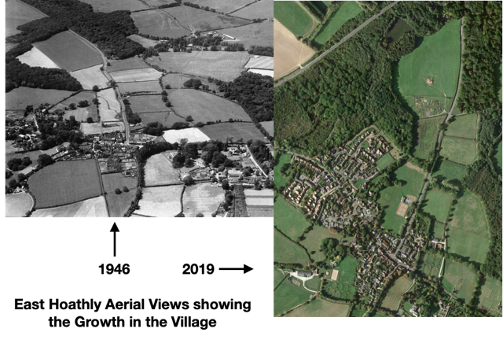

46. The following charts show the growth in housing in the Parish and the village of East Hoathly over time. Figure 3 shows the number of homes in the Parish expanding steadily from less than 125 in 1841 doubling to just under 250 in 1961. The rate of growth has risen steeply since 1961 with the completion of 931 homes by 2022. Figure 4 shows the number of homes in East Hoathly village expanding slowly from 55 in 1841 to 194 in 1976. The sharp rise since 1976 shows the completion of 642 homes by 2022. The Parish believes that significant new development should be allowed time to be absorbed into the community and that phasing should be considered for any major planning application.
Figure 3 - Growth in Number of Homes in
East Hoathly with Halland Parish

Figure 4 – Growth in Number of Homes in East Hoathly

47. East Hoathly village has seen significant growth in the last 22 years and is destined to grow further. In the first decade of this period, housing in the village of East Hoathly increased from 294 to 377 which represents a 27% increase in the number of homes. During the period since 1998 the Parish has not been allocated any housing as part of an adopted LP. However, since 1998 the Parish has seen significant housing development with more now approved by WDC.

a. The Mews, East Hoathly 2001/2 - Addition of 8 homes.

b. Juziers Drive/Trug Close/Carriers Way, East Hoathly 2009 - Addition of 45 homes.

c. Nightingales, East Hoathly 2009 - Addition of 30 homes.

48. The WDC Five Year Housing Land Supply Statement 2022 indicates that this Parish is destined for the following further additional housing amounting to 271 homes:

a. Old Hartfield, Halland 5 Almost complete

b. 23 High Street, East Hoathly 1

c. Land at Buttsfield Lane , EH 2

d. Staverton Nursery, Halland 1

e. Granary, Crockstead, Halland 1

f. Hesmonds Farm, East Hoathly 1

g. Hesmonds Stud, East Hoathly 205

h. South Street, East Hoathly 55

49. From 2021 to 2028, this will represent a 136% increase in the population of East Hoathly and a 90% increase in the population the Parish. This Parish believes that the scale of such increases is unsustainable without a strategic plan to improve services and infrastructure yet no plan has been put forward. The growth of this Parish, and in particular, East Hoathly village, will see this community grow proportionally bigger than any other community in Wealden as can be seen in Figure 5, which shows the population growth in the Parish in comparison with other parts of Wealden District that have also seen significant growth since 2001.

Affordable Housing

50. The Wealden Affordable Housing Delivery LP 2016 has the intention of delivering 35% affordable housing as part of any development of 5 (net) dwellings or more, although outside the High Weald National Landscape the policy in applies to development of 10 or more dwellings. WDC has identified a need to deliver 519 Affordable Rented Homes per year and 335 homes for Affordable Home Ownership.

51. This Parish absolutely recognises the importance of Affordable Housing need in the District but has significant concerns that the bulk of the Affordable Housing need is in urban areas close to the facilities they provide. There are only a handful of families on the WDC housing register with the Parish of East Hoathly with Halland as their first choice. It is clear that although there is a need for some affordable housing for people on the housing register, the local need is small and more than already addressed by recent planning approvals. Building affordable homes in excess of the local need necessitates placing people on the housing register into locations not of their choosing. This places them away from the services and jobs that they need to sustain them. It also often places people from urban settings into rural communities to which they have no connection.

Local Connection

52. The question of what constitutes a local connection is not a matter of land use policy but it is of significant interest to local people and is included here for the interest of those who may seek to gain access to Affordable Housing. It is an important matter that is controlled by the Housing Authority under the terms of the Housing Act. The following are the current criteria for applicants with a Local Connection in Section 3 of WDC’s Housing Allocations Policy 2020 that would be applied:

“a. Applicants who currently live within the Wealden District and have done so continuously for at least two years, or

b. Applicants who have lived in the Wealden District for 3 out of the last 5 years, or

c. Applicants who have a close adult relative (over 18 years of age) (mother, father, adult children or siblings) who currently lives in Wealden and has resided in the district for at least five years continuously, or
d. Exceptional circumstances - where failure to reside in the district would cause hardship to the applicant or others (to be agreed by the Wealden Housing Options and Strategy Manager on a case-by-case basis).”

Community Land Trust

53. The East Hoathly with Halland Community Land Trust was established in 2018. The Parish Council fully supports the aspirations of the CLT. Their vision is:

“We are an independent community-led organisation seeking to develop innovative, affordable housing to be held in perpetuity for the people of the parish of East Hoathly with Halland.

Our aim is to create an exemplar zero-carbon housing development in keeping with the historical heritage, local landscape and vibrant community fabric of the parish.

With shared values of community, companionship and ecological responsibility at its heart, the Community Land Trust will create high-quality sustainable homes within a financially empowering model. This ensures a future-proof legacy of affordable homes for those who can demonstrate an ongoing link to the local area, but who may not be able to otherwise afford a property in the local area, young families, downsizers, co-housers, alongside the provision of work-space appropriate to the heritage of the parish.

Flexibility is key: the scheme is site specific, offering a range of owner/occupier, leasing, social housing and co-housing options. Our mission is to initially develop a pilot scheme of 4-6 properties while in tandem consulting with the wider community to draw out the outline of a more comprehensive scheme

We are working in conjunction with the Sussex Community Housing Hub.”

54. The East Hoathly with Halland CLT commissioned a Housing Needs Survey from Action in Rural Sussex (AIRS) in 2019. The purpose of this study was to objectively assess the current scale and nature of the need for affordable housing in East Hoathly with Halland Parish. This identified those households whose housing needs were not currently being appropriately met and who could not afford to meet them on the open market within the parish. The Survey revealed strong support for a CLT provision of affordable housing. In the CLT Survey, 21 households identified their home as being unsuitable for their household’s current needs. The main reasons identified for this unsuitability were lack of affordability and the need for more secure tenure. Of these 21 households, 16 indicated they needed homes with 1 or 2 bedrooms.

EHHNP Policy 1 - Housing

P1.1 New housing development will be supported if it provides a mix of different house sizes to meet the needs of the local community and the proposal seeks to redress the imbalance of housing stock in the Parish. This would be through the delivery of a higher proportion of homes of one, two or three bedrooms and a greater balance of smaller homes for retirement and downsizing. New housing will also be supported if it reflects the needs of the older people, those with accessibility issues, wheelchair users and those with dementia.

EHHNP Aspiration 1 - Community Land Trust

A1.1 This Parish will continue to support the work of the established East Hoathly with Halland Community Land Trust which is working to develop innovative, affordable housing to be held in perpetuity for the people of the Parish of East Hoathly with Halland.

Housing Design Policies

55. The Housing Design Policies of the EHHNP apply to all housing development in the Parish. These principles should be applied to any scale of new housing development, infill development, or refurbishment/conversion of existing property. The Housing Design Policies do not apply to commercial buildings.

56. Architecture in the Parish spans 500 years of design ideas and fashions but is at its heart rural and generally following the traditional vernacular of Sussex. It is all set within a high quality landscape and aesthetically pleasing rural backdrop. The main settlements differ as follows:

a. East Hoathly has a few buildings dating from the seventeenth century and an historic core of Georgian and Victorian buildings. Modern buildings have been built to reflect the general style of the historic buildings with varying degrees of success.

b. Halland has a few buildings dating from the seventeenth century and a small number of nineteenth century houses built as a linear development centred on the A22/B2192 roundabout. Modern buildings have been built to reflect the general style of the historic buildings with varying degrees of success.

57. This Neighbourhood Plan supports the NPPF objective to create “high quality, beautiful and sustainable buildings and places” (NPPF 2023, Paragraph 131). Development proposals will be required to demonstrate that their design is in accordance with the provisions of the National Design Code and Wealden Design Guide 2008 in relation to the Low Weald Character Area or any subsequent design guide or code produced by WDC. This would also conform to the saved development plan policies EN1 and EN27, within the Wealden LP 1998. Development proposals within or on the edge of the designated Conservation Area should take into account the information available in the draft East Hoathly Conservation Area Character Appraisal 2021 and any future management plan for more local design and material guidance.

58. The following section examines factors that have informed the Housing Design Policies, beginning with the EHHNP Character Area Appraisal and Sustainability.

EHHNP Character Area Appraisal

59. A Character Area Appraisal has been prepared as a supporting document to the EHHNP. The Character Area Appraisal analyses the character of the Parish by identifying distinct character areas within the Parish and then assessing them against a list of criteria looking at topography, land use, access, landmarks, views, buildings, streetscape, layout and dark skies. The appraisal identified detractors to the character of the Parish. These are features that add little to or detract from the character of the Parish. They are features that can be found in many parishes and do not reflect the character and history of East Hoathly with Halland. The Character Appraisal recommends that whenever there is the opportunity to remedy detractors that already exist, these should be taken to enhance the character of the Parish. It is also recommended that these design features should be avoided in new developments or be factors to which designers should be sensitive.

60. The Character Appraisal made a number of recommendations based on the identified detractors, which have been incorporated into the design policy.

Sustainability

61. The Parish is a very small part of the global Climate Emergency but it will have a significant effect on our lives. It will be a difficult task to change our behaviour to meet the demands of this situation but everyone will have to make changes to the way they live. Adapting our homes, vehicles and lifestyles to be more energy efficient, carbon neutral and more sustainable will be expensive and challenging. Older homes may find it particularly problematic to adapt. It is therefore even more important that new developments should be at the leading edge of sustainability, energy efficiency and carbon neutral standards.

62. The Centre for Sustainable Energy has prepared Carbon Emission Estimates to give communities an opportunity to see the level of Carbon Emissions in their Parish and how they compare within their District and Nationally. This Parish has Emissions amounting to 18,634 tonnes of Carbon Dioxide equivalent per year. On a household basis, this is almost twice the Wealden average of Carbon Emissions and more than twice the National average. The comparison charts are shown at Annex C.

63. Future development should enhance the community’s sustainability by promoting energy efficiency. Development should be aiming towards a less car dependent future favouring home working (with faster, reliable broadband) and a greener approach to transport. The sustainability of designs should be at the forefront of all development proposals and those that follow sustainable design criteria will be supported:

High Energy Efficient Buildings

a. New buildings should be as energy efficient as possible. Development proposals which demonstrate that the proposed buildings have a net emission rate of zero, or are proposed to be certified Passivhaus buildings, will be encouraged, and will be considered favourably subject to other policies.

b. Buildings should be designed to maximize solar gain and incorporate technologies that maximize the use of renewable energy sources.

Renewables

c. It is vital that new developments make maximum use of renewable energy and that this should be the starting point of their design and build.

(1) Proposals for new development are encouraged to incorporate solar photovoltaic panels, solar thermal panels, heat pumps and biomass boilers.
(2) New developments also need to consider any negative impacts they may have on the operation of existing buildings, including impacts on renewable or low carbon energy supply. Where a proposed development is identified as being likely to have negative impacts on renewable or low carbon energy supply on adjoining land, the applicant will need to undertake the relevant analysis to demonstrate and quantify the nature of the impact and justify this impact.

d. Applications for renewable energy schemes will be supported if they can demonstrate that they do not have a significant adverse effect on landscape and village character, biodiversity, heritage or cultural assets or amenity value.

Water

e. Water is a resource that we need to conserve and use more wisely. We currently waste too much water and use mains water for uses that do not need such purity. New developments should be designed to minimize water consumption and the storage and reuse of grey water should become the norm.

EHHNP Policy 2 – Housing Design - Resource Efficiency

P2.1 Development will be supported if the homes are designed to minimize energy usage and make the most efficient use of natural resources. Designs that achieve the following will be supported providing that they avoid an adverse impact on the landscape and village character, biodiversity or heritage assets:

a. High Energy Efficiency Buildings that have a net emission rate of zero or are certified Passivhaus buildings.

b. Buildings designed to maximize solar gain and incorporate technologies that maximize the use of renewable energy sources.

c. Buildings designed to minimize water consumption and that incorporate the reuse of grey water.

d. Buildings that incorporate solar photovoltaic panels, solar thermal panels and heat pumps.

e. New developments also need to consider any negative impacts they may have on the operation of existing buildings, including impacts on renewable or low carbon energy supply. Where a proposed development is identified as being likely to have negative impacts on renewable or low carbon energy supply on adjoining land, the applicant will need to undertake the relevant analysis to demonstrate and quantify the nature of the impact and justify this impact.

P2.2 Applications for renewable energy schemes within housing developments will be supported if they can demonstrate that they do not have a significant adverse effect on the landscape and village character, biodiversity or heritage assets.

SECTION 5 - CONSERVATION
EHHNP Policy 3 – Housing Design - Layout and Materials

P3.1 All new housing development in the Parish should contribute to the creation of high-quality places through a design-led approach and reflecting a thorough site appraisal. All buildings, spaces and the public realm should be well-designed, accessible for all ages and abilities and display a high level of architectural quality which responds positively to local context. Housing development proposals will be required to demonstrate that their design is in accordance with the provisions of the National Design Guide and Wealden Design Guide 2008 and any subsequent design guide or code produced by Wealden District Council.

P3.2 Development that maintains or enhances the character of the area, having regard to the character assessment and its recommendations, would be supported.

64. This Section encompasses all matters relating to the Conservation in the Parish. The protection and enhancement of these assets is important because of their intrinsic value but also because of the mental health and wellbeing benefits that they bring to residents. It applies to designated heritage assets and their settings including Listed Buildings, Scheduled Monuments and the Conservation Area and non-designated heritage assets and their settings, including sites of archaeological interest.

Archaeology

65. There will be archaeological interest in a heritage asset if it holds, or potentially holds, evidence of past human activity. The EHHNP area contains 4 Archaeological Notification Areas which denote areas containing recorded archaeological remains. All proposed development is required under the NPPF to check for potential impacts on heritage in these areas. Developers must also consult the Historic Environment Record to determine the likelihood that currently unidentified heritage assets, particularly sites of historic and archaeological interest will be discovered.

66. There has only been limited archaeological investigation in the Parish which means that prehistoric and early historic activity is not fully understood, although there is evidence of early activity in the area. Mesolithic sites have been recorded in Halland Park to the West of the Parish and several finds of Mesolithic flints have been recorded in Halland Park. A Bronze Age axe was found on the Eastern side of South Street. Roman occupation of the wider area commenced in A.D.43, after the Roman conquest. The Roman fort of Anderida lies approximately 13 miles to the South East at Pevensey, with the Roman road from the fort extending westwards from Pevensey to Lewes, 9 miles to the South West and a Roman villa in Laughton. There are limited records of Roman finds in the Parish but a Roman bloomery has been found in Halland.

67. The Parish has an important historic past dating back to Norman times:

a. The name of East Hoathly may have been derived from the De Hodleigh family who owned land in the area from 1296. Another possibility is a variation of Hothly or hath leah - an Old English term for a forest clearing. The hamlet/settlement/village of Halland was originally known as the Nursery/Nurseries in recognition of its cluster of horticultural nurseries. Its name was changed to Halland in 1891 which was taken from the nearby Halland Park Farm. The name of Halland derives from the Hall family, former owners of the land for which the earliest reference appears to be in 1533.

b. The Pelham family bought the land from the Halls and Sir Thomas Pelham built Halland House in 1594. A later Thomas Pelham with his brother Henry raised troops to fight against the Jacobite Rising of 1715 and was rewarded by being created Duke of Newcastle. Both Henry and Thomas went on to become British Prime Ministers residing in Halland House throughout. The house went into decline and was demolished in 1788.

c. Historic landscape characteristics of the Parish include:

(1) An extensive area of cohesive assarts ancient fieldscapes.

(2) Remnant ancient landscape surrounding East Hoathly and Halland.

(3) Areas of regular piecemeal enclosure.

(4) Linear belts of Ancient Woodland lining stream corridors and marking some field boundaries, with several large areas of Ancient Woodland.

(5) Ponds and streams located throughout the landscape.

(6) Many places have views of the Lewes Downs, South Downs and High Weald National Landscape.

(7) A good network of footpaths linking the settlements to the wider landscape, including the Wealdway and Vanguard Way.

d. The settlements of Halland and East Hoathly both exhibit linear historic development extending along their original roads:

(1) For Halland this was the crossroads of the road from Uckfield to East Hoathly and the road from Ringmer to Blackboys.

(2) For East Hoathly this was the junction of Waldron Road, London Road, High Street and Mill Lane.

Designated Heritage Assets

68. The Parish has 34 Listed Buildings and one Scheduled Monument. The locations of these buildings are shown on the following map and the details are shown at Annex D.

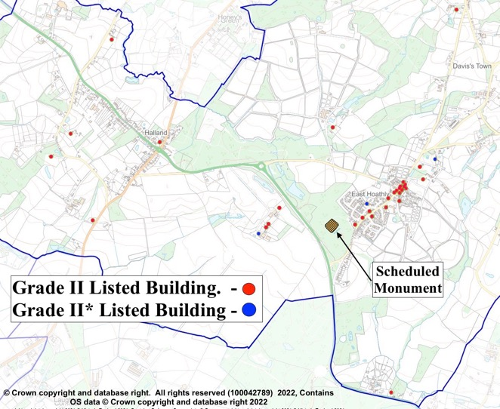

Figure 6 - Designated Heritage Assets in Parish
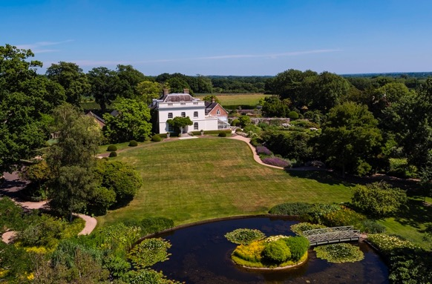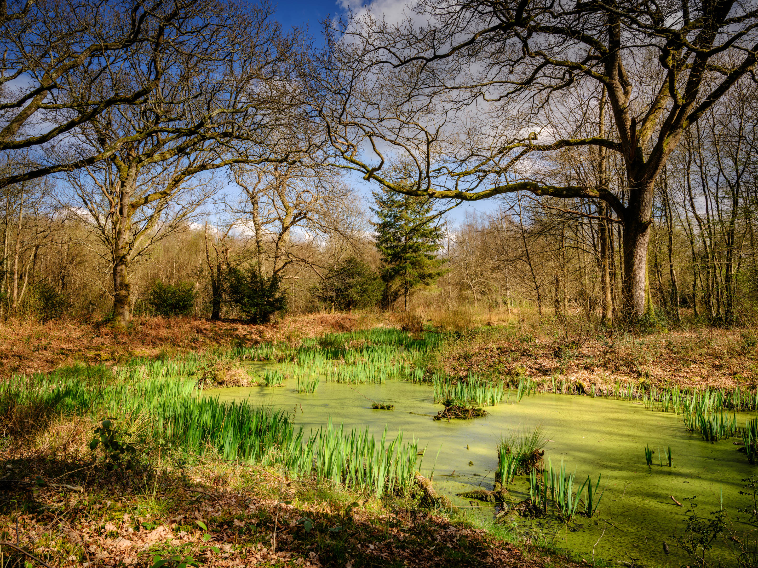
Grade II* Belmont House East Hoathly
Scheduled Monument - Moat Wood
69. Designated Heritage Assets are protected by legislation and this extends to include their setting. In accordance with NPPF 2023 Paragraph 201: “Local planning authorities should identify and assess the particular significance of any heritage asset that may be affected by a proposal (including by development affecting the setting of a heritage asset) taking account of the available evidence and any necessary expertise. They should take this into account when considering the impact of a proposal on a heritage asset, to avoid or minimise any conflict between the heritage asset’s conservation and any aspect of the proposal”.
Bow Bells Milestones

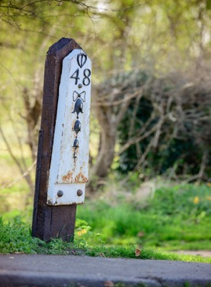

Bow Bells Pelham Milepost Marker

70. Bow Bells milestones extend along the A22 between Horsebridge and East Grinstead. This is the longest sequence of milestones in the country. The iron milestones were erected in the 18th century and feature a string of five bells below a bow of ribbon. The bells were a reference to Bow Bells Church in the City of London from where most roads heading south were measured. The milestones were erected by the Turnpike Trusts along this turnpike route in the 18th century, with the Uckfield to Horsebridge turnpike (via East Hoathly) completed by 1768. Between Uckfield and Horsebridge the Pelham Buckle is shown above the mile mark, denoting the Pelham landowners along this stretch of the turnpike. Four Pelham Buckle Mileposts survive within the Parish and the details are shown at Annex E. Historic England have designated a Bow Bells milestone in Danehill as a Heritage Asset and the same criteria should apply to those in this Parish. The Parish Council will seek to get those milestones in the Parish designated as listed buildings.

Non-Designated Heritage Assets

71. The Parish has many historic assets that are not designated. It is possible to apply for these to be included on a Local List of non-designated heritage assets. Any such application has to provide detailed evidence to support the case. The Local List can include things such as:

a. Cultural landscapes and areas of special local character.

b. Places of important social history.

c. Assets associated with significant patterns of settlement.

d. Assets associated with figures of significant importance.

e. Significant buildings (design, materials, purpose).

f. Assets associated with historically important areas or landscapes.

72. The draft East Hoathly Conservation Area Character Appraisal 2021 identifies some buildings that could be considered for adding to a potential Local List of non-designated heritage assets. In due course, it is intended to complete a full review of the Parish with a view to submitting for a Local List of approved non-designated heritage assets at a future review of the EHHNP.

East Hoathly Conservation Area

73. WDC originally designated a Conservation Area for East Hoathly in 1995. The Conservation Area boundary was reviewed in 2017 and redesignated with an enlarged boundary. This is shown below. A WDC draft Conservation Area Character Appraisal was published in January 2021. The Character Appraisal describes the landscape setting for the area and the historic development of the Parish. It examines the character of the area in detail including the design of buildings, materials used, building patterns, usage of buildings and some of the key individuals and events affecting the Parish. It considers the contribution of the natural environment and identifies issues that have a negative impact on the character and appearance of the area.

74. The whole of the Conservation Area is protected by additional planning controls. This protection extends to the need to consider the impact of development on the significance of the Conservation Area through development in its setting. New development within the Conservation Area or within its setting should enhance or better reveal its significance and make a positive contribution to the asset.

75. An important part of the setting of the East Hoathly Conservation Area is the open countryside surrounding the village and the views into and out of the Conservation Area. This is noted in the WDC Draft Conservation Area Character Appraisal 2021:

a. “Views across the wider countryside are also important, with views in and out of the conservation area providing a strong sense of place and affording strong inter-visibility with historic buildings in the historic core”.

b. “Views through the character area are along the roads and back to the village core, and across the fields to the west and views to the large houses set back to the eastern side of the road, which are often glimpsed through trees. Views across the wider countryside are important and the fields to the west allow views in and out of the conservation area and to the large area of woodland beyond”.

c. “The landscape around East Hoathly still has a very rural character of fields, hedges, treed boundaries, and woodland, which provides an important backdrop to the settlement. Views across the wider countryside are also important, with views in and out of the conservation area providing a strong sense of place and affording strong inter-visibility with historic buildings in the historic core. There are views across surrounding fields and to area of woodland beyond, as well as views southwards towards the South Downs”.

d. “Views across the wider countryside are also important, with views across the fields adjacent to the conservation area to the west and southwards towards the South Downs”.

e. “Open spaces within and on the edge of the conservation area are important as they help to define the built environment and create a sense of place”.

f. “The open landscape makes an important contribution to the traditional open setting of the conservation area. The rural location of the village within the gently sloping agricultural landscape of the Low Weald and in close proximity to the South Downs means that there is open fields and woodland surrounding the conservation area”.

g. “The most important views looking into, out of and through the conservation area are shown on the character appraisal map in Appendix 1. These contribute to the character and setting of the conservation area and care needs to be taken to ensure that they are not lost or compromised by future development or poorly sited services”.

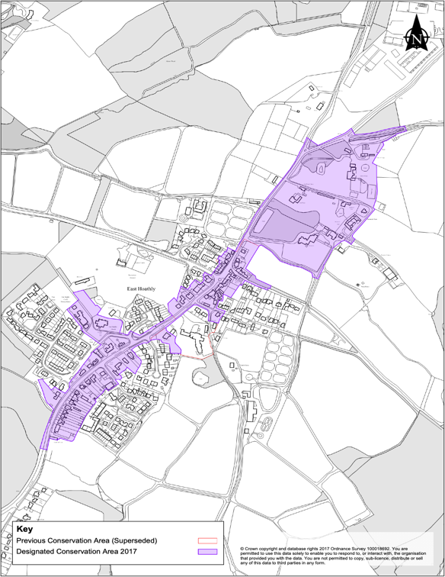

Figure 7 - East Hoathly Conservation Area

76. WDC are expected to produce a Management Plan for the Conservation Area. In the preparation of this Management Plan, it is hoped that the Parish will be able to work with WDC on developing an Article 4 direction in the future, that will control the remaining Permitted Development rights that are leading to erosion of character and detail within the Conservation Area.

EHHNP Policy 4 – Conservation of Historic Environment

P4.1 Proposals for new development that preserve or enhance designated heritage assets, including the Conservation Area, and their settings, will be supported.

P4.2 Proposals for new development that recognise the importance of non-designated heritage assets and are sympathetic to their setting and character will be supported.

EHHNP Aspiration 2 – Conservation of Historic Environment

Pelham Buckle Milepost Markers

A2.1 The Parish Council will seek to get those milestones in the Parish designated as listed buildings.

East Hoathly Conservation Area

A2.2 This Parish seeks, in liaison with WDC, to establish an Article 4 Direction that will control Permitted Development rights within the East Hoathly Conservation Area.

Rural Landmarks

77. In addition to the assets identified to be nominated as ACVs, the consultation process also recognized the importance of other things that make the Parish demonstrably rural and special. The Fingerpost signs that mark many of the junctions of minor roads in the Parish are an example of this. They have age and charm and remind people that they are on a quiet country lane and not a major highway. Many of these Fingerposts have been lost in recent years and this Parish will seek to retain all the remaining ones and reinstate some of the lost Fingerposts.

78. Post Boxes are also a reminder of the rural setting for our Parish and this Parish currently has 8 remaining. They help with sustainability preventing the need to get into a car and drive to post a letter. This Parish will strive to retain the remaining Post Boxes. The Fingerposts and Post Boxes are shown at Annex G.

EHHNP Aspiration 3 – Conservation of Community Assets

Fingerpost Signs and Post Boxes

A3.1 This Parish seeks to retain remaining Fingerpost Signs and to reinstate those that have been lost.

A3.2 This Parish seeks to retain remaining Post Boxes.

SECTION 6 - NATURAL ENVIRONMENT

79. The natural environment surrounding the built areas is the reason our villages exist. The natural environment has been sculpted by the farming community over many centuries and continues to evolve as the economics and practices of farming change. They now provide the priceless backdrop to the community giving aesthetic pleasure and habitats for the wildlife and plants that enrich our lives. The natural environment provides important benefits for the health and wellbeing of residents of all ages and abilities. This can be through active travel, recreation and play, connected neighbourhoods and also the mental and wellbeing benefits associated with access to natural environments. These benefits also encourage visitors to our local economy.

80. The WDC Green Infrastructure Study 2017 sets out a potential green infrastructure network for Wealden, based on an analysis of the District’s green and blue assets, where there are deficiencies and where there are opportunities for improvements/enhancements/provision. Whilst not an adopted strategy for the District, the potential Green Infrastructure Network provides a framework for the delivery of Green Infrastructure to support the planning of sustainable development. WDC are reviewing this study to inform the new draft WLP.

81. Our Parish was part of one of the Strategic Green Access Links in this Network. This connected the communities and facilities of the Parish via a range of Public Right of Ways (PROWs) and principally, the Wealdway and Vanguard Way. It proposed that these links were protected and enhanced for pedestrians and cyclists and connections to public transport links improved. The proposal noted that it is important that the network is not compromised by inappropriate development and/or land management. It stated: “Where development is planned within or in close proximity to Green Infrastructure assets, it should become an integral feature to the design and ‘identity’ of the development site to ensure that the connectivity of the network for both public benefit and biodiversity is retained and enhanced”.

82. The WDC Landscape Character Assessment 2022 categorised the Parish in 3 parts as shown in Figure 8:

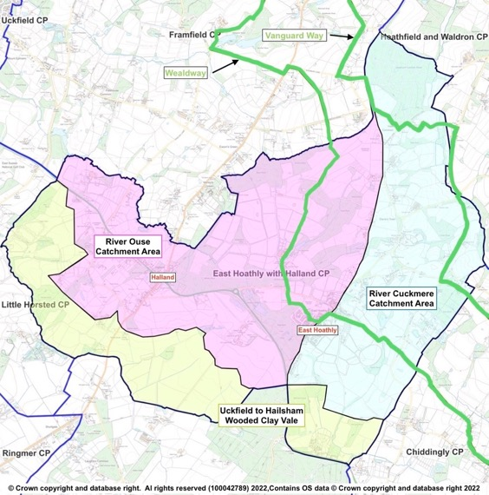

Figure 8 – WDC Landscape Character Assessment 2022 - Characterisation of Parish

a. Wooded Clay Vale (Zone 3)
The Landscape Character Assessment describes this area as a low-lying landscape, crossed by the narrow river valleys of the Uck and its tributaries in the west and the Cuckmere in the east. The landscape supports a patchwork of arable and pastoral fields, interspersed with areas of woodland, much of ancient origin, and more extensive mixed plantations. Scattered linear settlements and farmsteads are strung along the rural road network.
b. High Weald – Ouse Catchment (Zone 6D)

The Landscape Character Assessment describes this area as a rolling landscape of ridges and valleys containing the River Ouse and its tributaries that drain south-westwards from Ashdown Forest and the Central High Weald into Lewes District. A wooded landscape with an intricate pattern of small irregular fields, streams and small, historic ridge-top settlements. This categorisation is slightly confused. Within the Parish, the watercourses that drain to the North East and along the northern boundary of the Parish, all flow into the River Uck rather than directly into the River Ouse and the Landscape Character Assessment describes the River Uck Catchment area as being in Zone 3.

c. High Weald – Cuckmere Catchment (Zone 6E)
The Landscape Character Assessment describes this area as a rolling landscape of ridges and valleys containing the River Cuckmere and its tributaries that drain south from the Central High Weald into the Low Weald. A wooded landscape with a pattern of small-scale irregular fields, streams and historic ridge-top villages.
83. The Landscape Character Assessment produced guidelines for each Zone to recommend how the landscape can be managed to ensure future change respects local character. Any proposed development should conform to all the guidelines specified in the Landscape Character Assessment but the key guidelines relating to the Parish landscape are:

a. Wooded Clay Vale (Zone 3)

Retain and enhance the biodiversity of watercourses and their associated wetland habitats by minimising water pollution from agriculture through sensitive land management practices, including restoration of buffer strips along watercourses to minimise run off.

Conserve and manage the streamside woodlands and copses, conserving and restoring riverside vegetation and wetland habitats, to ‘slow the flow’ and increase biodiversity.

Improve the connectivity of woodlands across the area through tree planting and hedgerow corridors.

Protect and manage the existing hedgerow network, and plan for restoration and linkages between hedgerows, including planting hedgerow trees to increase biodiversity and connectivity. Encourage the conservation of historic field patterns and boundary features.

Conserve the dispersed rural settlement pattern, encouraging the use of local materials, to maintain a strong local identity. Use woodland or tree planting to screen development on the edge of settlements.

Ensure existing public rights of way and public access within woodlands are maintained and explore opportunities for new pathways extending from urban areas. Plant wooded corridors along footpaths, such as the Vanguard Way and the Wealdway.

Maintain the rural character of the landscape away from the large urban areas, retaining tranquillity and dark skies where present.

Retain and where possible enhance long views to the South Downs and High Weald, which form a strong backdrop to the landscape and provide a sense of place in the landscape. Any new developments should consider intervisibility with the South Downs and High Weald.

b. High Weald – Ouse Catchment (Zone 6D)

Monitor water quality in the rivers and streams. Minimise water pollution from agriculture through sensitive land management practices, including regenerative agricultural systems such as no or minimal till, holistic grazing, reduction or removal of chemical inputs, cover crops and restoration of buffer strips along watercourses and field ponds, to minimise run off in order to maintain the biodiversity of wetland habitats.

Protect and manage the existing hedgerow network, and plan for the restoration of, and linkages between, hedgerows, including establishing hedgerow oaks, to maintain habitats.

Maintain and restore links between the numerous woodlands in the area, other woodland habitats (such as hedgerows and parkland), and species-rich habitats such as wet meadows, unimproved grassland and heathland to create a robust network of woodland and open semi-natural habitats.

Limit the amount and scale of development in rural areas, protecting the existing low-density settlement pattern of dispersed rural villages, hamlets, and scattered farms, and the separation between these different settlement types.

Extend woodland around settlements and infrastructure development to filter light pollution and soften the visual impact of further urbanisation.

Protect long views to the wooded Central High Weald to the North and east and to the distinctive ridge of the South Downs to the South.

Maintain the strong scenic qualities of the landscape and its sense of remoteness, tranquillity and experience of dark skies.

c. High Weald – Cuckmere Catchment (Zone 6E)

Safeguard ancient woodland and protect and enhance vulnerable woodland habitats including gill woodlands and wet woodlands for the benefit of biodiversity and the landscape structure.

Protect and manage the existing hedgerow network, and plan for the restoration of, and linkages between, hedgerows, including establishing hedgerow oaks, to maintain habitats.

Maintain and restore links between the numerous woodlands in the area, other woodland habitats (such as hedgerows and parkland) and species-rich habitats such as wet meadows and unimproved grasslands, to create a robust network of woodland and open semi-natural habitats for the benefit of biodiversity and to contribute to an integrated green infrastructure network.

Limit the amount and scale development in rural areas, protecting the existing settlement pattern of dispersed rural villages, hamlets and scattered farmsteads, and the separation of these different settlement types.

Retain the characteristic contrast between areas of enclosed character and long open views to the Pevensey Levels, South Downs and landmark church towers.

Maintain the strong scenic qualities of the landscape and its sense of remoteness, tranquillity and experience of dark skies.

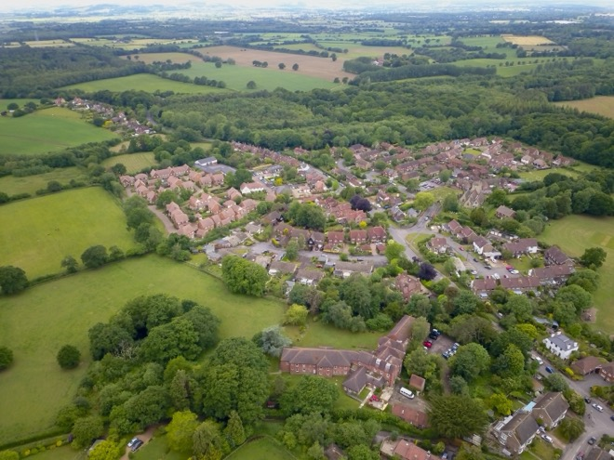
Proximity of woodland and open countryside to East Hoathly

84. The close proximity of open fields and ancient woodland to the very heart of our villages provides a strong sense of connection to nature and the wider landscape of this part of East Sussex, including unspoilt long-distance views to the South Downs. The roads entering East Hoathly have attractive wide and open verges that creates a sense of anticipation as the village is approached.

85. Parish Surveys and the Consultation Process of this Plan have identified a strong feeling within the Parish to preserve the rural village character and setting. It is the principal reason why people have enjoyed living in the village for so long and is why many came to live here in the first place.

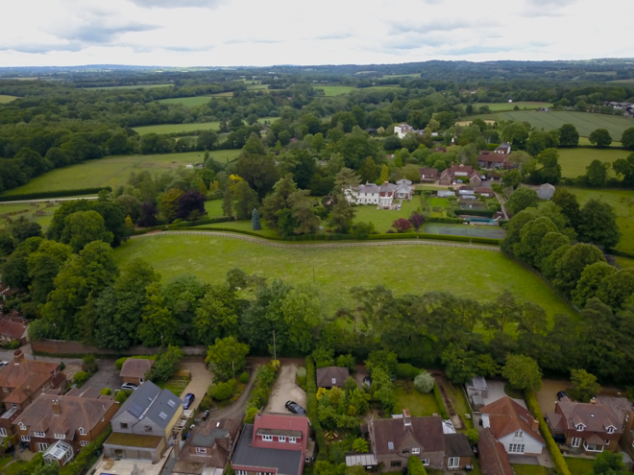
North End of Conservation Area towards Hesmond’s House and Belmont

86. Much of the Parish is agricultural farmland. Much of this is registered as part of Countryside Stewardship Scheme, Environmental Stewardship Scheme and the Organic Farming Scheme. These schemes are designed to enhance the environment and biodiversity and the current land under these schemes is shown at Annex H.

87. The Natural Environment surrounding the built areas is a mix of woodland, hedgerows and agricultural fields all interwoven with a network of waterways and ponds that provide a rich haven for biodiversity and is a constant reminder that this is a rural village.

Woodlands, Trees and Hedgerows

88. The Parish is liberally scattered with woodland which accounts for 22% of the area of the Parish. A significant proportion of this woodland is designated as Ancient Woodland and this makes up 72% of all the woodland in the Parish.

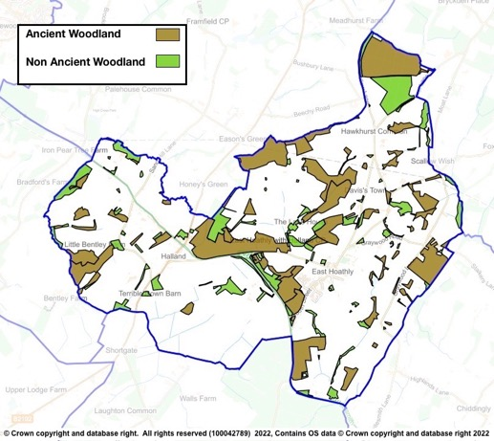
Figure 9 - Parish Woodland

89. In addition to the large amount of woodland, there is also a large network of hedgerows that have still not been fully surveyed. Many of those that have been surveyed are recorded as Species Rich. The most important of these hedgerows are those that connect with Ancient Woodland as they provide vital transit corridors for wildlife. There are many large woodlands in the Parish, but also many of the very important smaller Ghyll and Shaw woodlands that are in particular need of protection. The Ancient Woodland, Ghyll Woodland, Orchards, Veteran Trees and trees protected by Tree Preservation Orders are shown at Annex I. The surveyed hedgerows in the Parish are recorded at Annex J. It is intended to continue the hedgerow surveys.

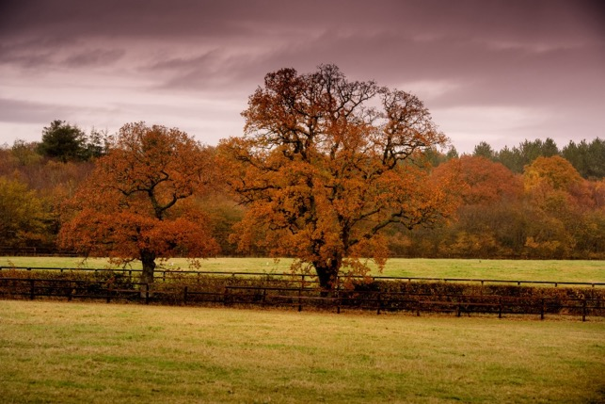

View of Parish Landscape with Woodland, Hedgerows and Trees

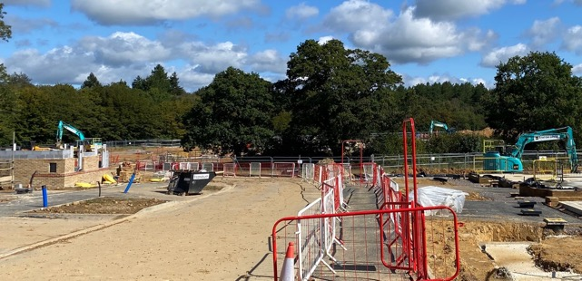

The Changing Parish Landscape

90. Trees and hedgerows should be incorporated into all development proposals to create a rural and peaceful ambience and to allow the development to blend into its surroundings. Trees provide Climate Change mitigation and new developments should consider tree lined streets, parks and community orchards in their planning (NPPF 2023, Paragraph 136). Care should be taken when using tree and hedgerow planting as screening so that it does not detract from skyline or distant views both into and out of the development site.

Waterways and Ponds

91. The waterways, ponds and ditches in the Parish feeds the River Cuckmere to the South and River Uck to the North. This waterway network is vitally important in draining the agricultural land to make it workable and to prevent the flooding of the built environment. It is also a haven for wildlife and provides habitats for a wide range of plants.

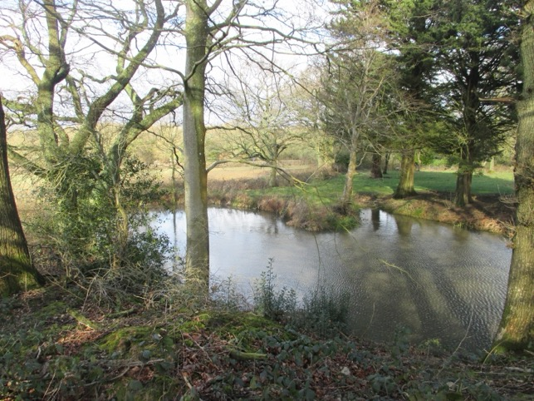

View of Parish Landscape with Pond

92. The WDC Landscape Character Assessment 2022 identifies the importance of maintaining the water quality in ponds and watercourses in the differing landscapes of this Parish. It is important that development in the Parish does not damage the quality of water in these important river catchment areas.

93. The discharge of sewage into watercourses is a particular concern in this Parish. Figures from the Rivers Trust in Table 9 show the very high frequency and duration of storm overflows. The Government Storm Overflow Evidence Project states in the Executive Summary Background Section that “overflows are designed to operate infrequently and as the result of heavy rainfall and this is the basis of their environmental permits”. The report fails to define what heavy rainfall is. Many people believe that the environmental permits should not allow water companies to continue with this practice.

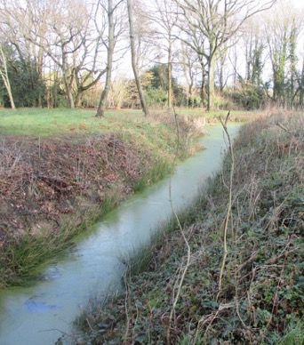

View of Parish Landscape with Drainage Ditch

94. The Meteorological Office does not define what amounts to “heavy rainfall”. However, it does record data for days when rainfall exceeds 1mm, these are defined as a “wet day” as opposed to a “dry day” when less than 1mm rainfall occurs. The wettest days recorded in South East England were 2020 – 43mm, 2012 – 24mm and 2022 – 28mm. A conservative assumption might be to consider “heavy rainfall” as exceeding 8mm in 24 hours. This is also shown in Table 6 in order to contrast the sewage discharges against days that could be regarded as “heavy rainfall”. This clearly shows that sewage is being discharged at both Treatment Plants far more often than when “heavy rainfall” occurs.

Table 6 - Sewage Discharges into Watercourses
Sewage Treatment Plant | Year | Halland | East Hoathly | Days in year where rainfall exceeded 1mm | Days in year where rainfall exceeded 8mm
Settled Storm Overflows | 2020 | 112 | 41 | 132 | 32
 | 2021 | 119 | 46 | 122 | 23
 | 2022 | 97 | 35 | 108 | 26
Hours Overflowing | 2020 | 2045 | 416
 | 2021 | 1906 | 593
 | 2022 | 1712 | 416

Biodiversity

95. The Government have now passed into law the Environment Act 2021 which will require new development to leave nature in a measurably better state than beforehand. Developers will need to use the Natural England Metric 3.0 (or any subsequent version) to calculate and provide evidence to show that they have achieved the required biodiversity net gain requirements. It is expected that this will require a minimum 10% biodiversity net gain on the undeveloped site.

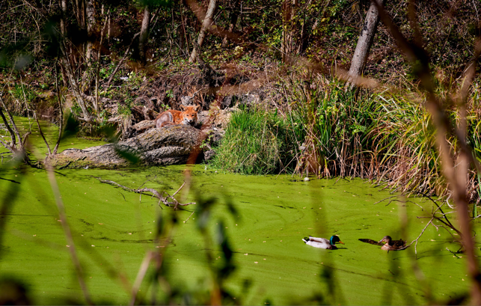

Residents of Long Pond, East Hoathly

96. One of the most effective ways of improving biodiversity is re-wilding areas that have been used for agriculture. The area for re-wilding has its internal fences and boundaries removed/opened-up and then left for nature to re-occupy. Self-seeded plants and trees are allowed to emerge and the result is usually an immediate and spectacular improvement in biodiversity. These areas can appear to be untidy to people accustomed to seeing trimmed hedges and uniform crops. However, these farming vistas often contain very little biodiversity especially if they have been treated with pesticides and herbicides. The variety and density of plant life and the insects and animals that can be supported is significantly greater on an area of land subject to re-wilding.

97. Re-wilding is supported by Natural England as one of the ways of achieving the minimum 10% biodiversity net gain. If a developer proposes to make use of re-wilding in order to achieve the minimum 10% biodiversity net gain, then it will be important that the proposed re-wilding site is appropriate within its wider setting. In order to limit any adverse reaction to the appearance of re-wilding, it is proposed that if potential re-wilding sites are adjacent to main settlements they should be suitably screened. Whenever possible, re-wilding sites should be connected by wildlife corridors to other wildlife habitats.

98. The Sussex Biodiversity Record Centre has recorded 51 species that are red listed (in England or Great Britain) indicating that they are under
threat of extinction and one species of rabbit that is on the global red list. In addition, 32 species are identified as Priority Species in the UK Biodiversity
Action Plan. In total there are 26 internationally designated species, 86 nationally designated species and 175 species with some other designation,
mostly indicating that they are scarce in England or rare in Sussex.

99. However, these records note that they are not comprehensive and acknowledge that significant gaps exist in their records. A measure of how much is being added to the biodiversity records can be assessed by comparing the current report to the previous report from 2017. In 5 years the records show an increase in recorded species that are protected and designated from 115 to 175, an increase of 52%.

100. Some of the rare and protected species that live in this area are skylark, nightingale, 15 species of bats, water vole, common toad, great crested newt, pearl-bordered fritillary butterfly, wasp spider, brilliant emerald dragonfly, dormouse, polecat, adder, grass snake and slow worms. There are several Badger setts recorded in the Parish. Badgers and deer regularly visit local gardens and in recent years, Buzzards and Red Kites are frequently seen in the skies above the Parish.

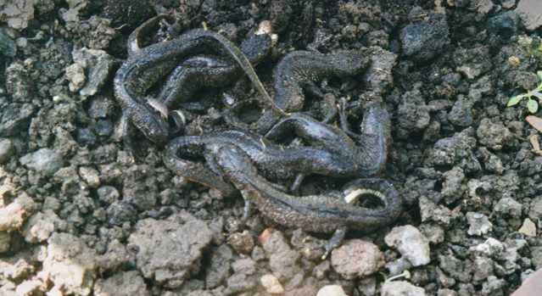
Six Great Crested Newts found sheltering
under a Seed Tray in East Hoathly

101. One of the protected species present in our Parish is the Barn Owl with 5 nesting sites currently known. The mix of woodland, hedgerows and open countryside is the perfect environment for these endangered birds and all planning applications must ensure that they will not cause harm to the Barn Owls, their eggs or nests. This is particularly important during the nesting period when it is an offence to disturb them whilst they are nesting, building a nest, or to disturb them whilst they are in or near a nest that contains their young or to disturb their dependent young.

102. The following sites have been recorded with special biodiversity significance:

a. Park Corner Heath - A Site of Special Scientific Interest which is adjacent to the southern border of the Parish.

b. Moat Wood - An area of Ancient Woodland and a Medieval Moat which is a Scheduled Monument. Part of this land was purchased by the Parish Council and the management of the land passed to the Woodland Trust.

c. Croom Cottage Meadow - A Local Wildlife Site (LWS) with rare wild flowers and orchids.

d. Halland - Wildlife Verge with orchids and wildflowers (ESCC Wildlife Verge Ref 2/46/30).

e. Long Pond - A breeding pond for Great Crested Newts.

103. The Consultation Process of this Plan identified a strong feeling within the Parish to preserve and enhance our existing Natural Environment. This section has examined the place of this Parish within the wider Wealden landscape of green infrastructure and blue infrastructure. It has looked more specifically at the importance of woodland, hedgerows and trees in our landscape and the network of ponds and waterways in the Parish. The biodiversity that exists in this landscape is significant, much of it is protected, some of it is rare and endangered. EHHNP Policy 6 sets out measures to protect and enhance this Natural Environment.

EHHNP Policy 5 - Natural Environment

P5.1 Relevant Proposals for new development must deliver a minimum overall net gain in biodiversity of 10% above the ecological baseline. Those that exceed the minimum will be encouraged and supported.

P5.2 Biodiversity net gain must be provided on-site wherever possible. Where it can be robustly demonstrated that on-site provision is not possible, suitable off-site provision will be sought.

P5.3 All development proposals must follow the mitigation hierarchy when considering the impacts and potential harm of development on biodiversity and the natural environment:

a. Avoid harm/impacts in the first place; then

b. Adequately mitigate any residual harm/impacts; and then

c. Compensate (as a last resort) for unavoidable harm/impacts.

P5.4 If significant harm cannot be ruled out through the mitigation hierarchy, development proposals will not be supported.

P5.5 Development proposals that seek to conserve biodiversity will be supported where they:

a. Protect existing Ancient Woodland, Ghyll Woodland, ancient trees and veteran trees; and,

b. Protect species rich hedgerows, particularly those that connect to Ancient Woodland; and,

c. Avoid loss or damage of Woodland, Trees; and,

d. Avoid loss or damage of hedgerows; and,

e. Avoid loss of ponds and streams; and,

f. Provide surface water disposal from sites in accordance with the national surface water drainage hierarchy and the East Sussex SuDS drainage hierarchy.

P5.6 Development that seeks to enhance biodiversity will be supported if they enhance public access to nature and incorporate such things as:

a. Create new woodlands, hedgerows and ponds; and,

b. Creation of new wildlife habitats; and,

c. Connect and enhance existing wildlife habitats; and,
d. Provide opportunities for gardening, wildlife and food production within existing and new residential areas, including the utilization of underused roadside verges for wildlife habitat, where it is safe to do so; and,

e. Plant trees.

Dark Skies

104. NPPF 2023 (Paragraph 191c) requires that new development should “limit the impact of light pollution from artificial light on local amenity, intrinsically dark landscapes and nature conservation”. Wealden District has the darkest skies in the South East of England and this should be preserved. Dark skies are hugely beneficial to nocturnal wildlife and of significant importance to those people who enjoy the night sky. The Neighbourhood Plan consultation process recorded the desire of many people to maintain the existing benefits of the Dark Skies of the Parish.

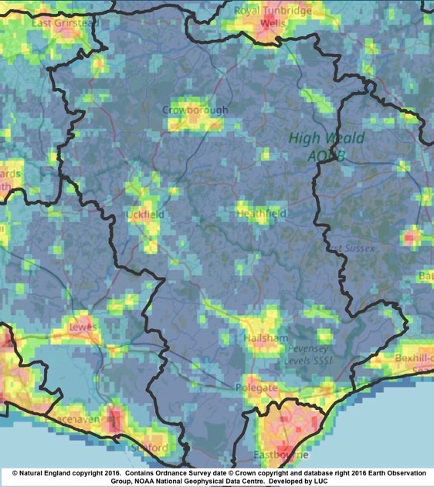

Figure 10 - Wealden District Light Pollution
Wealden is the 20th darkest of the 326 districts in England. It is the darkest in the South East (Kent, Sussex, Surrey, Hampshire, Buckinghamshire and Oxfordshire)

105. The Parish currently has highway lighting on the A22 at the Halland roundabout, the Shaw Roundabout and the junction with South Street. Within East Hoathly there is very limited street lighting on the High Street extending to the beginning of the London Road and Waldron Road. There is also low-level lighting in the Juziers Drive/Trug Close development. Many residents feel that additional street lighting and security lights to new and existing developments should be resisted. Some people believe that street lighting and security lights are required to improve safety and reduce crime. However, a study by the London School of Hygiene & Tropical Medicine and University College London, in the Journal of Epidemiology and Community Health, reported on their analysis of 14 years of data from 62 councils in England and Wales, that there was no evidence of a link between reduced street lighting, crime and night-time vehicle collisions. The design and layout of new developments should be planned carefully to minimise the impacts of any lighting schemes and be subject to planning conditions to minimise/prevent light pollution. Figure 11 shows the currently low levels of light pollution (with the exception of the A22 lighting) in the Parish.

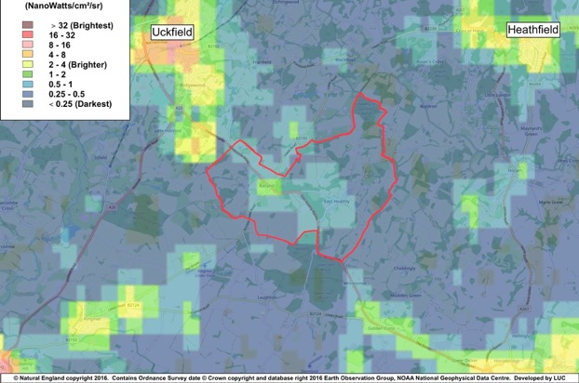
Figure 11 - Dark Skies Map showing relative darkness of Parish

106. New development should not cause the light levels recorded by CPRE to be exceeded and the Parish should seek to reduce the existing light levels by reviewing the choice of lighting in public places, the timing of its operation and providing guidance to homeowners to limit their light pollution by such measures as correctly directed lights that are controlled by timing devices. Developers should make every effort to limit light pollution for new developments and in particular to not allow light to be radiated upwards where it adds to light pollution but adds nothing to visibility on the ground. They should strive to not allow new developments to worsen the existing levels of light pollution. The Institute of Lighting Professionals Guidance Note 01/21, The Reduction of Obtrusive Light, gives guidance on this matter.

EHHNP Policy 6 - Dark Skies

P6.1 New development must clearly demonstrate that all opportunities to reduce light pollution have been taken with a particular focus on preventing sky glow from light radiating upwards.

P6.2 Development proposals will be supported where they limit light pollution and developers should strive not to allow new developments to worsen the existing levels of light pollution.

EHHNP Aspiration 4 – Dark Skies

A4.1 This Parish seeks to reduce the existing light levels by reviewing the choice of lighting in public places, the timing of its operation and providing guidance to homeowners to limit their light pollution by such measures as correctly directed lights that are controlled by timing devices.

The Importance of Greenspaces

107. Greenspaces can provide social, environmental and economic benefits in a neighbourhood. Greenspaces provide access to the natural environment and help mental health and wellbeing. They provide the opportunity of increased physical activity for all ages and abilities with the resulting physical health and mental wellbeing benefits. The Locality guide on Local Green Spaces identifies the following community and environmental benefits of greenspaces:

“a. Being part of the public realm, where informal social interaction can take place.
b. Providing pitches and facilities for sports and supporting physical activity
c. Forming part of a network of paths and spaces, enabling movement through an area
d. Providing habitats for wildlife and natural corridors and spaces through urban areas
e. Providing flexible space for recreation, local cultural events and performance
f. Adding to local amenity, providing an attractive setting and outlook for surrounding residential and commercial properties
g. Forming part of the character or setting of historic areas, buildings and townscape
h. Forming part of flood mitigation, such as SUDS
i. Providing areas and opportunities for growing local food”.

108. The Locality Guide also recognises the importance of greenspaces by stating “Green spaces contribute to quality of place, together with buildings, urban spaces and the wider public realm. Quality of place is a key factor in attracting investment, jobs and growth to an area. It is also important in making an area an attractive place to live, work and spend leisure time. So green spaces have real economic value to the surrounding area, in addition to supporting healthy lifestyles and community-wellbeing”. Maintaining greenspaces and improving accessibility for all ages and abilities is important. It is also important to improve the connection of greenspaces throughout the community.

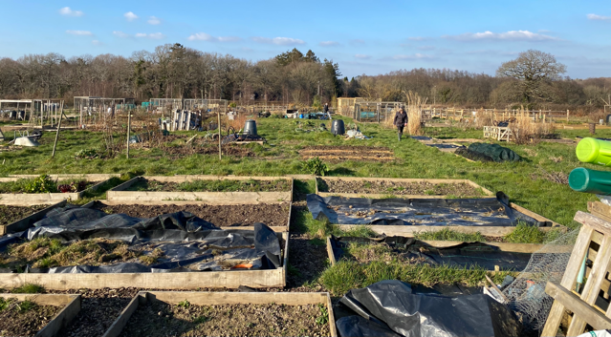
East Hoathly Garden Plots - allowing people to grow their own food

109. The WDC Open Space Report 2022 indicates, in the Parish Area Summary, that the available amenity greenspace in the Parish should be 9,464 m², whereas only 1,200m² is provided. It also rated both amenity greenspace sites as below the quality threshold. In addition, it rated the Parish’s Natural and Semi-Natural space as being of low quality.

110. Policy WCS 13 of the WDC Core Strategy LP 2013, states that “All new residential development will be required to contribute to the green infrastructure network and where appropriate to make provision for new or enhancement of existing open space. Where the scale of development would be too small to make on-site provision, the Council will seek developer contributions either towards the improvement of existing open spaces or towards the provision of open space elsewhere”. The Parish would like the flexibility to request that some new developments forego the addition of children’s play equipment in favour of using that part of developer contributions towards the improvement of existing open spaces and play equipment.

Local Green Space

111. Greenspaces that are of particular importance to local communities can be designated as part of a Neighbourhood Plan as a Local Green Space. The NPPF 2023, Paragraph 106, requires that the “Local Green Space designation should only be used where the green space is:

a. In reasonably close proximity to the community it serves;

b. Demonstrably special to a local community and holds a particular local significance, for example because of its beauty, historic significance, recreational value (including as a playing field), tranquillity or richness of its wildlife; and

c. Local in character and is not an extensive tract of land”.

112. During the Consultation Process of this Plan the public made it very clear that they placed great importance on the greenspaces within the built environment and surrounding it. They were asked to prioritise those areas that they most valued and 20 potential Local Green Spaces were identified. The details of the potential sites are included in the Local Green Space Assessment which has been published separately. They are assessed against the criteria set out in Paragraph 106 of the NPPF 2023. Five of these potential Local Green Spaces were subsequently rejected by the Parish Council.

113. Following the examination of the NP, 13 LGS are designated in Policy 7.

EHHNP Policy 7 - Local Green Spaces

P7.1 This Parish designates the following locations as Local Green Spaces as shown on the Policies Map for East Hoathly and the Policy Map for Halland. Development on these local green spaces will not be supported other than in very special circumstances (as specified in the NPPF paragraphs 152 to 156):

a. Local Green Space 1 - East Hoathly War Memorial Sports Ground

b. Local Green Space 2 - East Hoathly Garden Plots (Allotments)

c. Local Green Space 4 - Long Pond

d. Local Green Space 6 - Juziers Play Area

e. Local Green Space 7 - Juziers Drains/Swales

f. Local Green Space 8 - Church Marks Lane Lawn

g. Local Green Space 9 - Nightingales Play Area

h. Local Green Space 10 - Nightingales Lawn

i. Local Green Space 11 - East Hoathly Churchyard

j. Local Green Space 12 - School Field

k. Local Green Space 13 - Church Marks Green

l. Local Green Space 14 - Croom Cottage Meadow

m. Local Green Space 20 - Halland Chapel Burial Ground

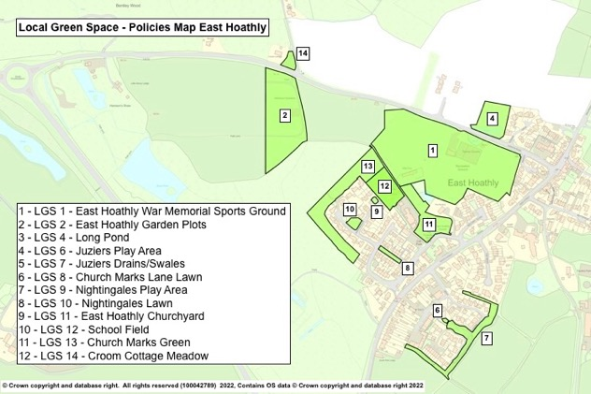

Figure 12 – Local Green Space – Policies Map East Hoathly

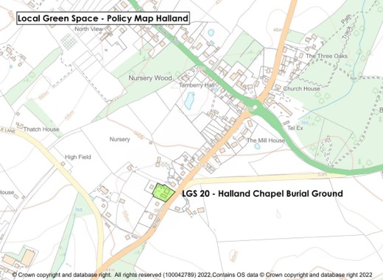

Figure 13 – Local Green Space – Policy Map Halland

SECTION 7 – HEALTH AND WELLBEING

114. The Health and Wellbeing of the residents of our Parish is at the forefront of our thinking in relation to the Neighbourhood Plan. This Section covers such matters as Physical Fitness and Sport, Recreational Activities, Social Groups, Arts and Crafts, Spiritual Health and Medical Facilities. It encompasses all ages from cradle to grave and includes consideration of our residents’ pets and animals.

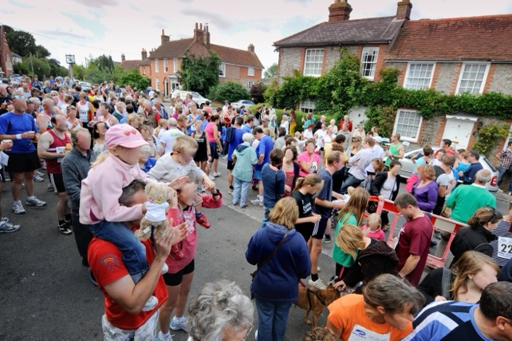
Kings Head Canter - Fun Run

115. Health and Wellbeing can be affected by many factors and living in a rural environment is generally considered beneficial. However, there is potential for isolation (particularly for the elderly) causing mental stress often leading to mental and physical illness. Living in rural villages surrounded by nature is uplifting for most people and retaining the links to the countryside is an important factor in maintaining the Health and Wellbeing of residents.

116. It is important that developments are designed to encourage opportunities for people to meet each other. This social interaction can have hugely beneficial effects on Health and Wellbeing. Cul-de-sacs with no through routes are less useful in creating opportunities for people to meet each other. The incorporation of seating areas into developments that are on
the main through routes is another important consideration to improve the potential for meeting people.

117. Development sites closest to community facilities, shops, pubs and GPs should be prioritized for retirement homes.

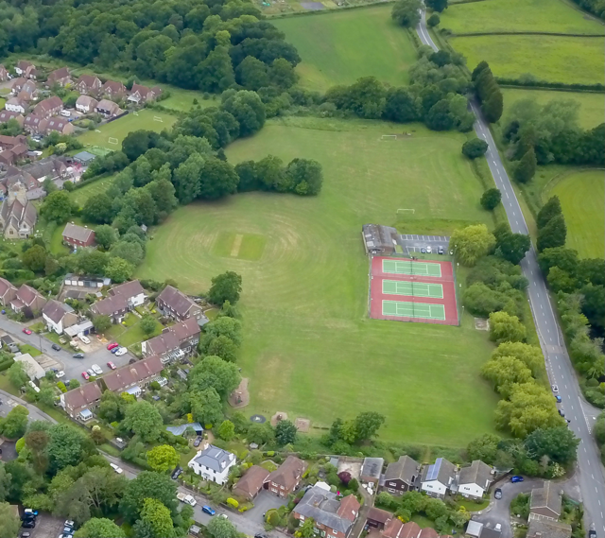

East Hoathly War Memorial Sports Ground

118. Paragraph 109 of this Plan has already noted the deficiencies in the quality of natural and semi-natural space and both the significant lack of amenity greenspace and its low quality. This deficit has an adverse effect on wellbeing. New developments should provide the right amount and type of open space and recreational facilities to provide opportunities for people to improve their health and well-being.

119. The key facilities that the Parish controls to enhance the Health and Well-being of parishioners are the War Memorial Sports Ground, Pavilion and Village Hall.

Sports Ground

a. The War Memorial Sports Ground Trust was established in 1947 after the purchase of the 4 Hectare site with the proceeds of a War Memorial Fund. The Conveyance stipulates that the land must not be used for any other purpose than as a sports and recreation ground for the benefit and use of the Parish. East Hoathly Parish Council became the Trustees in 1952 and the Trust was registered as a charity in 1963. The Sports Ground is central to the sporting life of our community and also for many recreational activities including annual events such as Midsummer Magic and Carnival Night. It has also been the venue for Dog Shows, Fetes and Flower Shows. It is currently home to:

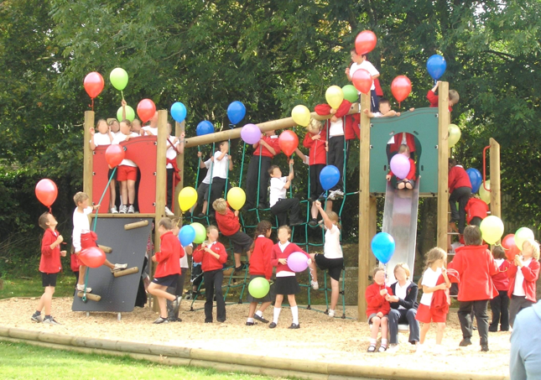

East Hoathly Sports Ground - Play Area

(1) East Hoathly Tennis Club (Three floodlit courts).

(2) East Hoathly Cricket Club.

(3) Children’s Play Area.

(4) Basketball Hoop.

(5) East Hoathly Rifle Club.

(6) Occasional use by visiting Cycle Club.

b. The Sports Ground is badly drained and often waterlogged in winter conditions. The lack of playable conditions led to the demise of the East Hoathly Football Club and it is unlikely that this will start again without improvements to the drainage. The possibility of the level of the football pitch area being raised by infilling the area with waste soil has been examined.

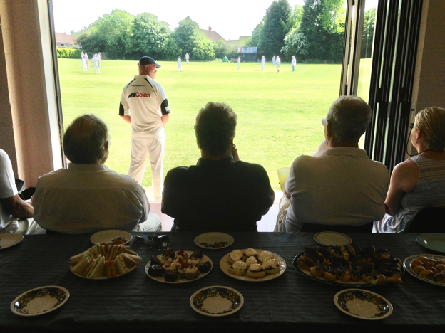

East Hoathly Cricket Club

Pavilion

c. The Pavilion is situated on the War Memorial Sports Ground and is part of the War Memorial Sports Ground Trust. The Pavilion was built in 1980 and is of simple brick construction within a steel agricultural style framework with an asbestos roof. It is now in poor condition, energy inefficient, with inadequate shower and changing facilities for players and officials. The Pavilion has one changing room large enough for a football team with showers and one toilet. The second changing room is only large enough for half a football team with a very small shower and no toilet. If mixed gender teams are playing there is no capacity to have separate changing facilities. There are no changing facilities for officials. The building was not designed to cater for disabled people or wheelchair access. Disabled facilities are limited to one toilet.

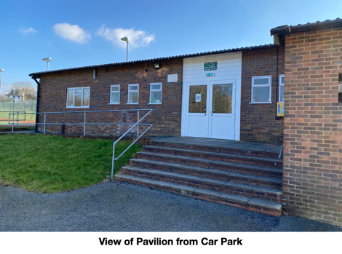

Village Hall

d. The Village Hall was built in 1926 and is essentially of wooden construction with the addition of a brick extension at the front. It is generally in good condition although is somewhat dated and not energy efficient. The Village Hall has a wide range of users in addition to its use for private functions:

(1) Village Playgroup.

(2) Preservation Society.

(3) Short Mat Bowls Club.

(4) Carnival Society.

(5) Parish Council.

(6) Show Society.

(7) Dance Club.

(8) Twinning Association.

(9) Drama Society.

(10) British Legion.

(11) School.

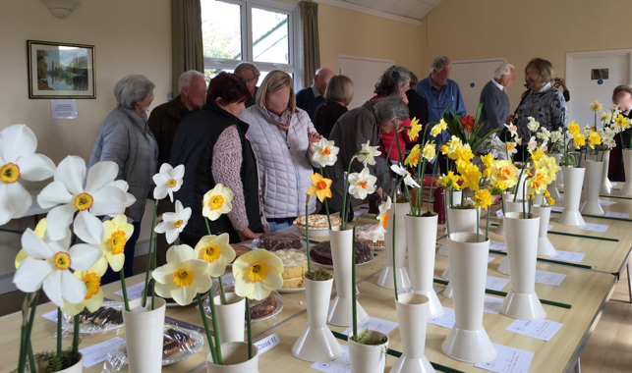
Show Society Event in Village Hall

120. There has been a long running aspiration that a new Pavilion is required in combination with improvements to the drainage of the Sports Ground. It has been suggested that one option is to replace the Pavilion with a new facility that incorporates the functions of the Village Hall. The Consultation Process of the Neighbourhood Plan and the Parish Survey sought the opinions of parishioners on the future of these facilities. The results of the consultation were:

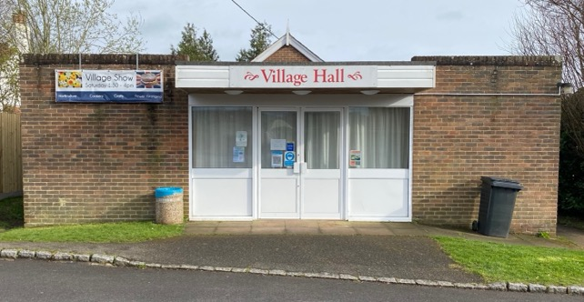

East Hoathly Village Hall

a. Option 1 - Replace the Pavilion and our Village Hall with a new building which incorporates the functions of the Village Hall

This option received 63% support, but many had significant reservations. The reservations were mostly concerned with funding and running costs being viable. Many groups were concerned that the facility should be capable of the widest range of activities to ensure that it was well used (e.g. Badminton, Netball, Stoolball, Dance, Gym, Disabled Access).

b. Option 2 - Retain Village Hall but extend Pavilion

This option received 58% support. It was only considered sensible if the football pitch was rectified and more use was likely. The retention of the Village Hall and its heritage was considered important and it was considered to have a good atmosphere.

c. Option 3 - Maintain existing Pavilion and Village Hall

This option received 42% support. The majority of people did not feel that the existing state of the Pavilion could be allowed to continue and this option therefore received the least support.

121. The Neighbourhood Plan Consultation and Parish Surveys identified a number of desires from parishioners to improve the recreational facilities available:

a. Indoor Badminton Court.

b. Stage.

c. Pool Table.

d. Improvement of the Football Pitch drainage to allow the Football Club to be re-started.

e. Space for a Youth Club.

f. Space for an Arts Club.

122. Halland has no publicly accessible communal open/greenspace, no meeting room and no recreational facilities. As Halland has grown in size with regular infill developments there is now a need to provide some facilities to help build the community.

123. The Parish has set up a Recreation Group which is creating a plan for the proposed improvements and changes to the Sports Ground. They will also be exploring the Options for a new Pavilion further with a view to putting forward a definitive plan in due course.

Medical Services

124. The East Hoathly Surgery was incorporated into the Buxted Medical Practice in 2001 (the Horam Medical Practice has also now been added to this combined Practice). For over a decade, the Surgery has suffered from a lack of GPs and this is now reflected in the combined Buxted Medical Practice. In the last few years, this has resulted in an increasing number of East Hoathly patients being referred to the main Surgery in Buxted. During the Covid-19 lockdown, the East Hoathly Surgery closed completely and all access was via Buxted. This declining access to medical services is of considerable concern for many parishioners.

125. A Neighbourhood Plan cannot take any action to improve this situation. The surgery is aware of the shortage in GP cover and is actively recruiting. The situation is replicated throughout the Medical Practices in the South East. This adversely affects the Health and Wellbeing of parishioners but it seems that no solution is on the horizon.

126. The Parish has three Defibrillators, one located at Buffalo Bill’s (formerly The Forge), Halland, one at the East Hoathly Pavilion and one at East Hoathly Medical Centre. There is also one just outside the Parish at Broomfield Farm Caravan Club Site, Stalkers Lane. Defibrillators save lives and it would be beneficial to have two additional units. One to be sited in East Hoathly that is accessible at all times. The second to be sited in Halland at the suggested location of Staverton Nursery. It would also be beneficial to have wider publicity of their locations and training opportunities for the public.

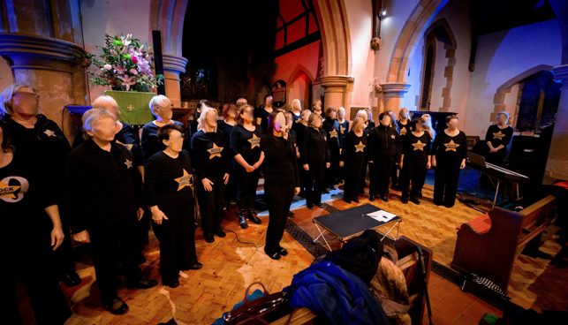
“Raise The Roof” Concert in East Hoathly Church

Arts and Crafts

127. There are many people in the community who are artists, writers, musicians, craftspeople or are in some way involved in the business of the arts and crafts. Most are amateur but some are professionals working as individuals or running a business from home. Many of them take part in exhibitions and performances in the Parish and elsewhere. The activities of these people enriches their own lives but also those of the wider community who can visit the exhibitions, performances and take part in courses and activity sessions.

128. There is no formal organisation of the Arts and Crafts community. The Consultation process of the Neighbourhood Plan revealed a desire for there to be some form of focus for this talented group of people. This might be some form of Craft Centre or a regular event that brings all their activities together. It should be noted that these activities generally require an indoor space.

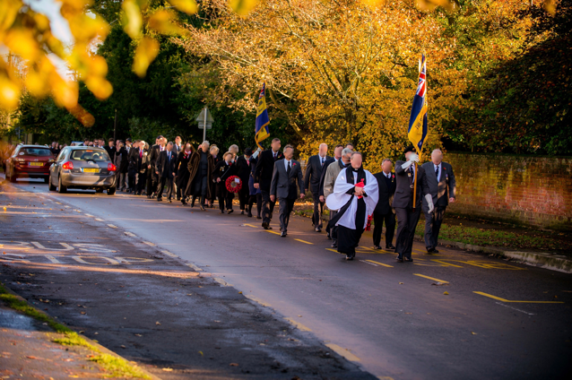
Church Remembrance Day Parade - East Hoathly

Spiritual Health

129. Spiritual Health can be supported in a variety of forms. Many people have their own philosophy and belief systems that sustain them and some people choose to follow an established religion. The Parish has two formal places of worship:

a. East Hoathly Church - This is a Church of England place of worship. Since 1983, it has been part of a United Benefice, sharing a Rector with Chiddingly Parish.

b. Halland Chapel - This is an Independent Calvinistic Church founded in 1886 and the Chapel was opened in 1892. In 1976, a Church Hall was erected. This Chapel attracts a congregation from outside the Parish.

c. It is known that parishioners also attend other places of worship outside the Parish such as Framfield Church (St Thomas à Becket Church of England - its ecclesiastic parish boundary includes a major portion of Halland) and the Baptist Chapel, Blackboys.



Carnival Night Firework Display above East Hoathly Church
130. Both places of worship have burial grounds and provide places for quiet reflection and remembrance.

131. Both churches are part of the community and in addition to their spiritual leadership they offer community support and activities that enrich the lives of those in the Parish. This can be through the use of the Church facilities for community activities or a supportive presence at many Parish events. The East Hoathly Church also has formal links with the East Hoathly Church of England School enabling it to spread its influence much more broadly into the community and our young people.

EHHNP Aspiration 5 - Health and Wellbeing

A5.1 This Parish seeks to improve the Sports Ground and upgrade the Pavilion.

A5.2 This Parish seeks to provide community facilities for the residents of Halland (preferably in the North West quadrant of the A22/B2192). The facilities that would be supported are as follows:

a. An open/greenspace with Children’s Play Area accessible by the maximum number of residents without the need to cross a main road.

b. A community hall/meeting place.

SECTION 8 - BUSINESS

Historic Perspective

132. Employment in the Parish has changed enormously over the centuries. In the 19th Century the Parish was an agricultural economy with significant reliance on agricultural labourers to work the land. The villages had a range of shops providing the goods and services required on a daily basis and these added to the employment opportunities in the Parish. Employment was also possible as servants and staff to the larger properties. The 20th century saw this employment model change completely.

133. The Parish remains a largely rural agricultural economy, but it now employs very few people. Most of the businesses that had been established in the Parish have now closed and the sites have been developed for housing. The Wealden LP 1998 proposed the protection and expansion of the business area to the East of South Street but by 2009 this had been developed as a mixed-use site with housing and a considerably reduced business area. Modern homes are now unlikely to employ staff and most of the shops and pubs have closed. Hence, the opportunities for employment in the Parish are now hugely diminished as can be seen in Chart 3. This shows a comparison of those employed in the Parish and those living in the Parish since 1861. In 1861 around 215 people lived in the Parish and 400 people worked in the Parish. This ratio changed slowly and by 1961 around 501 people lived in the Parish but only 200 people worked in the Parish. By 2011 this ratio had changed dramatically with 1600 people living in the Parish but a mere 99 employed in the Parish.

Figure 14 - Employment in Parish

Current Employment Model

134. The transition of this employment landscape into the 21st Century has seen an increasing number of people working from their homes using phone services and now increasingly internet access. In addition, there are an increasing number of people who are now self-employed and running their business from their home. This has resulted in new problems for the Parish:

a. The Broadband provision to the Parish is generally poor (see Paragraphs 143 to 147 of this Plan). The effect of poor internet provision is that it is difficult to run existing internet-based businesses without fast internet speeds and will not attract new business to the area who need fast internet speeds.

b. Mobile phone service is patchy for several service providers and this can be very frustrating for all users but is particularly problematic for businesses where communication is vital and often reflects poorly on the business itself.

c. Self-employed businesses often have an additional vehicle for the business and this has to be parked in the Parish. Paragraph 113 of NPPF 2023 recognises the need for overnight parking of lorries but this does not extend to self-employed business vans and vehicles. The parking allocation in modern housing developments does not allow for these additional vehicles and they usually end up being parked on the streets. This creates access problems, as the streets are not designed to have vehicles parked on them. The result is that they are commonly parked on the approaches to the village. Often these vehicles are large working vehicles and they are inappropriate in scale and appearance to park in residential areas.

d. The majority of employed people leave the Parish by car to get to work. The commuting is often lengthy and congested. This is bad for the environment and the health and well-being of everyone.

e. Several businesses, and those working from home, indicated that the frequency of Power Cuts is problematic for their businesses. Digital equipment was adversely affected and some businesses had freezer storage that sometimes resulted in loss and wastage.

135. Data from the 2011 ONS Census relating to our Parish shows that of the 1,236 residents (16+) in the Parish, 809 people had some form of work. This included full-time, part-time and self-employment. Of these employed residents, 76.4% used a vehicle to get to work and almost all of these journeys were outside the Parish.

Post Office

136. Feedback from local businesses and in particular many of those who run a business from home is that the Post Office is vital to their business. Many of these rely on dispatching orders by post and the Post Office has estimated that 69% of East Hoathly Post Office mail transactions are business related and 30% are business-banking transactions.

Centralised Delivery Hubs

137. The Parish is increasingly being visited by delivery vans as people’s lifestyles have changed and many more items are being ordered online for home delivery. Some of these items are then returned to the vendor which necessitates another vehicle to come and collect the item. Many delivery vans are large and diesel powered, precisely the sort of vehicles that should be dissuaded from coming into the Parish. They congest the roads, pollute the environment and frequently disturb residents when they cannot find the correct address. It is hugely inefficient for the businesses carrying out the deliveries and very bad for the environment. If the items ordered online were purchased in a retail centre, it is likely that it would be coordinated with other shopping and therefore does lead to a significant amount of traffic in rural areas. A solution might be to have centralised distribution hubs collecting deliveries from all suppliers so that deliveries to homes could be dramatically reduced.

Changes of Use and Permitted Development Rights

138. The Town and Country Planning (Use Classes) Amendment Regulations came into force on 1 September 2020. This introduced a new Commercial, Business and Service use called Use Class E. Use Class E comprises a wide variety of uses including retail, cafe, medical and health services, day nurseries, indoor sport and recreation facilities, offices and light industry that does not harm residential amenity. These businesses can now change use within Use Class E without planning permission. Under changes to the Permitted Development Rights, vacant and redundant office and light industrial buildings and other buildings in Use Class E, in certain circumstances, can be converted to residential use without planning permission (this would be subject to prior approval from the local planning authority). This could lead to a further loss of businesses in the Parish.

Tourism

139. It has not been possible to assess how important Tourism is to our Parish but many businesses benefit from it and it is generally believed to be important. Tourists visit the pubs and cafes and the East Hoathly Village Stores. Many of them stay at local Hotels, Bed and Breakfast establishments, Caravan Parks and Campsites.

140. Tourists visit East Hoathly because it is an attractive village with an interesting history and to enjoy the local walks, cycling and scenery. Many are also visiting other local attractions and venues. They therefore add to the local economy and the wider economy. It is important to provide the facilities they require whilst retaining the attractiveness that draws them here in the first place.

EHHNP Policy 8 - Business

P8.1 The loss of land or buildings currently in business use will be supported only if:
a. Permitted Development Rights apply; or,

b. It is demonstrated that the business is not viable and has been marketed for a period of 18 months at a realistic valuation for existing and other commercial uses. When the review of the submitted viability information by an independent consultant is considered necessary, the applicant will be required to cover such costs for the local planning authority.

P8.2 The EHHNP is keen to retain key employment sites (including care homes) within the Parish settlements. Any change of use from employment/commercial uses of these sites will need to comply with the provisions of this policy. The sites are:

a. Carriers Way, East Hoathly, BN8 6AG.

b. Village Works, East Hoathly, BN8 6QA.

c. Lydford’s Care Home, East Hoathly, BN8 6DR.

d. Staverton Nursery, Halland, BN8 6PU.

e. Halland Forge Motel, Halland, BN8 6PW.

f. Garage, Halland, BN8 6PS.

g. Halland House Care Home, BN8 6PS.

P8.3 The improvement and enhancement of the key sites listed in P8.2 above and other business uses, will be supported if:

a. There is no detrimental impact on neighbouring properties or the landscape or heritage assets; and,

b. Traffic generation is acceptable and there are adequate levels of parking on site or nearby; and,

c. It includes opportunities to support sustainable transport; and,

d. The design, materials, massing of the proposed extension/redevelopment plus any landscaping scheme can mitigate any impacts on the street scene and local amenities; and,

e. Extensions are located within the existing business curtilage.

P8.4 Proposals involving changes of use of ground floor premises from “town centre uses” to residential which are not permitted development will only be supported where it can be shown that the development would not harm the vitality of local shopping facilities or the amenities of the area.

P8.5 New housing developments that provide local employment in mixed residential and commercial developments or small-scale social enterprises or live work units are welcome, particularly where they reduce out-commuting, providing they:

a. They are limited to Business Use Classes E(g), F2(a) and F2(b); and,

b. Do not have a detrimental impact on the landscape; and,

c. Can be carried out in any residential area without detriment to the amenity of that area by reason of noise, vibration, smell, fumes, smoke, soot, ash, dust or grit.

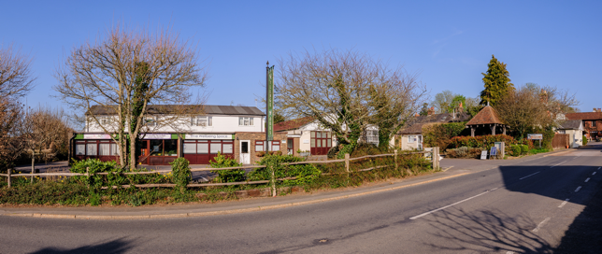

Village Works - East Hoathly

SECTION 9 – ACCESSIBILITY AND CONNECTIVITY

141. Rural villages in the modern world are in a fascinating position. They are increasingly separated from connections to local services such as shops and facilities, yet can be instantaneously connected to the world via the internet. The seemingly inevitable reductions in public transport to rural communities are perhaps being balanced by increasing broadband speeds. However, it remains important that accessibility to the things that sustain the Parish is maintained. Connectivity by phone and broadband can help to prevent isolation and thereby have an important impact on mental health and wellbeing.

142. Paragraph 2.14 of the WDC Core Strategy LP 2013 identified that “three quarters of small businesses in the District are farm based, often in former agricultural buildings converted to business space, and increasing numbers of people work from home …. the limited provision of high speed/capacity broadband in the District seriously restricts business development, particularly but not exclusively in the rural areas”. Paragraph 118 of NPPF 2023 clearly outlines the essential need for “advanced, high quality and reliable communications infrastructure”. This Parish is being let down in this respect. New developments are being permitted that will have fibre-optic high speed broadband provision whilst the already ill served existing parishioners will see no improvements.

Broadband

143. Broadband internet connection is now a fundamental part of modern living. It is the conduit for social networking, entertainment, online shopping, online education, research and business. It is increasingly the only viable way to book events, banking services, online utility accounts, access businesses, district council services, government services and medical services.

144. Broadband service is dependent on the physical infrastructure and the provision of cabling. Much of the Parish Broadband supply is by copper wire with some fibre-optic cabling to main junction boxes. Most of the cabling from the junction boxes into homes and businesses is copper wire. Most of the copper wire cabling is above ground and delivered into homes via telegraph poles. This copper cabling is much slower than fibre-optic cable and above ground cabling is inherently vulnerable to interference by weather and tree damage. Current Broadband Speeds:

a. Parish Survey - Average Download 36 Mbps

b. UK - Average Download 50 Mbps

c. Government Target by 2030 1000 Mbps

145. The Broadband provision to the Parish is generally poor, well below the UK average and currently only 3.6% of the 2030 Government target. The amount of data that can be fed into the main cables that supply the main junction boxes has a fixed limit. At any point in time, that data capacity is then shared out by all the current customers connected to that junction box irrespective of which company the customer uses to pay for their service. If another subscriber is added, then everyone gets a slightly smaller share. The result is that the broadband speed is decreased very slightly for everyone. The trend is for more subscribers making ever larger demands on a system that is already working beyond its capacity.

146 Service providers will eventually improve the capacity of the cabling to the junction boxes but rural parishes are likely to be at the back of the queue with preference given to the urban centres. It will also not address the issue of the unreliable and slow overhead cabling from the junction boxes to homes and businesses.

147. A scheme exists with funding for Community Fibre Partnerships and this is something that may benefit the Parish and should be explored by the Parish Council. It is also hoped to encourage developers of any new housing developments in the Parish to consider providing the same fibre-optic cabling to homes that are adjacent to the proposed new development. This gesture would compensate nearby homes for the disturbance of the building work and for the probable loss of views and privacy.

Mobile Phones

148. Mobile phone service is patchy for several service providers and this can be very frustrating for all users. The Ofcom assessment of Mobile phone coverage for this Parish supports this experience that the level of phone coverage is poor, particularly for receiving voice calls indoors. Only one service provider is shown to have adequate coverage to allow indoor calls to be received without “experiencing some problems”.

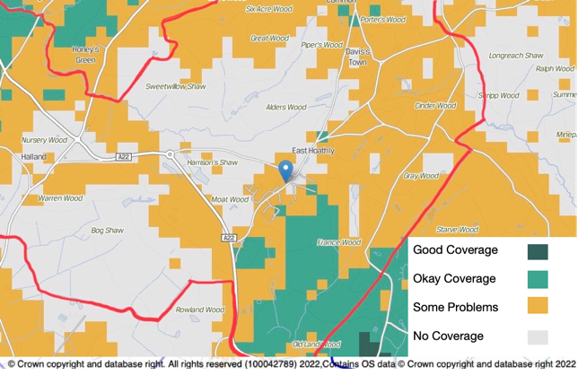

Figure 15 – Example of mobile phone coverage in Parish

149. The existing mobile phone coverage is generally 4G and the majority of people are likely to have a 4G enabled phone. 5G is now being provided by some service providers but this is only available in a limited number of larger towns and cities. There is no forecast of when rural areas will get 5G coverage. Improving the 4G coverage to allow reliable indoor service will require more mobile phone masts of greater power.

150. The safety of Mobile Phone Masts is a concern for many people and the UK Government has issued guidelines related to exposure and potential detrimental effects. The siting of any masts in the Parish is therefore of considerable concern and in particular if the site proposed is close to schools or housing.

EHHNP Policy 9 - Communications
P9.1 If planning permission is required for mobile phone masts, proposals to improve mobile phone coverage will be supported providing they are sited safely, sympathetically within the landscape and, where appropriate, camouflaged (in accordance with NPPF 2023 Paragraph 119).

EHHNP Aspiration 6 - Broadband

A6.1 The Parish will investigate the establishment of a Community Fibre Partnership to improve Broadband service.

A6.2 The Parish hopes to persuade developers, installing fibre-optic broadband cable to new developments, to consider providing the same fibre-optic cabling to adjacent homes.

Vehicles

Car/Van Ownership

151. Table 7 shows data from the 2011 Census comparing the Parish with Wealden District, the South East region and England. The highlighted text shows the significantly higher level of car/van ownership in comparison to the rest of England. It shows that the car/van ownership for the Parish is 1.8 per household compared to 1.2 in England. The percentage of households with 2 or more cars/vans in the Parish is 61.3% which is double the level of England and compares with 48.3% for Wealden District.

Table 7 - Cars/Vans per Household

Area | All homes | No  Cars/  Vans | 1  Car/Van | 2  Cars/Vans | 3  Cars/  Vans | 4 +  Cars/  Vans | All  Cars/Vans in area | No of Cars/  Vans per home
England | 22,063,368 | 5,691,251 | 9,301,776 | 5,441,593 | 1,203,865 | 424,883 | 25,696,833 | 1.2
 |  | 25.8% | 42.2% | 24.7% | 5.5% | 1.9%
South East | 3,555,463 | 660,430 | 1,483,911 | 1,059,380 | 253,552 | 98,190 | 4,803,729 | 1.4
 |  | 18.6% | 41.7% | 29.8% | 7.1% | 2.8%
Wealden | 62,676 | 7,801 | 24,608 | 21,416 | 6,091 | 2,760 | 98,259 | 1.6
 |  | 12.4% | 39.3% | 34.2% | 9.7% | 4.4%
East Hoathly with Halland | 620 | 39 | 201 | 268 | 76 | 36 | 1,127 | 1.8
 |  | 6.3% | 32.4% | 43.2% | 12.3% | 5.8%

152. Parish surveys show that the level of car/van ownership is even higher than that recorded in the 2011 Census. The Parish survey in 2016 showed a figure of 2.02 cars per household. Surveys carried out by counting the number of cars in the East Hoathly village during 2 nights in 2019 showed a level of 2.24 cars/vans per household. This seems to indicate a clear trend that car/van ownership is increasing in the Parish and also indicates an increasing level of car dependency.

Travel to Work

153. Table 8 shows Method of Travel to Work data from the 2011 Census comparing the Parish with Wealden District and the South East region. The highlighted text shows the significantly lower level of Public Transport usage in the Parish. It also shows the slightly higher level of dependency on vehicles to get to work at 81.2%.

Table 8 - Method of Travel to Work

Area | Total people who Travel to Work | Public Transport | Car/Van/Taxi/Motor Cycle | Cycle | Foot
South East | 3,762,813 | 327,233 | 2,844,304 | 127,614 | 463,662
 |  | 8.7% | 75.6% | 3.4% | 12.3%
Wealden | 63,682 | 6,539 | 50,666 | 717 | 5,760
 |  | 10.3% | 79.6% | 1.1% | 9.0%
East Hoathly with Halland | 702 | 48 | 570 | 7 | 77
 |  | 6.8% | 81.2% | 1.0% | 11.0%

Vehicle Dependency

154. The statistics from Tables 7 and 8 show the vehicle dependent nature of this rural parish and car dependency. There are arguments that the changing nature of modern life is reducing this car dependency with more people working from home and the use of home delivery reducing the need to travel to larger urban centres. However, these changes in modern life bring with them additional pressure on rural parishes from vehicles:

a. Every home delivery brings a vehicle into the Parish (often with a much larger vehicle than the car that would have done the job).

b. Home deliveries are now made for individual small items which might previously have been collected as part of a bigger shopping trip.

c. Deliveries of takeaway food is very limited in the Parish as most firms will not deliver to such locations but Individual meals can now be ordered from outlets such as “Dispatch” and always by some form of vehicle.

d. Supermarket home deliveries have increased, particularly during the Covid-19 pandemic, but this is not believed to have reduced the number of shopping trips made by most households and is expected to significantly reduce after the Covid-19 pandemic.

e. People who have chosen to work from home, rather than in an urban centre, now have to travel for shopping and leisure facilities whereas previously they may have incorporated this into their working travel.

Car Parking

155. The ESCC Guidance for Parking at New Developments 2024 recognises the increasing trend in car ownership. It acknowledges that poor parking design and inadequate space for manoeuvring can exacerbate parking issues. It recognises that tandem parking is rarely effective and leads to on-street parking. It states that dependant on location, only 19% - 45% of garages nationally are used for cars. All of this leads to new developments that have garages not used for cars and significant levels of on-street parking.

156. Car Parking is a problem in most of the Parish housing developments. Older developments were built in an era when car ownership was limited and the size of vehicles was much smaller than the modern vehicles now available. Many of these older developments were allocated communal garage areas (East Hoathly has 6 of these communal garage areas) but the size of these garages is now too small for many modern vehicles and the access is often narrow with very tight turning areas. This view is supported by the WDC Design Guide. The vehicles that should be garaged in them are therefore generally parked on the streets. This issue was also highlighted in the EHHNP Character Appraisal 2022.

157. Many parishioners also have the addition of caravans or other recreational equipment that takes up their allotted space and thereby forces them to park their cars on the streets.

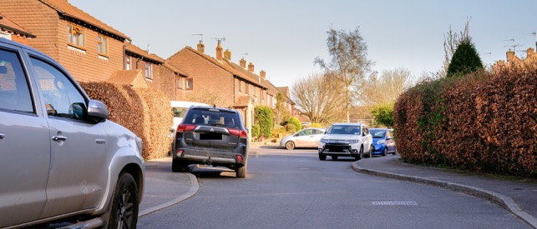

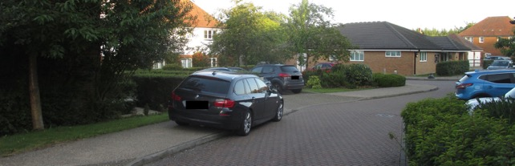

Examples of On-Street Parking in the most recent Parish Housing Developments

158. Parking for new developments is generally provided to the minimum standard set down by ESCC and these spaces are too small for many modern vehicles and too few for existing vehicle ownership. The result is more on-street parking. From an aesthetic perspective it also creates a very unappealing view of the places in which people live. Cluttered forecourts crammed with vehicles that spill out onto the roads and encumber the pavements.

159. The most recent developments in the Parish do not identify which parking spaces are allocated for visitors and all parking spaces are normally occupied. It is not possible to prove that the allocated visitor parking spaces are being used by visitors, but it is possible to assert that if you try to visit the new developments you are highly unlikely to be able to locate an empty visitor parking space. So, either residents are using the visitor parking spaces or, there are too few visitor parking spaces.

160. The space allocated for a parking bay is too small and for the average sized car, only leaves 63 cm between vehicles which is too narrow to open doors fully or gain entry without contortions. However, almost one third of all vehicles registered in the UK are SUVs (the largest category of car with an average parking gap of 53 cm). The result is more on-street parking. This is readily visible in our newest housing developments. WDC support the ESCC standards but this Parish wishes to note that these standards are inadequate.

161. Self-employed residents often have an additional vehicle for their trade and this has to be parked in the Parish. NPPF 2023, Paragraph 113 recognises the need for overnight parking of lorries but this does not extend to self-employed business vans and vehicles. The parking allocation in modern housing developments does not allow for these additional vehicles and they usually end up being parked on the streets. These are often large vans and this creates access problems as the narrow streets are not designed to have such vehicles parked on them. The result is that they are commonly parked on the approaches to the village. These large working vehicles are inappropriate in scale and appearance to park in residential areas.

162. The amount of parking provided for new developments is insufficient to cater for current vehicle ownership including work vehicles and leisure vehicles/trailers. This results in a high level of on-street parking. This causes accessibility problems for large service and delivery vehicles and this could be a serious problem for emergency vehicle access.

163. Visitors to East Hoathly have difficulty finding a place to park. There is a car park at the Pavilion and one on Church Marks Lane which serves the Village Hall, School and Church. Both car parks are intended for the use of the facilities by which they are located and not primarily for visitors to the village. It would be beneficial to have a visitor car park and the Parish Council are exploring possibilities of achieving this.

Streetscape

164. The visual appearance of the Streetscape is a very important factor in establishing the character of the place people live. This was frequently identified as an issue in the EHHNP Character Appraisal 2022.

165. Household waste collection has changed significantly in recent decades. The requirement to separate waste for recycling and the fortnightly collection of each type of waste means that there is a need for more bin space and storage space for household waste. The increasing amount of home deliveries of goods and corresponding increase in volume of packaging materials has exacerbated the amount of household waste. Many urban environments are blighted by a permanent frontage of properties with overflowing waste containers. The rural environment is less troubled by this but it is now evident in many of our developments. New developments should be designed to have adequate concealed waste storage for bins and packaging materials.

166. The supply of electricity and telephone cables to most properties in the Parish is by overhead supply and there is no fibre-optic cable provision into homes. This leads to a poor quality of provision. There are frequent power cuts (see Annex A, Paragraph 37) and broadband is often intermittent and slow. New developments should have underground supplies for electrical supply, telephone and fibre-optic cable.

Bus Service

167. The Parish bus services have been detailed in Annex A at Paragraphs 17, 26 and 27 of this Plan.

168. The ESCC Bus Service Improvement Plan includes an aspiration to add Sunday and evening services for Route 54 in Halland and East Hoathly (dependent on significant new funding) and the introduction of Real Time Passenger Information signs. New housing developments will come with transport assessments that predict increased use of bus services. The planning conditions of a new development normally requires that money is allocated to a Travel Plan and sometimes money is allocated to fund temporary bus services. This Parish has seen no evidence to show that new developments lead to increased use of the bus service and this is evidenced by the very low level of bus usage in the Parish. This Parish fully understands the intent behind the policy to provide an alternative to the car, but the reality is that unfunded aspirations and ineffective new development Travel Plans do not appear to be improving levels of usage in this Parish.

Footpaths/Bridleways

169. The Parish has a well-used network of Footpaths allowing residents and visitors to enjoy the local countryside. In contrast, there is only one Bridleway in the Parish extending along Mill Lane to Ailies Lane.

Wealdway and Vanguard Way

a. Parts of the Wealdway and Vanguard Way pass through the Parish (See Paragraph 81 of this Plan). The Wealdway is an important public footpath running from The Thames Estuary to Eastbourne via East Hoathly. The Vanguard Way is an important public footpath running from East Croydon via East Hoathly to Newhaven. Parts of both of these paths were included in the circular Wealden Millennium Walk in 2000. These important public footpath routes are significant attractions for our Parish and bring many visitors to the area. The existing public rights of way and the Parishes single bridleway are shown at Annex K.

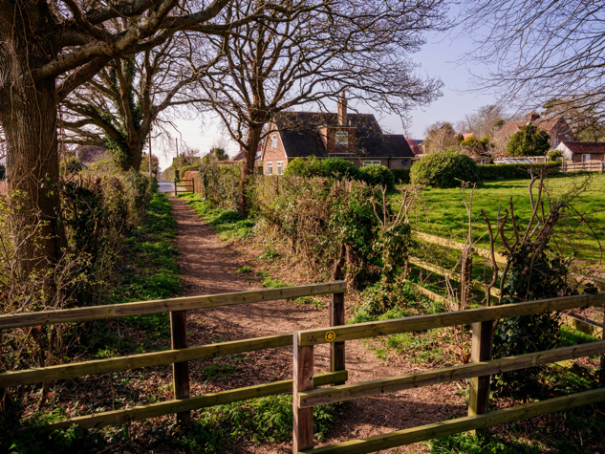
Wealdway entering East Hoathly from Chiddingly

East Sussex County Council Walks

b. ESCC has in the past, produced guides to local walks. The only one they now show for this Parish can be found by typing the following into your internet browser:

https://www.eastsussex.gov.uk/media/vnajfzez/east-hoathly-walk.pdf

or select the following link: Link to ESCC Walk in East Hoathly

Wealden Walks

c. WDC currently have a Wealden Walks Blog which has a link to 34 walks within the District. Two of the walks, that are centred on Laughton, very briefly enter the Parish at Halland Park Farm. The walks are titled: “Pelhams, Parks and Poachers” and “The Village in the Middle”. They can be accessed by typing the following into your internet browser:
https://www.wealden.gov.uk/wealden-walks-blog/

or select the following link: Link to Wealden Walks Blog

Thomas Turner Walks

d. The Diary of Thomas Turner 1754 - 1765 is an important record of life in a Georgian Village. In carrying out his duties as Shopkeeper, Draper, Teacher, Surveyor, Overseer, Undertaker and Church Warden, Thomas Turner spent many hours walking and riding around the Parish. A pamphlet produced in 1996 by Bruce Cripps records Eight walks “In the Steps of Thomas Turner”.

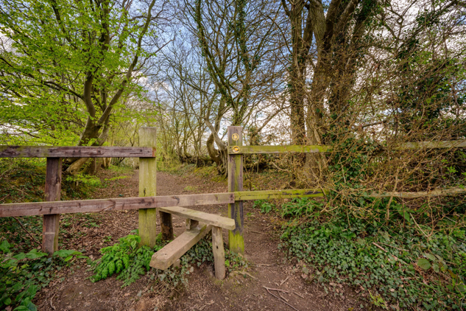
Entry to Moat Wood, East Hoathly

Footpath Adoption

e. The Parish is endeavouring to adopt a commonly used footpath in Pine Wood (adjoining Moat Wood) as a PROW.

f. The Neighbourhood Plan Consultation process revealed the desire to add linking footpaths to the existing footpath network. These linking paths would enable the generally radial paths leaving the settlements to be linked into circular walks. The Parish Council hope to discuss the potential of adding these footpaths with local landowners.

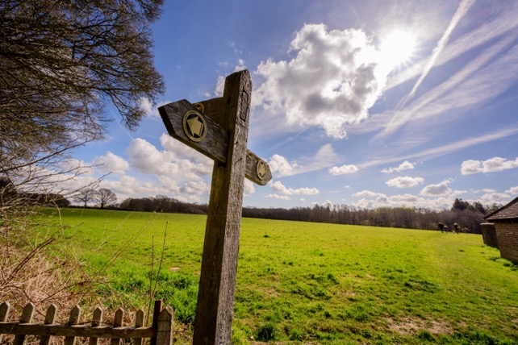

Footpath Sign

170. The maintenance of the footpaths and pavements within the settlements is a concern for many parishioners. These are often being damaged by vehicles mounting the footpath/pavement in order to park or pass other vehicles in the road. The verges are destroyed and the resulting debris then spoils the paths and blocks drains.

171. Residents and visitors would benefit from access to a Notice Board or Information Point that provides details of the local points of interest and local walks. The Parish Council are investigating this.

Cycleways/Routes

172. There are no cycle routes from the National Cycle Network in or near to the Parish. There are no cycleways in the Parish. The recently published East Sussex Local Cycling & Walking Infrastructure Plan (LCWIP) contained no reference to this Parish.

East Hoathly and Halland Link

173. The footpath which connects East Hoathly to Halland is through woodland and fields in one of the lowest lying parts of the Parish. The route is an attractive country walk but is often muddy and waterlogged. It is very enclosed in parts and is not an easily usable route connecting our communities. It is unsuitable for cycles, pushchairs or disabled access. The alternative route is to walk along the A22 and then down London Road. This is not advisable as the traffic is fast moving and the verges are narrow in places and uneven.

174. The Parish has been exploring the possibility of a route that would provide a safe walking and cycleway connecting East Hoathly with Halland. This would allow each settlement to more easily use each other’s facilities and services more easily. This might be walking access to Staverton Nursery for East Hoathly residents or the Primary School and East Hoathly Church for Halland residents. As part of this process, discussion has taken place over the use of the woodland footpaths through Bentley Wood to the Shaw Roundabout.

EHHNP Aspiration 7 - Accessibility

A7.1 This Parish seeks to create a safe footpath and cycleway connecting East Hoathly and Halland that can be used by all residents in all weathers.

A7.2 This Parish seeks to establish an Information Point for residents and visitors to discover information about the local walks, heritage and places of refreshment.

SECTION 10 - COMMUNITY INFRASTRUCTURE LEVY

175. The Community Infrastructure Levy (CIL) is a charge legislated for by Government and adopted by Local Planning Authorities for new development. CIL is paid by the developer to WDC. Not all development is liable to CIL as there are a number of exemptions to both individuals and developers. The exact amount of CIL for any project is calculated by WDC. Our Parish is located in the higher rate band for CIL payments for housing, so the general charge on developers will be £200/m² plus an annual indexation rate determined by the Building Cost Information Service. As an example, for residential planning permissions granted in 2023, the combined CIL charge including the indexation will be £260/m². Retail development is charged differently and full details of the CIL is available on the WDC Website.

176. The Parish receives 15% of the CIL (subject to a cap) received by WDC. There is detailed guidance on the permitted uses of CIL money, but in general, it can be spent on the provision, improvement, replacement, operation or maintenance of infrastructure, or anything else that is concerned with addressing demands that development places on an area. If the Parish succeed in getting the EHHNP adopted, it will receive 25% of future CIL receipts (uncapped).

177. As an example, the current amount of the CIL payment for the development of 6 homes at Old Hartfield, Halland, for which planning permission was granted in 2019, would amount to £62,901.10 of which the Parish should receive £9,435.17. With a Neighbourhood Plan in place, the Parish would receive £15,725.28.

178. However, the Government has imposed a cap on the amount of CIL that a Parish without a Neighbourhood Plan can receive in any year and this is currently set at £100 for every home in the Parish that pays Council Tax. This amounts to around 663 homes and therefore a maximum CIL payment of £66,300. Redrow predicted, for the Hesmond’s development of 205 homes, a CIL payment to WDC of £4,300,000. This Parish would therefore receive £66,300 without a Neighbourhood Plan but £1,075,000 with a Neighbourhood Plan.

Spending the CIL

Local Planning Authority (WDC)

179. The Local Planning Authority must spend the CIL on infrastructure needed to support the development of their area (full details are published in Government Guidance). CIL can be used to fund a wide range of infrastructure, including transport, flood defences, schools, hospitals, and other health and social care facilities. This definition allows the CIL to be used to fund a very broad range of facilities such as play areas, open spaces, parks and greenspaces, cultural and sports facilities, healthcare facilities, academies and free schools, district heating schemes and police stations and other community safety facilities. Charging authorities may not use the CIL to fund affordable housing. The CIL can be used to increase the capacity of existing infrastructure or to repair failing existing infrastructure, if that is necessary to support development.

Parish

180. The neighbourhood portion of the CIL can be spent on a wider range of things than the rest of the CIL, provided that it meets the requirement to ‘support the development of the area’. The wider definition means that the neighbourhood portion can be spent on things other than infrastructure (as defined in the Community Infrastructure Levy Regulations) provided it is concerned with addressing the demands that development places on the parish’s area. For example, the CIL could be used to fund affordable housing.

181. The Parish councils should work closely with WDC to agree on infrastructure spending priorities. The Parish Council’s Priority List for CIL expenditure is shown at Annex L. This will be reviewed annually and take into account the infrastructure demands imposed by any new development proposals. The items on the Priority List do not form part of the Statutory NP and will not form part of the Independent Examination.
Annexes: Page

A. Sustainability and Infrastructure in East Hoathly with Halland Parish. 115
B. Children of Primary School Age in East Hoathly with Halland Parish. 136
C. Carbon Emission Estimates in East Hoathly with Halland Parish. 137
D. Listed Buildings in East Hoathly with Halland Parish. 140
E. Pelham Buckle Milepost Markers in East Hoathly with Halland Parish. 142
F. Assets of Community Value in East Hoathly with Halland Parish. 143
G. Fingerpost Signs and Post Boxes in East Hoathly with Halland Parish. 144
H. Land Stewardship Schemes in East Hoathly with Halland Parish. 146
I. Ancient Woodland and Tree Preservation Orders in East Hoathly with
Halland Parish. 145
J. Hedgerows in East Hoathly with Halland Parish. 149
K. Public Rights of Way and Bridleways in East Hoathly with Halland Parish. 153
L. East Hoathly with Halland Parish Council CIL Expenditure Priorities. 154

Tables:

1. Housing Type. 25
2. Housing – Number of Bedrooms. 26
3. Housing – By Number of Bedrooms and Tenure. 27
4. Housing – Tenure/Ownership. 27
5. WDC Housing Mix Recommendation. 28
6. Sewage Discharges in Watercourses. 64
7. Cars/Vans per Household. 100
8. Method of Travel to Work. 101
9. Facilities in East Hoathly and Halland. 116
10. Children of Reception/Primary School Age. 136
11. Tree Preservation Orders. 147

Figures:

1. East Hoathly with Halland Neighbourhood Area. 4
2. The Parish Boundary shown in Blue was enlarged to the West of the
Red line in 1990 to incorporate the whole of the Settlement of Halland. 12
3. Growth in Number of Homes in Parish. 31
4. Growth in Number of Homes in East Hoathly. 31
5. Percentage Change in Population. 33
6. Designated Heritage Assets in Parish. 44
7. East Hoathly Conservation Area. 50
8. WDC Landscape Character Assessment 2022 – Characterisation of
Parish. 54
9. Parish Woodland. 60
10. Wealden District Light Pollution. 70
11. Dark Skies Map showing relative darkness of the Parish. 70
12. Local Green Space – Policies Map East Hoathly. 77
13. Local Green Space – Policy Map Halland. 77
14. Employment in Parish. 90
15. Example of mobile phone coverage in Parish. 98
16. Parish Carbon Emissions by Source. 137
17. Parish Carbon Emissions by Consumption. 138
18. Parish Carbon Emissions in Comparison with Wealden by Source. 138
19. Parish Carbon Emissions in Comparison with England by Source. 139
20. Pelham Buckle Milepost Markers. 142
21. Fingerpost Signs and Post Boxes. 144
22. Land Stewardship Schemes. 145
23. Parish Woodland. 146
24. Surveyed Hedgerows to South East of East Hoathly. 150
25. Surveyed Hedgerows to West of East Hoathly. 150
26. Surveyed Hedgerows to South West of Halland. 151
27. Surveyed Hedgerows to East of East Hoathly. 151
28. Surveyed Hedgerows to North of East Hoathly. 152

Picture Credits and Copyright:

Pictures on the following pages are copyrighted to Mr Jim Holden:

1, 5, 10, 15, 16, 17, 45, 46, 60, 65, 74, 78, 86, 87, 88, 95, 106, 108, 109, 117, 118, 119, 120, 121, 123 and 125

Pictures on page 129 are copyrighted to Ms Katherine Gutkind.

Annex A

SUSTAINABILITY AND INFRASTRUCTURE

IN EAST HOATHLY WITH HALLAND PARISH

Sustainability

Current Sustainability

1. The Wealden Core Strategy LP 2013 defined the settlements of this Parish, within the settlement hierarchy, as:

a. East Hoathly - Neighbourhood Centre - A settlement with limited, basic or no facilities but with access to another centre, or a settlement with facilities but poor accessibility or access only to a service or local centre.

b. Halland - Unclassified Settlement - A settlement with few or no facilities and services, and where further development would be unsustainable.

2. The Wealden Core Strategy LP 2013 also removed the Development Boundary (included within the saved policies of the Wealden LP 1998) from both East Hoathly and Halland and proposed no growth for the Parish. WDC are currently updating its sustainable settlement study alongside the emerging Local Plan.

3. The Parish has a range of facilities and infrastructure that provides residents with some of their needs. They have to travel outside the Parish to meet the remainder of their needs. When more needs can be satisfied locally the location is more sustainable. The facilities currently available within our Parish are shown in Table 9 below:

Table 9 – Facilities in East Hoathly and Halland

Facility | East Hoathly | Halland
Nursery School | ✓ | ✓
Primary School | ✓
Doctor’s Surgery | ✓
Dispensary | ✓
Convenience Store | ✓ | ✓
Café | ✓ | ✓
Garden Centre |  | ✓
Post Office | ✓
Public House | ✓ | ✓
Place of Worship | Church of England | Independent Chapel
Community Hall | ✓
Children’s Play Area | ✓
Sports Pitches | ✓
Pavilion | ✓
Bus Services | ✓ | ✓
Employment Opportunities | Very Limited | Extremely Limited
Supermarket
Town Centre Shopping
Secondary School
Tertiary Education
Childcare Facilities
Veterinary Services | ✓  (Complementary medicine only)
Restaurants/Takeaways
Library
Swimming Pool
Leisure Centre
Cinema
Train Station
Hospital
NHS Dentist
NHS Optician
Civic Amenities

East Hoathly Church of England Primary School

4. East Hoathly CE Primary School is part of the Pioneer Federation, a partnership with Chiddingly Primary School, St Mary’s Hartfield CE Primary School and Park Mead Primary School (Upper Dicker). The Pioneer Federation seeks to promote educational provision and wellbeing.

Doctor’s Surgery

5. The East Hoathly Surgery was incorporated into the Buxted Medical Practice in 2001 (the Manor Oak Surgery, Horam has also now been added to this combined Practice).

6. The Doctor’s Surgery incorporates a Dispensary which is of considerable benefit to parishioners.

Convenience Store

7. East Hoathly benefits from having the Village Stores which stocks a limited range of groceries, a limited range of fresh produce, newspapers and periodicals. Halland benefits from having a very small selection of groceries and a limited range of fresh fruit and vegetables at Staverton Nursery.

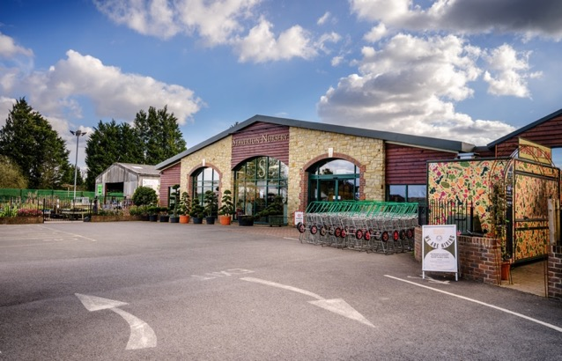
Staverton Nursery

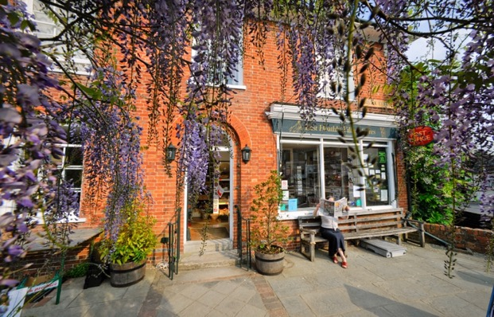
East Hoathly Village Stores

Cafes

8. East Hoathly benefits from having Muffins Coffee Shop/Boutique which serves a range of light meals and cakes. Muffins also sells jewellery, gifts, cards and prints. Halland also benefits from having a cafe as part of Staverton Nursery.

Garden Centre

9. Halland benefits from having a Garden Centre.

Post Office

10. East Hoathly benefits hugely from having a Post Office as part of the Village Stores. A significant number of business and home workers use the Post Office.

Public House

11. East Hoathly benefits from having the Kings Head Pub. Halland benefits from having the Blacksmiths Arms.

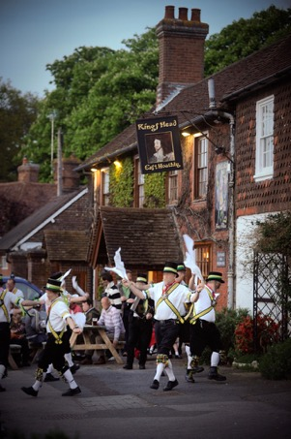
Morris Dancing outside the
Kings Head, East Hoathly

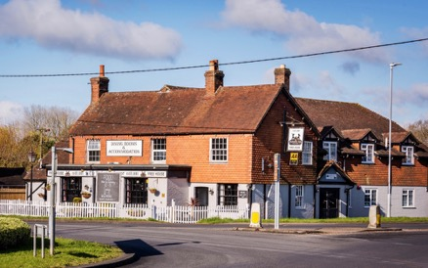

Blacksmiths Arms, Halland

Place of Worship

12. East Hoathly benefits from having the East Hoathly Church (Church of England). Halland benefits from having the Halland Chapel (Independent). Each serves the needs of their congregation but it should be noted that the needs of other denominations have to be found outside the Parish. East Hoathly Church has a formal connection with East Hoathly School and an active role in community life. East Hoathly Church hosts many village events including dramatic productions, music and cultural events.

Community Hall

13. East Hoathly benefits from having a Village Hall. This is used for a range of village society events and private hire for classes, meetings and social events.

Children’s Play Area

14. East Hoathly benefits from having a Children’s Play Area on the Sports Ground. There is also a smaller Play Area in the Nightingales development.

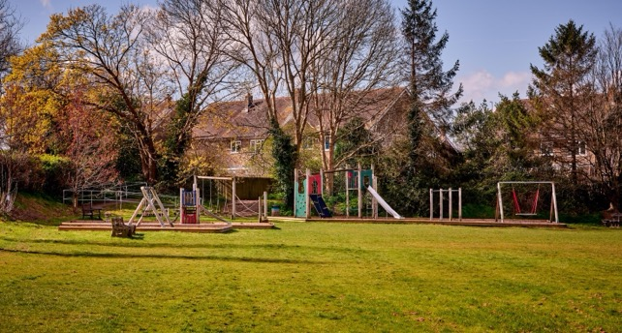

Children’s Play Area, East Hoathly

Sports Ground

15. East Hoathly benefits from having a Sports Ground with football pitch, cricket pitch, three tennis courts and a Rifle Club.

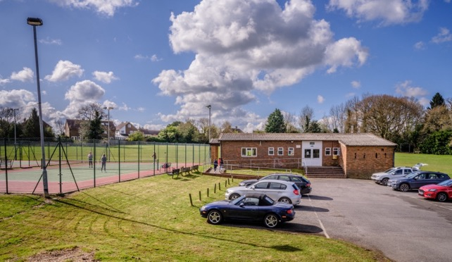

Pavilion and Tennis Courts, East Hoathly

Pavilion

16. East Hoathly benefits from having a Pavilion on the Sports Ground which has a kitchen, male and female toilets, one full sized changing room one small changing room and a main room.

Bus Service

17. One bus service passes through East Hoathly and two services visit Halland.

a. Route 54 Bus Service (Eastbourne - Hailsham - Uckfield)
This bus visits Halland and East Hoathly. Fourteen buses per day in each direction (excluding Sunday), roughly one bus per hour from 06.57 to 19.35

b. Route 28 Bus Service (Tunbridge Wells - Lewes - Brighton) This service only visits Halland.

(1) Six buses per weekday, three starting in Tunbridge Wells and three from Uckfield, 05.54, 07.47, 20.05, 21.05, 22.05 and 23.37. Only Five buses in return direction, three terminating at Uckfield.

(2) Five buses per Saturday, four starting in Tunbridge Wells and one from Uckfield, 06.09, 20.05, 21.05, 22.05 and 23.37. Only Four buses in return direction, three terminating at Uckfield.

(3) Eleven buses per Sunday two starting from Tunbridge Wells and 9 from Uckfield, roughly one bus per hour from 09.19 to 21.04. Only Eight buses in return direction all terminating at Uckfield.

c. Route 142 This service only visits East Hoathly. The Route 142 Bus Service (Polegate to Lewes) is one bus per school day and is for school children only. It stops in East Hoathly but is not accessible by the general public.

Other Businesses (excluding those covered above)

18. East Hoathly and Halland both benefit from the presence of other businesses. These offer some local employment opportunities albeit few in number. These businesses add to the local economy attracting customers into the villages and whilst they are very much valued, they do not serve the day-to-day needs of the community and are not considered to add, in any meaningful way, to sustainability.

Changes in Sustainability

19. Sustainability changes over time. New facilities can open, or existing ones can close. New services can be provided, or existing ones can be reduced. Existing facilities can increase their capacity, or they can reach the limit of their capacity. The categorisation of a settlement in a settlement hierarchy is a statement of the sustainability assessed at that time but any changes in sustainability should always be considered when determining the current sustainability of a settlement. This is particularly important when considering planning applications where the last categorisation in an adopted LP is cited as the current level of sustainability. East Hoathly and Halland were last categorised in 2013 and much has changed since then. This section examines the changes in sustainability during this period.

East Hoathly Church of England Primary School

20. The East Sussex School Organisation Plan 2020 - 2024 indicates that “Birth and GP registration data point to East Hoathly CE Primary School having potentially high in-area numbers in 2021/22 and 2022/23. The school may have to rely on the school admissions system restricting inflows to enable it to keep its intake numbers to the Published Admission Number (PAN) of 15”.

21. The East Sussex School Organisation Plan 2021 - 2025 is rather less helpful as it provides no data for East Hoathly School. It mentions no plans to expand East Hoathly School and does not yet acknowledge the proposed increase of 262 homes in the Parish.

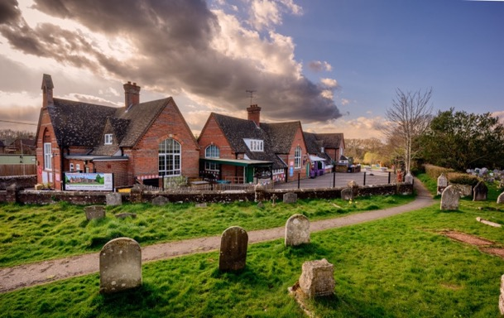

East Hoathly Church of England Primary School

22. The key point is that the school is at or very close to its PAN capacity and is forecast to remain in this situation until at least 2024. The recent approvals to add 262 homes in East Hoathly will add an estimated 55 children of Primary School age to the Parish (See Annex B). When these homes are completed, this could result in 184 children of Primary School age and a school with a capacity of 105. New housing may be built in phases (although WDC are opposed to this) and incoming families may not choose to change their children’s school immediately. Some families may choose to send their children to private schools and this will reduce the figure. Some parents will choose to send their children to schools outside the Parish but this may be balanced by parents who live outside the Parish choosing to send their children to East Hoathly School. All children schooled outside the Parish require vehicle usage with the pollution and congestion that arises from it.

Doctor’s Surgery

23. For over a decade the Surgery has suffered from a lack of General Practitioners (GPs) and this is equally reflected in the combined Buxted Medical Practice. An increasing number of East Hoathly patients are now being referred to the main Surgery in Buxted. During the Covid-19 lockdown, the East Hoathly Surgery closed completely as a result of staff shortages and all access to medical services was via Buxted. This declining access to medical services is of considerable concern for many parishioners.

24. The Surgery are aware of the shortage in GP cover and is actively recruiting. The situation is replicated throughout the Medical Practices of the South East. It may become the norm to have to travel to a larger facility to get GP access and this should be reflected in the sustainability criteria.

Sports Ground/Pavilion

25. The Sports Ground is poorly drained and this leads to unplayable conditions after wet weather. This was deemed unacceptable by the local football league and the players from the East Hoathly Football Club went elsewhere and the Club closed. The Pavilion is old and in poor condition. It has limited facilities most of which need refurbishment and do not meet modern sporting standards. The Tennis Club is identified as having capacity issues (too many members for the number of courts available) in the WDC Playing Pitch and Outdoor Sports Strategy Report 2022.

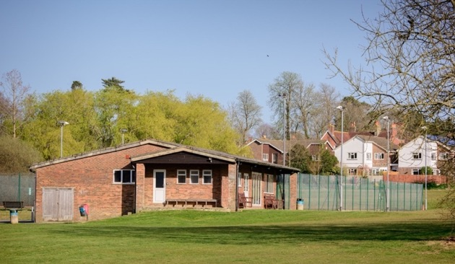

East Hoathly Sports Pavilion and Tennis Courts

Bus Service

26. The Bus Services have been reduced in frequency over many years. The Sunday service for the 54 Bus Service has ceased in the Parish and there are no longer any evening services. The timetable for the 28 Bus Service (which only visits Halland) is complex and curious. It is difficult to comprehend for whom the rather fractured service is intended. For those who use bus travel, it is really important, the problem is that very few people need or choose to use it. Local surveys showed that in a whole day (averaged for School Terms/Holidays), only 19 people from the Parish used the 54 Bus and no one used the 28 Bus. The average number of people on the buses that passed through the Parish was 3 per bus (the majority of the buses were double decker with an average bus capacity of 66).

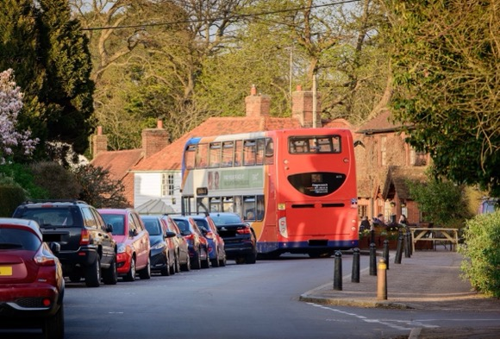

54 Bus - Negotiating the East Hoathly Post Office Bend

27. For those few people who use the bus it is a very important service but it is difficult to describe this extremely low level of bus usage as anything but ineffectual in being an alternative to car transport. It should be noted that this is following two housing developments in this community that have produced travel plans to improve bus usage which do not appear to have been effective. This is despite the cost of bus travel being reduced since August 2022 in an attempt to encourage greater usage and parish councils are being asked to promote the new tariffs. The East Sussex Bus Service Improvement Plan (BSIP) has proposals to provide an evening and Sunday bus service on Route 54, but this aspiration is dependent upon significant additional funding and there is no timetable for its implementation.

Other facilities Lost

28. The following facilities have been closed in the last 27 years:

a. The Smock Shop (traditional Sussex rural clothing) in East Hoathly closed in 1996.

b. The Public Toilets in East Hoathly closed in 1998.

c. The Halland Post Office closed in 1998.

d. The Butchers Shop in East Hoathly closed in 2001.

e. The Foresters Pub in East Hoathly closed in 2017.

Changes in Local Businesses

29. The Parish has many local businesses that do not feature on the list of facilities providing sustainability but they are an important part of our local economy. They attract customers and visitors to the community and provide limited employment opportunities for local people. However, as the nature of these businesses change, then it can have a detrimental effect on sustainability. If a food business changes to a gift shop, the level of employment may stay the same but the ability of the new shop to sustain the local inhabitants may be reduced. People need food on a regular basis but only occasionally need to buy a gift. Therefore, the need for the local inhabitants to travel is increased thereby reducing sustainability. In employment terms the change of nature of these business premises is often neutral but the effect on the community is important. Some examples of this have been:

a. The Butchers Shop was replaced by a Craft Shop which then became a Book Shop.

b. The Petrol Station/Garage was replaced with a range of small business units currently: Homeopathic Vet, Osteopathic Practitioner, Sign-writer, Glass Bead Maker, Photographers, Health House and Dressmakers.

Reductions in Local Employment

30. Since 1964 East Hoathly has seen a continuing reduction in local employment opportunities as planning consents have been granted to build housing on the sites of local businesses:

a. 1964 - Susans Close built on the site of a Workshop and Garden.

b. 1988 - Thomas Turner Drive built on the site of Trills Builders.

c. 1988 - Carpenters Croft built on the site of Bookers Pill Factory.

d. 2001/2 - An extension to the Mews built on the site of Chapman and Smith Safir Works.

e. 2009 - Juziers Drive and Trug Close built on the site of E&A Carriers and PB Fencing.

f. The current planning approvals for 260 homes will remove one of the Hesmond’s Stud business units and associated workers leading to further loss of local employment. The removal of agricultural land from a working farm to develop the land at South Street will reduce the level of work being done by that farm, and hence reduce the employment capacity of that farm.

31. Most of the facilities/services that provide sustainability in the Parish have been diminished in recent decades and there has been a gradual reduction in local employment opportunities. There have been improvements with the provision of a children’s play area in East Hoathly and the growth of Staverton Nursery in Halland to provide a small selection of groceries and a cafe. However, the overriding trend has been for a reduction in the level of sustainability and an increased dependence on cars (See Paragraphs 151 to 154 of the EHHNP). Many parishioners believe that East Hoathly should be redefined as an Unsustainable Settlement.

Infrastructure

Local Roads

32. The A22 Bypass was completed in 1993 and removed the bulk of North - South traffic from the centre of East Hoathly. This undoubtedly improved the quality of life for everyone in the village and allowed the atmosphere of a rural village to return. However, in recent years the amount of traffic on the A22 passing through Halland has considerably increased. The same is true of East Hoathly with ever more vehicles in the centre of the Village navigating the sharp and hazardous Post Office bend. Pedestrian safety has become an issue once again, particularly for the young and elderly.

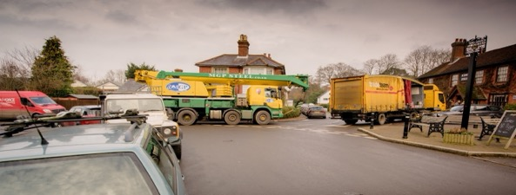
East Hoathly Post Office Corner - From High Street
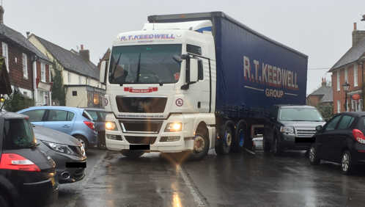
East Hoathly Post Office Corner from Waldron Road

33. The number of vehicles in Wealden has increased around 5% per year since 2009 and congestion has worsened steadily. Traffic in the narrow rural lanes has increased because of vehicles using back roads to avoid congestion on the A22 and B2192, the creation of many more farm based rural businesses and the growing number of home deliveries now drawing large delivery vehicles into both settlements and their narrow lanes. The speed of vehicles is usually too high, verges are being damaged by large vehicles and these lanes are increasingly unsafe and unpleasant for people trying to walk or cycle.

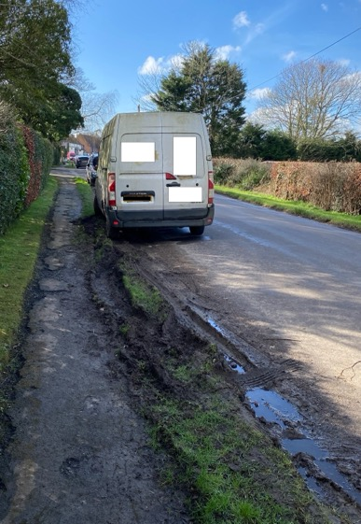
Damage to Verges on Waldron Road

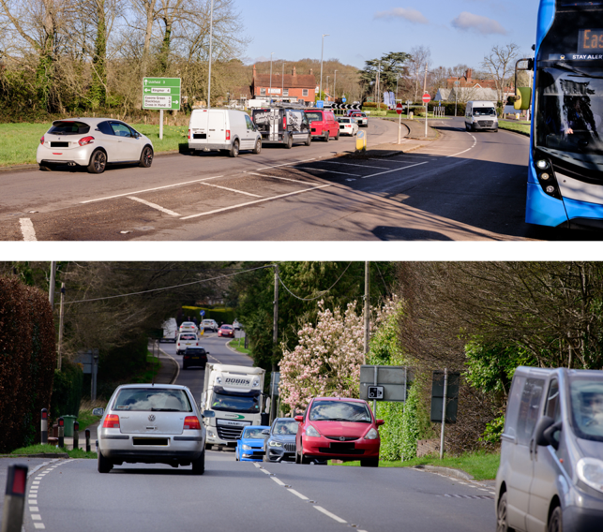

Traffic Congestion on A22 in Halland

34. The lanes to which this particularly applies are:

a. Knowle Lane in Halland.

b. Back Lane in Halland.

c. Waldron Road in East Hoathly.

d. Ailies Lane in East Hoathly.

35. East Hoathly and Halland are rural villages where everything that is needed to live and run households is delivered by road. Many houses in the villages and almost all isolated houses use oil or bottled gas and this is delivered by road. There is a significant and growing reliance on items being ordered online and therefore delivered by vehicles.

Sewage System

36. The East Hoathly and Halland Sewage Plants are known to be working close to their capacity. Both plants regularly discharge untreated sewage overflow into their river catchment areas (See Paragraphs 93 to 94 of the EHHNP for details). The existing sewage pipe network for East Hoathly was laid in the early 1950s. Since then, the housing connected to this network has been increased from 130 homes in 1950 to 380 homes in 2020. This is a 192% increase in the number of homes added to the sewage pipe network. It is known to be problematic in many properties in East Hoathly and during periods of heavy rainfall many properties suffer from hydraulic overload causing in their properties. The addition of a further 262 new homes will put more strain on the existing system.

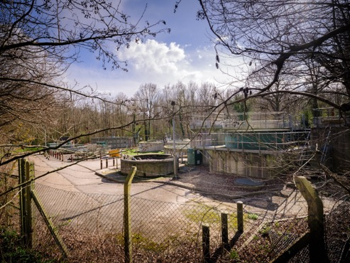

East Hoathly Sewage Treatment Plant

Electrical Supply

37. The electrical supply network to almost all homes in the Parish is from overhead cables. These are vulnerable to weather and tree disruption. Most of the homes in the Parish suffer from frequent power cuts. UK Power Networks recorded 24 power cuts for BN8 6** in the years 2018/2019 and 33 power cuts in the years 2020/21. Modern homes are increasingly dependent on electric devices and timing devices. This level of power cuts is clearly frustrating and irritating for all consumers but is particularly problematic for businesses and those with freezers.

38. The Climate Emergency should be pushing us into a future of renewable energy for all new developments. New developments will be dependent on Electric Vehicles (EVs), electric heating and electric cooking. Existing properties will also be required to transition to an electric future. There is considerable local concern that the existing electrical network is inadequate so the change to an all-electric future may not be possible without a significant upgrade to the existing electrical network. South Eastern Power Networks have no plans in their Long-Term Development Statement to upgrade the branch of the power distribution network that supplies East Hoathly with Halland and many other parishes.

Electric Vehicles

39. The government has set a date of 2030 to stop the sale of new fossil fuel vehicles and for all new vehicles to have 100% zero emissions from 2035. From 2030, all new vehicle owners may therefore need to install charging points in their homes. The Parish/WDC will also seek to install charging points in the public car parks. It is vital that all new developments are built with electric charging points and the Government have introduced changes to building regulations to enable this. The new building regulations make it mandatory for each new dwelling (with an associated parking space but excluding those within covered car parks) to have a charging point but does not make it mandatory for every new parking space to be built with a charging point. The new building regulations also sets a price cap on the provision of the charging points so that if the cost of providing the charging points exceeds the price cap, the developer can choose not to provide them. The building regulations also do not have any requirement for a development’s visitor parking to be provided with EV charging facilities. This Parish believes that future building regulations should require that every new development should provide a charging point for every resident’s parking space and for 1 in every 2 visitor spaces.

40. The transition to EVs and providing charging facilities will pose significant issues to all communities. Existing homes will have to fit their own charging arrangements and this could lead to unsightly cabling being added to forecourts. This will be of particular concern in the Conservation Area where many homes only have on-street parking and cables crossing pavements are not permitted. The Building Regulations 2010 (Part S) Regulation 44E (4) allows that the provision of a charging points for Listed Buildings and within Conservation Areas is not mandatory if “where compliance would unacceptably alter the building’s character or appearance”. However, this does not address how that Listed Building or home in the Conservation Area could then install a charging point that is acceptable. This will have a significant impact on the character, appearance and safety of the places we live and work. WDC currently deal with each EV charging point application on a case-by-case basis but this Parish feels that more substantial guidance is required to control what will become a fundamental part of house design and the visible frontage of almost every home and business.
41. UK Power Networks state that in early 2021 there were 100,000 EVs using their networks. They forecast having 4.5 million by 2030 (just in London, the South East and East of England). They have produced an Electric Vehicle Strategy that begins to explore the issues raised by the transition to EVs. This strategy document identifies several issues:

a. They believe the current transition to EVs is currently 40% below the target.

b. They acknowledge that the use of one 50kW rapid electric vehicle charger is the equivalent to the routine use of a block of 25 flats.

c. That there is poor provision of charging infrastructure and high connection costs especially for rural areas.

d. There is a question as to whether there will be enough capacity to supply the need.

e. There is a question as to whether there will be voltage and thermal issues caused by the new loads.

42. The Wealden Climate Emergency Plan 2019 acknowledges the need to move towards electric but does not contain any calculation of the expected change in power demand and thereby no assessment of the credibility of achieving it. It noted that in 2019 there were 12 publicly accessible charging points in Wealden and a press release in November 2020 this had increased to 17. An imminent role out plan was announced in November 2021 but was not published. A WDC press release dated 6 May 2022 stated that there are 23 EV charging points in Wealden District (although the Zapmap Website only shows 22 as at 19 July 2022). There remains no public charging point in this Parish.

43. What seems to be clear is that the deadline for all new vehicles being EVs is rapidly approaching but much of the infrastructure is not in place. The cost is going to be high and that rural areas will be the most expensive. The building regulations cap cost and the higher costs of rural infrastructure upgrades are likely to mean that this Parish will be left behind in this transition.

Accessibility

44. The Accessibility of the Parish is an important factor in its sustainability. This is covered in more detail in Section 9. This includes the Infrastructure for Broadband and Mobile Phone Coverage as well as footpaths and bus services.

Annex B

CHILDREN OF PRIMARY SCHOOL AGE

IN EAST HOATHLY WITH HALLAND PARISH

1. This annex seeks to examine the number of children of Primary School age in the Parish. Table 10 projects how many might be expected as a result of the currently approved planning applications.

Table 10 - Children of Reception/Primary School Age

Census Groups | Totals | Expected from Approved Developments
All Residents | 1600 | 676
Age 5 - 11 | 129 | 55
Households | 620 | 262

Children of Primary School age in Parish in 2011 129
Following addition of 262 new homes 184
Capacity of East Hoathly School 105

Expected deficit 79
2. New housing may be built in phases (although WDC are opposed to this) and incoming families may not choose to change their children’s school immediately. Some families may choose to send their children to private schools and this will reduce the figure. Some parents will choose to send their children to schools outside the Parish but this may be balanced by parents who live outside the Parish choosing to send their children to East Hoathly School. All children schooled outside the Parish require vehicle usage with the pollution and congestion that arises from it.

3. The data is taken from the 2011 ONS Census. The figures in the yellow box are estimated figures extrapolated in proportion to 2011 Census data for the number of residents in the Parish in relation to the number of homes and the number of Primary School Aged Children in the Parish in relation to the number of all residents.

Annex C

CARBON EMISSION ESTIMATES

IN EAST HOATHLY WITH HALLAND PARISH

1. Carbon Emission Estimates have been prepared by the Centre for Sustainable Energy as part of their Climate Emergency Support Programme. The following graphics give an indication of the Parishes total Carbon Emissions and its breakdown.

Figure 16 - Parish Carbon Emissions by Source

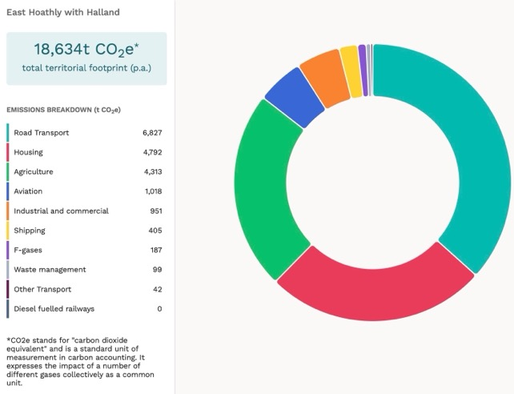

2. Figure 16 above, shows Carbon Emissions that are produced directly from our Parish. Of particular note is the high level of emissions from Road Transport which reflects that we are a car dependent community with a major A road (A22) running through the centre of the Parish.
Figure 17 - Parish Carbon Emissions by Consumption

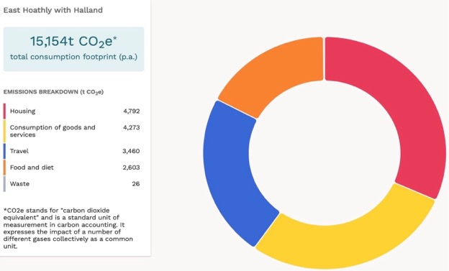

3. Figure 17 above, shows Carbon Emissions on a Consumption basis. This adds to Figure 16 with emissions caused by what we buy and what we eat (where that is imported from other parts of the UK or the world).

Figure 18 - Parish Carbon Emissions in Comparison with Wealden by Source

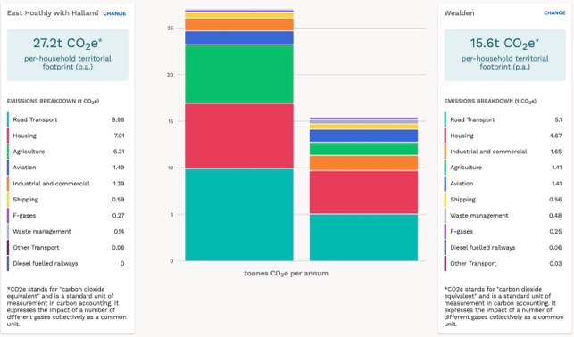
4. Figure 18 above, shows a comparison of a household in our Pariagainst the Wealden average. Figure 19 below, shows a comparison of a household in our Parish against the average in England. We have almost twice the Wealden average of Carbon Emissions. We have more than twice the average for England.

Figure 19 - Parish Carbon Emissions in Comparison with England by Source

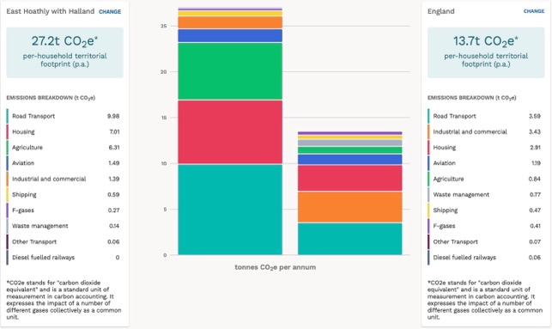

5. It clearly shows that our Parish has a much greater level of Carbon Emissions than in Wealden and when compared to average in England. This is largely because we are a rural parish that has commensurately higher level of agricultural emissions. However, the most significant item is that of transport reflecting that we are a highly car dependent community.

Further Information

6. Further more detailed breakdowns can be viewed by visiting the Impact – Community Carbon Calculator by typing the following into your internet browser:

https://impact-tool.org.uk

or select the following link: Link to Impact - Community Carbon Calculator

Annex D

LISTED BUILDINGS

IN EAST HOATHLY WITH HALLAND PARISH

Serial | Listing Number | Grade | Description
1 | 1043288 | II | East Hoathly Stores, 9, 11 and 13 High Street, East Hoathly, BN8 6DR
2 | 1353330 | II | East Hoathly Post Office and House Attached, 2 High Street, East Hoathly, BN8 6EB
3 | 1043286 | II | Godfreys, Halland, BN8 6RB
4 | 1193320 | II | Whyly, East Hoathly, BN8 6EL
5 | 1043251 | II | Yew Tree Cottage, 20 South Street, East Hoathly, BN8 6DS
6 | 1353331 | II | Price’s Cottages, Whitesmith, BN8 6JD
7 | 1353332 | II | Sellens Cottages, 7, 9 and 11 South Street, East Hoathly, BN8 6DS
8 | 1043249 | II | The White House, 20 High Street, East Hoathly, BN8 6PS
9 | 1043250 | II | Jasmine Cottages, 2 and 4 Mill Lane, East Hoathly, BN8 6QB
10 | 1043254 | II | The Mill House, 2 Waldron Road, East Hoathly, BN8 6DP
11 | 1043285 | II* | The Parish Church, Church Marks Lane, East Hoathly
12 | 1043287 | II | Hartfield Farmhouse, Halland, BN8 6PW
13 | 1286188 | II | Fern Cottage, 4 Waldron Road, East Hoathly, BN8 6DP
14 | 1353293 | II | Cherry Tree Cottages, 24 and 26 South Street, East Hoathly, BN8 6DS
15 | 1353294 | II | Lavender Cottage, 15 Waldron Road, East Hoathly, BN8 6PW
16 | 1193427 | II | The Gate House, Waldron Road, East Hoathly, BN8 6QH
17 | 1043253 | II | 5, 7 and 9 Waldron Road, East Hoathly, BN8 6DP
18 | 1043289 | II | Rosemount, High Street, East Hoathly, BN8 6DR
19 | 1286184 | II | Piper’s Farmhouse, Hollow Lane, East Hoathly, BN8 6RA
20 | 1353295 | II | Hesmonds, Waldron Road, East Hoathly, BN8 6QH
21 | 1193327 | II | The Ruins of the old house known as Halland House in the grounds of Halland Park House, Shortgate, BN8 6RB
22 | 1043248 | II | 6,8 and 10 High Street, East Hoathly, BN8 6EB
23 | 1043252 | II | Spring Cottage, 1 and 3 Waldron Road, East Hoathly, BN8 6DP
24 | 1043255 | II* | Belmont, Waldron Road, East Hoathly, BN8 6QJ
25 | 1286193 | II | Aberdeen House, 5 High Street, 7 High Street, The King’s Head Inn, 1 and 3 High Street, East Hoathly, BN8 6DR
26 | 1028363 | II | Vine Cottage, Terrible Down, Halland,
27 | 1028388 | II | Lower Sandhill House, Easons Green,
28 | 1028391 | II | Peckhams, Knowle Lane, Halland, BN8 6PR
29 | 1286218 | II | Old Post Office Cottage, Buttsfield Lane, East Hoathly, BN8 6EF
30 | 1444079 | II | Telephone Kiosk, Mill Lane/Waldron Road, East Hoathly
31 | 1043102 | II | Halland Park Farmhouse, Shortgate, BN8 6RB
32 | 1353376 | II* | Barn at Halland Park Farm to South West of the Farmhouse, Shortgate, BN8 6RB
33 | 1452099 | 2 | Foresters Arms, 6 South Street, East Hoathly, BN8 6DS
34 | 1468363 | II | Bentley Wood, Knowle Lane, Halland, BN8 6PR
35 | 1020515 |  | Scheduled Monument - Moated site in Moat Wood, 580 m East of Halland Park Farm, East Hoathly

Description of Scheduled Monument

The peak period for moated sites was about 1250 to 1350 and the majority were prestigious residences where the moat was generally intended as a status symbol rather than for practical military defence. This monument includes a medieval moated site, situated on the south western outskirts of East Hoathly village, on low lying ground which forms part of the Sussex Weald. The roughly north west-south east aligned moated site survives in the form of earthworks and associated buried remains. The square, central island measures around 35m across and is surrounded by a ditch, up to 19m wide and 1.3m deep. The north western and north eastern arms of the moat remain partly - filled. Elsewhere, the ditch has become partly infilled over the years, and contains a low, central bank in the south east, about 4m wide and 0.3m high. The ditch was in turn surrounded by an outer bank, and sections of the bank, measuring up to 6m wide and 1m high, survive around the western corner of the moat and along its north eastern side. The eastern corner of the moat has been partly disturbed by past modern drainage operations, and the outer bank has been partly levelled by other activities, including the construction and use of the footpaths on the north western and south western sides of the moat. Although no upstanding remains of former buildings have been identified, traces of buildings can be expected to survive as buried features beneath the present ground surface of the central island.

Annex E

PELHAM BUCKLE MILEPOST MARKERS

IN EAST HOATHLY WITH HALLAND PARISH

Milepost 46 A22 Near Crockstead MES 21804

Milepost 47 A22 South of Halland MES 21803

Milepost 48 London Road, East Hoathly MES 33241

Milepost 49 A22 Park Lane Corner MES 21802

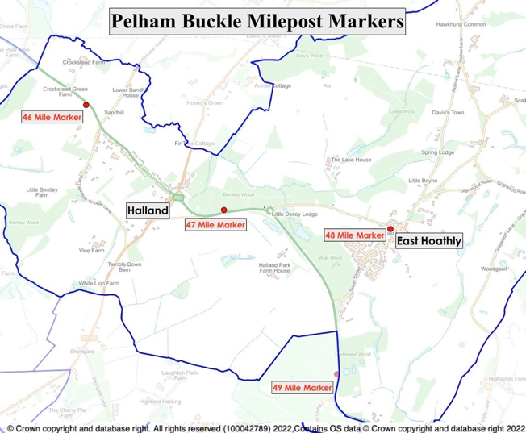
Figure 20 – Pelham Buckle Milepost Markers

Annex F

ASSETS OF COMMUNITY VALUE

IN EAST HOATHLY WITH HALLAND PARISH

Serial | Reference | Start Date | End Date | Description
1 | 22007 | 27 Sep 2022 | 26 Sep 2027 | The Kings Head, East Hoathly
2 | 22008 | 27 Sep 2022 | 26 Sep 2027 | The Blacksmith’s Arms, Halland
3 | 21004 | 30 Jun 2021 | 29 Jun 2026 | Garden Plots, East Hoathly
4 | 22003 | 13 May 2022 | 12 May 2027 | East Hoathly Medical Centre

Annex G

FINGERPOST SIGNS AND POST BOXES

IN EAST HOATHLY WITH HALLAND PARISH

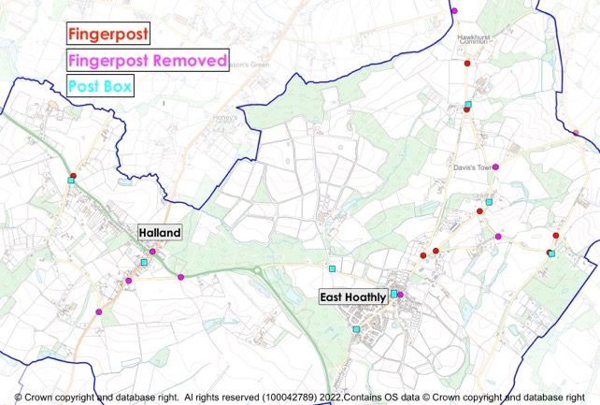

Figure 21 – Fingerpost Signs and Post Boxes

Annex H

LAND STEWARDSHIP SCHEMES

IN EAST HOATHLY WITH HALLAND PARISH

1. The Countryside Stewardship Scheme provides financial incentives for farmers, woodland owners, foresters and land managers to look after and improve the environment.

2. The Environmental Stewardship Scheme is a land management scheme that provides funding to farmers and other land managers in England to deliver effective environmental management

3. The Organic Farming Scheme aims to encourage the expansion of organic production. Under the scheme, farmers moving from conventional to organic farming methods receive financial help during the conversion process.

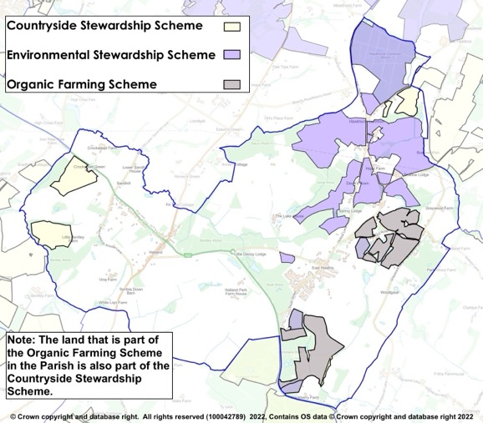
Figure 22 – Land Stewardship Schemes

Annex I

ANCIENT WOODLAND AND

TREE PRESERVATION ORDERS

IN EAST HOATHLY WITH HALLAND PARISH

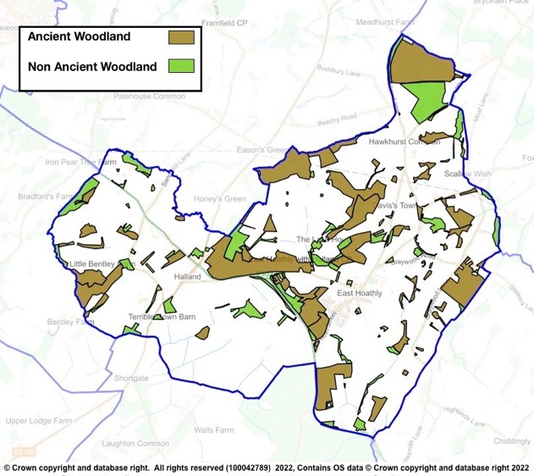

Figure 23 - Parish Woodland

Table 11 - Tree Preservation Orders

Serial | TPO Number | Location | Species | Confirm-ation Date | Grid Ref
1 | HRDC 1973 (3) | Land Adj Cherry Tree Cottage, South St | T1 - Yew |  | 551936  116004
2 | 14 1998 | Land at Slays Wood, Adj Annan Court, Easons Green | W1 & W2 - Woodland consisting mainly of Silver Birch, Sweet Chestnut, Hornbeam and Oak. |  | 551205  117796
3 | 22 1978 | Land at Upper Hook Fd, Waldron Rd | T1 Oak | 23/1/80 | 552480  116590
4 | 22 1991 | Engineering Works, The Mews | T1 - Scots Pine  G1 - Group of 3 Cherry Laurel, 11 Portugal Laurel, 2 Hawthorn, 1 Holly, 2 Variegated Holly, 1 Western Red Cedar | 16/5/91 | 5213  1606
5 |  |  | T1 Scots Pine presumed to be felled - noted on land parcel for 16 The Mews - 17/11/08
6 | 23 1997 | Land at Slays Wood, Adj Annan Court, Easons Green | W1 - Woodland comprised predominantly Oak, Silver Birch, Hornbeam and Sweet Chestnut | 12/5/98 | 551115  117788
7 | 25 1981 | Land between Gables and Myrtle View, A22 | T1 - Holly, T2 - Ash, T3 - Oak, T4 - Oak, T5 - Oak, T6 - Oak, G1 - Group of 40 Aspen | 14/10/81 | 550130  116730
8 | 26 2004 | Graywood N of Quadrangle | W1 - Woodland maily Hornbearm, Ash, Oak, Sweet Chestnut, W2 - Woodland mainly Hornbeam, Ash, Oak, Sweet Chestnut, W3 - Woodland mainly Hornbeam, Ash, Oak and Sweet Chestnut | 8/7/91 | 5365  1654
9 | 26 2004 | Crockstead Farm | A1 - Area of Misc deciduous and coniferous trees | 23/12/04 | 549440  117941
10 | 29 2004 | Downs Cottage, 31 Mill Lane | T1 - Horse Chestnut | 14/12/04 | 552466  116194
11 | 30 2002 | Moat Wood | W1 - Mixed deciduous Ancient Semi-Natural woodland consisting mainly of Ash, Birch, Cherry, Douglas Fir, Hazel, Hornbeam, Oak, Sweet Chestnut, Sycamore and Willow. Note - 5 Oak, 1 Willow, 1 Poplar, 2 Birch and 4 Sweet Chestnut removed from TPO - felled 13/10/2015 | 20/12/02 | 551567  116128
12 | 36 1996 | Great Ailies Farm | W1 - mainly Oak, Hornbeam, Ash, Holly and Field Maple | 18/4/97 | 5334  1602
13 | 46 1986 | Harrisons Shaw | W1 - Woodland mainly Oak, Sweet Chestnut and Ash | 31/1/87 | 5128  1643
14 | 48 2006 | Martinland Wood | W1 - Woodland consisting of all deciduous and coniferous trees incl Birch, Ash, Sycamore and Native species | 3/10/06 | 551941  115118
15 | 5 1990 | Rear of 22 South St | T1 - Holm Oak, T2 - Sweet Chestnut, T3 - Ash, G1 Group of 3 Ash, G2 - Group of 2 Ash and 2 Oak | 2/4/90 | 5190  1600
16 | 56 2004 | Safir Works, South St | T1 - Common Oak, T2 - Common Oak, G1 - Group of 7 Ash, 4 Common Oak, 1 Horse Chestnut | 13/5/05 | 552090  115920
17 | 58 1990 | Nursery Wood | W1 - Woodland mixed hardwoods mainly Oak, Sweet Chestnut, Hornbeam, Holly, Birch and Gean | 3/9/90 | 5000  1676
18 | 71 1991 | Rear of Yew Tree Cottage, Halland | T1, T2 and T3 English Oak | 3/2/92 | 5035  1677
19 | 99 1990 | N of Belmont - Supersedes 16 1986 | W1 - Woodland mainly Oak, Sycamore, Ash, Holly, Hornbeam, Beech, Birch, Sweet Chestnut | 20/11/90 | 552667  116679
20 | 2018/0008 | Adj to Park Lodge | G1 - 7 Common Oak | 11/6/19 | 551952  115840

Annex J

HEDGEROWS

IN EAST HOATHLY WITH HALLAND PARISH

1. A countryside hedgerow is a boundary line of bushes, which can include trees. A hedgerow is protected, meaning it cannot be removed, if it meets the following criteria for length, location and importance:

Length

a. If it is more than 20m long with gaps of 20m or less in its length, or

b. If it is less than 20m long, but meets another hedge at each end.

Location

c. A hedgerow is protected if it is on or next to land used for agriculture or forestry, land used for breeding or keeping horses, ponies or donkeys, common land.

Importance

d. A hedgerow is important and is protected if it is at least 30 years old and marks all or part of the parish boundary, is part of a field system that existed before 1845, contains protected species, contains species that are endangered, vulnerable or rare, includes woody species as specified in Hedgerow Regulations.

2. Hedgerows are surveyed and assessed in accordance with the Hedgerow Regulations 1997 and the findings recorded by the Sussex Biodiversity Trust. This was part of the Sussex Hedgerow Project under the control of the Sussex Biodiversity Records Centre in which they provided training for Parish volunteers to carry out the surveys. The hedgerow is recorded for its length, width and the presence of associated ditches, walls or banks. The woody species and herb layer are separately listed and assessed for their quality and variety. Native species and alien species are recorded. Following the survey, the Hedgerow is graded and recorded. The hedgerows that have been surveyed in the Parish are shown below:
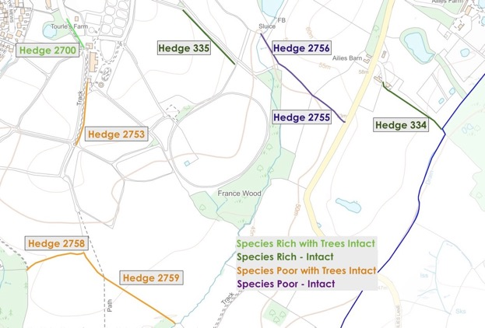

Figure 24 - Surveyed Hedgerows to South East of East Hoathly

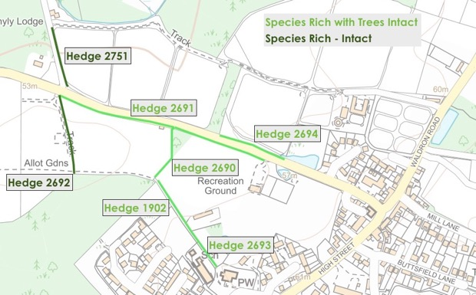

Figure 25 - Surveyed Hedgerows to West of East Hoathly
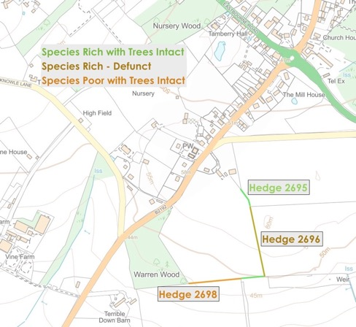

Figure 26 - Surveyed Hedgerows to South West of Halland

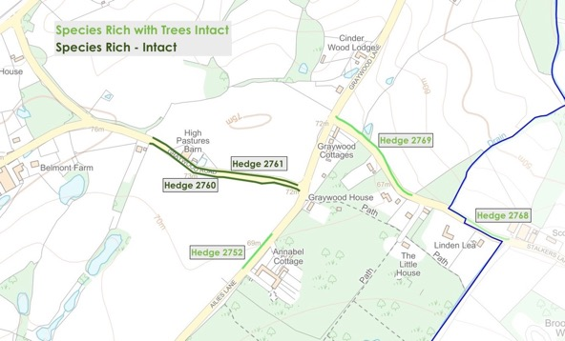

Figure 27 - Surveyed Hedgerows to East of East Hoathly
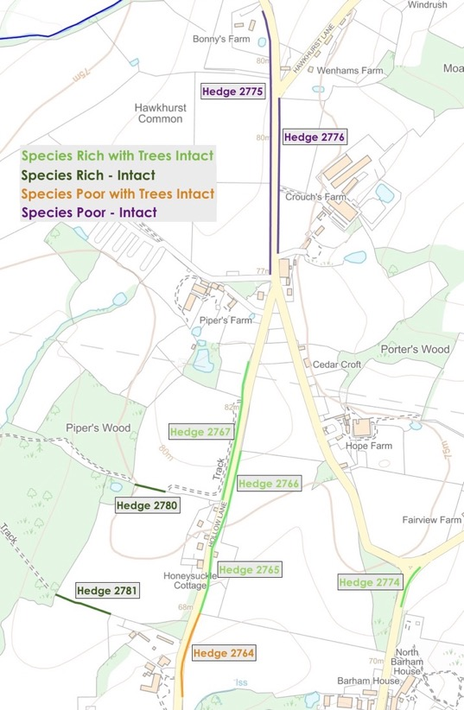

Figure 28 - Surveyed Hedgerows to North of East Hoathly

Annex K

PUBLIC RIGHTS OF WAY AND BRIDLEWAYS

IN EAST HOATHLY WITH HALLAND PARISH

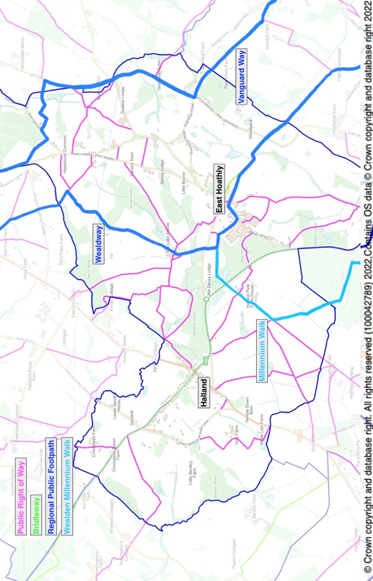

Annex L

Not Part of Statutory NP or Independent Examination

EAST HOATHLY WITH HALLAND PARISH COUNCIL

CIL EXPENDITURE PRIORITIES

The Parish Council CIL Expenditure Priorities in descending order of priority are:

a. Community Land Trust Aspiration 1

b. Pelham Buckle Mileposts Aspiration 2

c. Provision of Open/Greenspace in Halland Aspiration 5

d. Improvements to Sports Ground Aspiration 5

e. Upgrading Pavilion Aspiration 5

f. Community Fibre Project Aspiration 6

g. East Hoathly to Halland Path/Cycleway Aspiration 7

h. Visitor Information Point Aspiration 7

Not Part of Statutory NP or Independent Examination

neighbourhoodplanning.org
WDC SEA Screening Opinion - Feb 2022.
WDC HRA Screening Report - Feb 2022.
Wealden Landscape Study 2014 - The Low Weald Landscape.
Sussex Biodiversity Record Centre - Report SxBRC/21/1019 dated 21 Mar 2022.
Census 2021
EHHNP Website - Parish Statistics.
ESHER Reference: MES 15563 and MES 21353.
ESHER Reference: MES 15564, MES 15565, MES 3113, MES 23121, MES 23122 and MES 21352.
ESHER Reference: MES 3114.
The History, Antiquities and Topography of the County of Sussex Thomas Walker Horsfield FSA, page 358.
WDC Draft East Hoathly Conservation Area Character Appraisal 2021, Paragraph 2.3.8.
WDC Draft East Hoathly Conservation Area Character Appraisal 2021, Paragraph 2.5.22.
https://historicengland.org.uk/sitesearch?searchType=site&search=East+Hoathly+with+Halland+Parish (also shown in Annex D).
WDC Draft East Hoathly Conservation Area Character Appraisal 2021.
https://www.wealden.gov.uk/planning-and-building-control/planning-policy/adopted-local-plan-documents/adopted-wealden-local-plan-1998/
https://www.wealden.gov.uk/UploadedFiles/Index_of_Saved_Policies.pdf
https://www.wealden.gov.uk/planning-and-building-control/planning-policy/adopted-local-plan-documents/core-strategy-local-plan/
https://www.wealden.gov.uk/planning-and-building-control/planning-policy/adopted-local-plan-documents/affordable-housing-delivery-local-plan/
https://www.eastsussexinfigures.org.uk.
Page 3, WDC Local Housing Needs Assessment 2021.
Pages 19/20, Government response to the Planning for the right homes in the right places consultation 2018.
East Hoathly with Halland Parish Plan 2008, East Hoathly with Halland Parish Survey 2016. See EHHNP Website.
https://www.rtpi.org.uk/practice/2020/september/dementia-and-town-planning/
https://www.eastsussexjsna.org.uk/about-us/jsna-summary-east-sussex/
https://www.housinglin.org.uk/Topics/browse/Design-building/HAPPI/
ONS 2011 Census Data Table KS401EW.
ONS 2011 Census Data Table QS411EW.
ONS 2011 Census Data Table CT0545.
ONS 2011 Census Data Table KS402EW.
WDC Housing Needs Assessment 2021, Table on Page 3.
WDC Housing Needs Assessment 2021, Page 3.
EHHNP Website - Parish Statistics.
Planning Application WD/2016/2796/MAO Decision Notice dated 11 Jun 2021.
Planning Application WD/2019/1674/MAO Appeal Decision Notice dated 27 Jul 2021.
EHHNP Website - Parish Statistics.
EHHNP Website - Parish Statistics.
EHHNP Website - Parish Statistics.
EHHNP Website - Parish Statistics.
EHHNP Website - Parish Statistics.
WDC Housing Needs Assessment 2021, Page 93.
https://www.wealden.gov.uk/housing-health-and-advice/housing/housing-allocations-policy/
East Hoathly with Halland Character Area Appraisal, March 2022.
https://escc.maps.arcgis.com/apps/webappviewer/index.html?id=78ce56f03ccf42b3810b30a5023d4989
ESHER Reference: MES 15563 and MES 21353.
ESHER Reference: MES 15564, MES 15565, MES 3113, MES 23121, MES 23122 and MES 21352.
ESHER Reference: MES 3114.
The History, Antiquities and Topography of the County of Sussex Thomas Walker Horsfield FSA, page 358.
WDC Draft East Hoathly Conservation Area Character Appraisal 2021, Paragraph 2.3.8.
Planning (Listed Buildings and Conservation Areas) Act 1990.
Historic England List Entry Number 1252622.
Historic England Local Heritage Listing – Historic England Advice Note 7 (Second Edition), Paragraph 1 and Paragraph 40.
WDC Draft Conservation Area Character Appraisal Jan 2021, Paragraph 3.3.6.
WDC Draft Conservation Area Character Appraisal Jan 2021, Paragraph 3.4.6.
WDC Draft Conservation Area Character Appraisal Jan 2021, Paragraph 5.1.2 and 5.2.
WDC Draft Conservation Area Character Appraisal Jan 2021, Paragraph 3.5.5.
WDC Draft Conservation Area Character Appraisal Jan 2021, Paragraph 5.4.1.
WDC Draft Conservation Area Character Appraisal Jan 2021, Paragraph 5.4.3.
WDC Draft Conservation Area Character Appraisal Jan 2021, Paragraph 5.5.1.
WDC Green Infrastructure Study 2017, Paragraph 5.2.5.
GI Network Plan provides a strategic framework for the delivery of GI. It is only illustrative and does not necessarily indicate a constraint on development
WDC Landscape Character Assessment 2022: https://www.wealden.gov.uk/UploadedFiles/Wealden-LCA.pdf
WDC Landscape Character Assessment 2022 pages 84, 172 and 185.
Rivers Trust Website - https://experience.arcgis.com/experience/e834e261b53740eba2fe6736e37bbc7b/page/Map/?data_id=dataSource_4-1788e0d0481-layer-54%3A16460&org=theriverstrust
Stantec/Water UK - Storm Overflow Evidence Project - Nov 2021.
Met Office – Southern England: Climate - https://www.metoffice.gov.uk/binaries/content/assets/metofficegovuk/pdf/weather/learn-about/uk-past-events/regional-climates/southern-england_-climate---met-office.pdf
Met Office Data - https://www.metoffice.gov.uk/hadobs/hadukp/data/daily/HadSEEP_daily_totals.txt
Met Office Data - https://www.metoffice.gov.uk/pub/data/weather/uk/climate/datasets/Raindays1mm/date/England_SE_and_Central_S.txt
Met Office Data - https://www.metoffice.gov.uk/hadobs/hadukp/data/daily/HadSEEP_daily_totals.txt
Sussex Biodiversity Record Centre - Report SxBRC/21/1019 dated 21 Mar 2022.
Sussex Biodiversity Record Centre - Report SxBRC/16/740 dated 9 Feb 2017.
Parish Online Mapping – ESCC Shared Data, Wildlife Verges.
https://www.lshtm.ac.uk/newsevents/news/2015/reduced_street_lighting_does_not_increase_crime.html
England’s Light Pollution and Dark Skies - CPRE Website.
https://theilp.org.uk/publication/guidance-note-1-for-the-reduction-of-obtrusive-light-2021/
Locality Guide – Neighbourhood Plan – Local Green Spaces – 2021, Paragraph 1.
Locality Guide – Neighbourhood Plan – Local Green Spaces – 2021, Paragraph 1.
EHHNP Website - Parish Statistics.
https://www.planningportal.co.uk/permission/common-projects/change-of-use/use-classes
Ofcom UK Home Broadband Performance Report 2021.
Government manifesto commitment for nationwide gigabit broadband by 2025 (revised in 2022 to a minimum of 85% of premises by 2025). Levelling Up White Paper 2022 set a new target for gigabit broadband by 2030 for 99% of premises.
Ofcom Website mobile phone availability checker for O2 indoor 4G calls.
ONS 2011 Census Data Table QS416EW.
EHHNP Website - Parish Statistics.
EHHNP Website - Parish Statistics.
ONS 2011 Census Data Table QS701EW.
https://www.statista.com/statistics/448040/influence-of-covid-19-on-online-grocery-shopping-uk/
East Sussex County Council Guidance for Parking at New Developments, March 2024
WDC Design Guide, Part 1, Figure 10.21.
EHHNP Website - Parish Statistics.
EHHNP Website - Parish Statistics.
https://www.eastsussex.gov.uk/roads-transport/public/bus-service-improvement-plan/bus-service-improvement-plan-for-east-sussex-county-council
https://www.wealden.gov.uk/planning-and-building-control/planning-advice/community-infrastructure-levy/paying-cil/
https://redrowconsults.co.uk/library/sites/13/east_hoathly_exhibition_boards_reduced_size_compressed_1.pdf
https://www.gov.uk/guidance/community-infrastructure-levy
https://www.legislation.gov.uk/uksi/2019/1103/contents/made
Wealden Core Strategy LP 2013, Table 1, Pages 9-10.
ESCC School Organisation Plan 2020 – 2024, Page 81.
ESCC School Organisation Plan 2021 - 2025.
WDC Playing Pitch and Outdoor Sports Strategy Report 2022, Paragraph 496.
Survey of Bus Usage - EHHNP Website - Parish Statistics.
ESCC Shared Traffic Data from Parish Online Mapping.
East Hoathly with Halland Parish Survey 2016 Results Summary and Feria Interim Report - see EHHNP Website.
Department For Transport Tables Veh0105 and CGN0405 – See EHHNP Website – Parish Statistics. The reduction in vehicles on roads during the Covid-19 Pandemic is now reversing and congestion is almost back to pre-pandemic levels.
UK Power Network Data - see EHHNP Website - Parish Statistics.
South East Power Network - Long Term Development Statement November 2021.
Government Ten Point Plan for a Green Industrial Revolution -https://www.gov.uk/government/publications/the-ten-point-plan-for-a-green-industrial-revolution
Building Regulations 2010 - Part S - Infrastructure for the Charging of Electric Vehicles 2021.
UK Power Network Website - Future Energy - Electric Vehicles - https://innovation.ukpowernetworks.co.uk/wp-content/uploads/2023/03/UK-Power-Networks-Electric-Vehicle-Strategy-2023_FINAL.pdf.
UK Power Networks Website - Electric Vehicle Strategy - https://innovation.ukpowernetworks.co.uk/wp-content/uploads/2019/11/UK-Power-Networks-Electric-Vehicle-Strategy-November-19.pdf.
WDC Climate Emergency Plan 2019.
WDC Press Release 10 November 2020 - WDC Website.
WDC Press Release 25 November 2021 - WDC Website.
ZapMap Website - recommended by WDC to see current charging point availability - see EHHNP Website - Parish Statistics.
EHHNP Website - Parish Statistics.
East Sussex Historic Environment Record reference.
Sussex Biodiversity Records Centre (Contact Andrew Lawson).

