EAST HOATHLY WITH HALLAND
NEIGHBOURHOOD PLAN

Submission Plan (Regulation 15)

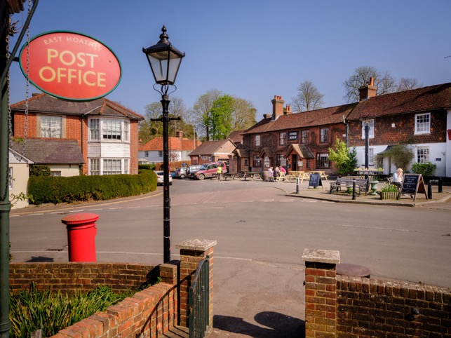
East Hoathly Village Corner

VERSION 19 – 26 August 2023

CONTENTS

LIST OF SECTIONS

Page

- Introduction. 4

2. Context. 13

3. Vision and Objectives. 24

4. Housing and Housing Design. 28

5. Conservation. 76

6. Natural Environment. 92

7. Health and Wellbeing. 114

8. Business. 126

9. Accessibility and Connectivity. 132

10. Community Infrastructure Levy. 141

List of Annexes, Tables and Figures. 143

POLICY LIST

Policy 1 Housing 66

Policy 2 Housing Design – Resource Efficiency 72

Policy 3 Housing Design – Layout and Materials 73

Policy 4 Conservation of Historic Environment 86

Policy 5 Dark Skies 91

Policy 6 Natural Environment 107

Policy 7 Local Green Space 112

Policy 8 Business 129

Policy 9 Communications 134

ASPIRATION LIST

Aspiration 1 Community Land Trust 66

Aspiration 2 Conservation of Historic Environment 86

Aspiration 3 Conservation of Community Assets 88

Aspiration 4 Dark Skies 91

Aspiration 5 Health and Wellbeing 125

Aspiration 6 Broadband 135

Aspiration 7 Accessibility 140

SECTION 1 - INTRODUCTION

1. This is the East Hoathly with Halland Submission Neighbourhood Plan (EHHNP) for the parish of East Hoathly with Halland. It sets out the community’s aspirations for our Parish over the period to 2039 and establishes policies in relation to land use and development. Once the plan has a positive referendum the plan will become part of the Local Development Plan and applications for planning permission must be determined in accordance with the development plan, unless material considerations indicate otherwise.

2. Wealden District Council (WDC) approved the whole of the Parish area to be designated as the East Hoathly with Halland Neighbourhood Development Area on 7 August 2017. The Plan Period will be 2022 to 2039.
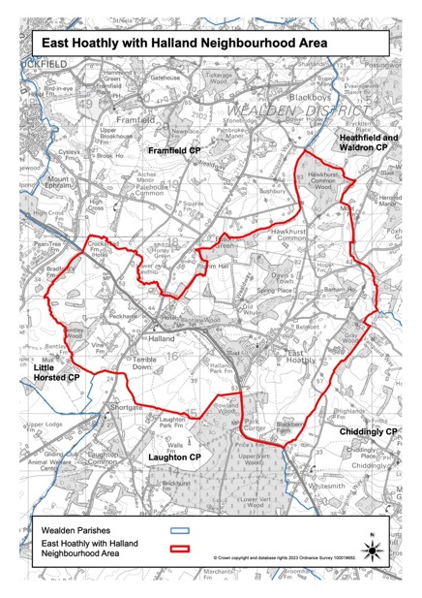
Figure 1 – East Hoathly with Halland Neighbourhood Area
3. The purpose of neighbourhood planning is to give local people and businesses a voice in how the places they live, work and play should change and develop over time. This can shape the future of our greenspaces, housing and business developments, enhance the protection of our environmental and heritage assets, protect the health of residents and enhance community wellbeing.

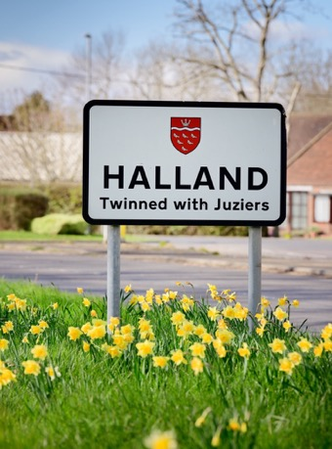

Halland Signpost

Structure of Neighbourhood Plan

4. The Plan comprises twelve sections. These are as follows:

a. Section 1 - Introduction. This Section outlines how the Neighbourhood Plan (NP) area was designated, the setting up of a Steering Group to carry out the work and an explanation of the process and guidelines to be followed.

b. Section 2 - Context. This Section gives a brief description of the Parish and its setting, the history of the area and the community. It describes the current position with regard to WDC’s adopted Local Plan (LP) policies.

c. Section 3 - Vision and Objectives. This Section presents the Vision and Objectives for our Parish as well as the overarching principles guiding sustainable development.

d. Sections 4 to 10. These Sections present the policies, associated projects and ambitions for our Parish. They are as follows:

(1) Section 4 - Housing Development and Design. The first part of this Section looks at Housing Development with an examination of its relationship with sustainability in this Parish. The second part examines matters of design and leads to a Design Policies which focusses on Resource Efficiency and the Layout and Construction of developments.

(2) Section 5 - Conservation. This Section examines matters relating to the conservation of buildings, landscape, the setting of heritage assets and character of the Parish.

(3) Section 6 - Natural Environment. This Section examines the Landscape, Woodlands, Trees, Hedgerows, Ponds, Waterways and biodiversity in the Parish. It proposes policy to protect and enhance the Natural Environment including the designation of fifteen Local Green Spaces.

(4) Section 7 - Health and Wellbeing. This Section considers the opportunities for living, working and playing in the parish, tackling health inequalities and improving life expectancy. It examines facilities such as the Sports Ground, Pavilion, Village Hall, Places of Worship, Doctors Surgery and the Arts and Crafts community.

(5) Section 8 - Business. This Section covers business matters.

(6) Section 9 – Accessibility and Connectivity. This Section covers matters related to access to Broadband provision, Mobile telephone coverage, Bus Services, Footpaths and Cycleways.

(7) Section 10 - Community Infrastructure Levy. This Section explains the Community Infrastructure Levy and how the Parish Council propose to make use of it.

e. Section 11 - This Section provides a summary of the Community Engagement that has taken place.

5. Within Sections 4 – 10 each subject includes some introductory and explanatory text followed by one or both of the following:

Policy Box

This Neighbourhood Plan establishes land use and development management policies for the Parish. These are contained in policy boxes, like this one.

Projects / Aspirations Box

This Neighbourhood Plan covers more than just traditional planning matters as it presents the community’s vision for the area. Items that the community are seeking, but that cannot be delivered through planning policy, are identified and contained in project / aspiration boxes, like this one.

It is important to note that these Projects / Aspirations will not form part of the Statutory NP and will not be subject to the Independent Examination.

6. The plan will become part of the Local Development Plan and therefore all local and neighbourhood plan policies should be read as a whole.

7. The Neighbourhood Plan does not allocate sites for development. It is anticipated that WDC will allocate land for development in the District as part of its new Local Plan process. In accordance with the NPPF, WDC may also provide a planning policy in its emerging Local Plan to provide a housing figure for future neighbourhood plans to consider delivering through a neighbourhood plan. However, this has not yet been confirmed but will be considered as part of the production of the emerging Local Plan.

Steering Group

8. The Parish Council established a Steering Group to carry out the work of creating a Neighbourhood Plan. This Steering Group comprises some members of the Parish Council and other members of the community. The Parish Council issued Terms of Reference for the Steering Group and has regularly overseen the work of the Steering Group. The Steering Group has endeavoured to engage, enthuse and energise residents and the wider community, including businesses and other stakeholders and organisations, to have their say on the Parish’s future and help shape the Neighbourhood Plan. In addition, the Steering Group have sought the expertise of an experienced firm of consultants during the process and in particular to run some of the formal Consultation events.

Process

9. The formal stages of preparing the Neighbourhood Plan in accordance with the Neighbourhood Planning (General) Regulations 2012 and the Wealden Guide to Neighbourhood Planning 2018 are:

Designation of a Neighbourhood Area

a. The first formal stage in the preparation of a Neighbourhood Plan is for the Parish to submit an Area Application to WDC. This is a request for a specified area to be designated as a Neighbourhood Area for the purposes of Neighbourhood Planning.

Preparation of draft Neighbourhood Plan
b. Preparation of a draft neighbourhood plan, including the collection of evidence, identification of planning issues and engagement and consultation with local residents. These will inform the development of a vision and aims for the plan, the assessment of options and the formulation of policies.
c. The Parish will request that WDC carry out a Screening Opinion to determine if an appropriate assessment or Strategic Environmental Assessment is required.
d. The Neighbourhood Plan will be subjected to a Sustainability Appraisal in order to ensure that it does not have harmful effects on issues such as biodiversity, population, health, fauna, flora, soil, water, air, climatic factors, material assets, cultural heritage and landscape.

Pre-Submission Consultation and Publicity (Regulation 14)
e. The Parish will carry out Regulation 14 consultation on its pre-submission draft.
Submission of the Neighbourhood Plan (Regulation 15)
f. Submission of the Neighbourhood Plan to WDC at Regulation 15. This will include:

(1) A map showing the area to which the Plan relates.

(2) A Consultation Statement – This will explain who was consulted and how. It will provide a summary of the main issues and concerns raised through the consultation and how these have been considered and addressed.

(3) A Basic Conditions statement - The Neighbourhood Plan must satisfy what are called the “Basic Conditions” including being in general conformity with the strategic policies of the Development Plan in Wealden District. This will be explained within a Basic Conditions Statement.

Checking and Publicising the Neighbourhood Plan and appointing an Independent Examiner (Regulation 16)

g. Once in receipt of the Submission Neighbourhood Plan, WDC will, at Regulation 16:

(1) Carry out checks on the documents submitted and issue a written decision within 7 working days as to whether the submission meets the necessary criteria.

(2) WDC will agree with the Parish Council a timetable for the consultation on the Submission Neighbourhood Plan including the dates for the consultation and the number of deposit points for hard copies of the consultation documents
(up to a maximum of five).

(3) WDC will publicise the Submission Neighbourhood Plan. The consultation period will last for no less than 6 weeks.

(4) WDC will liaise with the Neighbourhood Planning Independent Examiner Referral Service for the availability of up to three Independent Examiners. CVs of the available Examiners will be sent to the Parish Council.

(5) Within 6 weeks of the close of the consultation period and in agreement with the Parish Council, WDC will appoint an Independent Examiner.

(6) Within 2 weeks of appointment, WDC will send the relevant documents to the Examiner.

(7) The appointed Examiner will decide when to hold the examination and timescales for undertaking the examination.

Independent Examination

h. The Independent Examination is organized and funded by WDC.

i. The Independent Examiner will focus of whether the Plan meets the Basic Conditions. The Examiner is not testing the soundness of a neighbourhood plan or examining material considerations.

j. The Independent Examiner will submit a Report indicating if the Plan can proceed to a referendum and any necessary modifications.

Community Referendum

k. If the Neighbourhood Plan meets the Basic Conditions, WDC will organise and fund a Local Community Referendum to decide whether the Plan should be brought into force.

Adoption of the Plan

l. WDC will make (adopt) the Plan following a positive referendum vote if more than 50% of those voting in the referendum vote “yes” at the referendum and following a 6 week challenge period.

10. Comments have been invited at various consultation events and we would encourage you to continue contacting us with your thoughts and ideas. Further details can be found at the East Hoathly with Halland Neighbourhood Plan Website or write to the Parish Council. We look forward to hearing from you.

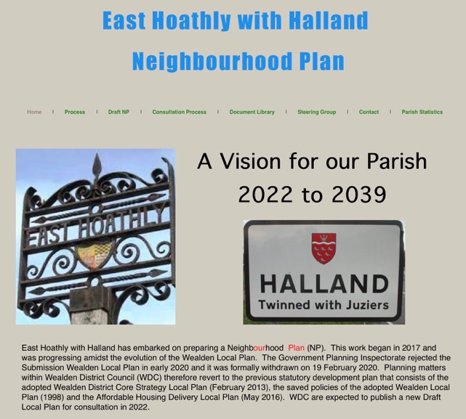

East Hoathly with Halland Neighbourhood Plan Website - Home Page

Access the Neighbourhood Plan Website by typing the following into your internet browser http://easthoathlyhallandneighbourhoodplan.co.uk
or select the link shown below:

Link to Neighbourhood Plan Website

Policies Governing Neighbourhood Plans

11. The Localism Act 2011 defined the current concept of Neighbourhood Planning and this has been incorporated into the Government’s National Planning Policy Framework (NPPF) since 2012, with the latest version published in 2021. WDC is the Planning Authority for this Parish. For clarity, direct extracts from WDC planning documents are shown in blue text.

12. Once adopted, the Neighbourhood Plan has legal status and will become part of the statutory development plan.

WDC’s Neighbourhood Plan Guide

13. This Draft NP has been prepared using the Wealden Guide to Neighbourhood Planning - November 2018 which is guidance provided by WDC based on Neighbourhood Planning (General) Regulations 2012 and the Neighbourhood Planning (Referendums) Regulations 2012 (as amended). Use has also been made of the guides published by Locality.

14. A request for a Screening Opinion on the Draft NP was submitted to WDC on 25 Oct 2021. WDC (after consultation with Historic England, Environment Agency and Natural England) concluded that a Strategic Environment Assessment (SEA) would not be required for the EHHNP. WDC (after consultation with those same bodies) concluded that an Appropriate Assessment under the Conservation of Habitats and Species Regulations 2017 would not be required for the EHHNP.

SECTION 2 - CONTEXT

15. This Section contains information about the Parish and how it fits into WDC’s plans. The size and status of the Parish has changed significantly in the last 30 years. WDC’s depiction of our Parish has changed during this time in their published Issues and Options Papers and Development Plans. They have varied from no proposals for growth to the potential for significant growth. It is important to understand this background Context in order to see how our Parish fits into WDC’s Planning Policies.

The Parish of East Hoathly with Halland

16. The Parish of East Hoathly with Halland comprises the Village of East Hoathly and the smaller settlement of Halland 2 Km to the West of East Hoathly. The Parish also includes the smaller hamlets of Barham, Davis Town and Graywood. East Hoathly is a village located on the old route of the A22, but now benefits from a bypass opened in 1992. Halland is a small, linear settlement bisected by the A22 and the B2192. The rural hinterland of the Parish is scattered with farmstead developments and associated rural cottages.

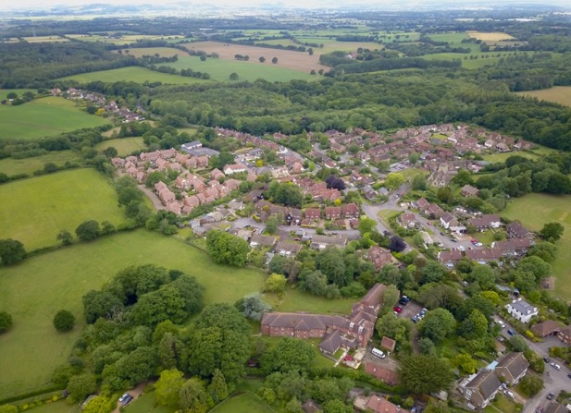

Aerial View of woodland and farmland surrounding East Hoathly
17. The Parish is located 6 Km South East of Uckfield and 10 Km North West of Hailsham that are both market towns connected by the A22. It is located in the Low Weald landscape which is between the High Weald Area of Outstanding Natural Beauty (AONB) to the North and the South Downs to the South. Its slightly elevated position affords wide ranging views southwards to the South Downs National Park.

Setting

18. The Parish is a rural, largely agricultural landscape with several historic farmsteads. The farmland is liberally scattered with woodland much of which is designated as Ancient Woodland and a large network of hedgerows over 50% of which are recorded as Species Rich. There are many large woods, but also many very important Ghyll and Shaw woodlands that are in particular need of protection. The Parish contains many historic field systems and a network of ponds and streams that add to the landscape value of the area.

19. East Hoathly has significant and attractive green approaches. The three roads entering the Village are generally tree lined with green verges and open vistas across pasture and into woodland. This is particularly so on the London Road. Halland also sits in a rural setting with attractive green approaches.

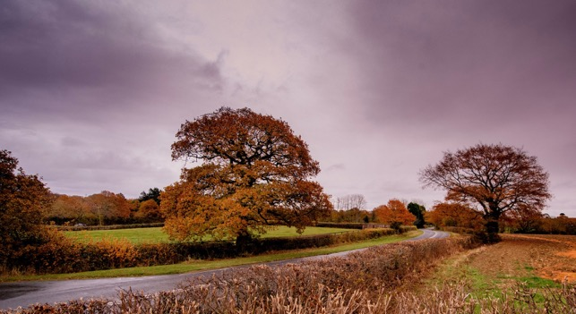

Approach to East Hoathly on London Road

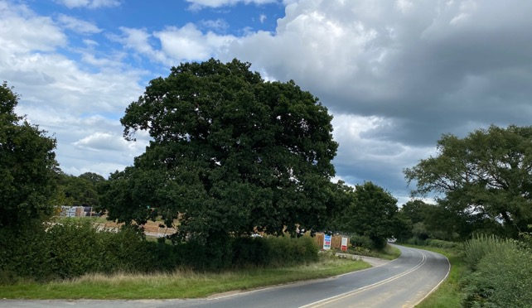
The Changing Face of the Approach to East Hoathly on London Road

20. The environment is rich with biodiversity all supported by a considerable number of ponds, ditches and streams which feed the River Cuckmere to the South and River Uck to the North. The most notable biodiversity features within or adjacent to the NP boundary are:

a. Park Corner Heath - A Site of Special Scientific Interest which is adjacent to the southern border of the Parish.

b. Moat Wood - An area of Ancient Woodland and a Medieval Moat which is a Scheduled Monument. Part of this land was purchased by the Parish Council and the management of the land passed to the Woodland Trust.

c. Croom Cottage Meadow - A Local Wildlife Site (LWS) with rare wild flowers and orchids.

d. Wildlife Verges on B2192 Lewes Road in Halland (ESCC Ref 2/46/30).

e. Long Pond - A breeding pond for Great Crested Newts.

21. The Sussex Biodiversity Record Centre has recorded 51 species that are red listed (in England or Great Britain) indicating that they are under threat of extinction and one species of rabbit that is on the global red list. In addition, 32 species are identified as Priority Species in the UK Biodiversity Action Plan. In total there are 26 internationally designated species, 86 nationally designated species and 175 species with some other designation, mostly indicating that they are scarce in England or rare in Sussex.

Community

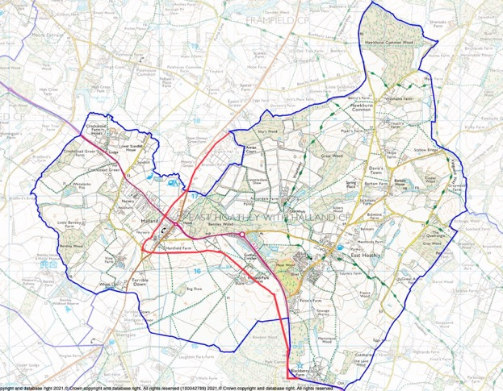

Figure 2 - The Parish Boundary shown in Blue was enlarged to the West of the Red line in 1990 to incorporate the whole of the Settlement of Halland (Prior to this, Halland had been administered by the Parishes of Laughton, Framfield and East Hoathly).

22. The Parish of East Hoathly with Halland is an open inclusive community that has seen significant expansion since the 1950s. The community has grown from 701 people in 1951 to 1600 people in 2011. East Hoathly village has seen significant growth in the last 22 years and is destined to grow further. In the first decade of this period, housing in the village of East Hoathly increased from 294 to 377 which represents a 27% increase in the number of homes. Most of the building in East Hoathly has been on the sites of former businesses and this has significantly changed the balance of the living and working community. Most residents now travel out of the Parish (almost exclusively by car) to work, for shopping and leisure.

Historic Context

23. There has only been limited archaeological investigation in the Parish which means that prehistoric and early historic activity is not fully understood, although there is evidence of early activity in the area. Mesolithic sites have been recorded in Halland Park to the West of the Parish and several finds of Mesolithic flints have been recorded in Halland Park. A Bronze Age axe was found on the Eastern side of South Street. Roman occupation of the wider area commenced in A.D.43, after the Roman conquest. The Roman fort of Anderida lies approximately 13 miles to the South East at Pevensey, with the Roman road from the fort extending westwards from Pevensey to Lewes, 9 miles to the South West and a Roman villa in Laughton. There are limited records of Roman finds in the Parish but a Roman bloomery has been found in Halland.
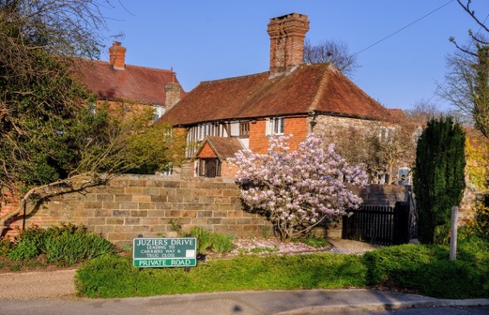

Sellens Cottage - Probable 15th Century Medieval Hall with floor and chimney added in 16th Century.

24. The Parish has an important historic past dating back to Norman times:

a. The name of East Hoathly may have been derived from the De Hodleigh family who owned land in the area from 1296. Another possibility is a variation of Hothly or hath leah - an Old English term for a forest clearing. The hamlet/settlement/village of Halland was originally known as the Nursery/Nurseries in recognition of its cluster of horticultural nurseries. Its name was changed to Halland in 1891 which was taken from the nearby Halland Park Farm. The name of Halland derives from the Hall family, former owners of the land for which the earliest reference appears to be in 1533.

b. The Pelham family bought the land from the Halls and Sir Thomas Pelham built Halland House in 1594. A later Thomas Pelham with his brother Henry raised troops to fight against the Jacobite Rising of 1715 and was rewarded by being created Duke of Newcastle. Both Henry and Thomas went on to become British Prime Ministers residing in Halland House throughout. The house went into decline and was demolished in 1788.

c. Historic landscape characteristics of the Parish include:

(1) An extensive area of cohesive assarts ancient fieldscapes.

(2) Remnant ancient landscape surrounding East Hoathly and Halland.

(3) Areas of regular piecemeal enclosure.

(4) Linear belts of Ancient Woodland lining stream corridors and marking some field boundaries, with several large areas of Ancient Woodland.

(5) Ponds and streams located throughout the landscape.

(6) Many places have views of the Lewes Downs, South Downs and High Weald AONB.

(7) A good network of footpaths linking the settlements to the wider landscape, including the Wealdway and Vanguard Way.

d. The settlements of Halland and East Hoathly both exhibit linear historic development extending along their original roads:

(1) For Halland this was the crossroads of the road from Uckfield to East Hoathly and the road from Ringmer to Blackboys.

(2) For East Hoathly this was the junction of Waldron Road, London Road, High Street and Mill Lane.The Parish has an important historic past dating back to Norman times:

e. The area of Halland was administered by three parishes until 1990 when the whole of its area was absorbed with East Hoathly to become East Hoathly with Halland Parish.

f. The Diaries of Thomas Turner recorded Georgian rural life from 1754 to 1765.

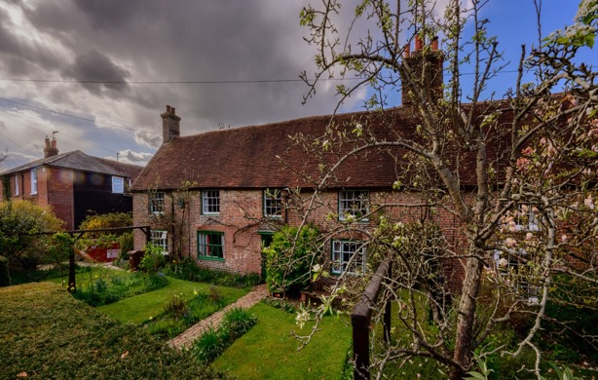

Thomas Turner’s House, East Hoathly

g. The Cricket Club was founded in 1759.

h. There has been a school in East Hoathly since at least 1755 with the current building dating to 1865.

i. The Parish Church was rebuilt in 1855 although the tower is believed to be circa 1500 and evidence was found during the rebuilding in 1855 of a 12th Century Norman Pillar Piscina and Norman windows.

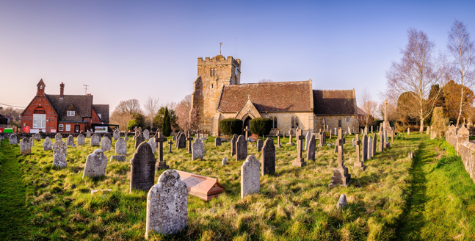

East Hoathly School and Church

j. Within Moat Wood there is a moated site, designated a Scheduled Monument. The site was probably set within a medieval landscape of dispersed settlement, comprising farmsteads, cottages and hamlets surrounded by fields and woodland.

k. East Hoathly has a history of torchlit bonfire parades and celebrations dating back to 1870 and the 1918 armistice saw the creation of the Carnival Society in commemoration of the dead of the First World War and subsequently the Second World War.

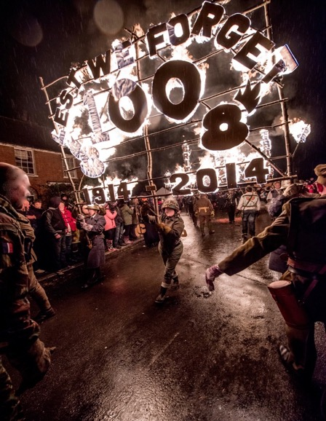

East Hoathly Carnival Parade

25. The Parish has 34 Listed Buildings and a single Scheduled Monument (full details can be found in Annex D). The Scheduled Monument is located near the centre of Moat Wood, East Hoathly. The majority of the Listed Buildings are within the designated East Hoathly Conservation Area (The Conservation Area was originally designated in 1995 but was reviewed and re-designated in 2017 and a larger part of the village was included). The designation of the Conservation Area introduces a general control over the demolition of unlisted buildings and provides a basis for planning policies to promote the conservation of all aspects of character or appearance that define an area’s special interest, including landscape and public spaces. The designation is supported by a draft Character Appraisal from 2021 that sets out the distinctive character and sense of place that create the area’s special interest, and considers the location and landscape setting of the area; Historic development; The character of the area in detail; Building materials and details: The contribution of the natural environment; and Issues having a negative impact on the character and appearance of the area. This should lead to a Management Plan for the Conservation Area.

Position within the WDC Planning Policies

26. WDC currently has three adopted planning documents.

a. Wealden LP 1998 - This covered the period 1994 to 2004. WDC has saved (meaning that this was approved by the Secretary of State in September 2007 and therefore remain valid policy) some of the policies from this plan and these are also available to view on the WDC Website. In the Wealden LP 1998, Halland and East Hoathly had Development Boundaries but no allocation of housing.

b. Wealden Core Strategy LP 2013 - This covered the period 2013 to 2027. The Wealden Core Strategy LP 2013 removed the Development Boundaries and allocated no housing allocation for the Parish.

c. Wealden Affordable Housing Delivery LP 2016 - This had no time period specified and is only related to the provision of Affordable Housing. This policy superseded WDC8 in the Wealden Core Strategy LP 2013. No allocations of housing were included.

27. Outside the adopted planning documents, WDC has produced Issues and Options documents in addition to all the documents pertaining to the now withdrawn Wealden Submission LP 2019. The options considered in these documents may not have become policy, but they have had a significant impact on the community. They show that the ideas put forward for the future of this Parish have varied considerably since 1998. It indicates to landowners and developers the options that WDC have considered. One result of this is that planning applications are submitted and many of these have been approved despite not being part of any adopted LP.

28. We fully accept that most of the options considered by WDC did not become policy but they were made public and the Parish Council believe that they have resulted planning applications being put forward in the Parish. They are part of the public discourse and it is important not to ignore them. They are part of the context of this NP. The detail of the changes in the way East Hoathly and Halland have been defined and categorised since 1998 can be seen in Annex A. This contains the proposals put forward in the now withdrawn Wealden Submission LP 2019. The Parish is fully aware that this withdrawn plan is not policy and carries no weight. However, it is part of the narrative history and context of WDC’s consideration of options for this community.

SECTION 3 - VISION AND OBJECTIVES

Vision

VISION FOR EAST HOATHLY WITH HALLAND IN 2039

Our Vision is that in 2039, East Hoathly with Halland will remain a thriving, healthy, safe and caring community that has met its changing needs and which caters for the health and wellbeing of residents of all ages. It will be less car dependent with more residents working in the parish. It will have preserved the distinctive character that has evolved over eight centuries.

It will have ensured the protection of its Heritage Assets and Green Spaces.

It will have accommodated housing developments to meet the needs of local people and supported a Community Land Trust (CLT) to provide affordable rented homes. It will have improved the balance of housing stock available and ensured that new homes are sympathetic to the distinctive nature of the Parish.

It will have sought to enhance its sustainability by supporting remaining and new businesses, improving accessibility and supporting improvements to utilities and services. It will have promoted and enabled healthier lifestyles.

It will have improved its contribution to a Carbon Neutral future and to achieving Climate Emergency targets.

Objectives

29. The Objectives are specific statements that set out what the community wants to achieve in realizing its Vision. The Objectives are separated into the categories of Development, Conservation, Environment, Health and Leisure, Business and Accessibility.

Development

a. Objective 1 To accommodate new housing development in accordance with WDCs emerging LP and to ensure that the Parish has an improved balance of housing stock to provide both smaller dwellings and retirement living accommodation.

b. Objective 2 To support the delivery of affordable rented homes for local working people.

c. Objective 3 To support the development of high quality, beautiful and sustainable homes that ensure that future developments will make a positive contribution to local character and distinctiveness.

d. Objective 4 To support development that promotes sustainable transport use by improving access to sustainable transport including walking, cycling, wheeling and bus services and the provision of sufficient EV charging points for residents and visitors.

e. Objective 5 To support the creation of resource efficient homes including net zero residential and non-residential development within the Parish.

Conservation

f. Objective 6 To preserve Listed Buildings in the Parish and their setting and any features of special architectural or historic interest; to protect the Scheduled Monument from damage; identify additional buildings suitable for statutory protection.

g. Objective 7 To preserve and enhance the Conservation Area.

h. Objective 8 To identify potential Assets of Community Value.

Environment

i. Objective 9 To protect and enhance the existing Ancient Woodland in the Parish and protect other important woodland and trees.

j. Objective 10 To protect and enhance the existing green infrastructure, and in particular the Hedgerows in the Parish (excluding private gardens).

k. Objective 11 To protect and enhance ponds and other waterways in the Parish (excluding private gardens) as habitats and to protect their role in the drainage system.

l. Objective 12 To identify Local Green Spaces to be designated within the Parish.

m. Objective 13 To protect and enhance the biodiversity in the Parish.

Health and Leisure

m. Objective 14 To improve the facilities for Leisure and Recreation in the Parish and in particular to improve the drainage of the East Hoathly War Memorial Sports Ground.

n. Objective 15 To maintain and improve access to nature and to play and recreation, increasing physical activity and providing health and wellbeing benefits such as positive mental health.

o. Objective 16 To maintain and improve social cohesion and reduce social isolation and loneliness.

p. Objective 17 To maintain and enhance opportunities for growing healthy food.

q. Objective 18 To provide lifetime and adaptable homes that meet the needs of an aging population.

r. Objective 19 To maximize opportunities for healthy design principles including active travel.

s. Objective 20 To identify a potential community open/greenspace and play area in Halland.

Business

t. Objective 21 To support local employers and agricultural/rural businesses within the Parish.

Accessibility

u. Objective 22 To improve access to key services and amenities within the Parish by protecting and enhancing Parish Footpaths and the single Bridleway, and to pursue opportunities for improved walking, cycling and wheeling infrastructure.

v. Objective 23 To support the improvement of bus services in the Parish.

w. Objective 24 To support the improvement of Mobile and Broadband services for domestic and business users and encourage the growth of people using Broadband to work from home.

Policies

30. The EHHNP objectives lead to the creation of policies and aspirations which aim to achieve the community’s vision for the Parish in the period 2022 – 2039.

31. The EHHNP must conform with the strategic policies of the WDC development plan and this includes the saved policies of the Wealden LP 1998, the Wealden Core Strategy LP 2013 and Wealden Affordable Housing Delivery LP 2016. It must also have regard to national policies contained within the NPPF 2021. The EHHNP policies alongside policies set out in the development plan will be used by WDC as the local planning authority to consider and determine planning applications. If WDC’s policies or the NPPF changes during the adoption process or subsequently, then any policy changes relevant to the EHHNP will be reviewed as part of the EHHNP Review Process and any new Wealden LP would take precedence if there was a conflict.

32. The Parish is aware that the NPPF 2021 has a presumption in favour of sustainable development and that any plan and decisions must take a positive approach in considering sustainable development.

SECTION 4 - HOUSING

AND HOUSING DESIGN

33. Section 4 examines the Parish in terms of its sustainability, changes in sustainability, infrastructure, housing, vehicles, streetscape and demography. This leads to policies dealing with housing and a housing design that focusses on resource efficiency, layout and materials used.

Sustainability

Current Sustainability

34. The Wealden Core Strategy LP 2013 defined the settlements of this Parish, within the settlement hierarchy, as:

a. East Hoathly - Neighbourhood Centre - A settlement with limited, basic or no facilities but with access to another centre, or a settlement with facilities but poor accessibility or access only to a service or local centre.

b. Halland - Unclassified Settlement - A settlement with few or no facilities and services, and where further development would be unsustainable.

35. The Wealden Core Strategy LP 2013 also removed the Development Boundary (included within the saved policies of the Wealden LP 1998) from both East Hoathly and Halland and proposed no growth for the Parish. WDC are currently updating its sustainable settlement study alongside the emerging Local Plan.

36. The Parish has a range of facilities and infrastructure that provides residents with some of their needs. They have to travel outside the Parish to meet the remainder of their needs. When more needs can be satisfied locally the location is more sustainable. The facilities currently available within our Parish are shown in Table 1 below:

Table 1 – Facilities in East Hoathly and Halland

Facility | East Hoathly | Halland
Nursery School | ✓ | ✓
Primary School | ✓
Doctor’s Surgery | ✓
Dispensary | ✓
Convenience Store | ✓ | ✓
Café | ✓ | ✓
Garden Centre |  | ✓
Post Office | ✓
Public House | ✓ | ✓
Place of Worship | Church of England | Independent Chapel
Community Hall | ✓
Children’s Play Area | ✓
Sports Pitches | ✓
Pavilion | ✓
Bus Services | ✓ | ✓
Employment Opportunities | Very Limited | Extremely Limited
Supermarket
Town Centre Shopping
Secondary School
Tertiary Education
Childcare Facilities
Veterinary Services | ✓  (Complementary medicine only)
Restaurants/Takeaways
Library
Swimming Pool
Leisure Centre
Cinema
Train Station
Hospital
NHS Dentist
NHS Optician
Civic Amenities

East Hoathly Church of England Primary School

37. East Hoathly CE Primary School is part of the Pioneer Federation, a partnership with Chiddingly Primary School, St Mary’s Hartfield CE Primary School and Park Mead Primary School (Upper Dicker). The Pioneer Federation seeks to promote educational provision and wellbeing.

Doctor’s Surgery

38. The East Hoathly Surgery was incorporated into the Buxted Medical Practice in 2001 (the Manor Oak Surgery, Horam has also now been added to this combined Practice).

39. The Doctor’s Surgery incorporates a Dispensary which is of considerable benefit to parishioners.

Convenience Store

40. East Hoathly benefits from having the Village Stores which stocks a limited range of groceries, a limited range of fresh produce, newspapers and periodicals. Halland benefits from having a very small selection of groceries and a limited range of fresh fruit and vegetables at Staverton Nursery.

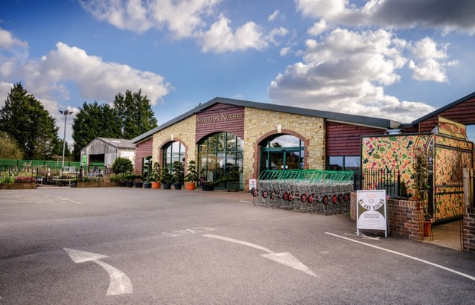
Staverton Nursery

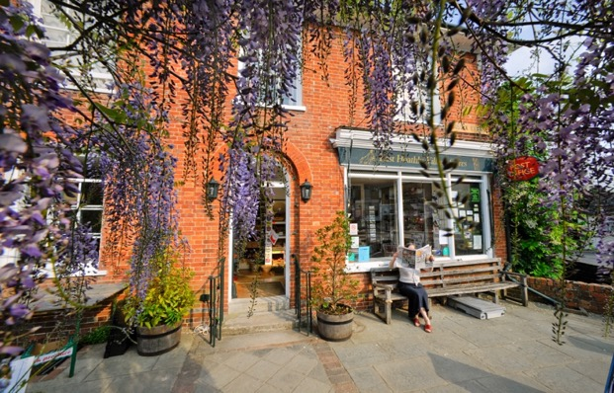
East Hoathly Village Stores

Cafes

41. East Hoathly benefits from having Muffins Coffee Shop/Boutique which serves a range of light meals and cakes. Muffins also sells jewellery, gifts, cards and prints. Halland also benefits from having a cafe as part of Staverton Nursery.

Garden Centre

42. Halland benefits from having a Garden Centre.

Post Office

43. East Hoathly benefits hugely from having a Post Office as part of the Village Stores. A significant number of business and home workers use the Post Office.

Public House

44. East Hoathly benefits from having the Kings Head Pub. Halland benefits from having the Blacksmiths Arms.

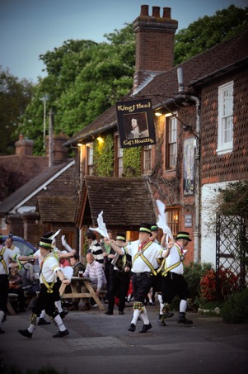
Morris Dancing outside the
Kings Head, East Hoathly

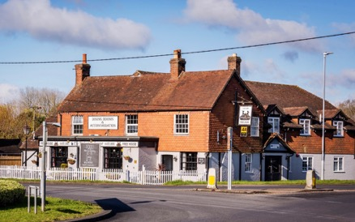

Blacksmiths Arms, Halland

Place of Worship

45. East Hoathly benefits from having the East Hoathly Church (Church of England). Halland benefits from having the Halland Chapel (Independent). Each serves the needs of their congregation but it should be noted that the needs of other denominations have to be found outside the Parish. East Hoathly Church has a formal connection with East Hoathly School and an active role in community life. East Hoathly Church hosts many village events including dramatic productions, music and cultural events.

Community Hall

46. East Hoathly benefits from having a Village Hall. This is used for a range of village society events and private hire for classes, meetings and social events.

Children’s Play Area

47. East Hoathly benefits from having a Children’s Play Area on the Sports Ground. There is also a smaller Play Area in the Nightingales development.

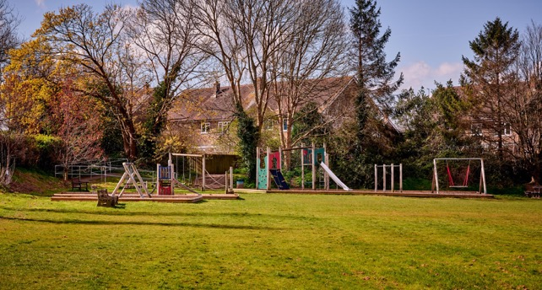

Childrens Play Area, East Hoathly

Sports Ground

48. East Hoathly benefits from having a Sports Ground with football pitch, cricket pitch, three tennis courts and a Rifle Club.

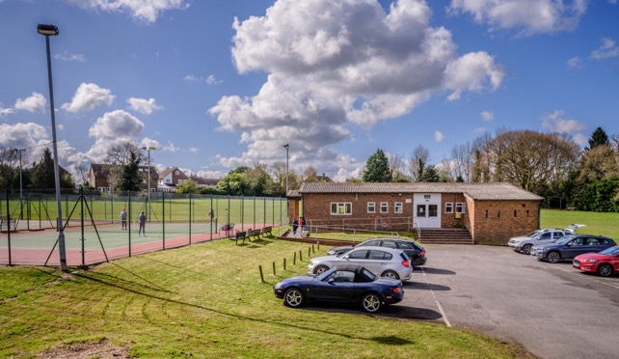

Pavilion and Tennis Courts, East Hoathly

Pavilion

49. East Hoathly benefits from having a Pavilion on the Sports Ground which has a kitchen, male and female toilets, one full sized changing room one small changing room and a main room.

Bus Service

50. One bus service passes through East Hoathly and two services visit Halland.

a. Route 54 Bus Service (Eastbourne - Hailsham - Uckfield)
This bus visits Halland and East Hoathly. Fourteen buses per day in each direction (excluding Sunday), roughly one bus per hour from 06.57 to 19.35

b. Route 28 Bus Service (Tunbridge Wells - Lewes - Brighton) This service only visits Halland.
(1) Six buses per weekday, three starting in Tunbridge Wells and three from Uckfield, 05.54, 07.47, 20.05, 21.05, 22.05 and 23.37. Only Five buses in return direction, three terminating at Uckfield.

(2) Five buses per Saturday, four starting in Tunbridge Wells and one from Uckfield, 06.09, 20.05, 21.05, 22.05 and 23.37. Only Four buses in return direction, three terminating at Uckfield.

(3) Eleven buses per Sunday two starting from Tunbridge Wells and 9 from Uckfield, roughly one bus per hour from 09.19 to 21.04. Only Eight buses in return direction all terminating at Uckfield.

c. Route 142 This service only visits East Hoathly. The Route 142 Bus Service (Polegate to Lewes) is one bus per school day and is for school children only. It stops in East Hoathly but is not accessible by the general public.

Other Businesses (excluding those covered above)

51. East Hoathly and Halland both benefit from the presence of other businesses. These offer some local employment opportunities albeit few in number. These businesses add to the local economy attracting customers into the villages and whilst they are very much valued, they do not serve the day-to-day needs of the community and are not considered to add, in any meaningful way, to sustainability.

Changes in Sustainability

52. Sustainability changes over time. New facilities can open, or existing ones can close. New services can be provided, or existing ones can be reduced. Existing facilities can increase their capacity, or they can reach the limit of their capacity. The categorization of a settlement in a settlement hierarchy is a statement of the sustainability assessed at that time but any changes in sustainability should always be considered when determining the current sustainability of a settlement. This is particularly important when considering planning applications where the last categorization in an adopted LP is cited as the current level of sustainability. East Hoathly and Halland were last categorized in 2013 and much has changed since then. This section examines the changes in sustainability during this period.

East Hoathly Church of England Primary School

53. The East Sussex School Organisation Plan 2020 - 2024 indicates that “Birth and GP registration data point to East Hoathly CE Primary School having potentially high in-area numbers in 2021/22 and 2022/23. The school may have to rely on the school admissions system restricting inflows to enable it to keep its intake numbers to the Published Admission Number (PAN) of 15”.

54. The latest East Sussex School Organisation Plan 2021 - 2025 is rather less helpful as it provides no data for East Hoathly School. It mentions no plans to expand East Hoathly School and does not yet acknowledge the proposed increase of 262 homes in the Parish.

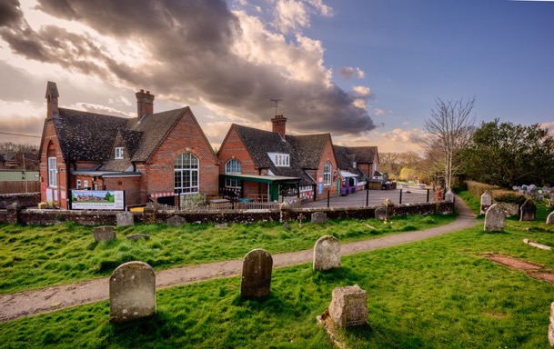

East Hoathly Church of England Primary School

55. The key point is that the school is at or very close to its PAN capacity and is forecast to remain in this situation until at least 2024. The recent approvals to add 262 homes in East Hoathly will add an estimated 55 children of Primary School age to the Parish (See Annex B). When these homes are completed, this could result in 184 children of Primary School age and a school with a capacity of 105. New housing may be built in phases (although WDC are opposed to this) and incoming families may not choose to change their children’s school immediately. Some families may choose to send their children to private schools and this will reduce the figure. Some parents will choose to send their children to schools outside the Parish but this may be balanced by parents who live outside the Parish choosing to send their children to East Hoathly School. All children schooled outside the Parish require vehicle usage with the pollution and congestion that arises from it.

Doctor’s Surgery

56. For over a decade the Surgery has suffered from a lack of General Practitioners (GPs) and this is equally reflected in the combined Buxted Medical Practice. An increasing number of East Hoathly patients are now being referred to the main Surgery in Buxted. During the Covid-19 lockdown, the East Hoathly Surgery closed completely as a result of staff shortages and all access to medical services was via Buxted. This declining access to medical services is of considerable concern for many parishioners.

57. The Surgery are aware of the shortage in GP cover and is actively recruiting. The situation is replicated throughout the Medical Practices of the South East. It may become the norm to have to travel to a larger facility to get GP access and this should be reflected in the sustainability criteria.

Sports Ground/Pavilion

58. The Sports Ground is poorly drained and this leads to unplayable conditions after wet weather. This was deemed unacceptable by the local football league and the players from the East Hoathly Football Club went elsewhere and the Club closed. The Pavilion is old and in poor condition. It has limited facilities most of which need refurbishment and do not meet modern sporting standards. The The Tennis Club is identified as having capacity issues (too many members for the number of courts available) in the WDC Playing Pitch and Outdoor Sports Strategy Report 2022.

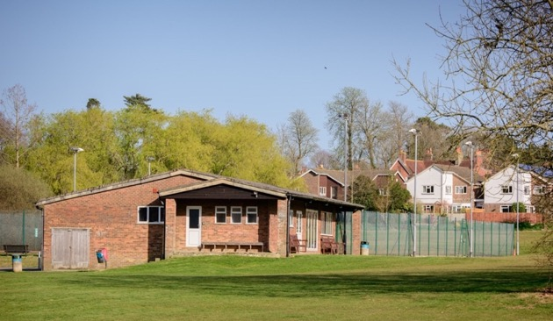

East Hoathly Sports Pavilion and Tennis Courts

Bus Service

59. The Bus Services have been reduced in frequency over many years. The Sunday service for the 54 Bus Service has ceased in the Parish and there are no longer any evening services. The timetable for the 28 Bus Service (which only visits Halland) is complex and curious. It is difficult to comprehend for whom the rather fractured service is intended. For those who use bus travel, it is really important, the problem is that very few people need or choose to use it. Local surveys showed that in a whole day (averaged for School Terms/Holidays), only 19 people from the Parish used the 54 Bus and no one used the 28 Bus. The average number of people on the buses that passed through the Parish was 3 per bus (the majority of the buses were double decker with an average bus capacity of 66).

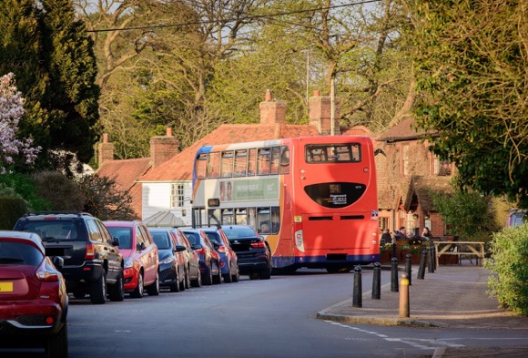

54 Bus - Negotiating the East Hoathly Post Office Bend

60. For those few people who use the bus it is a very important service but it is difficult to describe this extremely low level of bus usage as anything but ineffectual in being an alternative to car transport. It should be noted that this is following two housing developments in this community that have produced travel plans to improve bus usage which do not appear to have been effective. This is despite the cost of bus travel being reduced since August 2022 in an attempt to encourage greater usage and parish councils are being asked to promote the new tariffs. The East Sussex Bus Service Improvement Plan (BSIP) has proposals to provide an evening and Sunday bus service on Route 54, but this aspiration is dependent upon significant additional funding and there is no timetable for its implementation.

Other facilities Lost

61. The following facilities have been closed in the last 27 years:

a. The Smock Shop (traditional Sussex rural clothing) in East Hoathly closed in 1996.

b. The Public Toilets in East Hoathly closed in 1998.

c. The Halland Post Office closed in 1998.

d. The Butchers Shop in East Hoathly closed in 2001.

e. The Foresters Pub in East Hoathly closed in 2017.

Changes in Local Businesses

62. The Parish has many local businesses that do not feature on the list of facilities providing sustainability but they are an important part of our local economy. They attract customers and visitors to the community and provide limited employment opportunities for local people. However, as the nature of these businesses change, then it can have a detrimental effect on sustainability. If a food business changes to a gift shop, the level of employment may stay the same but the ability of the new shop to sustain the local inhabitants may be reduced. People need food on a regular basis but only occasionally need to buy a gift. Therefore, the need for the local inhabitants to travel is increased thereby reducing sustainability. In employment terms the change of nature of these business premises is often neutral but the effect on the community is important. Some examples of this have been:

a. The Butchers Shop was replaced by a Craft Shop which then became a Book Shop.

b. The Petrol Station/Garage was replaced with a range of small business units currently: Homeopathic Vet, Osteopathic Practitioner, Sign-writer, Glass Bead Maker, Photographers, Health House and Dressmakers.

Reductions in Local Employment

63. Since 1964 East Hoathly has seen a continuing reduction in local employment opportunities as planning consents have been granted to build housing on the sites of local businesses:

a. 1964 - Susans Close built on the site of a Workshop and Garden.

b. 1988 - Thomas Turner Drive built on the site of Trills Builders.

c. 1988 - Carpenters Croft built on the site of Bookers Pill Factory.

d. 2001/2 - An extension to the Mews built on the site of Chapman and Smith Safir Works.

e. 2009 - Juziers Drive and Trug Close built on the site of E&A Carriers and PB Fencing.

f. The current planning approvals for 260 homes will remove one of the Hesmond’s Stud business units and associated workers leading to further loss of local employment. The removal of agricultural land from a working farm to develop the land at South Street will reduce the level of work being done by that farm, and hence reduce the employment capacity of that farm.

64. Most of the facilities/services that provide sustainability in the Parish have been diminished in recent decades and there has been a gradual reduction in local employment opportunities. There have been improvements with the provision of a children’s play area in East Hoathly and the growth of Staverton Nursery in Halland to provide a small selection of groceries and a cafe. However, the overriding trend has been for a reduction in the level of sustainability and an increased dependence on cars (See Paragraphs 99 to 102). Many parishioners believe that East Hoathly should be redefined as an Unsustainable Settlement.

Infrastructure

Local Roads

65. The A22 Bypass was completed in 1993 and removed the bulk of North - South traffic from the centre of East Hoathly. This undoubtedly improved the quality of life for everyone in the village and allowed the atmosphere of a rural village to return. However, in recent years the amount of traffic on the A22 passing through Halland has considerably increased. The same is true of East Hoathly with ever more vehicles in the centre of the Village navigating the sharp and hazardous Post Office bend. Pedestrian safety has become an issue once again, particularly for the young and elderly.

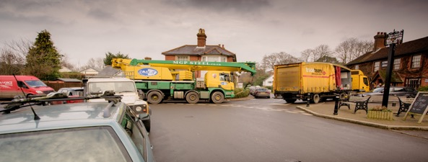
East Hoathly Post Office Corner - From High Street
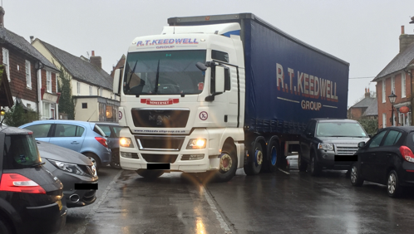
East Hoathly Post Office Corner from Waldron Road
66. The number of vehicles in Wealden has increased around 5% per year since 2009 and congestion has worsened steadily. Traffic in the narrow rural lanes has increased because of vehicles using back roads to avoid congestion on the A22 and B2192, the creation of many more farm based rural businesses and the growing number of home deliveries now drawing large delivery vehicles into both settlements and their narrow lanes. The speed of vehicles is usually too high, verges are being damaged by large vehicles and these lanes are increasingly unsafe and unpleasant for people trying to walk or cycle.

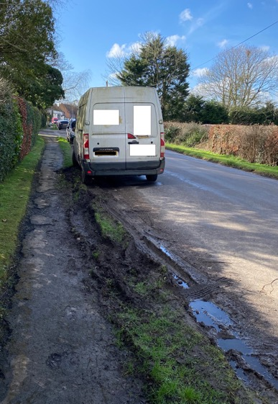
Damage to Verges on Waldron Road

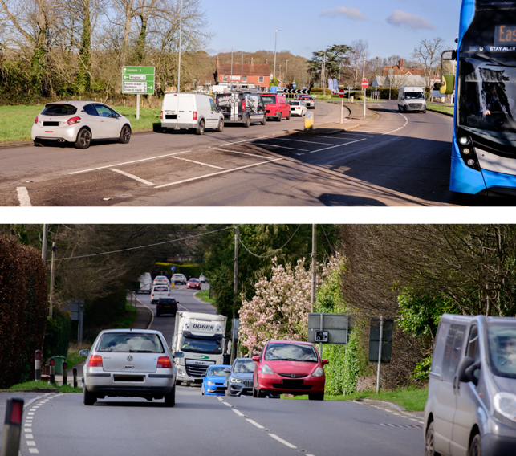

Traffic Congestion on A22 in Halland

67. The lanes to which this particularly applies are:

a. Knowle Lane in Halland.

b. Back Lane in Halland.

c. Waldron Road in East Hoathly.

d. Ailies Lane in East Hoathly.

68. East Hoathly and Halland are rural villages where everything that is needed to live and run households is delivered by road. Many houses in the villages and almost all isolated houses use oil or bottled gas and this is delivered by road. There is a significant and growing reliance on items being ordered online and therefore delivered by vehicles.

Sewage System

69. The East Hoathly and Halland Sewage Plants are known to be working close to their capacity. Both plants regularly discharge untreated sewage overflow into their river catchment areas (See Paragraphs 163 to 165 of this Plan for details). The existing sewage pipe network for East Hoathly was laid in the early 1950s. Since then, the housing connected to this network has been increased from 130 homes in 1950 to 380 homes in 2020. This is a 192% increase in the number of homes added to the sewage pipe network. It is known to be problematic in many properties in East Hoathly and during periods of heavy rainfall many properties suffer from hydraulic overload causing in their properties. The addition of a further 262 new homes will put more strain on the existing system.

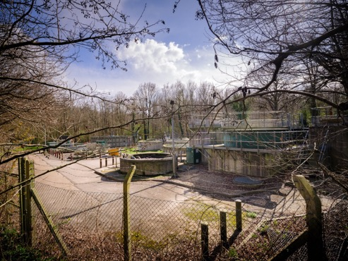

East Hoathly Sewage Treatment Plant

Electrical Supply

70. The electrical supply network to almost all homes in the Parish is from overhead cables. These are vulnerable to weather and tree disruption. Most of the homes in the Parish suffer from frequent power cuts. UK Power Networks recorded 24 power cuts for BN8 6** in the years 2018/2019 and 33 power cuts in the years 2020/21. Modern homes are increasingly dependent on electric devices and timing devices. This level of power cuts is clearly frustrating and irritating for all consumers but is particularly problematic for businesses and those with freezers.

71. The Climate Emergency should be pushing us into a future of renewable energy for all new developments. New developments will be dependent on Electric Vehicles (EVs), electric heating and electric cooking. Existing properties will also be required to transition to an electric future. There is considerable local concern that the existing electrical network is inadequate so the change to an all-electric future may not be possible without a significant upgrade to the existing electrical network. South Eastern Power Networks have no plans in their Long-Term Development Statement to upgrade the branch of the power distribution network that supplies East Hoathly with Halland and many other parishes.

Electric Vehicles

72. The government has set a date of 2030 to stop the sale of new fossil fuel vehicles and for all new vehicles to have 100% zero emissions from 2035. From 2030, all new vehicle owners may therefore need to install charging points in their homes. The Parish/WDC will also seek to install charging points in the public car parks. It is vital that all new developments are built with electric charging points and the Government have introduced changes to building regulations to enable this. The new building regulations make it mandatory for each new dwelling (with an associated parking space but excluding those within covered car parks) to have a charging point but does not make it mandatory for every new parking space to be built with a charging point. The new building regulations also sets a price cap on the provision of the charging points so that if the cost of providing the charging points exceeds the price cap, the developer can choose not to provide them. The building regulations also do not have any requirement for a development’s visitor parking to be provided with EV charging facilities. This Parish believes that future building regulations should require that every new development should provide a charging point for every resident’s parking space and for 1 in every 2 visitor spaces.

73. The transition to EVs and providing charging facilities will pose significant issues to all communities. Existing homes will have to fit their own charging arrangements and this could lead to unsightly cabling being added to forecourts. This will be of particular concern in the Conservation Area where many homes only have on-street parking and cables crossing pavements are not permitted. The Building Regulations 2010 (Part S) Regulation 44E (4) allows that the provision of a charging points for Listed Buildings and within Conservation Areas is not mandatory if “where compliance would unacceptably alter the building’s character or appearance”. However, this does not address how that Listed Building or home in the Conservation Area could then install a charging point that is acceptable. This will have a significant impact on the character, appearance and safety of the places we live and work. WDC currently deal with each EV charging point application on a case-by-case basis but this Parish feels that more substantial guidance is required to control what will become a fundamental part of house design and the visible frontage of almost every home and business.
74. UK Power Networks state that in early 2021 there were 100,000 EVs using their networks. They forecast having 4.5 million by 2030 (just in London, the South East and East of England). They have produced an Electric Vehicle Strategy that begins to explore the issues raised by the transition to EVs. This strategy document identifies several issues:

a. They believe the current transition to EVs is currently 40% below the target.

b. They acknowledge that the use of one 50kW rapid electric vehicle charger is the equivalent to the routine use of a block of 25 flats.

c. That there is poor provision of charging infrastructure and high connection costs especially for rural areas.

d. There is a question as to whether there will be enough capacity to supply the need.

e. There is a question as to whether there will be voltage and thermal issues caused by the new loads.

75. The Wealden Climate Emergency Plan 2019 acknowledges the need to move towards electric but does not contain any calculation of the expected change in power demand and thereby no assessment of the credibility of achieving it. It noted that in 2019 there were 12 publicly accessible charging points in Wealden and a press release in November 2020 this had increased to 17. An imminent role out plan was announced in November 2021 but was not published. A WDC press release dated 6 May 2022 stated that there are 23 EV charging points in Wealden District (although the Zapmap Website only shows 22 as at 19 July 2022). There remains no public charging point in this Parish.

76. What seems to be clear is that the deadline for all new vehicles being EVs is rapidly approaching but much of the infrastructure is not in place. The cost is going to be high and that rural areas will be the most expensive. The building regulations cap cost and the higher costs of rural infrastructure upgrades are likely to mean that this Parish will be left behind in this transition.

Accessibility

77. The Accessibility of the Parish is an important factor in its sustainability. This is covered in more detail in Section 9. This includes the Infrastructure for Broadband and Mobile Phone Coverage as well as footpaths and bus services.

Housing

Housing in the Parish

78. The Housing in the Parish is mostly concentrated in the villages of East Hoathly and Halland with some smaller hamlets and a significant number of isolated rural dwellings. This Parish is conscious of the changing needs of the local community and the housing stock. This Plan seeks to redress the imbalance in the Parish housing stock and to provide smaller homes for local people to downsize and for local people to access the housing market. The following tables show data from the 2011 Census comparing the Parish with Wealden and the South East region and England. In some cases, data is also available for East Hoathly village.

79. Table 2 shows the different forms of housing available. The highlighted text shows the significant imbalance in the housing stock with fewer flats compared with a larger proportion of detached homes.

Table 2 - Housing Type

Area | All Dwellings | Detached | Semi-Detached | Terraced | Flat
South East | 3,694,388 | 1,037,388 | 1,022,394 | 829,923 | 788,570
 |  | 28.1% | 27.7% | 22.5% | 21.3%
Wealden | 65,159 | 29,030 | 19,581 | 8,289 | 7,532
 |  | 44.6% | 30.1% | 12.7% | 11.6%
East Hoathly with Halland | 639 | 322 | 190 | 87 | 34
 |  | 50.4% | 29.7% | 13.6% | 5.3%

80. Table 3 shows the different forms of housing available. The highlighted text shows the significant imbalance in the housing stock, with fewer homes with one bedroom when compared with a larger proportion of houses with four or more bedrooms.

Table 3 - Housing - Number of Bedrooms

Area | Total | No Bedrooms | 1  Bedroom | 2  Bedrooms | 3  Bedrooms | 4+ Bedrooms
South East | 3,555,463 | 8,531 | 413,761 | 932,994 | 1,383,662 | 816,515
 |  | 0.2% | 11.6% | 26.2% | 38.9% | 23.0%
Wealden | 62,676 | 94 | 4,783 | 17,670 | 22,213 | 17,916
 |  | 0.1% | 7.6% | 28.2% | 35.4% | 28.6%
East Hoathly with Halland | 620 | 1 | 28 | 128 | 224 | 239
 |  | 0.2% | 4.5% | 20.6% | 36.1% | 38.5%

81. Table 4 repeats some of the data from Table 3 but adds a comparison with the Rented sector. The highlighted text shows the significant imbalance in the housing stock with fewer homes with one bedroom when compared with a larger proportion of houses with three or more bedrooms. Data for the rented sector in the Parish is not available but it might be that a similar trend is followed in the highlighted text for One Bed Social Rented homes.

Table 4 - Housing - By Number of Bedrooms and Tenure

Area | One Bed  All Sectors | Two Bed  All Sectors | Three + Bed All Sectors | One Bed  Social Rented | Two Bed Social Rented | Three + Bed Social Rented
England | 12.0% | 27.9% | 60.1% | 30.8% | 34.4% | 34.8%
South East | 11.9% | 26.2% | 26.2% | 32.4% | 33.0% | 34.6%
East Sussex | 12.7% | 30.9% | 56.4% | 32.8% | 32.4% | 63.5%
Wealden | 7.8% | 28.2% | 64.0% | 24.1% | 44.5% | 42.2%
East Hoathly with Halland | 4.7% | 20.6% | 74.7% | Data not available | Data not available | Data not available

82. Table 5 shows data from the 2011 Census comparing the Parish with Wealden District, the South East region and England. The highlighted text shows the significant imbalance in the forms of tenure in the Parish and the significant lack of rented accommodation in comparison to the rest of England and the South East region.

Table 5 - Housing - Tenure/Ownership

Area | All Tenures | Owned | Social Rented | Private Rented | Rent Free
England | 22,063,368 | 13,975,024 | 3,903,550 | 3,401,675 | 295,110
 |  | 63.3% | 17.7% | 15.4% | 1.3%
South East | 3,555,463 | 2,404,517 | 487,473 | 578,592 | 45,601
 |  | 67.6% | 13.7% | 16.3% | 1.3%
Wealden | 62,676 | 49,355 | 4,808 | 6,973 | 1,037
 |  | 78.7% | 7.7% | 11.1% | 1.7%
East Hoathly with Halland | 620 | 480 | 53 | 64 | 15
 |  | 77.4% | 8.5% | 10.3% | 2.4%

83. Table 6 shows the Housing Mix by bedroom types recommended in the WDC Housing Needs Assessment 2021 for the whole District. This identifies a need for more homes with one bedroom in the Affordable Homes sector, but does not reflect that this is also needed in the Market sector. The WDC evidence base shows that only 5% of Market housing is to be one bed compared with the current stock figure of 7.8 % for Wealden and an East Sussex figure of 12.7%. Over 77% of the housing in this Parish is privately owned so, not tackling the market sector for one Bedroom houses will not rebalance the housing needs of the Wealden District nor this Parish. The WDC recommendations also still propose a significant proportion of 4+ Bedroom homes that are already in excess of the District and Parish needs.

Table 6 - WDC Housing Mix Recommendation

Housing Type | 1 Bedroom | 2 Bedrooms | 3 Bedrooms | 4+ Bedrooms
Market | 5% | 30% | 40% | 25%
Affordable Owned | 20% | 40% | 30% | 10%
Affordable Rented | 40% | 30% | 25% | 5%

84. The WDC Housing Needs Assessment 2021 identifies a predicted 56% increase in the population of 65 + year old residents in the next 20 years. This supports the findings of the Parish Survey 2016, Feria Interim Report and EHHNP Consultation Process which also identified the needs of the Parish for smaller homes in all sectors as starter homes for local people, and homes suitable for downsizing.

85. The ONS data and the WDC Housing Needs Assessment 2021 clearly show that this Parish has an imbalanced housing stock with too many large detached homes and a deficit of smaller one and two bed homes. This is particularly the case in the rented sector. These are the kind of homes needed as starter homes for local people and for the elderly who wish to downsize. This would provide housing that is aligned to the needs of the community.

New Housing Development Approvals in the Parish

86. WDC granted Outline Planning Consent for 205 homes in East Hoathly on Hesmond’s Stud land in July 2020. This planning application was determined in a situation where WDC could not demonstrate a 5 Year Land Supply position and therefore adopted local planning policies relevant to the determination of the housing application were considered out of date.

87. WDC rejected a planning application for 55 homes on South Street in East Hoathly in 2020, but the applicant successfully appealed this decision and this application now has outline planning consent. Again, this planning appeal was determined in a situation where WDC could not demonstrate a 5 Year Land Supply position and therefore adopted local planning policies relevant to the determination of the appeal were considered out of date.

88. The proposed development on South Street will provide some additional open space for its residents on the greenfield development site.
The proposed development at Hesmond’s Stud will provide a temporary addition of 5 buses on a Sunday for 3 years and the provision of some open space for the new residents on the greenfield development site. The view of residents is that these additions to facilities and services are not considered, by any measure, adequate to cope with a more than doubling in the size of East Hoathly.

Scale

89. The scale of any development is a matter that should form part of the WDC strategic plan and the NPPF requires that this be considered. Paragraph 73 of NPPF 2021 makes it clear that any large-scale development should ensure that the size and location of any development will be sustainable. It should also consider matters such as phasing of delivery in order to manage the impact on the local services, infrastructure and local community.

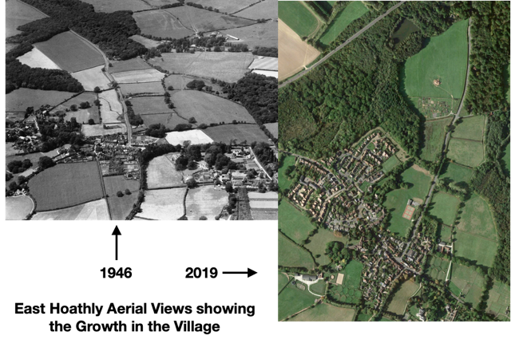

90. The following charts show the growth in housing in the Parish and the village of East Hoathly over time. Figure 3 shows the number of homes in the Parish expanding steadily from less than 125 in 1841 doubling to just under 250 in 1961. The rate of growth has risen steeply since 1961 with the completion of 931 homes by 2022. Figure 4 shows the number of homes in East Hoathly village expanding slowly from 55 in 1841 to 194 in 1976. The sharp rise since 1976 shows the completion of 642 homes by 2022. The Parish believes that significant new development should be allowed time to be absorbed into the community and that phasing should be considered for any major planning application.

Figure 3 - Growth in Number of Homes in
East Hoathly with Halland Parish

Figure 4 – Growth in Number of Homes in East Hoathly

91. East Hoathly village has seen significant growth in the last 22 years and is destined to grow further. In the first decade of this period, housing in the village of East Hoathly increased from 294 to 377 which represents a 27% increase in the number of homes. During the period since 1998 the Parish has not been allocated any housing as part of an adopted LP. However, since 1998 the Parish has seen significant housing development with more now approved by WDC.

a. The Mews, East Hoathly 2001/2 - Addition of 8 homes.

b. Juziers Drive/Trug Close/Carriers Way, East Hoathly 2009 - Addition of 45 homes.

c. Nightingales, East Hoathly 2009 - Addition of 30 homes.

92. The WDC Five Year Housing Land Supply Statement 2022 indicates that this Parish is destined for the following further additional housing amounting to 271 homes:

a. Old Hartfield, Halland 5 Almost complete

b. 23 High Street, East Hoathly 1

c. Land at Buttsfield Lane , EH 2

d. Staverton Nursery, Halland 1

e. Granary, Crockstead, Halland 1

f. Hesmonds Farm, East Hoathly 1

g. Hesmonds Stud, East Hoathly 205

h. South Street, East Hoathly 55

93. From 2021 to 2028, this will represent a 136% increase in the population of East Hoathly and a 90% increase in the population the Parish. This Parish believes that the scale of such increases is unsustainable without a strategic plan to improve services and infrastructure yet no plan has been put forward. The growth of this Parish, and in particular, East Hoathly village, will see this community grow proportionally bigger than any other community in Wealden as can be seen in Figure 5, which shows the population growth in the Parish in comparison with other parts of Wealden District that have also seen significant growth since 2001.

Affordable Housing

94. The Wealden Affordable Housing Delivery LP 2016 has the intention of delivering 35% affordable housing as part of any development of 11 or more houses outside of the High Weald AONB. WDC has identified a need to deliver 519 Affordable Rented Homes per year and 335 homes for Affordable Home Ownership.

95. This Parish absolutely recognizes the importance of Affordable Housing need in the District, but has significant concerns that the bulk of the Affordable Housing need is in urban areas close to the facilities they provide. There are only a handful of families on the WDC housing register with the Parish of East Hoathly with Halland as their first choice. It is clear that although there is a need for some affordable housing for people on the housing register, the local need is small and more than already addressed by recent planning approvals. Building affordable homes in excess of the local need necessitates placing people on the housing register into locations not of their choosing. This places them away from the services and jobs that they need to sustain them. It also often places people from urban settings into rural communities to which they have no connection.

Local Connection

96. The question of what constitutes a local connection is not a matter of land use policy but it is of significant interest to local people and is included here for the interest of those who may seek to gain access to Affordable Housing. It is an important matter that is controlled by the Housing Authority under the terms of the Housing Act. The following are the current criteria for applicants with a Local Connection in Section 3 of WDC’s Housing Allocations Policy 2020 that would be applied:

“a. Applicants who currently live within the Wealden District and have done so continuously for at least two years, or

b. Applicants who have lived in the Wealden District for 3 out of the last 5 years, or

c. Applicants who have a close adult relative (over 18 years of age) (mother, father, adult children or siblings) who currently lives in Wealden and has resided in the district for at least five years continuously, or
d. Exceptional circumstances - where failure to reside in the district would cause hardship to the applicant or others (to be agreed by the Wealden Housing Options and Strategy Manager on a case-by-case basis).”

Community Land Trust

97. The East Hoathly with Halland Community Land Trust was established in 2018. The Parish Council fully supports the aspirations of the CLT. Their vision is:

“We are an independent community-led organisation seeking to develop innovative, affordable housing to be held in perpetuity for the people of the parish of East Hoathly with Halland.

Our aim is to create an exemplar zero-carbon housing development in keeping with the historical heritage, local landscape and vibrant community fabric of the parish.

With shared values of community, companionship and ecological responsibility at its heart, the Community Land Trust will create high-quality sustainable homes within a financially empowering model. This ensures a future-proof legacy of affordable homes for those who can demonstrate an ongoing link to the local area, but who may not be able to otherwise afford a property in the local area, young families, downsizers, co-housers, alongside the provision of work-space appropriate to the heritage of the parish.

Flexibility is key: the scheme is site specific, offering a range of owner/occupier, leasing, social housing and co-housing options. Our mission is to initially develop a pilot scheme of 4-6 properties while in tandem consulting with the wider community to draw out the outline of a more comprehensive scheme

We are working in conjunction with the Sussex Community Housing Hub.”

98. The East Hoathly with Halland CLT commissioned a Housing Needs Survey from Action in Rural Sussex (AIRS) in 2019. The purpose of this study was to objectively assess the current scale and nature of the need for affordable housing in East Hoathly with Halland Parish. This identified those households whose housing needs were not currently being appropriately met and who could not afford to meet them on the open market within the parish. The Survey revealed strong support for a CLT provision of affordable housing. In the CLT Survey, 21 households identified their home as being unsuitable for their household’s current needs. The main reasons identified for this unsuitability were lack of affordability and the need for more secure tenure. Of these 21 households, 16 indicated they needed homes with 1 or 2 bedrooms.

Vehicles

Car/Van Ownership

99. Table 7 shows data from the 2011 Census comparing the Parish with Wealden District, the South East region and England. The highlighted text shows the significantly higher level of car/van ownership in comparison to the rest of England. It shows that the car/van ownership for the Parish is 1.8 per household compared to 1.2 in England. The percentage of households with 2 or more cars/vans in the Parish is 61.3% which is double the level of England and compares with 48.3% for Wealden District.

Table 7 - Cars/Vans per Household

Area | All homes | N°  Cars/  Vans | 1  Car/Van | 2  Cars/Vans | 3  Cars/  Vans | 4 +  Cars/  Vans | All  Cars/Vans in area | N° of Cars/  Vans per home
England | 22,063,368 | 5,691,251 | 9,301,776 | 5,441,593 | 1,203,865 | 424,883 | 25,696,833 | 1.2
 |  | 25.8% | 42.2% | 24.7% | 5.5% | 1.9%
South East | 3,555,463 | 660,430 | 1,483,911 | 1,059,380 | 253,552 | 98,190 | 4,803,729 | 1.4
 |  | 18.6% | 41.7% | 29.8% | 7.1% | 2.8%
Wealden | 62,676 | 7,801 | 24,608 | 21,416 | 6,091 | 2,760 | 98,259 | 1.6
 |  | 12.4% | 39.3% | 34.2% | 9.7% | 4.4%
East Hoathly with Halland | 620 | 39 | 201 | 268 | 76 | 36 | 1,127 | 1.8
 |  | 6.3% | 32.4% | 43.2% | 12.3% | 5.8%
100. Parish surveys show that the level of car/van ownership is even higher than that recorded in the 2011 Census. The Parish survey in 2016 showed a figure of 2.02 cars per household. Surveys carried out by counting the number of cars in the East Hoathly village during 2 nights in 2019 showed a level of 2.24 cars/vans per household. This seems to indicate a clear trend that car/van ownership is increasing in the Parish and also indicates an increasing level of car dependency.

Travel to Work

101. Table 8 shows Method of Travel to Work data from the 2011 Census comparing the Parish with Wealden District and the South East region. The highlighted text shows the significantly lower level of Public Transport usage in the Parish. It also shows the slightly higher level of dependency on vehicles to get to work at 81.2%.

Table 8 - Method of Travel to Work

Area | Total people who Travel to Work | Public Transport | Car/Van/Taxi/Motor Cycle | Cycle | Foot
South East | 3,762,813 | 327,233 | 2,844,304 | 127,614 | 463,662
 |  | 8.7% | 75.6% | 3.4% | 12.3%
Wealden | 63,682 | 6,539 | 50,666 | 717 | 5,760
 |  | 10.3% | 79.6% | 1.1% | 9.0%
East Hoathly with Halland | 702 | 48 | 570 | 7 | 77
 |  | 6.8% | 81.2% | 1.0% | 11.0%

Vehicle Dependency

102. The statistics from Tables 7 and 8 show the vehicle dependent nature of this rural parish and car dependency. There are arguments that the changing nature of modern life is reducing this car dependency with more people working from home and the use of home delivery reducing the need to travel to larger urban centres. However, these changes in modern life bring with them additional pressure on rural parishes from vehicles:

a. Every home delivery brings a vehicle into the Parish (often with a much larger vehicle than the car that would have done the job).

b. Home deliveries are now made for individual small items which might previously have been collected as part of a bigger shopping trip.

c. Deliveries of takeaway food is very limited in the Parish as most firms will not deliver to such locations but Individual meals can now be ordered from outlets such as “Dispatch” and always by some form of vehicle.

d. Supermarket home deliveries have increased, particularly during the Covid-19 pandemic, but this is not believed to have reduced the number of shopping trips made by most households and is expected to significantly reduce after the Covid-19 pandemic.

e. People who have chosen to work from home, rather than in an urban centre, now have to travel for shopping and leisure facilities whereas previously they may have incorporated this into their working travel.

Car Parking

103. The ESCC Guidance for Parking at New Residential Development 2017 recognizes the increasing trend in car ownership. It acknowledges that poor parking design and inadequate space for maneuvering can exacerbate parking issues. It recognizes that tandem parking is rarely effective and leads to on-street parking. It states that only 33% of garages in East Sussex are used for cars. All of this leads to new developments that have garages not used for cars and significant levels of on-street parking.

104. Car Parking is a problem in most of the Parish housing developments. Older developments were built in an era when car ownership was limited and the size of vehicles was much smaller than the modern vehicles now available. Many of these older developments were allocated communal garage areas (East Hoathly has 6 of these communal garage areas) but the size of these garages is now too small for many modern vehicles and the access is often narrow with very tight turning areas. This view is supported by the WDC Design Guide. The vehicles that should be garaged in them are therefore generally parked on the streets. This issue was also highlighted in the EHHNP Character Appraisal 2022.

105. Many parishioners also have the addition of caravans or other recreational equipment that takes up their allotted space and thereby forces them to park their cars on the streets.

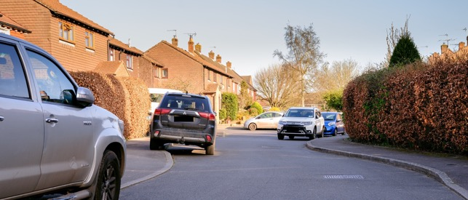

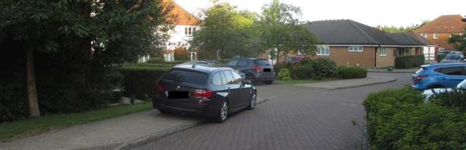

Examples of On-Street Parking in the most recent Parish Housing Developments

106. Parking for new developments is generally provided to the minimum standard set down by ESCC and these spaces are too small for many modern vehicles and too few for existing vehicle ownership. The result is more on-street parking. From an aesthetic perspective it also creates a very unappealing view of the places in which people live. Cluttered forecourts crammed with vehicles that spill out onto the roads and encumber the pavements.

107. The most recent developments in the Parish do not identify which parking spaces are allocated for visitors and all parking spaces are normally occupied. It is not possible to prove that the allocated visitor parking spaces are being used by visitors but it is possible to assert that if you try to visit the new developments you are highly unlikely to be able to locate an empty visitor parking space. So, either residents are using the visitor parking spaces or, there are too few visitor parking spaces.

108. The space allocated for a parking bay is too small and for the average sized car, only leaves 63 cm between vehicles which is too narrow to open doors fully or gain entry without contortions. However, almost one third of all vehicles registered in the UK are SUVs (the largest category of car with an average parking gap of 53 cm). The result is more on-street parking. This is readily visible in our newest housing developments. WDC support the ESCC standards but this Parish wishes to note that these standards are inadequate.

109. Self-employed residents often have an additional vehicle for their trade and this has to be parked in the Parish. NPPF Paragraph 109 recognizes the need for overnight parking of lorries but this does not extend to self-employed business vans and vehicles. The parking allocation in modern housing developments does not allow for these additional vehicles and they usually end up being parked on the streets. These are often large vans and this creates access problems as the narrow streets are not designed to have such vehicles parked on them. The result is that they are commonly parked on the approaches to the village. These large working vehicles are inappropriate in scale and appearance to park in residential areas.

Streetscape

110. The visual appearance of the Streetscape is a very important factor in establishing the character of the place people live. This was frequently identified as an issue in the EHHNP Character Appraisal 2022.

111. Household waste collection has changed significantly in recent decades. The requirement to separate waste for recycling and the fortnightly collection of each type of waste means that there is a need for more bin space and storage space for household waste. The increasing amount of home deliveries of goods and corresponding increase in volume of packaging materials has exacerbated the amount of household waste. Many urban environments are blighted by a permanent frontage of properties with overflowing waste containers. The rural environment is less troubled by this but it is now evident in many of our developments. New developments should be designed to have adequate concealed waste storage for bins and packaging materials.

112. The supply of electricity and telephone cables to most properties in the Parish is by overhead supply and there is no fibre-optic cable provision into homes. This leads to a poor quality of provision. There are frequent power cuts (see Paragraph 70) and broadband is often intermittent and slow. New developments should have underground supplies for electrical supply, telephone and fibre-optic cable.

Demography

113. The demography of the Parish shows that the population is ageing, with those aged over 45 increasing from 47% in 2001 to 53% in 2011 with the trend expected to be confirmed when the 2021 census data is available. The WDC Local Housing Needs Assessment 2021 projects that in the plan period, there will be a 56% increase in the population aged over 65. This therefore increases the need for homes suitable for retirement. The ageing population brings with it a greater need for homes suitable for those with mobility problems, wheelchair users and those requiring accessible and adaptable dwellings.

114. The current state pension age is 66 (due to begin increasing again from 2026) and this is generally taken as retirement age. The Government Response to Planning for the Right Homes in the Right Places Consultation proposed to widen the definition of retirement, in respect of accommodation, to include people approaching retirement. Older persons accommodation needs range from those who might be aged 55 and older who are active elderly but do not require support or care services, to those who require residential care homes or nursing homes. Older people may be completely independent but just want to downsize as they retire, or approach retirement. This can then transition into requiring some support or care to help them remain in their own home which might need adaptions and accessibility changes. Irrespective of the level of support or care the elderly need, the need for more retirement homes has been a constant comment in surveys and discussions on housing. In this Parish it has identified a need for 1 and 2 bedroom homes for retirement and downsizing.

115. Levels of diversity in this rural parish are extremely low with only 1% of the population in 2001 being from an ethnic background other than white and 3% in 2011.

116. Data for the health of the population show that in 2011, 84% were in good health with 12% described as fair health and 4% in bad health. Dementia in the aging population is a factor that will become increasing significant in coming decades. Creating a built environment that enables older people to live well and cope with illnesses such as dementia will become ever more important. Developers should be encouraged to follow the guidance of the Royal Town Planning Institute on dementia, the East Sussex Dementia Joint Strategic Needs Assessement and the Housing our Aging Population Panel for Innovation (HAPPI) guidelines.

Summary - Sustainability, Infrastructure, Housing, Vehicles Streetscape and Demography

117. Paragraphs 33 to 116 have examined the factors that have a bearing on planning policy in relation to housing. The first part examined the sustainability of the Parish, looking at the current facilities and services and changes that have affected sustainability. This was followed by an explanation of the infrastructure issues that are affecting the Parish. The final element explored the current housing stock and housing needs including the overriding importance that vehicles play in such a vehicle dependent Parish. This information has been used to inform the Housing Policies that now follow.

EHHNP Policy 1 - Housing

P1.1 New housing development will be supported if it provides a mix of different house sizes to meet the needs of the local community and the proposal seeks to redress the imbalance of housing stock in the Parish. This would be through the delivery of a higher proportion of homes of one or two bedrooms and a greater balance of smaller homes for retirement and downsizing. New housing will also be supported if it reflects the needs of the older people, those with accessibility issues, wheelchair users and those with dementia.

EHHNP Aspiration 1 - Community Land Trust

A1.1 This Parish will continue to support the work of the established East Hoathly with Halland Community Land Trust which is working to develop innovative, affordable housing to be held in perpetuity for the people of the Parish of East Hoathly with Halland.

Housing Design Policies

118. The Housing Design Policies of the EHHNP apply to all housing development in the Parish. These principles should be applied to any scale of new housing development, infill development, or refurbishment/conversion of existing property. The Housing Design Policies do not apply to commercial buildings.

119. Architecture in the Parish spans 500 years of design ideas and fashions but is at its heart rural and generally following the traditional vernacular of Sussex. It is all set within a high quality landscape and aesthetically pleasing rural backdrop. The main settlements differ as follows:

a. East Hoathly has a few buildings dating from the seventeenth century and an historic core of Georgian and Victorian buildings. Modern buildings have been built to reflect the general style of the historic buildings with varying degrees of success.

b. Halland has a few buildings dating from the seventeenth century and a small number of nineteenth century houses built as a linear development centred on the A22/B2192 roundabout. Modern buildings have been built to reflect the general style of the historic buildings with varying degrees of success.

120. This Neighbourhood Plan supports the NPPF objective to create “high quality, beautiful and sustainable buildings and places” (NPPF 2021, Paragraph 126). Development proposals will be required to demonstrate that their design is in accordance with the provisions of the National Design Code and Wealden Design Guide 2008 in relation to the Low Weald Character Area or any subsequent design guide or code produced by WDC. This would also conform to the saved development plan policies EN1 and EN27, within the Wealden LP 1998. Development proposals within or on the edge of the designated Conservation Area should take into account the information available in the draft East Hoathly Conservation Area Character Appraisal 2021 and any future management plan for more local design and material guidance.

121. The following section examines factors that have informed the Housing Design Policies, beginning with the EHHNP Character Area Appraisal and Sustainability.

EHHNP Character Area Appraisal

122. A Character Area Appraisal has been prepared as a supporting document to the EHHNP. The Character Area Appraisal analyses the character of the Parish by identifying distinct character areas within the Parish and then assessing them against a list of criteria looking at topography, land use, access, landmarks, views, buildings, streetscape, layout and dark skies. The appraisal identified detractors to the character of the Parish. These are features that add little to or detract from the character of the Parish. They are features that can be found in many parishes and do not reflect the character and history of East Hoathly with Halland. The Character Appraisal recommends that whenever there is the opportunity to remedy detractors that already exist, these should be taken to enhance the character of the Parish. It is also recommended that these design features should be avoided in new developments or be factors to which designers should be sensitive.

123. The Character Appraisal made the following recommendations based on the identified detractors:

a. Designs should reflect the traditional layout of rural settlements avoiding cul-de-sacs where possible. If cul-de-sacs are proposed, they should reflect the best examples of the Parish with permeability and access to allow pedestrians and cyclists to have connections through the cul-de-sac to the remainder of the settlement and its surroundings.

b. The architecture, materials and density of any development should be compatible with the local vernacular in the Parish and make a positive contribution to local character and distinctiveness.

c. Provision for electrical supply, telephone cable and fibre-optic cable should, whenever possible, all be underground from the entrance to the development.

d. Designs should seek to avoid road layouts where the width of the road, or curves in the road, create a situation that is vulnerable to the road being blocked by parked vehicles.

e. Designs and layouts should achieve a sense of place by protecting and enhancing the quality, distinctiveness and character of the existing settlement. Respecting or enhancing the character of the site and its surroundings in terms of its proportion, form, massing, density, height, size, scale, materials and detailed design features.

f. Designs and layouts for new development should, where possible, seek to avoid uniformity. Designs and layouts should seek to reflect the range and variety of buildings that have already been established in the settlement and maintain the character and charm of existing historic rural developments. Whenever possible, gaps in the built environment should be maintained and infill development resisted if it damages the character and appearance of the settlement.

g. Designs should ensure development of land in proximity to heritage assets and their settings, conserves, preserves, reflects and enhances the heritage asset and the historic environment in accordance with their significance.
h. Designs should ensure development safeguards, respects and enhances the natural environment, the biodiversity, landscape and wildlife corridors and the countryside. Incorporating where appropriate, biodiversity, trees, landscaping and public and private open spaces and supports the creation of wildlife corridors.

i. Designs should ensure the layout and the design takes account of the potential users of the development to promote active travel and provide safe, convenient and attractive links within the development and to existing networks for people with disabilities and restricted mobility, pedestrians, cyclists and public transport users.

j. Designs should ensure that the development does not cause an unacceptable adverse impact on the amenities of occupiers of existing or proposed nearby properties. Wherever possible, the significant views into and out of settlements should be preserved.

k. Boundary treatments should be varied, incorporating a mix of such things as walls, hedgerows, post and rail fencing, picket fencing and railings. Close boarded fencing should be avoided.

l. Designs should ensure that adequate infrastructure, services and community facilities are, or will be, made available to serve the development.

m. Ensure that site layout and building design helps to provide a safe and secure environment which promotes the health and wellbeing of residents, reduces social isolation, supports healthy lifestyles and improves social cohesion by providing places for people to meet and sit in open spaces and greenspaces.

Sustainability

124. The Parish is a very small part of the global Climate Emergency but it will have a significant effect on our lives. It will be a difficult task to change our behaviour to meet the demands of this situation but everyone will have to make changes to the way they live. Adapting our homes, vehicles and lifestyles to be more energy efficient, carbon neutral and more sustainable will be expensive and challenging. Older homes may find it particularly problematic to adapt. It is therefore even more important that new developments should be at the leading edge of sustainability, energy efficiency and carbon neutral standards.

125. The Centre for Sustainable Energy has prepared Carbon Emission Estimates to give communities an opportunity to see the level of Carbon Emissions in their Parish and how they compare within their District and Nationally. This Parish has Emissions amounting to 18,634 tonnes of Carbon Dioxide equivalent per year. On a household basis, this is almost twice the Wealden average of Carbon Emissions and more than twice the National average. The comparison charts are shown at Annex C.

126. Future development should enhance the community’s sustainability by promoting energy efficiency. Development should be aiming towards a less car dependent future favoring home working (with faster, reliable broadband) and a greener approach to transport. The sustainability of designs should be at the forefront of all development proposals and those that follow sustainable design criteria will be supported:

High Energy Efficient Buildings

a. New buildings should be as energy efficient as possible. Development proposals which demonstrate that the proposed buildings have a net emission rate of zero, or are proposed to be certified Passivhaus buildings, will be encouraged, and will be considered favorably subject to other policies.

b. Buildings should be designed to maximize solar gain and incorporate technologies that maximize the use of renewable energy sources.

Renewables

c. It is vital that new developments make maximum use of renewable energy and that this should be the starting point of their design and build.

(1) Proposals for new development are encouraged to incorporate solar photovoltaic panels, solar thermal panels, heat pumps and biomass boilers.
(2) New developments also need to consider any negative impacts they may have on the operation of existing buildings, including impacts on renewable or low carbon energy supply. Where a proposed development is identified as being likely to have negative impacts on renewable or low carbon energy supply on adjoining land, the applicant will need to undertake the relevant analysis to demonstrate and quantify the nature of the impact and justify this impact.

d. Applications for renewable energy schemes will be supported if they can demonstrate that they do not have a significant adverse effect on landscape and village character, biodiversity, heritage or cultural assets or amenity value.

Water

e. Water is a resource that we need to conserve and use more wisely. We currently waste too much water and use mains water for uses that do not need such purity. New developments should be designed to minimize water consumption and the storage and reuse of grey water should become the norm.

Summary – Housing Design

127. Paragraphs 118 to 126 have examined the factors that have a bearing on the Housing Design Policies. The first part examined the East Hoathly with Halland Character Appraisal and the second part examined Sustainability as it pertains to Resource Efficiency and the Layout and Construction of developments. The Housing Design Policies also draw on information in Paragraphs 65 to 116 which examined Infrastructure, Housing, Vehicles, Demography and Streetscape. This information has been used to inform the Housing Design Policies that now follow.
EHHNP Policy 2 – Housing Design - Resource Efficiency

P2.1 Development will be supported if the homes are designed to minimize energy usage and make the most efficient use of natural resources. Designs that achieve the following will be supported providing that they avoid an adverse impact on the landscape and village character, biodiversity or heritage assets:

a. High Energy Efficiency Buildings that have a net emission rate of zero or are certified Passivhaus buildings.

b. Buildings designed to maximize solar gain and incorporate technologies that maximize the use of renewable energy sources.

c. Buildings designed to minimize water consumption and that incorporate the reuse of grey water.

d. Buildings that incorporate solar photovoltaic panels, solar thermal panels and heat pumps.

e. New developments also need to consider any negative impacts they may have on the operation of existing buildings, including impacts on renewable or low carbon energy supply. Where a proposed development is identified as being likely to have negative impacts on renewable or low carbon energy supply on adjoining land, the applicant will need to undertake the relevant analysis to demonstrate and quantify the nature of the impact and justify this impact.

P2.2 Applications for renewable energy schemes will be supported if they can demonstrate that they do not have a significant adverse effect on the landscape and village character, biodiversity or heritage assets.

EHHNP Policy 3 – Housing Design - Layout and Materials

P3.1 All new development in the Parish should contribute to the creation of high-quality places through a design-led approach and reflecting a thorough site appraisal. All buildings, spaces and the public realm should be well-designed, accessible for all ages and abilities and display a high level of architectural quality which responds positively to local context. Development proposals will be required to demonstrate that their design is in accordance with the provisions of the National Design Code and Wealden Design Guide 2008 and any subsequent design guide or code produced by WDC.

P3.2 New housing development will be supported if it maintains or enhances the character of the area and has regard to the EHHNP Character Appraisal and the following in particular:

a. Reflect the traditional layout of rural settlements avoiding cul-de-sacs where possible. If cul-de-sacs are proposed, they should reflect the best examples of the Parish with permeability and access to allow pedestrians and cyclists to have connections through the cul-de-sac to the remainder of the settlement and its surroundings.

b. The architecture, materials and density of any development should be compatible with the local vernacular in the Parish and make a positive contribution to local character and distinctiveness.

c. Waste bin and bulk waste storage areas should be concealed.

d. Provision for electrical supply, telephone cable and fibre-optic cable should, whenever possible, all be underground from the entrance to the development.

e. Designs should seek to exceed the minimum requirements to provide EV charging points and should strive to provide them for all parking spaces and one EV charging point for every two visitor spaces.

f. Designs should seek to exceed the minimum requirement for parking space allocations and the size of vehicle parking spaces and garages. Designs should seek to reflect the current pattern of vehicle ownership in the Parish and the larger size of many modern vehicles. Designs of forecourts should seek to provide a visually attractive, beautiful space rather than a car park with trailing EV charging cables.

g. Designs should seek to avoid road layouts where the width of the road, or curves in the road, create a situation that is vulnerable to the road being blocked by parked vehicles.

h. Designs and layouts should achieve a sense of place by protecting and enhancing the quality, distinctiveness and character of the existing settlement. Respecting or enhancing the character of the site and its surroundings in terms of its proportion, form, massing, density, height, size, scale, materials and detailed design features.

i. Designs and layouts for new development should, where possible, seek to avoid uniformity. Designs and layouts should seek to reflect the range and variety of buildings that have already been established in the settlement and maintain the character and charm of existing historic rural developments. Whenever possible, gaps in the built environment should be maintained and infill development resisted if it damages the character and appearance of the settlement.

j. Ensure development of land in proximity to heritage assets and their settings, conserves, preserves, reflects and enhances the heritage asset and the historic environment in accordance with their significance.
k. Ensure development safeguards, respects and enhances the natural environment, the biodiversity, landscape, wildlife corridors and the countryside. Incorporating where appropriate, biodiversity, trees, landscaping and public and private open spaces and supports the creation of wildlife corridors.

l. Ensure the layout and the design takes account of the potential users of the development to promote active travel and provide safe, convenient and attractive links within the development and to existing networks for people with disabilities and restricted mobility, pedestrians, cyclists and public transport users.

m. Ensure that the development does not cause an unacceptable adverse impact on the amenities of occupiers of existing or proposed nearby properties. Wherever possible, the significant views into and out of settlements should be preserved.

n. Incorporate sustainable drainage systems with maintenance regimes to minimize vulnerability to flooding and climate change.

o. Boundary treatments should be varied, incorporating a mix of such things as walls, hedgerows, post and rail fencing, picket fencing and railings. Close boarded fencing should be avoided.

p. Ensure that adequate infrastructure, services and community facilities are, or will be, made available to serve the development. New and improved utility infrastructure will be encouraged and supported in order to meet the identified needs of the community subject to other policies in the plan.

q. Ensure that site layout and building design helps to provide a safe and secure environment which promotes the health and wellbeing of residents, reduces social isolation, supports healthy lifestyles and improves social cohesion by providing places for people to meet and sit in open spaces and greenspaces.

SECTION 5 - CONSERVATION

128. This Section encompasses all matters relating to the Conservation in the Parish. The protection and enhancement of these assets is important because of their intrinsic value but also because of the mental health and wellbeing benefits that they bring to residents. It applies to:

a. Archaeology.

b. Historic Environment:

(1) Designated Heritage Assets and the settings of Heritage Assets.

(2) Designated East Hoathly Conservation Area and its setting

(3) Non-designated Heritage Assets and their settings.

c. Assets of Community Value.

d. Dark Skies.

Archaeology

129. There will be archaeological interest in a heritage asset if it holds, or potentially holds, evidence of past human activity. The EHHNP area contains 4 Archaeological Notification Areas which denote areas containing recorded archaeological remains. All proposed development is required under the NPPF to check for potential impacts on heritage in these areas. Developers must also consult the Historic Environment Record to determine the likelihood that currently unidentified heritage assets, particularly sites of historic and archaeological interest will be discovered.

130. There has only been limited archaeological investigation in the Parish which means that prehistoric and early historic activity is not fully understood, although there is evidence of early activity in the area. Mesolithic sites have been recorded in Halland Park to the West of the Parish and several finds of Mesolithic flints have been recorded in Halland Park. A Bronze Age axe was found on the Eastern side of South Street. Roman occupation of the wider area commenced in A.D.43, after the Roman conquest. The Roman fort of Anderida lies approximately 13 miles to the South East at Pevensey, with the Roman road from the fort extending westwards from Pevensey to Lewes, 9 miles to the South West and a Roman villa in Laughton. There are limited records of Roman finds in the Parish but a Roman bloomery has been found in Halland.

131. The Parish has an important historic past dating back to Norman times:

a. The name of East Hoathly may have been derived from the De Hodleigh family who owned land in the area from 1296. Another possibility is a variation of Hothly or hath leah - an Old English term for a forest clearing. The hamlet/settlement/village of Halland was originally known as the Nursery/Nurseries in recognition of its cluster of horticultural nurseries. Its name was changed to Halland in 1891 which was taken from the nearby Halland Park Farm. The name of Halland derives from the Hall family, former owners of the land for which the earliest reference appears to be in 1533.

b. The Pelham family bought the land from the Halls and Sir Thomas Pelham built Halland House in 1594. A later Thomas Pelham with his brother Henry raised troops to fight against the Jacobite Rising of 1715 and was rewarded by being created Duke of Newcastle. Both Henry and Thomas went on to become British Prime Ministers residing in Halland House throughout. The house went into decline and was demolished in 1788.

c. Historic landscape characteristics of the Parish include:

(1) An extensive area of cohesive assarts ancient fieldscapes.

(2) Remnant ancient landscape surrounding East Hoathly and Halland.

(3) Areas of regular piecemeal enclosure.

(4) Linear belts of Ancient Woodland lining stream corridors and marking some field boundaries, with several large areas of Ancient Woodland.

(5) Ponds and streams located throughout the landscape.

(6) Many places have views of the Lewes Downs, South Downs and High Weald AONB.

(7) A good network of footpaths linking the settlements to the wider landscape, including the Wealdway and Vanguard Way.

d. The settlements of Halland and East Hoathly both exhibit linear historic development extending along their original roads:

(1) For Halland this was the crossroads of the road from Uckfield to East Hoathly and the road from Ringmer to Blackboys.

(2) For East Hoathly this was the junction of Waldron Road, London Road, High Street and Mill Lane.

Designated Heritage Assets

132. The Parish has 34 Listed Buildings and one Scheduled Monument. The locations of these buildings are shown on the following map and the details are shown at Annex D.

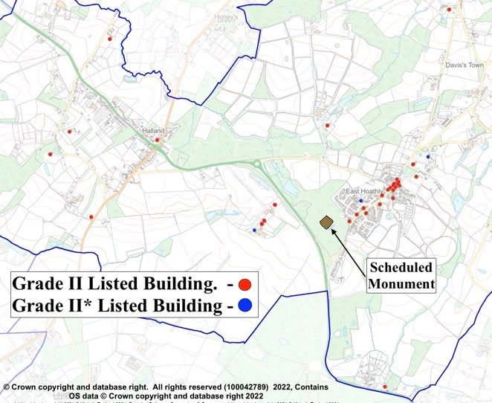

Figure 6 - Designated Heritage Assets in Parish
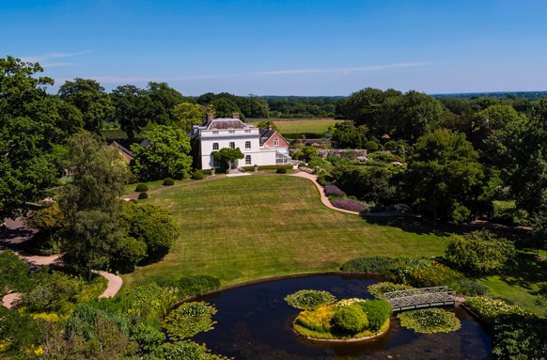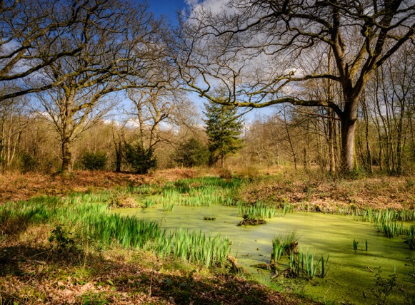
Grade II* Belmont House East Hoathly
Scheduled Monument - Moat Wood
133. Designated Heritage Assets are protected by legislation and this extends to include their setting. In accordance with NPPF 2021 Paragraph 195: “Local planning authorities should identify and assess the particular significance of any heritage asset that may be affected by a proposal (including by development affecting the setting of a heritage asset) taking account of the available evidence and any necessary expertise. They should take this into account when considering the impact of a proposal on a heritage asset, to avoid or minimize any conflict between the heritage asset’s conservation and any aspect of the proposal”.
Bow Bells Milestones

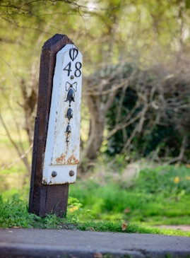

Bow Bells Pelham Milepost Marker

134. Bow Bells milestones extend along the A22 between Horsebridge and East Grinstead. This is the longest sequence of milestones in the country. The iron milestones were erected in the 18th century and feature a string of five bells below a bow of ribbon. The bells were a reference to Bow Bells Church in the City of London from where most roads heading south were measured. The milestones were erected by the Turnpike Trusts along this turnpike route in the 18th century, with the Uckfield to Horsebridge turnpike (via East Hoathly) completed by 1768. Between Uckfield and Horsebridge the Pelham Buckle is shown above the mile mark, denoting the Pelham landowners along this stretch of the turnpike. Four Pelham Buckle Mileposts survive within the Parish and the details are shown at Annex E. Historic England have designated a Bow Bells milestone in Danehill as a Heritage Asset and the same criteria should apply to those in this Parish. These historic milestones should be protected and the Parish Council will
seek to get them designated as Heritage Assets.

Non-Designated Heritage Assets

135. The Parish has many historic assets that are not designated. It is possible to apply for these to be included on a Local List of non-designated heritage assets. Any such application has to provide detailed evidence to support the case. The Local List can include things such as:

a. Cultural landscapes and areas of special local character.

b. Places of important social history.

c. Significant patterns of settlement.

d. Local figures of significant importance.

e. Significant buildings (design, materials, purpose).

f. Locally important landscapes.

g. Historically important areas.

136. The draft East Hoathly Conservation Area Character Appraisal 2021 identifies some buildings that could be considered for adding to a potential Local List of non-designated heritage assets. In due course, it is intended to complete a full review of the Parish with a view to submitting for a Local List of approved non-designated heritage assets at a future review of the EHHNP.

East Hoathly Conservation Area

137. WDC originally designated a Conservation Area for East Hoathly in 1995. The Conservation Area boundary was reviewed in 2017, and redesignated with an enlarged boundary. This is shown below. A WDC draft Conservation Area Character Appraisal was published in January 2021. The Character Appraisal describes the landscape setting for the area and the historic development of the Parish. It examines the character of the area in detail including the design of buildings, materials used, building patterns, usage of buildings and some of the key individuals and events affecting the Parish. It considers the contribution of the natural environment and identifies issues that have a negative impact on the character and appearance of the area.

138. The whole of the Conservation Area is protected by additional planning controls. This protection extends to the need to consider the impact of development on the significance of the Conservation Area through development in its setting. New development within the Conservation Area or within its setting should enhance or better reveal its significance and make a positive contribution to the asset.

139. An important part of the setting of the East Hoathly Conservation Area is the open countryside surrounding the village and the views into and out of the Conservation Area. This is noted in the WDC Draft Conservation Area Character Appraisal 2021:

a. “Views across the wider countryside are also important, with views in and out of the conservation area providing a strong sense of place and affording strong inter-visibility with historic buildings in the historic core”.

b. “Views through the character area are along the roads and back to the village core, and across the fields to the west and views to the large houses set back to the eastern side of the road, which are often glimpsed through trees. Views across the wider countryside are important and the fields to the west allow views in and out of the conservation area and to the large area of woodland beyond”.

c. “The landscape around East Hoathly still has a very rural character of fields, hedges, treed boundaries, and woodland, which provides an important backdrop to the settlement. Views across the wider countryside are also important, with views in and out of the conservation area providing a strong sense of place and affording strong inter-visibility with historic buildings in the historic core. There are views across surrounding fields and to area of woodland beyond, as well as views southwards towards the South Downs”.
d. “Views across the wider countryside are also important, with views across the fields adjacent to the conservation area to the west and southwards towards the South Downs”.

e. “Open spaces within and on the edge of the conservation area are important as they help to define the built environment and create a sense of place”.

f. “The open landscape makes an important contribution to the traditional open setting of the conservation area. The rural location of the village within the gently sloping agricultural landscape of the Low Weald and in close proximity to the South Downs means that there is open fields and woodland surrounding the conservation area”.

g. “The most important views looking into, out of and through the conservation area are shown on the character appraisal map in Appendix 1. These contribute to the character and setting of the conservation area and care needs to be taken to ensure that they are not lost or compromised by future development or poorly sited services”.

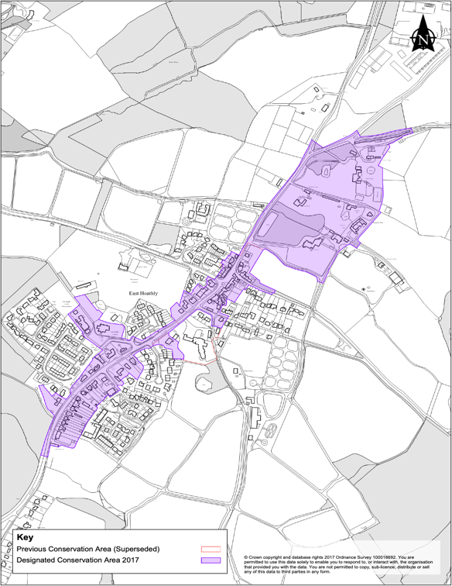

Figure 7 - East Hoathly Conservation Area

140. WDC are expected to produce a Management Plan for the Conservation Area. In the preparation of this Management Plan, it is hoped that the Parish will be able to work with WDC on developing an Article 4 direction in the future, that will control the remaining Permitted Development rights that are leading to erosion of character and detail within the Conservation Area.

EHHNP Policy 4 – Conservation of Historic Environment

P4.1 Proposals for new development that preserve and sustain designated Heritage Assets, the Conservation Area, the settings of the Heritage Assets or setting of the Conservation Area will be supported.

P4.2 Proposals for new development that recognize the importance of non-designated heritage assets and be sympathetic to their setting and character will be supported.

P4.3 Proposals for new development must show that they have investigated the Historic Environment Record and ensure that the any known or potential archaeological evidence is correctly investigated and reported.

EHHNP Aspiration 2 – Conservation of Historic Environment

Pelham Buckle Milepost Markers

A2.1 This Parish is proposing to seek designation for the Four Pelham Buckle Milepost Markers in the Parish, as heritage assets.

East Hoathly Conservation Area

A2.2 This Parish seeks, in liaison with WDC, to establish an Article 4 Direction that will control Permitted Development rights within the East Hoathly Conservation Area.

Assets of Community Value

141. A building or other land can be listed as an Asset of Community Value (ACV) if its main use has recently been or is presently used to further the social wellbeing or social interests of the local community and could do so in the future (the land or building would need to be listed on the register held by WDC). The Localism Act states that ‘social interests’ include cultural, recreational and sporting interests. The Parish currently has four ACVs (The Blacksmith’s Arms in Halland, The King’s Head in East Hoathly, the Garden Plots in East Hoathly) and the East Hoathly Medical Centre - these are detailed at Annex F.

142. Once listed as ACVs with the local authority, the local community will be informed if they are put up for sale within the five-year listing period. The community can then enact the Community Right to Bid, which gives them a moratorium period of six months to determine if they can raise the finance to purchase the asset.

143. ACVs are not nominated as part of EHHNP but the consultation process has identified several potential assets within the Parish to which many people have a strong connection and these will be considered for nominations as ACVs. Residents recognize the importance of these assets to the character of this community and want them to be protected. These include the Village Hall, Pavilion and Halland Chapel. The location and description of these items is shown at Annex G.

Rural Landmarks

144. In addition to the assets identified to be nominated as ACVs, the consultation process also recognized the importance of other things that make the Parish demonstrably rural and special. The Fingerpost signs that mark many of the junctions of minor roads in the Parish are an example of this. They have age and charm and remind people that they are on a quiet country lane and not a major highway. Many of these Fingerposts have been lost in recent years and this Parish will seek to retain all the remaining ones and reinstate some of the lost Fingerposts.

145. Post Boxes are also a reminder of the rural setting for our Parish and this Parish currently has 8 remaining. They help with sustainability preventing the need to get into a car and drive to post a letter. This Parish will strive to retain the remaining Post Boxes. The Fingerposts and Post Boxes are shown at Annex H.

EHHNP Aspiration 3 – Conservation of Community Assets

Proposed Assets of Community Value

A3.1 This Parish seeks to obtain listing as Assets of Community Value:

a. Village Hall.

b. Pavilion.

c. Halland Chapel.

Fingerpost Signs and Post Boxes

A3.2 This Parish seeks to retain remaining Fingerpost Signs and to reinstate those that have been lost.

A3.3 This Parish seeks to retain remaining Post Boxes.

Dark Skies

146. NPPF 2021 (Paragraph 185c) requires that new development should “limit the impact of light pollution from artificial light on local amenity, intrinsically dark landscapes and nature conservation”. Wealden District has the darkest skies in the South East of England and this should be preserved. Dark skies are hugely beneficial to nocturnal wildlife and of significant importance to those people who enjoy the night sky. The Neighbourhood Plan consultation process recorded the desire of many people to maintain the existing benefits of the Dark Skies of the Parish.

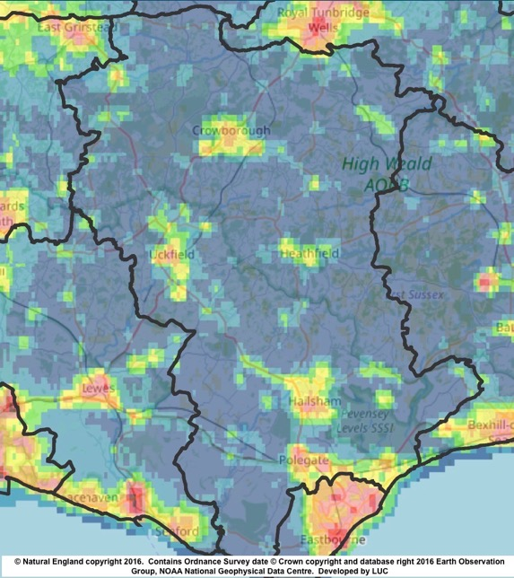

Figure 8 - Wealden District Light Pollution
Wealden is the 20th darkest of the 326 districts in England. It is the darkest in the South East (Kent, Sussex, Surrey, Hampshire, Buckinghamshire and Oxfordshire)

147. The Parish currently has highway lighting on the A22 at the Halland roundabout, the Shaw Roundabout and the junction with South Street. Within East Hoathly there is very limited street lighting on the High Street extending to the beginning of the London Road and Waldron Road. There is also low-level lighting in the Juziers Drive/Trug Close development. Many residents feel that additional street lighting and security lights to new and existing developments should be resisted. Some people believe that street lighting and security lights are required to improve safety and reduce crime. However, a study by the London School of Hygiene & Tropical Medicine and University College London, in the Journal of Epidemiology and Community Health, reported on their analysis of 14 years of data from 62 councils in England and Wales, that there was no evidence of a link between reduced street lighting, crime and night-time vehicle collisions. The design and layout of new developments should be planned carefully to minimize the impacts of any lighting schemes and be subject to planning conditions to minimize/prevent light pollution. Figure 9 shows the currently low levels of light pollution (with the exception of the A22 lighting) in the Parish.

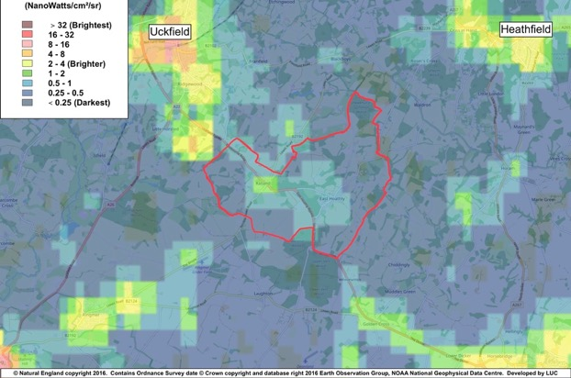
Figure 9 - Dark Skies Map showing relative darkness of Parish

148. New development should not cause the light levels recorded by CPRE to be exceeded and the Parish should seek to reduce the existing light levels by reviewing the choice of lighting in public places, the timing of its operation and providing guidance to homeowners to limit their light pollution by such measures as correctly directed lights that are controlled by timing devices. Developers should make every effort to limit light pollution for new developments and in particular to not allow light to be radiated upwards where it adds to light pollution but adds nothing to visibility on the ground. They should strive to not allow new developments to worsen the existing levels of light pollution. The Institute of Lighting Professionals Guidance Note 01/21, The Reduction of Obtrusive Light, gives guidance on this matter.

EHHNP Policy 5 - Dark Skies

P5.1 New development must clearly demonstrate that all opportunities to reduce light pollution have been taken with a particular focus on preventing sky glow from radiating upwards.

P5.2 Development proposals will be supported where they limit light pollution and developers should strive not to allow new developments to worsen the existing levels of light pollution.

EHHNP Aspiration 4 – Dark Skies

A4.1 This Parish seeks to reduce the existing light levels by reviewing the choice of lighting in public places, the timing of its operation and providing guidance to homeowners to limit their light pollution by such measures as correctly directed lights that are controlled by timing devices.

SECTION 6 - NATURAL ENVIRONMENT

149. The natural environment surrounding the built areas is the reason our villages exist. The natural environment has been sculpted by the farming community over many centuries and continues to evolve as the economics and practices of farming change. They now provide the priceless backdrop to the community giving aesthetic pleasure and habitats for the wildlife and plants that enrich our lives. The natural environment provides important benefits for the health and wellbeing of residents of all ages and abilities. This can be through active travel, recreation and play, connected neighbourhoods and also the mental and wellbeing benefits associated with access to natural environments. These benefits also encourage visitors to our local economy.

150. The WDC Green Infrastructure Study 2017 sets out a potential green infrastructure network for Wealden, based on an analysis of the District’s green and blue assets, where there are deficiencies and where there are opportunities for improvements/enhancements/provision. Whilst not an adopted strategy for the District, the potential Green Infrastructure Network provides a framework for the delivery of Green Infrastructure to support the planning of sustainable development. WDC are reviewing this study to inform the new draft WLP.

151. Our Parish was part of one of the Strategic Green Access Links in this Network. This connected the communities and facilities of the Parish via a range of Public Right of Ways (PROWs) and principally, the Wealdway and Vanguard Way. It proposed that these links were protected and enhanced for pedestrians and cyclists and connections to public transport links improved. The proposal noted that it is important that the network is not compromised by inappropriate development and/or land management. It stated: “Where development is planned within or in close proximity to Green Infrastructure assets, it should become an integral feature to the design and ‘identity’ of the development site to ensure that the connectivity of the network for both public benefit and biodiversity is retained and enhanced”.

152. The WDC Landscape Character Assessment 2022 categorized the Parish in 3 parts as shown in Figure 10:

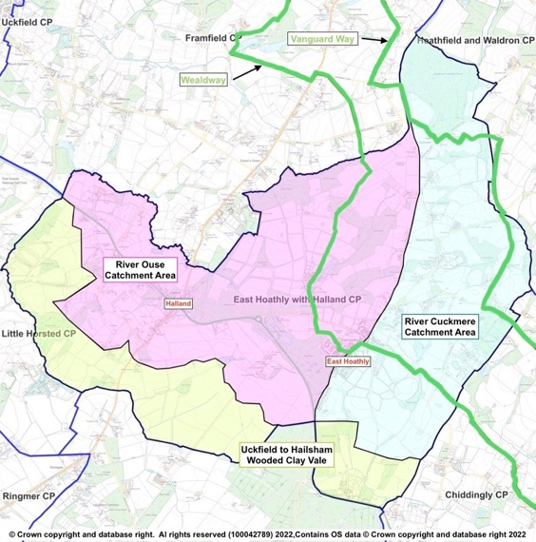

Figure 10 – WDC Landscape Character Assessment 2022 - Characterization of Parish

a. Wooded Clay Vale (Zone 3)
The Landscape Character Assessment describes this area as a low-lying landscape, crossed by the narrow river valleys of the Uck and its tributaries in the west and the Cuckmere in the east. The landscape supports a patchwork of arable and pastoral fields, interspersed with areas of woodland, much of ancient origin, and more extensive mixed plantations. Scattered linear settlements and farmsteads are strung along the rural road network.
b. High Weald – Ouse Catchment (Zone 6D)

The Landscape Character Assessment describes this area as a rolling landscape of ridges and valleys containing the River Ouse and its tributaries that drain south-westwards from Ashdown Forest and the Central High Weald into Lewes District. A wooded landscape with an intricate pattern of small irregular fields, streams and small, historic ridge-top settlements. This categorization is slightly confused. Within the Parish, the watercourses that drain to the North East and along the northern boundary of the Parish, all flow into the River Uck rather than directly into the River Ouse and the Landscape Character Assessment describes the River Uck Catchment area as being in Zone 3.

c. High Weald – Cuckmere Catchment (Zone 6E)
The Landscape Character Assessment describes this area as a rolling landscape of ridges and valleys containing the River Cuckmere and its tributaries that drain south from the Central High Weald into the Low Weald. A wooded landscape with a pattern of small-scale irregular fields, streams and historic ridge-top villages.
153. The Landscape Character Assessment produced guidelines for each Zone to recommend how the landscape can be managed to ensure future change respects local character. Any proposed development should conform to all the guidelines specified in the Landscape Character Assessment but the key guidelines relating to the Parish landscape are:

a. Wooded Clay Vale (Zone 3)

Retain and enhance the biodiversity of watercourses and their associated wetland habitats by minimising water pollution from agriculture through sensitive land management practices, including restoration of buffer strips along watercourses to minimise run off.

Conserve and manage the streamside woodlands and copses, conserving and restoring riverside vegetation and wetland habitats, to ‘slow the flow’ and increase biodiversity.

Improve the connectivity of woodlands across the area through tree planting and hedgerow corridors.

Protect and manage the existing hedgerow network, and plan for restoration and linkages between hedgerows, including planting hedgerow trees to increase biodiversity and connectivity. Encourage the conservation of historic field patterns and boundary features.

Conserve the dispersed rural settlement pattern, encouraging the use of local materials, to maintain a strong local identity. Use woodland or tree planting to screen development on the edge of settlements.

Ensure existing public rights of way and public access within woodlands are maintained and explore opportunities for new pathways extending from urban areas. Plant wooded corridors along footpaths, such as the Vanguard Way and the Wealdway.

Maintain the rural character of the landscape away from the large urban areas, retaining tranquillity and dark skies where present.

Retain and where possible enhance long views to the South Downs and High Weald, which form a strong backdrop to the landscape and provide a sense of place in the landscape. Any new developments should consider intervisibility with the South Downs and High Weald.

b. High Weald – Ouse Catchment (Zone 6D)

Monitor water quality in the rivers and streams. Minimise water pollution from agriculture through sensitive land management practices, including regenerative agricultural systems such as no or minimal till, holistic grazing, reduction or removal of chemical inputs, cover crops and restoration of buffer strips along watercourses and field ponds, to minimise run off in order to maintain the biodiversity of wetland habitats.

Protect and manage the existing hedgerow network, and plan for the restoration of, and linkages between, hedgerows, including establishing hedgerow oaks, to maintain habitats.

Maintain and restore links between the numerous woodlands in the area, other woodland habitats (such as hedgerows and parkland), and species-rich habitats such as wet meadows, unimproved grassland and heathland to create a robust network of woodland and open semi-natural habitats.

Limit the amount and scale of development in rural areas, protecting the existing low-density settlement pattern of dispersed rural villages, hamlets, and scattered farms, and the separation between these different settlement types.

Extend woodland around settlements and infrastructure development to filter light pollution and soften the visual impact of further urbanisation.

Protect long views to the wooded Central High Weald to the North and east and to the distinctive ridge of the South Downs to the South.

Maintain the strong scenic qualities of the landscape and its sense of remoteness, tranquillity and experience of dark skies.

c. High Weald – Cuckmere Catchment (Zone 6E)

Safeguard ancient woodland and protect and enhance vulnerable woodland habitats including gill woodlands and wet woodlands for the benefit of biodiversity and the landscape structure.

Protect and manage the existing hedgerow network, and plan for the restoration of, and linkages between, hedgerows, including establishing hedgerow oaks, to maintain habitats.

Maintain and restore links between the numerous woodlands in the area, other woodland habitats (such as hedgerows and parkland) and species-rich habitats such as wet meadows and unimproved grasslands, to create a robust network of woodland and open semi-natural habitats for the benefit of biodiversity and to contribute to an integrated green infrastructure network.

Limit the amount and scale development in rural areas, protecting the existing settlement pattern of dispersed rural villages, hamlets and scattered farmsteads, and the separation of these different settlement types.

Retain the characteristic contrast between areas of enclosed character and long open views to the Pevensey Levels, South Downs and landmark church towers.

Maintain the strong scenic qualities of the landscape and its sense of remoteness, tranquillity and experience of dark skies.

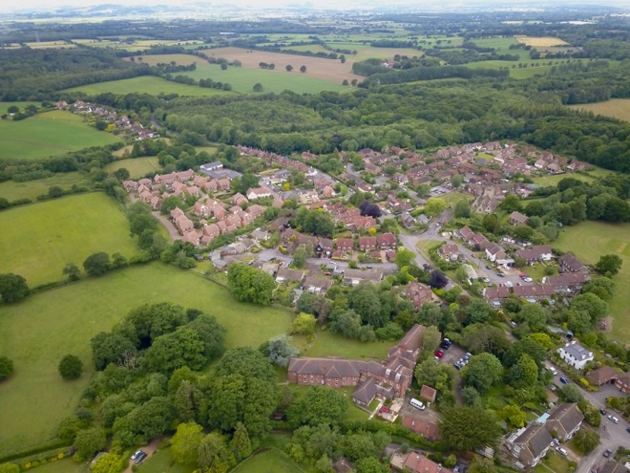
Proximity of woodland and open countryside to East Hoathly

154. The close proximity of open fields and ancient woodland to the very heart of our villages provides a strong sense of connection to nature and the wider landscape of this part of East Sussex, including unspoilt long-distance views to the South Downs. The roads entering East Hoathly have attractive wide and open verges that creates a sense of anticipation as the village is approached.

155. Parish Surveys and the Consultation Process of this Plan have identified a strong feeling within the Parish to preserve the rural village character and setting. It is the principal reason why people have enjoyed living in the village for so long and is why many came to live here in the first place.

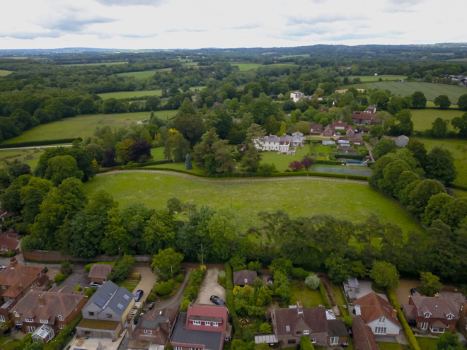
North End of Conservation Area towards Hesmond’s House and Belmont

156. Much of the Parish is agricultural farmland. Much of this is registered as part of Countryside Stewardship Scheme, Environmental Stewardship Scheme and the Organic Farming Scheme. These schemes are designed to enhance the environment and biodiversity and the current land under these schemes is shown at Annex I.

157. The Natural Environment surrounding the built areas is a mix of woodland, hedgerows and agricultural fields all interwoven with a network of waterways and ponds that provide a rich haven for biodiversity and is a constant reminder that this is a rural village.

Woodlands, Trees and Hedgerows

158. The Parish is liberally scattered with woodland which accounts for 22% of the area of the Parish. A significant proportion of this woodland is designated as Ancient Woodland and this makes up 72% of all the woodland in the Parish.

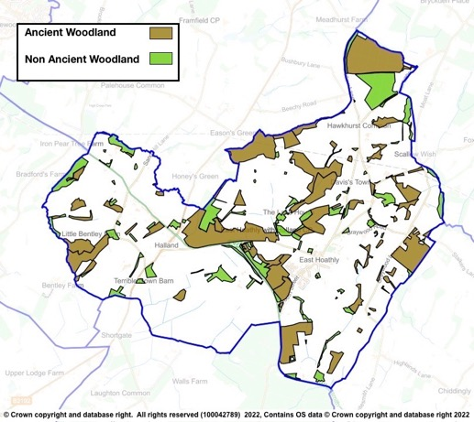
Figure 11 - Parish Woodland

159. In addition to the large amount of woodland, there is also a large network of hedgerows that have still not been fully surveyed. Many of those that have been surveyed are recorded as Species Rich. The most important of these hedgerows are those that connect with Ancient Woodland as they provide vital transit corridors for wildlife. There are many large woodlands in the Parish, but also many of the very important smaller Ghyll and Shaw woodlands that are in particular need of protection. The Ancient Woodland, Ghyll Woodland, Orchards, Veteran Trees and trees protected by Tree Preservation Orders are shown at Annex J. The surveyed hedgerows in the Parish are recorded at Annex K. It is intended to continue the hedgerow surveys.

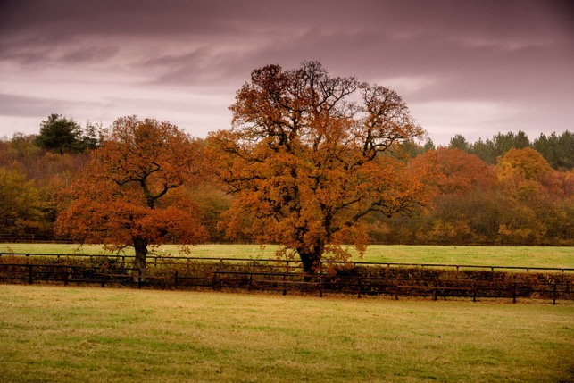

View of Parish Landscape with Woodland, Hedgerows and Trees

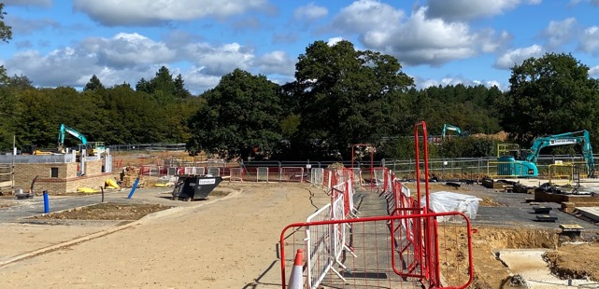

The Changing Parish Landscape

160. Trees and hedgerows should be incorporated into all development proposals to create a rural and peaceful ambience and to allow the development to blend into its surroundings. Trees provide Climate Change mitigation and new developments should consider tree lined streets, parks and community orchards in their planning (NPPF 2021, Paragraph 131). Care should be taken when using tree and hedgerow planting as screening so that it does not detract from skyline or distant views both into and out of the development site.

Waterways and Ponds

161. The waterways, ponds and ditches in the Parish feeds the River Cuckmere to the South and River Uck to the North. This waterway network is vitally important in draining the agricultural land to make it workable and to prevent the flooding of the built environment. It is also a haven for wildlife and provides habitats for a wide range of plants.

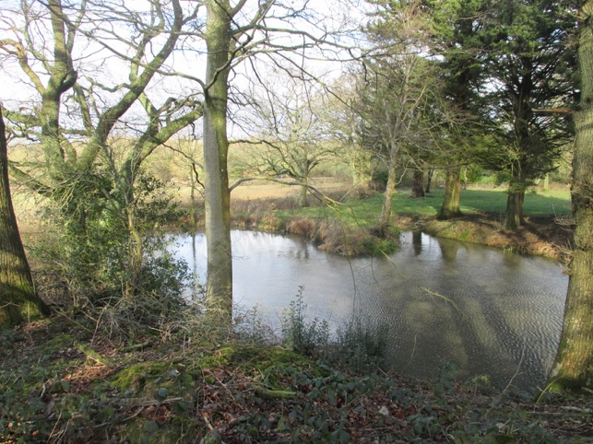

View of Parish Landscape with Pond

162. The WDC Landscape Character Assessment 2022 identifies the importance of maintaining the water quality in ponds and watercourses in the differing landscapes of this Parish. It is important that development in the Parish does not damage the quality of water in these important river catchment areas.

163. The discharge of sewage into watercourses is a particular concern in this Parish. Figures from the Rivers Trust in Table 9 show the very high frequency and duration of storm overflows. The Government Storm Overflow Evidence Project states in the Executive Summary Background Section that “overflows are designed to operate infrequently and as the result of heavy rainfall and this is the basis of their environmental permits”. The report fails to define what heavy rainfall is. Many people believe that the environmental permits should not allow water companies to continue with this practice.

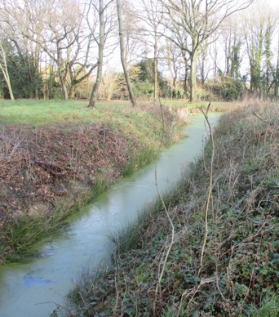

View of Parish Landscape with Drainage Ditch

164. The Meteorological Office does not define what amounts to “heavy rainfall”. However, it does record data for days when rainfall exceeds 1mm, these are defined as a “wet day” as opposed to a “dry day” when less than 1mm rainfall occurs. The wettest days recorded in South East England were 2020 – 43mm, 2012 – 24mm and 2022 – 28mm. A conservative assumption might be to consider “heavy rainfall” as exceeding 8mm in 24 hours. This is also shown in Table 10 in order to contrast the sewage discharges against days that could be regarded as “heavy rainfall”. This clearly shows that sewage is being discharged at both Treatment Plants far more often than when “heavy rainfall” occurs.

165. These figures are shocking and new development should not be allowed to make this situation worse. New developments should calculate the expected outflow to the Sewage Plants and show evidence to indicate that the Sewage Plant and connecting sewers can cope with the additional load without increasing the number of storm overflows.

Table 9 - Sewage Discharges into Watercourses
Sewage Treatment Plant | Year | Halland | East Hoathly | Days in year where rainfall exceeded 1mm | Days in year where rainfall exceeded 8mm
Settled Storm Overflows | 2020 | 112 | 41 | 132 | 32
 | 2021 | 119 | 46 | 122 | 23
 | 2022 | 97 | 35 | 108 | 26
Hours Overflowing | 2020 | 2045 | 416
 | 2021 | 1906 | 593
 | 2022 | 1712 | 416

Biodiversity

166. The Government have now passed into law the Environment Act 2021 which will require new development to leave nature in a measurably better state than beforehand. Developers will need to use the Natural England Metric 3.0 (or any subsequent version) to calculate and provide evidence to show that they have achieved the required biodiversity net gain requirements. It is expected that this will require a minimum 10% biodiversity net gain on the undeveloped site.

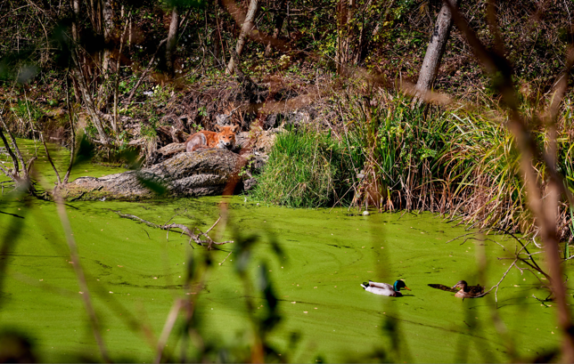

Residents of Long Pond, East Hoathly

167. One of the most effective ways of improving biodiversity is re-wilding areas that have been used for agriculture. The area for re-wilding has its internal fences and boundaries removed/opened-up and then left for nature to re-occupy. Self-seeded plants and trees are allowed to emerge and the result is usually an immediate and spectacular improvement in biodiversity. These areas can appear to be untidy to people accustomed to seeing trimmed hedges and uniform crops. However, these farming vistas often contain very little biodiversity especially if they have been treated with pesticides and herbicides. The variety and density of plant life and the insects and animals that can be supported is significantly greater on an area of land subject to re-wilding.

168. Re-wilding is supported by Natural England as one of the ways of achieving the minimum 10% biodiversity net gain. If a developer proposes to make use of re-wilding in order to achieve the minimum 10% biodiversity net gain, then it will be important that the proposed re-wilding site is appropriate within its wider setting. In order to limit any adverse reaction to the appearance of re-wilding, it is proposed that if potential re-wilding sites are adjacent to main settlements they should be suitably screened. Whenever possible, re-wilding sites should be connected by wildlife corridors to other wildlife habitats.

169. The Sussex Biodiversity Record Centre has recorded 51 species that are red listed (in England or Great Britain) indicating that they are under
threat of extinction and one species of rabbit that is on the global red list. In addition, 32 species are identified as Priority Species in the UK Biodiversity
Action Plan. In total there are 26 internationally designated species, 86 nationally designated species and 175 species with some other designation,
mostly indicating that they are scarce in England or rare in Sussex.

170. However, these records note that they are not comprehensive and acknowledge that significant gaps exist in their records. A measure of how much is being added to the biodiversity records can be assessed by comparing the current report to the previous report from 2017. In 5 years the records show an increase in recorded species that are protected and designated from 115 to 175, an increase of 52%. This Parish believes that the WDC Biodiversity Officer should check the quality and thoroughness of all biodiversity surveys presented with planning applications and publish that appraisal.

171. Some of the rare and protected species that live in this area are skylark, nightingale, 15 species of bats, water vole, common toad, great crested newt, pearl-bordered fritillary butterfly, wasp spider, brilliant emerald dragonfly, dormouse, polecat, adder, grass snake and slow worms. There are several Badger setts recorded in the Parish. Badgers and deer regularly visit local gardens and in recent years, Buzzards and Red Kites are frequently seen in the skies above the Parish.

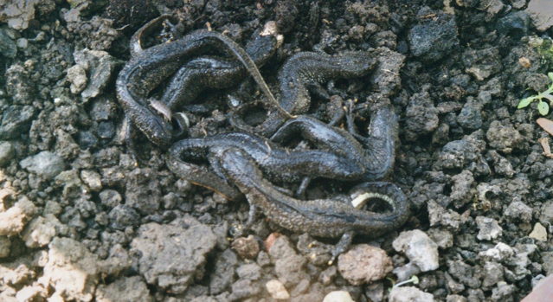
Six Great Crested Newts found sheltering
under a Seed Tray in East Hoathly

172. One of the protected species present in our Parish is the Barn Owl with 5 nesting sites currently known. The mix of woodland, hedgerows and open countryside is the perfect environment for these endangered birds and all planning applications must ensure that they will not cause harm to the Barn Owls, their eggs or nests. This is particularly important during the nesting period when it is an offence to disturb them whilst they are nesting, building a nest, or to disturb them whilst they are in or near a nest that contains their young or to disturb their dependent young.

173. The following sites have been recorded with special biodiversity significance:

a. Park Corner Heath - A Site of Special Scientific Interest which is adjacent to the southern border of the Parish.

b. Moat Wood - An area of Ancient Woodland and a Medieval Moat which is a Scheduled Monument. Part of this land was purchased by the Parish Council and the management of the land passed to the Woodland Trust.

c. Croom Cottage Meadow - A Local Wildlife Site (LWS) with rare wild flowers and orchids.

d. Halland - Wildlife Verge with orchids and wildflowers (ESCC Wildlife Verge Ref 2/46/30).

e. Long Pond - A breeding pond for Great Crested Newts.

174. The Consultation Process of this Plan identified a strong feeling within the Parish to preserve and enhance our existing Natural Environment. This section has examined the place of this Parish within the wider Wealden landscape of green infrastructure and blue infrastructure. It has looked more specifically at the importance of woodland, hedgerows and trees in our landscape and the network of ponds and waterways in the Parish. The biodiversity that exists in this landscape is significant, much of it is protected, some of it is rare and endangered. EHHNP Policy 6 sets out measures to protect and enhance this Natural Environment.

EHHNP Policy 6 - Natural Environment

P6.1 Relevant Proposals for new development must deliver a minimum overall net gain in biodiversity of 10% above the ecological baseline. Those that exceed the minimum will be encouraged and supported.

P6.2 Biodiversity net gain must be provided on-site wherever possible. Where it can be robustly demonstrated that on-site provision is not possible, suitable off-site provision will be sought.

P6.3 All development proposals must follow the mitigation hierarchy when considering the impacts and potential harm of development on biodiversity and the natural environment:

a. Avoid harm/impacts in the first place; then

b. Adequately mitigate any residual harm/impacts; and then

c. Compensate (as a last resort) for unavoidable harm/impacts.

P6.4 If significant harm cannot be ruled out through the mitigation hierarchy, development proposals will not be supported.

P6.5 Development that seeks to conserve biodiversity will be supported where they:

a. Protect existing Ancient Woodland, Ghyll Woodland, ancient trees and veteran trees; and,

b. Protect species rich hedgerows, particularly those that connect to Ancient Woodland; and,

c. Avoid loss or damage of Woodland, Trees; and,

d. Avoid loss or damage of hedgerows; and,

e. Avoid loss of ponds and streams; and,

f. Prevent connections of surface water to foul or combined sewer networks in accordance with the drainage hierarchy, as excess surface water in these networks can lead to the avoidable discharge of sewage into watercourses.

P6.6 Development that seeks to enhance biodiversity will be supported if they enhance public access to nature and incorporate such things as:

a. Create new woodlands, hedgerows and ponds; and,

b. Creation of new wildlife habitats; and,

c. Connect and enhance existing wildlife habitats; and,
d. Provide opportunities for gardening, wildlife and food production within existing and new residential areas, including the utilization of underused roadside verges for wildlife habitat, where it is safe to do so; and,

e. Plant trees.

The Importance of Greenspaces

175. Greenspaces can provide social, environmental and economic benefits in a neighbourhood. Greenspaces provide access to the natural environment and help mental health and wellbeing. They provide the opportunity of increased physical activity for all ages and abilities with the resulting physical health and mental wellbeing benefits. The Locality guide on Local Green Spaces identifies the following community and environmental benefits of greenspaces:

“a. Being part of the public realm, where informal social interaction can take place.
b. Providing pitches and facilities for sports and supporting physical activity
c. Forming part of a network of paths and spaces, enabling movement through an area
d. Providing habitats for wildlife and natural corridors and spaces through urban areas
e. Providing flexible space for recreation, local cultural events and performance
f. Adding to local amenity, providing an attractive setting and outlook for surrounding residential and commercial properties
g. Forming part of the character or setting of historic areas, buildings and townscape
h. Forming part of flood mitigation, such as SUDS
i. Providing areas and opportunities for growing local food”.

176. The Locality Guide also recognizes the importance of greenspaces by stating “Green spaces contribute to quality of place, together with buildings, urban spaces and the wider public realm. Quality of place is a key factor in attracting investment, jobs and growth to an area. It is also important in making an area an attractive place to live, work and spend leisure time. So green spaces have real economic value to the surrounding area, in addition to supporting healthy lifestyles and community-wellbeing”. Maintaining greenspaces and improving accessibility for all ages and abilities is important. It is also important to improve the connection of greenspaces throughout the community.

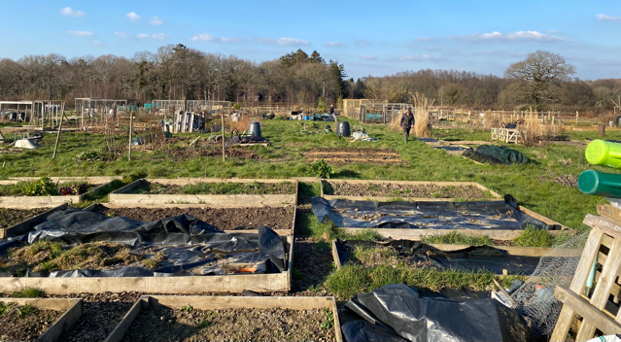
East Hoathly Garden Plots - allowing people to grow their own food

177. The WDC Open Space, Sports and Recreation Assessment 2016 identified that “there is a current deficit in open space, sports and recreation provision in East Hoathly. The study identifies a need for additional facilities including youth facilities and multi-functional green space”. A key element of this Assessment was that it recognized that there is no provision of publicly accessible greenspace in Halland. This 2016 assessment has now been superseded but its findings remain valid. The WDC Open Space Report 2022 indicates, in the Parish Area Summary, that the available amenity greenspace in the Parish should be 9,464 m², whereas only 1,200m² is provided. It also rated both amenity greenspace sites as below the quality threshold. In addition, it rated the Parish’s Natural and Semi-Natural space as being of low quality.

178. Policy WCS 13 of the WDC Core Strategy LP 2013, states that “All new residential development will be required to contribute to the green infrastructure network and where appropriate to make provision for new or enhancement of existing open space. Where the scale of development would be too small to make on-site provision, the Council will seek developer contributions either towards the improvement of existing open spaces or towards the provision of open space elsewhere”. The Parish would like the flexibility to request that some new developments forego the addition of children’s play equipment in favour of using that part of developer contributions towards the improvement of existing open spaces and play equipment.

Local Green Space

179. Greenspaces that are of particular importance to local communities can be designated as part of a Neighbourhood Plan as a Local Green Space. The NPPF 2021, Paragraph 102, requires that “Local Green Space designation should only be used where the green space is:

a. In reasonably close proximity to the community it serves;

b. Demonstrably special to a local community and holds a particular local significance, for example because of its beauty, historic significance, recreational value (including as a playing field), tranquility or richness of its wildlife; and

c. Local in character and is not an extensive tract of land”.

180. During the Consultation Process of this Plan the public made it very clear that they placed great importance on the greenspaces within the built environment and surrounding it. They were asked to prioritise those areas that they most valued and 20 potential Local Green Spaces were identified. The details of the potential Local Green Spaces shown at Annex L. They are assessed against the criteria set out in Paragraph 102 of the NPPF 2021. Five of these potential Local Green Spaces were subsequently rejected.

181. Following the rejection of 5 potential Local Green Spaces, the remaining 15 are designated in EHHNP Policy 7.

EHHNP Policy 7 - Local Green Spaces

P7.1 This Parish designates the following locations as Local Green Spaces as shown on the Policies Map for East Hoathly and the Policy Map for Halland. These locations are in close proximity to their community, demonstrably special and local in character. They benefit the health and wellbeing of residents of all ages and abilities. Development on these Local Green Spaces will not be supported other than in very special circumstances (as specified in NPPF Paragraphs 147 to 151, for example where it relates to necessary utilities infrastructure and where no reasonable alternative location is available):

a. Local Green Space 1 - East Hoathly War Memorial Sports Ground

b. Local Green Space 2 - East Hoathly Garden Plots (Allotments)

c. Local Green Space 3 - Moat Wood and Decoy Pond

d. Local Green Space 4 - Long Pond

e. Local Green Space 5 - Circle of Oaks Green Gap

f. Local Green Space 6 - Juziers Play Area

g. Local Green Space 7 - Juziers Drains/Swales

h. Local Green Space 8 - Church Marks Lane Lawn

i. Local Green Space 9 - Nightingales Play Area

j. Local Green Space 10 - Nightingales Lawn

k. Local Green Space 11 - East Hoathly Churchyard

l. Local Green Space 12 - School Field

m. Local Green Space 13 - Church Marks Green

n. Local Green Space 14 - Croom Cottage Meadow

o. Local Green Space 20 - Halland Chapel Burial Ground

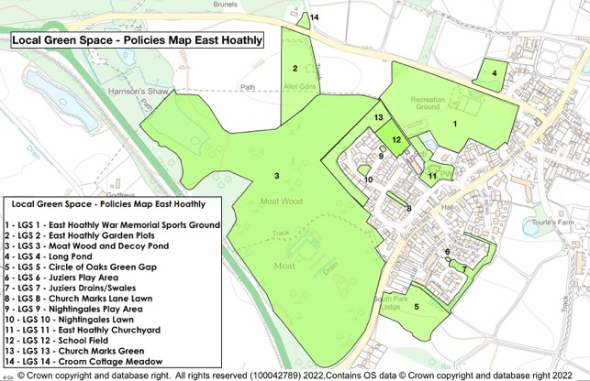

Figure 12 – Local Green Space – Policies Map East Hoathly

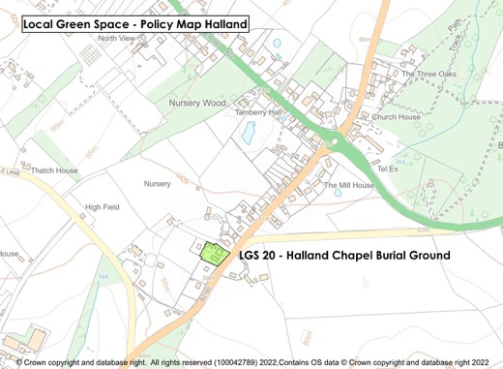

Figure 13 – Local Green Space – Policy Map Halland

SECTION 7 – HEALTH AND WELLBEING

182. The Health and Wellbeing of the residents of our Parish is at the forefront of our thinking in relation to the Neighbourhood Plan. This Section covers such matters as Physical Fitness and Sport, Recreational Activities, Social Groups, Arts and Crafts, Spiritual Health and Medical Facilities. It encompasses all ages from cradle to grave and includes consideration of our residents’ pets and animals.

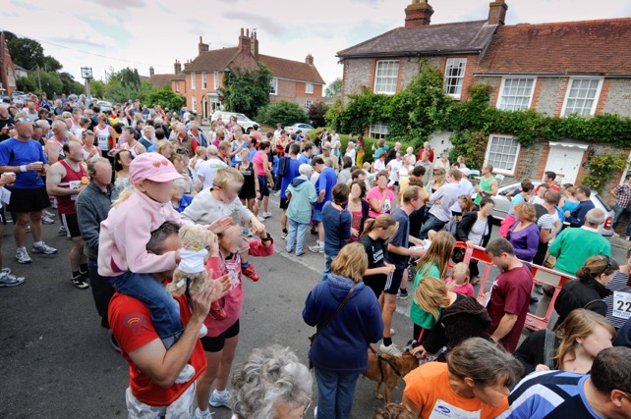
Kings Head Canter - Fun Run

183. Health and Wellbeing can be affected by many factors and living in a rural environment is generally considered beneficial. However, there is potential for isolation (particularly for the elderly) causing mental stress often leading to mental and physical illness. Living in rural villages surrounded by nature is uplifting for most people and retaining the links to the countryside is an important factor in maintaining the Health and Wellbeing of residents.

184. It is important that developments are designed to encourage opportunities for people to meet each other. This social interaction can have hugely beneficial effects on Health and Wellbeing. Cul-de-sacs with no through routes are less useful in creating opportunities for people to meet each other. The incorporation of seating areas into developments that are on
the main through routes is another important consideration to improve the potential for meeting people.

185. Development sites closest to community facilities, shops, pubs and GPs should be prioritized for retirement homes.

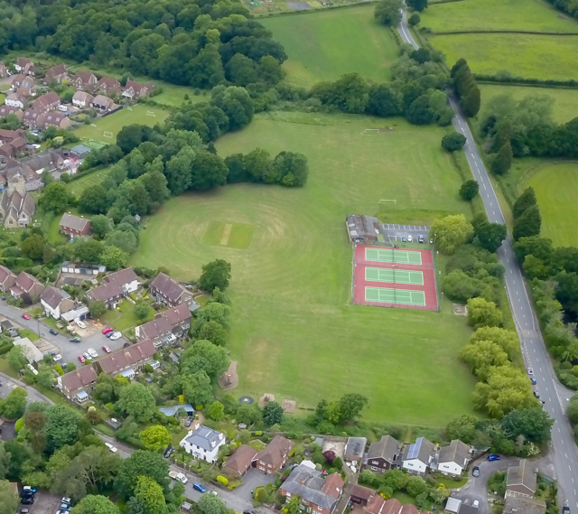

East Hoathly War Memorial Sports Ground

186. Paragraph 177 of this Plan has already noted the deficiencies in the quality of natural and semi-natural space and both the significant lack of amenity greenspace and its low quality. This deficit has an adverse effect on wellbeing. New developments should provide the right amount and type of open space and recreational facilities to provide opportunities for people to improve their health and well-being.

187. The key facilities that the Parish controls to enhance the Health and Well-being of parishioners are the War Memorial Sports Ground, Pavilion and Village Hall.

Sports Ground

a. The War Memorial Sports Ground Trust was established in 1947 after the purchase of the 4 Hectare site with the proceeds of a War Memorial Fund. The Conveyance stipulates that the land must not be used for any other purpose than as a sports and recreation ground for the benefit and use of the Parish. East Hoathly Parish Council became the Trustees in 1952 and the Trust was registered as a charity in 1963. The Sports Ground is central to the sporting life of our community and also for many recreational activities including annual events such as Midsummer Magic and Carnival Night. It has also been the venue for Dog Shows, Fetes and Flower Shows. It is currently home to:

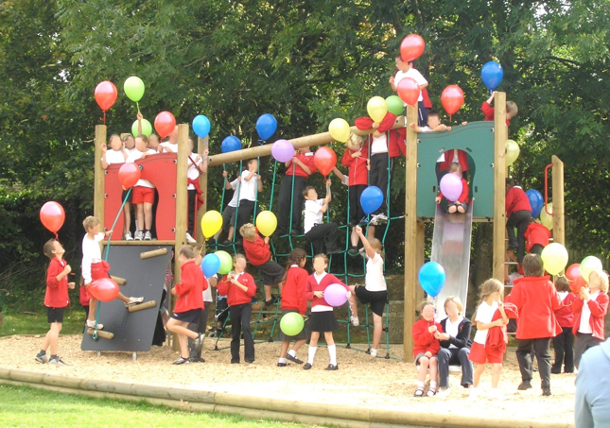

East Hoathly Sports Ground - Play Area

(1) East Hoathly Tennis Club (Three floodlit courts).

(2) East Hoathly Cricket Club.

(3) Children’s Play Area.

(4) Basketball Hoop.

(5) East Hoathly Rifle Club.

(6) Occasional use by visiting Cycle Club.

b. The Sports Ground is badly drained and often waterlogged in winter conditions. The lack of playable conditions led to the demise of the East Hoathly Football Club and it is unlikely that this will start again without improvements to the drainage. The possibility of the level of the football pitch area being raised by infilling the area with waste soil has been examined.

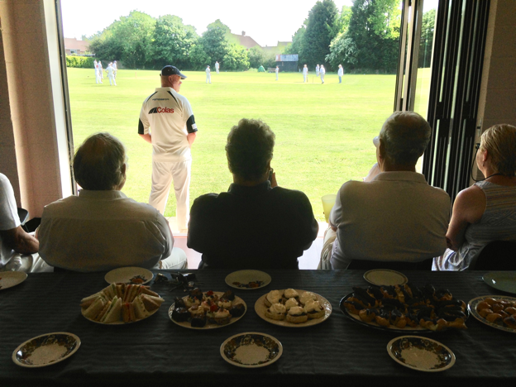

East Hoathly Cricket Club

Pavilion

c. The Pavilion is situated on the War Memorial Sports Ground and is part of the War Memorial Sports Ground Trust. The Pavilion was built in 1980 and is of simple brick construction within a steel agricultural style framework with an asbestos roof. It is now in poor condition, energy inefficient, with inadequate shower and changing facilities for players and officials. The Pavilion has one changing room large enough for a football team with showers and one toilet. The second changing room is only large enough for half a football team with a very small shower and no toilet. If mixed gender teams are playing there is no capacity to have separate changing facilities. There are no changing facilities for officials. The building was not designed to cater for disabled people or wheelchair access. Disabled facilities are limited to one toilet.

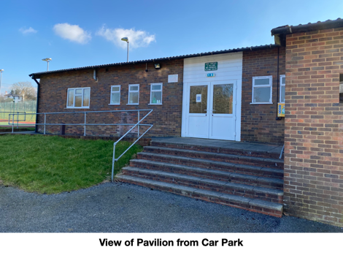

Village Hall

d. The Village Hall was built in 1926 and is essentially of wooden construction with the addition of a brick extension at the front. It is generally in good condition although is somewhat dated and not energy efficient. The Village Hall has a wide range of users in addition to its use for private functions:

(1) Village Playgroup.

(2) Preservation Society.

(3) Short Mat Bowls Club.

(4) Carnival Society.

(5) Parish Council.

(6) Show Society.

(7) Dance Club.

(8) Twinning Association.

(9) Drama Society.

(10) British Legion.

(11) School.

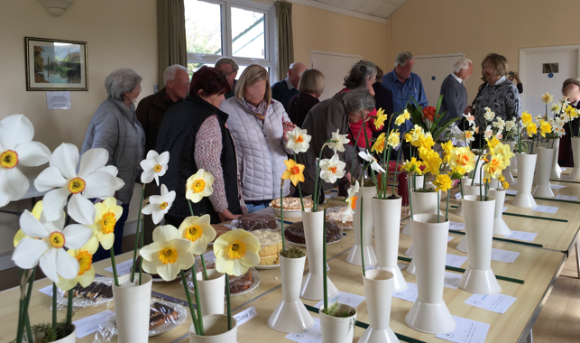
Show Society Event in Village Hall

188. There has been a long running aspiration that a new Pavilion is required in combination with improvements to the drainage of the Sports Ground. It has been suggested that one option is to replace the Pavilion with a new facility that incorporates the functions of the Village Hall. The Consultation Process of the Neighbourhood Plan and the Parish Survey sought the opinions of parishioners on the future of these facilities. The results of the consultation were:

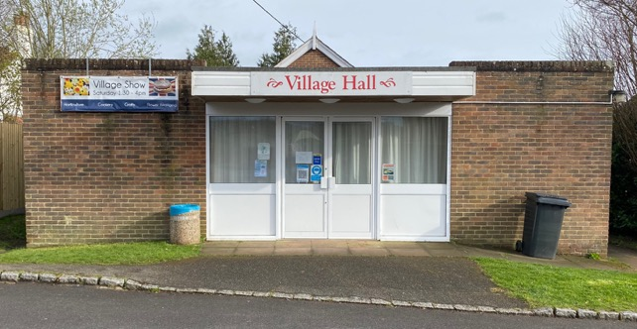

East Hoathly Village Hall

a. Option 1 - Replace the Pavilion and our Village Hall with a new building which incorporates the functions of the Village Hall

This option received 63% support but many had significant reservations. The reservations were mostly concerned with funding and running costs being viable. Many groups were concerned that the facility should be capable of the widest range of activities to ensure that it was well used (eg Badminton, Netball, Stoolball, Dance, Gym, Disabled Access).

b. Option 2 - Retain Village Hall but extend Pavilion

This option received 58% support. It was only considered sensible if the football pitch was rectified and more use was likely. The retention of the Village Hall and its heritage was considered important and it was considered to have a good atmosphere.

c. Option 3 - Maintain existing Pavilion and Village Hall

This option received 42% support. The majority of people did not feel that the existing state of the Pavilion could be allowed to continue and this option therefore received the least support.

189. The Neighbourhood Plan Consultation and Parish Surveys identified a number of desires from parishioners to improve the recreational facilities available:

a. Indoor Badminton Court.

b. Stage.

c. Pool Table.

d. Improvement of the Football Pitch drainage to allow the Football Club to be re-started.

e. Space for a Youth Club.

f. Space for an Arts Club.

190. Halland has no publicly accessible communal open/greenspace, no meeting room and no recreational facilities. As Halland has grown in size with regular infill developments there is now a need to provide some facilities to help build the community.

191. The Parish has set up a Recreation Group which is creating a plan for the proposed improvements and changes to the Sports Ground. They will also be exploring the Options for a new Pavilion further with a view to putting forward a definitive plan in due course.

Medical Services

192. The East Hoathly Surgery was incorporated into the Buxted Medical Practice in 2001 (the Horam Medical Practice has also now been added to this combined Practice). For over a decade, the Surgery has suffered from a lack of GPs and this is now reflected in the combined Buxted Medical Practice. In the last few years, this has resulted in an increasing number of East Hoathly patients being referred to the main Surgery in Buxted. During the Covid-19 lockdown, the East Hoathly Surgery closed completely and all access was via Buxted. This declining access to medical services is of considerable concern for many parishioners.

193. A Neighbourhood Plan cannot take any action to improve this situation. The surgery is aware of the shortage in GP cover and is actively recruiting. The situation is replicated throughout the Medical Practices in the South East. This adversely affects the Health and Wellbeing of parishioners but it seems that no solution is on the horizon.

194. The Parish has three Defibrillators, one located at Buffalo Bill’s (formerly The Forge), Halland, one at the East Hoathly Pavilion and one at East Hoathly Medical Centre. There is also one just outside the Parish at Broomfield Farm Caravan Club Site, Stalkers Lane. Defibrillators save lives and it would be beneficial to have two additional units. One to be sited in East Hoathly that is accessible at all times. The second to be sited in Halland at the suggested location of Staverton Nursery. It would also be beneficial to have wider publicity of their locations and training opportunities for the public.

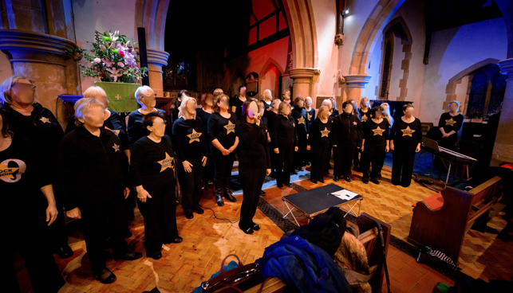
“Raise The Roof” Concert in East Hoathly Church

Arts and Crafts

195. There are many people in the community who are artists, writers, musicians, craftspeople or are in some way involved in the business of the arts and crafts. Most are amateur but some are professionals working as individuals or running a business from home. Many of them take part in exhibitions and performances in the Parish and elsewhere. The activities of these people enriches their own lives but also those of the wider community who can visit the exhibitions, performances and take part in courses and activity sessions.

196. There is no formal organisation of the Arts and Crafts community. The Consultation process of the Neighbourhood Plan revealed a desire for there to be some form of focus for this talented group of people. This might be some form of Craft Centre or a regular event that brings all their activities together. It should be noted that these activities generally require an indoor space.

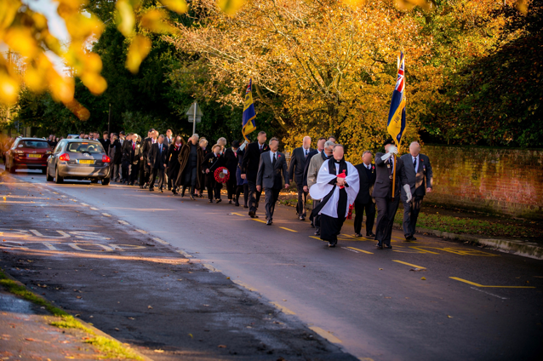
Church Remembrance Day Parade - East Hoathly

Spiritual Health

197. Spiritual Health can be supported in a variety of forms. Many people have their own philosophy and belief systems that sustain them and some people choose to follow an established religion. The Parish has two formal places of worship:

a. East Hoathly Church - This is a Church of England place of worship. Since 1983, it has been part of a United Benefice, sharing a Rector with Chiddingly Parish.

b. Halland Chapel - This is an Independent Calvinistic Church founded in 1886 and the Chapel was opened in 1892. In 1976, a Church Hall was erected. This Chapel attracts a congregation from outside the Parish.

c. It is known that parishioners also attend other places of worship outside the Parish such as Framfield Church (St Thomas à Becket Church of England - its ecclesiastic parish boundary includes a major portion of Halland) and the Baptist Chapel, Blackboys.

Carnival Night Firework Display above East Hoathly Church

198. Both places of worship have burial grounds and provide places for quiet reflection and remembrance.

199. Both churches are part of the community and in addition to their spiritual leadership they offer community support and activities that enrich the lives of those in the Parish. This can be through the use of the Church facilities for community activities or a supportive presence at many Parish events. The East Hoathly Church also has formal links with the East Hoathly Church of England School enabling it to spread its influence much more broadly into the community and our young people.

EHHNP Aspiration 5 - Health and Wellbeing

A5.1 This Parish seeks to improve the Sports Ground and upgrade the Pavilion.

A5.2 This Parish seeks to provide community facilities for the residents of Halland (preferably in the North West quadrant of the A22/B2192). The facilities that would be supported are as follows:

a. An open/greenspace with Children’s Play Area accessible by the maximum number of residents without the need to cross a main road.

b. A community hall/meeting place.

SECTION 8 - BUSINESS

Historic Perspective

200. Employment in the Parish has changed enormously over the centuries. In the 19th Century the Parish was an agricultural economy with significant reliance on agricultural labourers to work the land. The villages had a range of shops providing the goods and services required on a daily basis and these added to the employment opportunities in the Parish. Employment was also possible as servants and staff to the larger properties. The 20th century saw this employment model change completely.

201. The Parish remains a largely rural agricultural economy, but it now employs very few people. Most of the businesses that had been established in the Parish have now closed and the sites have been developed for housing. The Wealden LP 1998 proposed the protection and expansion of the business area to the East of South Street but by 2009 this had been developed as a mixed-use site with housing and a considerably reduced business area. Modern homes are now unlikely to employ staff and most of the shops and pubs have closed. Hence, the opportunities for employment in the Parish are now hugely diminished as can be seen in Chart 3. This shows a comparison of those employed in the Parish and those living in the Parish since 1861. In 1861 around 215 people lived in the Parish and 400 people worked in the Parish. This ratio changed slowly and by 1961 around 501 people lived in the Parish but only 200 people worked in the Parish. By 2011 this ratio had changed dramatically with 1600 people living in the Parish but a mere 99 employed in the Parish.

Figure 14 - Employment in Parish

Current Employment Model

202. The transition of this employment landscape into the 21st Century has seen an increasing number of people working from their homes using phone services and now increasingly internet access. In addition, there are an increasing number of people who are now self-employed and running their business from their home. This has resulted in new problems for the Parish:

a. The Broadband provision to the Parish is generally poor (see Paragraphs 211 to 215 of this Plan). The effect of poor internet provision is that it is difficult to run existing internet-based businesses without fast internet speeds and will not attract new business to the area who need fast internet speeds.

b. Mobile phone service is patchy for several service providers and this can be very frustrating for all users but is particularly problematic for businesses where communication is vital and often reflects poorly on the business itself.

c. Self-employed businesses often have an additional vehicle for the business and this has to be parked in the Parish. Paragraph 109 of NPPF 2021 recognizes the need for overnight parking of lorries but this does not extend to self-employed business vans and vehicles. The parking allocation in modern housing developments does not allow for these additional vehicles and they usually end up being parked on the streets. This creates access problems, as the streets are not designed to have vehicles parked on them. The result is that they are commonly parked on the approaches to the village. Often these vehicles are large working vehicles and they are inappropriate in scale and appearance to park in residential areas.

d. The majority of employed people leave the Parish by car to get to work. The commuting is often lengthy and congested. This is bad for the environment and the health and well-being of everyone.

e. Several businesses, and those working from home, indicated that the frequency of Power Cuts is problematic for their businesses. Digital equipment was adversely affected and some businesses had freezer storage that sometimes resulted in loss and wastage.

203. Data from the 2011 ONS Census relating to our Parish shows that of the 1,236 residents (16+) in the Parish, 809 people had some form of work. This included full-time, part-time and self-employment. Of these employed residents, 76.4% used a vehicle to get to work and almost all of these journeys were outside the Parish.

Post Office

204. Feedback from local businesses and in particular many of those who run a business from home is that the Post Office is vital to their business. Many of these rely on dispatching orders by post and the Post Office has estimated that 69 % of East Hoathly Post Office mail transactions are business related and 30 % are business-banking transactions.

Centralised Delivery Hubs

205. The Parish is increasingly being visited by delivery vans as people’s lifestyles have changed and many more items are being ordered online for home delivery. Some of these items are then returned to the vendor which necessitates another vehicle to come and collect the item. Many delivery vans are large and diesel powered, precisely the sort of vehicles that should be dissuaded from coming into the Parish. They congest the roads, pollute the environment and frequently disturb residents when they cannot find the correct address. It is hugely inefficient for the businesses carrying out the deliveries and very bad for the environment. If the items ordered online were purchased in a retail centre, it is likely that it would be coordinated with other shopping and therefore does lead to a significant amount of traffic in rural areas. A solution might be to have centralised distribution hubs collecting deliveries from all suppliers so that deliveries to homes could be dramatically reduced.

Changes of Use and Permitted Development Rights

206. The Town and Country Planning (Use Classes) Amendment Regulations came into force on 1 September 2020. This introduced a new Commercial, Business and Service use called Use Class E. Use Class E comprises a wide variety of uses including retail, cafe, medical and health services, day nurseries, indoor sport and recreation facilities, offices and light industry that does not harm residential amenity. These businesses can now change use within Use Class E without planning permission. Under changes to the Permitted Development Rights, vacant and redundant office and light industrial buildings and other buildings in Use Class E, in certain circumstances, can be converted to residential use without planning permission (this would be subject to prior approval from the local planning authority). This could lead to a further loss of businesses in the Parish.

Tourism

207. It has not been possible to assess how important Tourism is to our Parish but many businesses benefit from it and it is generally believed to be important. Tourists visit the pubs and cafes and the East Hoathly Village Stores. Many of them stay at local Hotels, Bed and Breakfast establishments, Caravan Parks and Campsites.

208. Tourists visit East Hoathly because it is an attractive village with an interesting history and to enjoy the local walks, cycling and scenery. Many are also visiting other local attractions and venues. They therefore add to the local economy and the wider economy. It is important to provide the facilities they require whilst retaining the attractiveness that draws them here in the first place.

EHHNP Policy 8 - Business

P8.1 Existing businesses that seek to change to residential use will be supported only if:

a. Permitted Development Rights apply; and,

b. They have demonstrated that the business is not viable and has been marketed for a period of 18 months at a realistic valuation for existing and other commercial uses. Were the review of the submitted viability information by an independent consultant is considered necessary, the applicant will be required to cover such costs for the local planning authority.

P8.2 The loss of land and buildings currently being used for business and providing employment will be resisted unless:

a. The use with equivalent floor space can be secured and delivered in a suitable alternative location, at a reasonable distance within the settlement, subject to conforming with strategic policies within the Local Plan; or,

b. An alternative employment use, with an equivalent job capacity, can be secured and delivered in a suitable alternative location at a reasonable distance within the Parish subject to conforming with strategic policies within the Local Plan.

P8.3 The EHHNP is keen to retain key employment sites within the Parish settlements. Any change of use from employment/commercial uses of these sites will need to comply with the provisions of this policy. The sites are:

a. Carriers Way, East Hoathly, BN8 6AG.

b. Village Works, East Hoathly, BN8 6QA.

c. Lydford’s Care Home, East Hoathly, BN8 6DR.

d. Staverton Nursery, Halland, BN8 6PU.

e. Halland Forge Motel, Halland, BN8 6PW.

f. Garage, Halland, BN8 6PS.

g. Halland House Care Home, BN8 6PS.

P8.4 The improvement and enhancement of the key employment sites listed in P8.3 above, will be supported if:

a. There is no detrimental impact on neighbouring properties or the landscape or heritage assets; and,

b. Traffic generation is acceptable and there are adequate levels of parking on site or nearby; and,

c. It includes opportunities to support sustainable transport; and,

d. The design, materials, massing of the proposed extension/redevelopment plus any landscaping scheme can mitigate any impacts on the street scene and local amenities; and,

e. Extensions are located within the existing business curtilage.

P8.5 Proposals involving changes of use of ground floor premises from “town centre uses” to residential will only be supported where it can be shown that the development would not harm the vitality of local shopping facilities or the amenities of the area.

P8.6 New housing developments that provide local employment in mixed residential and commercial developments or small-scale social enterprises or live work units are welcome, particularly where they reduce out-commuting, providing they:

a. They are limited to Business Use Classes E(g), F2(a) and F2(b); and,

b. Do not have a detrimental impact on the landscape; and,

c. Can be carried out in any residential area without detriment to the amenity of that area by reason of noise, vibration, smell, fumes, smoke, soot, ash, dust or grit.

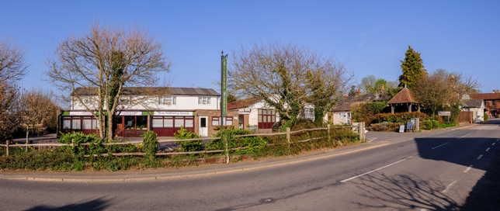

Village Works - East Hoathly

SECTION 9 – ACCESSIBILITY AND CONNECTIVITY

209. Rural villages in the modern world are in a fascinating position. They are increasingly separated from connections to local services such as shops and facilities, yet can be instantaneously connected to the world via the internet. The seemingly inevitable reductions in public transport to rural communities are perhaps being balanced by increasing broadband speeds. However, it remains important that accessibility to the things that sustain the Parish is maintained. Connectivity by phone and broadband can help to prevent isolation and thereby have an important impact on mental health and wellbeing.

210. Paragraph 2.14 of the WDC Core Strategy LP 2013 identified that “three quarters of small businesses in the District are farm based, often in former agricultural buildings converted to business space, and increasing numbers of people work from home …. the limited provision of high speed/capacity broadband in the District seriously restricts business development, particularly but not exclusively in the rural areas”. Paragraph 114 of NPPF 2021 clearly outlines the essential need for “advanced, high quality and reliable communications infrastructure”. This Parish is being let down in this respect. New developments are being permitted that will have fibre-optic high speed broadband provision whilst the already ill served existing parishioners will see no improvements.

Broadband

211. Broadband internet connection is now a fundamental part of modern living. It is the conduit for social networking, entertainment, online shopping, online education, research and business. It is increasingly the only viable way to book events, banking services, online utility accounts, access businesses, district council services, government services and medical services.

212. Broadband service is dependent on the physical infrastructure and the provision of cabling. Much of the Parish Broadband supply is by copper wire with some fibre-optic cabling to main junction boxes. Most of the cabling from the junction boxes into homes and businesses is copper wire. Most of the copper wire cabling is above ground and delivered into homes via telegraph poles. This copper cabling is much slower than fibre-optic cable and above ground cabling is inherently vulnerable to interference by weather and tree damage. Current Broadband Speeds:

a. Parish Survey - Average Download 36 Mbps

b. UK - Average Download 50 Mbps

c. Government Target by 2030 1000 Mbps

213. The Broadband provision to the Parish is generally poor, well below the UK average and currently only 3.6% of the 2030 Government target. The amount of data that can be fed into the main cables that supply the main junction boxes has a fixed limit. At any point in time, that data capacity is then shared out by all the current customers connected to that junction box irrespective of which company the customer uses to pay for their service. If another subscriber is added, then everyone gets a slightly smaller share. The result is that the broadband speed is decreased very slightly for everyone. The trend is for more subscribers making ever larger demands on a system that is already working beyond its capacity.

214. Service providers will eventually improve the capacity of the cabling to the junction boxes but rural parishes are likely to be at the back of the queue with preference given to the urban centres. It will also not address the issue of the unreliable and slow overhead cabling from the junction boxes to homes and businesses.

215. A scheme exists with funding for Community Fibre Partnerships and this is something that may benefit the Parish and should be explored by the Parish Council. It is also hoped to encourage developers of any new housing developments in the Parish to consider providing the same fibre-optic cabling to homes that are adjacent to the proposed new development. This gesture would compensate nearby homes for the disturbance of the building work and for the probable loss of views and privacy.

Mobile Phones

216. Mobile phone service is patchy for several service providers and this can be very frustrating for all users. The Ofcom assessment of Mobile phone coverage for this Parish supports this experience that the level of phone coverage is poor, particularly for receiving voice calls indoors. Only one service provider is shown to have adequate coverage to allow indoor calls to be received without “experiencing some problems”.

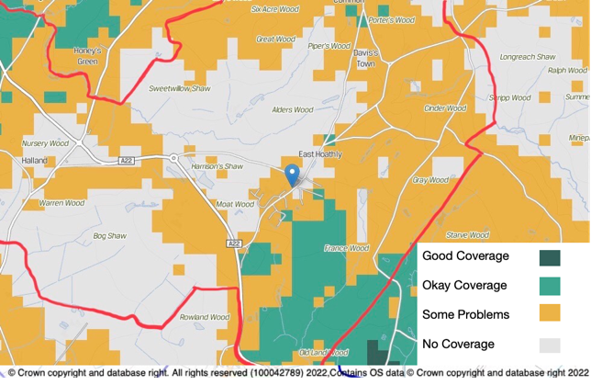

Figure 15 – Example of mobile phone coverage in Parish

217. The existing mobile phone coverage is generally 4G and the majority of people are likely to have a 4G enabled phone. 5G is now being provided by some service providers but this is only available in a limited number of larger towns and cities. There is no forecast of when rural areas will get 5G coverage. Improving the 4G coverage to allow reliable indoor service will require more mobile phone masts of greater power.

218. The safety of Mobile Phone Masts is a concern for many people and the UK Government has issued guidelines related to exposure and potential detrimental effects. The siting of any masts in the Parish is therefore of considerable concern and in particular if the site proposed is close to schools or housing.

EHHNP Policy 9 - Communications
P9.1 If planning permission is required for mobile phone masts, proposals to improve mobile phone coverage will be supported providing they are sited safely, sympathetically within the landscape and, where appropriate, camouflaged (in accordance with NPPF Paragraph 115).

EHHNP Aspiration 6 - Broadband

A6.1 The Parish will investigate the establishment of a Community Fibre Partnership to improve Broadband service.

A6.2 The Parish hopes to persuade developers, installing fibre-optic broadband cable to new developments, to consider providing the same fibre-optic cabling to adjacent homes.

Car Parking

219. Car Parking has already been examined in Section 4 at Paragraphs 103 to 109. Car Parking is also a factor in Accessibility and it has two fundamental aspects. Firstly, the need to be able to accommodate resident’s vehicles in a safe and appropriate manner so that they do not inhibit the access to other residents and pedestrians. Secondly, to be able to cater for visitors, tourists and delivery vehicles to be able to park safely and conveniently so that they do not inhibit the access to residents and pedestrians.

220. As previously discussed, the amount of parking provided for new developments is insufficient to cater for current vehicle ownership including work vehicles and leisure vehicles/trailers. This results in a high level of on-street parking. This causes accessibility problems for large service and delivery vehicles and this could be a serious problem for emergency vehicle access.

221. Visitors to East Hoathly have difficulty finding a place to park. There is a car park at the Pavilion and one on Church Marks Lane which serves the Village Hall, School and Church. Both car parks are intended for the use of the facilities by which they are located and not primarily for visitors to the village. It would be beneficial to have a visitor car park and the Parish Council are exploring possibilities of achieving this.

Bus Service

222. The Parish bus services have been detailed in Section 4 at Paragraphs 50, 59 and 60 of this Plan.

223. The ESCC Bus Service Improvement Plan includes an aspiration to add Sunday and evening services for Route 54 in Halland and East Hoathly (dependent on significant new funding) and the introduction of Real Time Passenger Information signs. New housing developments will come with transport assessments that predict increased use of bus services. The planning conditions of a new development normally requires that money is allocated to a Travel Plan and sometimes money is allocated to fund temporary bus services. This Parish has seen no evidence to show that new developments lead to increased use of the bus service and this is evidenced by the very low level of bus usage in the Parish. This Parish fully understands the intent behind the policy to provide an alternative to the car, but the reality is that unfunded aspirations and ineffective new development Travel Plans do not appear to be improving levels of usage in this Parish.

Footpaths/Bridleways

224. The Parish has a well-used network of Footpaths allowing residents and visitors to enjoy the local countryside. In contrast, there is only one Bridleway in the Parish extending along Mill Lane to Ailies Lane.

Wealdway and Vanguard Way

a. Parts of the Wealdway and Vanguard Way pass through the Parish (See Paragraph 151 of this Plan). The Wealdway is an important public footpath running from The Thames Estuary to Eastbourne via East Hoathly. The Vanguard Way is an important public footpath running from East Croydon via East Hoathly to Newhaven. Parts of both of these paths were included in the circular Wealden Millennium Walk in 2000. These important public footpath routes are significant attractions for our Parish and bring many visitors to the area. The existing public rights of way and the Parishes single bridleway are shown at Annex M.

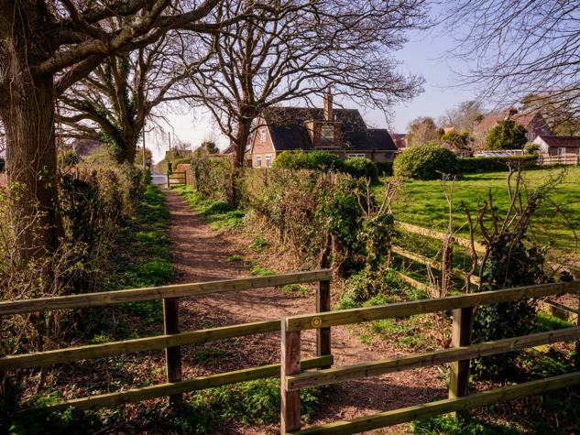
Wealdway entering East Hoathly from Chiddingly

East Sussex County Council Walks

b. ESCC has in the past, produced guides to local walks. The only one they now show for this Parish can be found by typing the following into your internet browser:

https://www.eastsussex.gov.uk/media/vnajfzez/east-hoathly-walk.pdf

or select the following link: Link to ESCC Walk in East Hoathly

Wealden Walks

c. WDC currently have a Wealden Walks Blog which has a link to 34 walks within the District. Two of the walks, that are centered on Laughton, very briefly enter the Parish at Halland Park Farm. The walks are titled: “Pelhams, Parks and Poachers” and “The Village in the Middle”. They can be accessed by typing the following into your internet browser:
https://www.wealden.gov.uk/wealden-walks-blog/

or select the following link: Link to Wealden Walks Blog

Thomas Turner Walks

d. The Diary of Thomas Turner 1754 - 1765 is an important record of life in a Georgian Village. In carrying out his duties as Shopkeeper, Draper, Teacher, Surveyor, Overseer, Undertaker and Church Warden, Thomas Turner spent many hours walking and riding around the Parish. A pamphlet produced in 1996 by Bruce Cripps records Eight walks “In the Steps of Thomas Turner”.

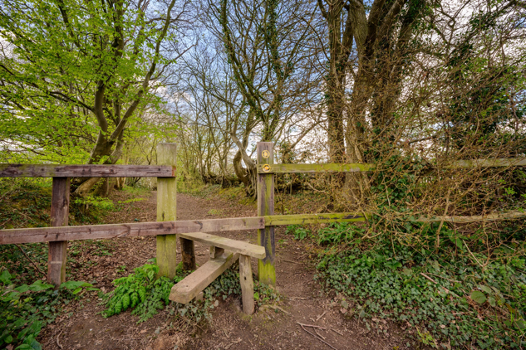
Entry to Moat Wood, East Hoathly

Footpath Adoption

e. The Parish is endeavouring to adopt a commonly used footpath in Pine Wood (adjoining Moat Wood) as a PROW.

f. The Neighbourhood Plan Consultation process revealed the desire to add linking footpaths to the existing footpath network. These linking paths would enable the generally radial paths leaving the settlements to be linked into circular walks. The Parish Council hope to discuss the potential of adding these footpaths with local landowners.

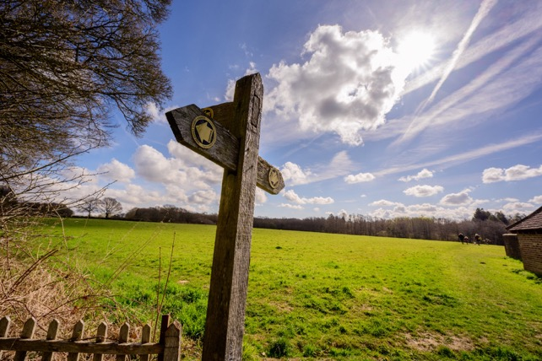

Footpath Sign

225. The maintenance of the footpaths and pavements within the settlements is a concern for many parishioners. These are often being damaged by vehicles mounting the footpath/pavement in order to park or pass other vehicles in the road. The verges are destroyed and the resulting debris then spoils the paths and blocks drains.

226. Residents and visitors would benefit from access to a Notice Board or Information Point that provides details of the local points of interest and local walks. The Parish Council are investigating this.

Cycleways/Routes

227. There are no cycle routes from the National Cycle Network in or near to the Parish. There are no cycleways in the Parish. The recently published East Sussex Local Cycling & Walking Infrastructure Plan (LCWIP) contained no reference to this Parish.

East Hoathly and Halland Link

228. The footpath which connects East Hoathly to Halland is through woodland and fields in one of the lowest lying parts of the Parish. The route is an attractive country walk but is often muddy and waterlogged. It is very enclosed in parts and is not an easily usable route connecting our communities. It is unsuitable for cycles, pushchairs or disabled access. The alternative route is to walk along the A22 and then down London Road. This is not advisable as the traffic is fast moving and the verges are narrow in places and uneven.

229. The Parish has been exploring the possibility of a route that would provide a safe walking and cycleway connecting East Hoathly with Halland. This would allow each settlement to more easily use each other’s facilities and services more easily. This might be walking access to Staverton Nursery for East Hoathly residents or the Primary School and East Hoathly Church for Halland residents. As part of this process, discussion has taken place over the use of the woodland footpaths through Bentley Wood to the Shaw Roundabout.

EHHNP Aspiration 7 - Accessibility

A7.1 This Parish seeks to create a safe footpath and cycleway connecting East Hoathly and Halland that can be used by all residents in all weathers.

A7.2 This Parish seeks to establish an Information Point for residents and visitors to discover information about the local walks, heritage and places of refreshment.

SECTION 10 - COMMUNITY INFRASTRUCTURE LEVY

230. The Community Infrastructure Levy (CIL) is a charge legislated for by Government and adopted by Local Planning Authorities for new development. CIL is paid by the developer to WDC. Not all development is liable to CIL as there are a number of exemptions to both individuals and developers. The exact amount of CIL for any project is calculated by WDC. Our Parish is located in the higher rate band for CIL payments for housing, so the general charge on developers will be £200/m² plus an annual indexation rate determined by the Building Cost Information Service. As an example, for residential planning permissions granted in 2023, the combined CIL charge including the indexation will be £260/m². Retail development is charged differently and full details of the CIL is available on the WDC Website.

231. The Parish receives 15% of the CIL (subject to a cap) received by WDC. There is detailed guidance on the permitted uses of CIL money, but in general, it can be spent on the provision, improvement, replacement, operation or maintenance of infrastructure, or anything else that is concerned with addressing demands that development places on an area. If the Parish succeed in getting the EHHNP adopted, it will receive 25% of future CIL receipts (uncapped).

232. As an example, the current amount of the CIL payment for the development of 6 homes at Old Hartfield, Halland, for which planning permission was granted in 2019, would amount to £62,901.10 of which the Parish should receive £9,435.17. With a Neighbourhood Plan in place, the Parish would receive £15,725.28.

233. However, the Government has imposed a cap on the amount of CIL that a Parish without a Neighbourhood Plan can receive in any year and this is currently set at £100 for every home in the Parish that pays Council Tax. This amounts to around 663 homes and therefore a maximum CIL payment of £66,300. Redrow predicted, for the Hesmond’s development of 205 homes, a CIL payment to WDC of £4,300,000. This Parish would therefore receive £66,300 without a Neighbourhood Plan but £1,075,000 with a Neighbourhood Plan.

Spending the CIL

Local Planning Authority (WDC)

234. The Local Planning Authority must spend the CIL on infrastructure needed to support the development of their area (full details are published in Government Guidance). CIL can be used to fund a wide range of infrastructure, including transport, flood defences, schools, hospitals, and other health and social care facilities. This definition allows the CIL to be used to fund a very broad range of facilities such as play areas, open spaces, parks and greenspaces, cultural and sports facilities, healthcare facilities, academies and free schools, district heating schemes and police stations and other community safety facilities. Charging authorities may not use the CIL to fund affordable housing. The CIL can be used to increase the capacity of existing infrastructure or to repair failing existing infrastructure, if that is necessary to support development.

Parish

235. The neighbourhood portion of the CIL can be spent on a wider range of things than the rest of the CIL, provided that it meets the requirement to ‘support the development of the area’. The wider definition means that the neighbourhood portion can be spent on things other than infrastructure (as defined in the Community Infrastructure Levy Regulations) provided it is concerned with addressing the demands that development places on the parish’s area. For example, the CIL could be used to fund affordable housing.

236. The Parish councils should work closely with WDC to agree on infrastructure spending priorities. The Parish Council’s Priority List for CIL expenditure is shown at Annex N. This will be reviewed annually and take into account the infrastructure demands imposed by any new development proposals. The items on the Priority List do not form part of the Statutory NP and will not form part of the Independent Examination.
Annexes: Page

A. The Evolution of WDC’s Plans for East Hoathly with Halland Parish. 146
B. Children of Primary School Age in East Hoathly with Halland Parish. 155
C. Carbon Emission Estimates in East Hoathly with Halland Parish. 156
D. Listed Buildings in East Hoathly with Halland Parish. 159
E. Pelham Buckle Milepost Markers in East Hoathly with Halland Parish. 161
F. Assets of Community Value in East Hoathly with Halland Parish. 162
G. Proposed Assets of Community Value in East Hoathly with Halland Parish.163
H. Fingerpost Signs and Post Boxes in East Hoathly with Halland Parish. 164
I. Land Stewardship Schemes in East Hoathly with Halland Parish. 165
J. Ancient Woodland and Tree Preservation Orders in East Hoathly with
Halland Parish. 166
K. Hedgerows in East Hoathly with Halland Parish. 169
L. Assessment of Potential Local Green Spaces in East Hoathly with
Halland Parish. 173
M. Public Rights of Way and Bridleways in East Hoathly with Halland Parish. 235
N. East Hoathly with Halland Parish Council CIL Expenditure Priorities. 236

Tables:

1. Facilities in East Hoathly and Halland. 29
2. Housing Type. 49
3. Housing – Number of Bedrooms. 49
4. Housing – By Number of Bedrooms and Tenure. 50
5. Housing – Tenure/Ownership. 50
6. WDC Housing Mix Recommendation. 51
7. Cars/Vans per Household. 59
8. Method of Travel to Work. 60
9. Sewage Discharges in Watercourses. 103
10. Settlement Capacities. 149
11. Children of Reception/Primary School Age. 155
12. Tree Preservation Orders. 167
13. Potential Local Green Space 1 – East Hoathly War Memorial Sports
Ground. 179
14. Potential Local Green Space 2 – East Hoathly Garden Plots (Allotments). 182
15. Potential Local Green Space 3 – Moat Wood and Decoy Pond. 186
16. Potential Local Green Space 4 – Long Pond. 190
17. Potential Local Green Space 5 – Circle of Oaks. 193
18. Potential Local Green Space 6 – Juziers Play Area. 197
19. Potential Local Green Space 7 – Juziers Drains/Swales. 200
20. Potential Local Green Space 8 – Church Marks Lane Lawn. 203
21. Potential Local Green Space 9 – Nightingales Play Area. 204
22. Potential Local Green Space 10 – Nightingales Lawn. 207
23. Potential Local Green Space 11 – East Hoathly Churchyard. 209
24. Potential Local Green Space 12 – School Field. 211
25. Potential Local Green Space 13 – Church Marks Green. 213
26. Potential Local Green Space 14 – Croom Cottage Meadow. 214
27. Potential Local Green Space 15 – Approach to East Hoathly on London
Road. 216
28. Potential Local Green Space 16 – South Downs View. 218
29. Potential Local Green Space 17 – Buttsfield Lane. 220
30. Potential Local Green Space 18 – Nursery Wood, Halland. 221
31. Potential Local Green Space 19 – Land to rear of The Blacksmith’s Arms,
Halland. 222
32. Potential Local Green Space 20 – Halland Chapel Burial Ground. 223
33. Summary Assessment of Potential Local Green Spaces against NPPF
2021 Criteria. 224
34. Level of public support for Potential Local Green Spaces in September
2019 Consultation Event. 233

Figures:

1. East Hoathly with Halland Neighbourhood Area. 4
2. The Parish Boundary shown in Blue was enlarged to the West of the
Red line in 1990 to incorporate the whole of the Settlement of Halland. 16
3. Growth in Number of Homes in Parish. 54
4. Growth in Number of Homes in East Hoathly. 54
5. Percentage Change in Population. 56
6. Designated Heritage Assets in Parish. 79
7. East Hoathly Conservation Area. 85
8. Wealden District Light Pollution. 89
9. Dark Skies Map showing relative darkness of the Parish. 90
10. WDC Landscape Character Assessment 2022 – Characterisation of
Parish. 93
11. Parish Woodland. 99
12. Local Green Space – Policies Map East Hoathly. 113
13. Local Green Space – Policy Map Halland. 113
14. Employment in Parish. 126
15. Example of mobile phone coverage in Parish. 134
16. Halland Core Area in Wealden Submission LP 2019 (now withdrawn). 148
17. Middle Super Output Area (MSOA) 13 South. 149
18. East Hoathly Development Boundary in Wealden Submission LP 2019
(now withdrawn). 152
19. Parish Carbon Emissions by Source. 156
20. Parish Carbon Emissions by Consumption. 157
21. Parish Carbon Emissions in Comparison with Wealden by Source. 157
22. Parish Carbon Emissions in Comparison with England by Source. 158
23. Pelham Buckle Milepost Markers. 161
24. Fingerpost Signs and Post Boxes. 163
25. Land Stewardship Schemes. 165
26. Parish Woodland. 166
27. Surveyed Hedgerows to South East of East Hoathly. 170
28. Surveyed Hedgerows to West of East Hoathly. 170
29. Surveyed Hedgerows to South West of Halland. 171
30. Surveyed Hedgerows to East of East Hoathly. 171
31. Surveyed Hedgerows to North of East Hoathly. 172
32. Potential Local Green Spaces in Parish. 175
33. Ownership of Moat Wood. 184
34. Potential Juziers Local Green Spaces. 195
35. Potential Nightingales Local Green Spaces. 201

Picture Credits and Copyright:

Pictures on the following pages are copyrighted to Mr Jim Holden:

1, 5, 14, 17, 19, 20, 21, 30, 31, 32, 33, 34, 36, 38, 39, 44, 80, 81, 100, 101, 104, 110, 114, 122, 123, 124, 131, 137, 138, 139, 176, 177, 178, 181, 183, 185, 189, 209 and 214.

Pictures on the page 42 are copyrighted to Ms Katherine Gutkind.

Annex A

THE EVOLUTION OF WDC’S PLANS

FOR EAST HOATHLY WITH HALLAND PARISH

1. This Annex is intended to show the evolution of WDC’s plans for East Hoathly with Halland Parish. It will include references to documents that did not become adopted policy, in particular the now withdrawn Wealden Submission LP 2019. This Parish is well aware that these documents hold no weight but they are part of the narrative of how WDC’s views about this Parish have evolved. These were part of public consultations and created a strong response from many people in this community. It is therefore appropriate to include reference to them in the EHHNP even though they have no planning weight. It will allow the public to see the complete chain of events that has led to the current EHHNP and the expectation of a new LP that is due to be published by WDC.

Halland

Evolution of Halland in WDC’s Plans

2. The Wealden LP 1998 defined a Development Boundary for Halland but did not categorise Halland within a Settlement Hierarchy. It described Halland in Chapter 19, Paragraph 19.16.1 as: “a small linear settlement …. essentially residential in character with limited facilities and services”. The stated aim in Chapter 19, Paragraph 19.16.2 was: “to protect the approaches and surrounding countryside from an extension of inappropriate, especially ribbon, development”.

3. The WDC Local Development Framework of 2 July 2007 included an Issues and Options Consultation Paper covering the period 2006 to 2026. Halland was described as having the potential to be an Expanded Village with 1800 to 2800 additional homes. This plan for Halland was eventually withdrawn.

4. The Wealden Core Strategy LP 2013 removed Halland’s Development Boundary. No housing was allocated to Halland and the settlement was not defined.

5. The Wealden Submission LP 2019 was withdrawn in February 2020 after it failed the first phase of public examination. It has no relevance in terms of planning but is still a record of how WDC viewed the future development of this Parish at that time.

Halland in the Wealden Submission LP 2019 (now withdrawn)

6. Halland was defined in the Wealden Submission LP 2019 (now withdrawn) Settlement Hierarchy Background Paper 2019 Table 6, as a Local Settlement and an Unsustainable Settlement. This definition stipulated that it was a “Settlement with accessibility by public transport with local to very limited facilities”. The Wealden Submission LP 2019 (now withdrawn) provided Halland with a defined Core Area to help to provide certainty for future development. The Wealden Submission LP 2019 (now withdrawn) Policy Rural Area Strategy (RAS) 1 detailed the constraints placed on development related to the Core Area:

Core Area

a. “The Halland Core Area has been given a Settlement Capacity of 30 dwellings up to 2028”.

b. “Development will only be permitted within and adjacent to the Core Area".

c. “The settlement capacity may only be exceeded if development is on suitable brownfield land and such development would be counted against the Settlement Capacity”.

d. “Housing developments are restricted to up to 5 dwellings/live-work units within and adjacent to the Core Area”.

e. “Dwellings/live-work units must be small scale with 1 or 2 bedrooms”.

f. “Coalescence of new developments is not permitted”.

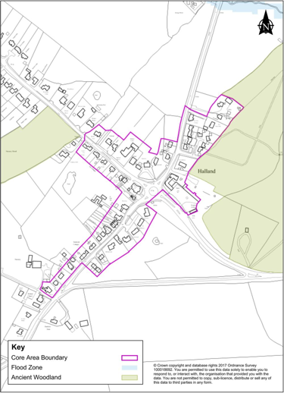

Figure 16 - Halland Core Area in Wealden Submission LP 2019 (now withdrawn)

Settlement Capacity

g. The Settlement Capacity for Halland was based on the WDC Middle Super Output Area (MSOA) 13 South. This was a boundary that encompasses the Parishes of Laughton, Chiddingly and East Hoathly with Halland. The MSOA boundary was used to facilitate the transport modelling that was used to assess the impact of pollution caused by developments proposed as part of the Wealden Submission LP 2019 (now withdrawn). The areas of particular sensitivity to developments in East Hoathly with Halland are the Lewes Downs Special Area of Conservation (SAC) and the Ashdown Forest SAC. The transport modelling calculated the pollution impact if development placed new houses in different parts of the District. Placing houses in MSOA 13 South was shown to have a significantly detrimental effect on the Lewes Downs SAC and Ashdown Forest SAC.

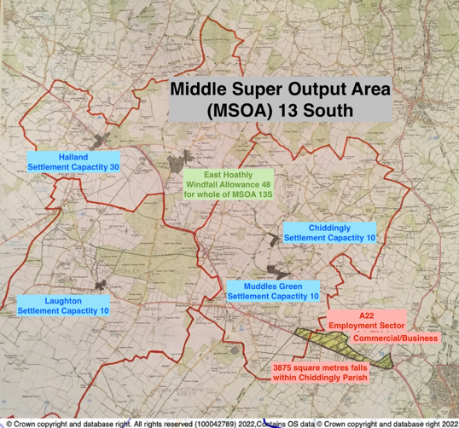

Figure 17 – Middle Super Output Area (MSOA) 13 South

h. WDC allocated (through Policy RAS 1) within MSOA 13 South some settlements with a Settlement Capacity. Whilst each of these settlements had a specified capacity for development they were allocated no Windfall Allowance to allow such development:

Table 10 – Settlement Capacities

Settlement | Settlement Capacity | Windfall Allowance
Laughton | 10 | 0
Chiddingly | 10 | 0
Muddles Green | 10 | 0
Halland | 30 | 0

East Hoathly

The Evolution of East Hoathly in WDC’s Plans

7. The Wealden LP 1998 defined a Development Boundary for East Hoathly but did not categorise East Hoathly within a Settlement Hierarchy. It described East Hoathly as a fairly substantial village with modest potential for growth.

8. In 2005 WDC published a Non Statutory LP that proposed the development of 45 homes inside the Development Boundary (Juziers) and 30 homes as an extension to the village (Nightingales).

9. The WDC Local Development Framework of 2 July 2007 included an Issues and Options Consultation Paper covering the period 2006 to 2026. East Hoathly was described as a Smaller Local Service Centre and having Intermediate Growth Potential but that there should be no further growth beyond 75 dwellings proposed in the 2005 Non Statutory LP. The 75 homes proposed for East Hoathly was approved by WDC but with an assurance that there should be no further growth.

10. In the Wealden Core Strategy LP 2013, East Hoathly was defined as a Neighbourhood Centre alongside small villages such as Chiddingly. No housing was allocated to the Parish and the Development Boundary had been removed.

11. In November 2015 WDC published LP Issues, Options and Recommendations Consultation. East Hoathly was defined as a Sustainable Settlement alongside towns such as Uckfield. This included a proposed allocation of 190 homes for East Hoathly.

12. On 3 March 2017 WDC published a Draft LP. East Hoathly was defined as Large Village Type 2. East Hoathly is the smallest of the villages defined as a Type 2 Village. This Draft included a proposed allocation of 205 homes and an enlarged Development Boundary including Broomy Lodge Field and Hesmonds land North of London Road. This Draft was withdrawn prior to being considered by the full council.

13. On 22 March 2017 an amended Draft LP was approved by WDC. East Hoathly now had an allocation of zero homes and a tightly drawn Development Boundary.

14. In July 2018 WDC published a revised Draft LP in which East Hoathly had a Windfall Allowance of 66 homes and a tightly drawn Development Boundary. Some of this Windfall Allowance had already been built or approved within the Plan period 2013 - 2028. This Draft became the Wealden Submission LP 2019 and was subject to a Public Examination by the Planning Inspectorate during 2019. The plan was rejected by the Planning Inspector after Stage One of the Inspection process in December 2019 and finally withdrawn by WDC in February 2020.

East Hoathly in the Wealden Submission LP 2019 (now withdrawn)

15. East Hoathly was defined in the Wealden Submission LP 2019 (now withdrawn) Settlement Hierarchy Background Paper Table 6, as a Large Village -Type 2 and as a Sustainable Settlement. This definition stipulates that it is a “Settlement which is accessible with very good local facilities but relatively smaller than Type 1 village. The range of retail outlets and businesses are more limited than larger villages, but with access to essential facilities”. The details of East Hoathly’s Development Boundary and windfall allowance are:

East Hoathly Development Boundary

a. The Wealden Submission LP 2019 (now withdrawn) provided East Hoathly with a Development Boundary which “seeks to prevent significant outward encroachment of development into the surrounding open countryside”:

(1) “To the South, the development boundary follows the clear physical edge to development backed by Moat Wood and open fields. The isolated ribbon of development fronting the A22 to the south of Park Lodge has been excluded since the intervening open land is considered to be an important and integral part of the countryside surrounding East Hoathly where any extension or consolidation of development would be harmful to the character and landscape setting of the village”.

(2) “West of South Street, the development boundary is drawn tightly around existing development. Elsewhere, the recreation ground clearly defines the edge of the built up part of the village and provides a visual link with the countryside beyond”.

(3) “To the North of the village, the development boundary includes Thomas Turner Drive and Carpenters Croft. Large houses set well back from the road in extensive, landscaped grounds have been excluded from the development boundary, since further building in this area would conflict with its essentially rural character”.

(4) “To the East, the development boundary includes dwellings in the block formed by Mill Lane and Buttsfield Lane. However, further outward expansion onto adjoining land would not be considered acceptable due to significant highway constraints”.

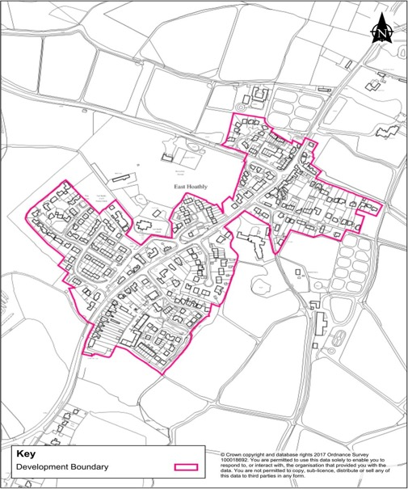

Figure 18 - East Hoathly Development Boundary in Wealden Submission LP 2019 (now withdrawn)

Windfall Allowance

b. The Wealden Submission LP 2019 (now withdrawn) made a Windfall Allowance for Housing and Employment/Jobs

Housing

(1) WDC Policy - Wealden Local Plan (WLP) 7 (now withdrawn) conflated East Hoathly and MSOA 13 South and made a Windfall Allowance of 48 dwellings up to 2028. WDC’s policy stated that these 48 dwellings must be: “within the East Hoathly Development Boundary and policy compliant dwellings in the countryside”.

(2) Under WDC’s Sustainable Settlement Strategy no land was allocated for this Windfall Allowance. WDC stated that this was: “due to environmental constraints or lack of land availability”.

(3) WDC Policy WLP 3 (now withdrawn) stated that: “Within development boundaries the principle of development is acceptable, subject to other policies contained within the development plan including Policy Ashdown Forest(AF) 1.”

(4) WDC Policy WLP 4 (now withdrawn) stated that “Outside of development boundaries development is deemed unsustainable, and not supported, unless it accords with specific policies in the development plan.”

(5) WDC allowed, under Policy RAS 2, for the possibility of new dwellings to come forward in the countryside that were outside the Development Boundary or Core Areas. These were subject to separate constraints and in general were limited to single new dwellings or the conversion of certain agricultural buildings into up to 5 dwellings.

(6) This meant that the Windfall Allowance of 48 for East Hoathly/MSOA 13 South could have been used to approve planning applications as follows:

(a) Developments inside the East Hoathly Development Boundary.

(b) Developments in the village of East Hoathly but outside the Development Boundary provided they were specified in this Neighbourhood Plan.

(c) Policy compliant dwellings in the countryside in the Parishes of Laughton, Chiddingly and East Hoathly with Halland.

(d) Policy HG 5 - Rural Exception Affordable Housing.

(7) It should be noted that any developments completed or planning applications that have been approved since the Windfall Allowance was specified (30 September 2017) would have been counted against this Allowance. By the time the Wealden Submission LP 2019 (now withdrawn) was withdrawn the amount of “Completions and Commitments” had exceeded the Windfall Allowance of 48. WDC had indicated that the Allowance was to be used on a “first come, first served” basis. WDC had indicated that no planning approvals would be granted in excess of this Allowance.

Employment/Jobs

(8) WDC Policies WLP 8 (now withdrawn) and WLP 9 (now withdrawn) conflated East Hoathly and MSOA 13 South and allocated Employment Land as part of the A22 Employment Corridor Site and Jobs Growth. Although this was shown in the Wealden Submission LP 2019 (now withdrawn) as “East Hoathly” the land was within the Chiddingly Parish Boundary and was their responsibility.

Annex B

CHILDREN OF PRIMARY SCHOOL AGE

IN EAST HOATHLY WITH HALLAND PARISH

1. This annex seeks to examine the number of children of Primary School age in the Parish. Table 11 projects how many might be expected as a result of the currently approved planning applications.

Table 11 - Children of Reception/Primary School Age

Census Groups | Totals | Expected from Approved Developments
All Residents | 1600 | 676
Age 5 - 11 | 129 | 55
Households | 620 | 262

Children of Primary School age in Parish in 2011 129
Following addition of 262 new homes 184
Capacity of East Hoathly School 105

Expected deficit 79
2. New housing may be built in phases (although WDC are opposed to this) and incoming families may not choose to change their children’s school immediately. Some families may choose to send their children to private schools and this will reduce the figure. Some parents will choose to send their children to schools outside the Parish but this may be balanced by parents who live outside the Parish choosing to send their children to East Hoathly School. All children schooled outside the Parish require vehicle usage with the pollution and congestion that arises from it.

3. The data is taken from the 2011 ONS Census. The figures in the yellow box are estimated figures extrapolated in proportion to 2011 Census data for the number of residents in the Parish in relation to the number of homes and the number of Primary School Aged Children in the Parish in relation to the number of all residents.

Annex C

CARBON EMISSION ESTIMATES

IN EAST HOATHLY WITH HALLAND PARISH

1. Carbon Emission Estimates have been prepared by the Centre for Sustainable Energy as part of their Climate Emergency Support Programme. The following graphics give an indication of the Parishes total Carbon Emissions and its breakdown.

Figure 19 - Parish Carbon Emissions by Source

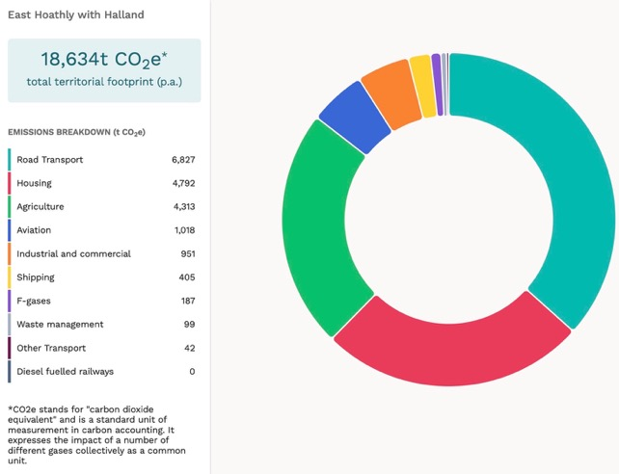

2. Chart 4 above, shows Carbon Emissions that are produced directly from our Parish. Of particular note is the high level of emissions from Road Transport which reflects that we are a car dependent community with a major A road (A22) running through the centre of the Parish.

Figure 20 - Parish Carbon Emissions by Consumption

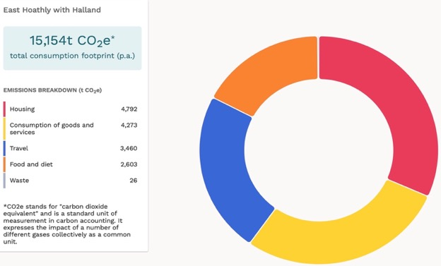

3. Chart 5 above, shows Carbon Emissions on a Consumption basis. This adds to Chart 4 with emissions caused by what we buy and what we eat (where that is imported from other parts of the UK or the world).

Figure 21 - Parish Carbon Emissions in Comparison with Wealden by Source

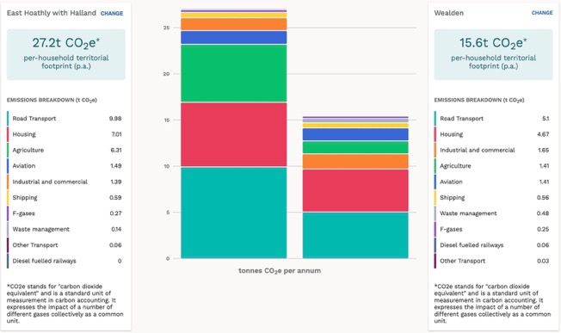
4. Chart 6 above, shows a comparison of a household in our Parish against the Wealden average. Chart 7 below, shows a comparison of a household in our Parish against the average in England. We have almost twice the Wealden average of Carbon Emissions. We have more than twice the average for England.

Figure 22 - Parish Carbon Emissions in Comparison with England by Source

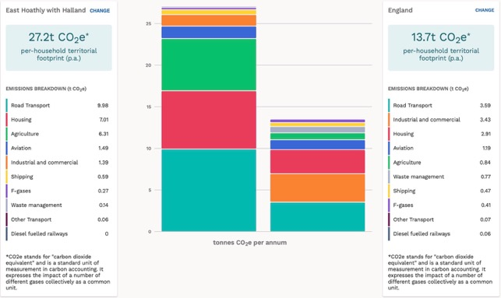

5. It clearly shows that our Parish has a much greater level of Carbon Emissions than in Wealden and when compared to average in England. This is largely because we are a rural parish that has commensurately higher level of agricultural emissions. However, the most significant item is that of transport reflecting that we are a highly car dependent community.

Further Information

6. Further more detailed breakdowns can be viewed by visiting the Impact – Community Carbon Calculator by typing the following into your internet browser:

https://impact-tool.org.uk

or select the following link: Link to Impact - Community Carbon Calculator

Annex D

LISTED BUILDINGS

IN EAST HOATHLY WITH HALLAND PARISH

Serial | Listing Number | Grade | Description
1 | 1043288 | II | East Hoathly Stores, 9, 11 and 13 High Street, East Hoathly, BN8 6DR
2 | 1353330 | II | East Hoathly Post Office and House Attached, 2 High Street, East Hoathly, BN8 6EB
3 | 1043286 | II | Godfreys, Halland, BN8 6RB
4 | 1193320 | II | Whyly, East Hoathly, BN8 6EL
5 | 1043251 | II | Yew Tree Cottage, 20 South Street, East Hoathly, BN8 6DS
6 | 1353331 | II | Price’s Cottages, Whitesmith, BN8 6JD
7 | 1353332 | II | Sellens Cottages, 7, 9 and 11 South Street, East Hoathly, BN8 6DS
8 | 1043249 | II | The White House, 20 High Street, East Hoathly, BN8 6PS
9 | 1043250 | II | Jasmine Cottages, 2 and 4 Mill Lane, East Hoathly, BN8 6QB
10 | 1043254 | II | The Mill House, 2 Waldron Road, East Hoathly, BN8 6DP
11 | 1043285 | II* | The Parish Church, Church Marks Lane, East Hoathly
12 | 1043287 | II | Hartfield Farmhouse, Halland, BN8 6PW
13 | 1286188 | II | Fern Cottage, 4 Waldron Road, East Hoathly, BN8 6DP
14 | 1353293 | II | Cherry Tree Cottages, 24 and 26 South Street, East Hoathly, BN8 6DS
15 | 1353294 | II | Lavender Cottage, 15 Waldron Road, East Hoathly, BN8 6PW
16 | 1193427 | II | The Gate House, Waldron Road, East Hoathly, BN8 6QH
17 | 1043253 | II | 5, 7 and 9 Waldron Road, East Hoathly, BN8 6DP
18 | 1043289 | II | Rosemount, High Street, East Hoathly, BN8 6DR
19 | 1286184 | II | Piper’s Farmhouse, Hollow Lane, East Hoathly, BN8 6RA
20 | 1353295 | II | Hesmonds, Waldron Road, East Hoathly, BN8 6QH
21 | 1193327 | II | The Ruins of the old house known as Halland House in the grounds of Halland Park House, Shortgate, BN8 6RB
22 | 1043248 | II | 6,8 and 10 High Street, East Hoathly, BN8 6EB
23 | 1043252 | II | Spring Cottage, 1 and 3 Waldron Road, East Hoathly, BN8 6DP
24 | 1043255 | II* | Belmont, Waldron Road, East Hoathly, BN8 6QJ
25 | 1286193 | II | Aberdeen House, 5 High Street, 7 High Street, The King’s Head Inn, 1 and 3 High Street, East Hoathly, BN8 6DR
26 | 1028363 | II | Vine Cottage, Terrible Down, Halland,
27 | 1028388 | II | Lower Sandhill House, Easons Green,
28 | 1028391 | II | Peckhams, Knowle Lane, Halland, BN8 6PR
29 | 1286218 | II | Old Post Office Cottage, Buttsfield Lane, East Hoathly, BN8 6EF
30 | 1444079 | II | Telephone Kiosk, Mill Lane/Waldron Road, East Hoathly
31 | 1043102 | II | Halland Park Farmhouse, Shortgate, BN8 6RB
32 | 1353376 | II* | Barn at Halland Park Farm to South West of the Farmhouse, Shortgate, BN8 6RB
33 | 1452099 | 2 | Foresters Arms, 6 South Street, East Hoathly, BN8 6DS
34 | 1468363 | II | Bentley Wood, Knowle Lane, Halland, BN8 6PR
35 | 1020515 |  | Scheduled Monument - Moated site in Moat Wood, 580 m East of Halland Park Farm, East Hoathly

Description of Scheduled Monument

The peak period for moated sites was about 1250 to 1350 and the majority were prestigious residences where the moat was generally intended as a status symbol rather than for practical military defence. This monument includes a medieval moated site, situated on the south western outskirts of East Hoathly village, on low lying ground which forms part of the Sussex Weald. The roughly north west-south east aligned moated site survives in the form of earthworks and associated buried remains. The square, central island measures around 35m across and is surrounded by a ditch, up to 19m wide and 1.3m deep. The north western and north eastern arms of the moat remain partly - filled. Elsewhere, the ditch has become partly infilled over the years, and contains a low, central bank in the south east, about 4m wide and 0.3m high. The ditch was in turn surrounded by an outer bank, and sections of the bank, measuring up to 6m wide and 1m high, survive around the western corner of the moat and along its north eastern side. The eastern corner of the moat has been partly disturbed by past modern drainage operations, and the outer bank has been partly levelled by other activities, including the construction and use of the footpaths on the north western and south western sides of the moat. Although no upstanding remains of former buildings have been identified, traces of buildings can be expected to survive as buried features beneath the present ground surface of the central island.

Annex E

PELHAM BUCKLE MILEPOST MARKERS

IN EAST HOATHLY WITH HALLAND PARISH

Milepost 46 A22 Near Crockstead MES 21804

Milepost 47 A22 South of Halland MES 21803

Milepost 48 London Road, East Hoathly MES 33241

Milepost 49 A22 Park Lane Corner MES 21802

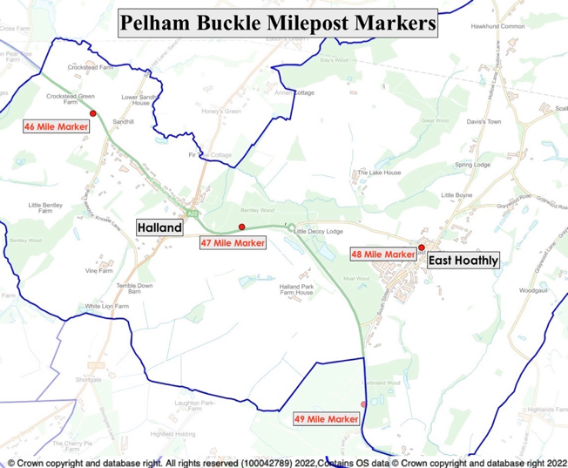

Figure 23 – Pelham Buckle Milepost Markers

Annex F

ASSETS OF COMMUNITY VALUE

IN EAST HOATHLY WITH HALLAND PARISH

Serial | Reference | Start Date | End Date | Description
1 | 22007 | 27 Sep 2022 | 26 Sep 2027 | The Kings Head, East Hoathly
2 | 22008 | 27 Sep 2022 | 26 Sep 2027 | The Blacksmith’s Arms, Halland
3 | 21004 | 30 Jun 2021 | 29 Jun 2026 | Garden Plots, East Hoathly
4 | 22003 | 13 May 2022 | 12 May 2027 | East Hoathly Medical Centre

Annex G

POTENTIAL ASSETS OF COMMUNITY VALUE

IN EAST HOATHLY WITH HALLAND PARISH

Serial | Description
1 | Village Hall
2 | Sports Ground Pavilion
3 | Halland Chapel

Annex H

FINGERPOST SIGNS AND POST BOXES

IN EAST HOATHLY WITH HALLAND PARISH

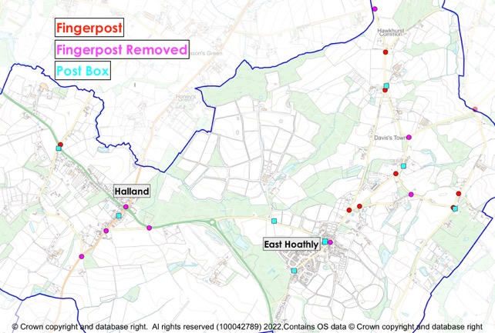

Figure 24 – Fingerpost Signs and Post Boxes

Annex I

LAND STEWARDSHIP SCHEMES

IN EAST HOATHLY WITH HALLAND PARISH

1. The Countryside Stewardship Scheme provides financial incentives for farmers, woodland owners, foresters and land managers to look after and improve the environment.

2. The Environmental Stewardship Scheme is a land management scheme that provides funding to farmers and other land managers in England to deliver effective environmental management

3. The Organic Farming Scheme aims to encourage the expansion of organic production. Under the scheme, farmers moving from conventional to organic farming methods receive financial help during the conversion process.

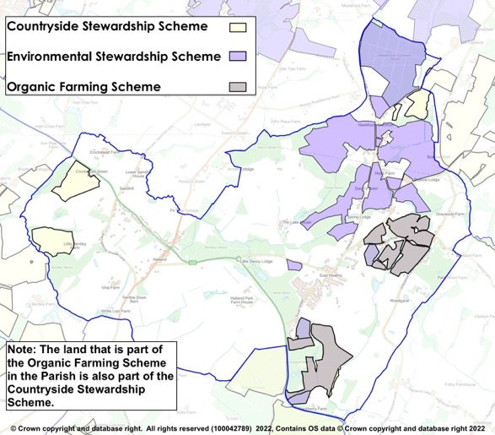
Figure 25 – Land Stewardship Schemes

Annex J

ANCIENT WOODLAND AND

TREE PRESERVATION ORDERS

IN EAST HOATHLY WITH HALLAND PARISH

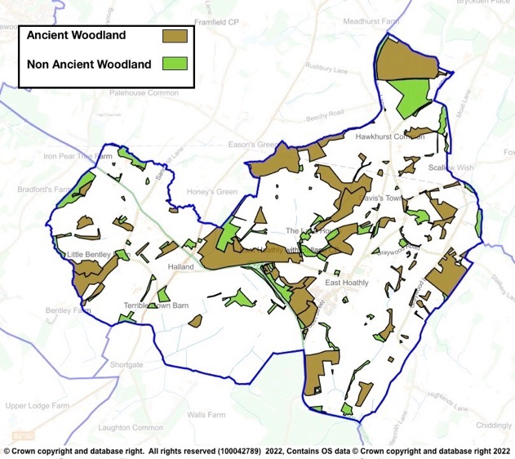

Figure 26 - Parish Woodland

Table 12 - Tree Preservation Orders

Serial | TPO Number | Location | Species | Confirm-ation Date | Grid Ref
1 | HRDC 1973 (3) | Land Adj Cherry Tree Cottage, South St | T1 - Yew |  | 551936  116004
2 | 14 1998 | Land at Slays Wood, Adj Annan Court, Easons Green | W1 & W2 - Woodland consisting mainly of Silver Birch, Sweet Chestnut, Hornbeam and Oak. |  | 551205  117796
3 | 22 1978 | Land at Upper Hook Fd, Waldron Rd | T1 Oak | 23/1/80 | 552480  116590
4 | 22 1991 | Engineering Works, The Mews | T1 - Scots Pine  G1 - Group of 3 Cherry Laurel, 11 Portugal Laurel, 2 Hawthorn, 1 Holly, 2 Variegated Holly, 1 Western Red Cedar | 16/5/91 | 5213  1606
5 |  |  | T1 Scots Pine presumed to be felled - noted on land parcel for 16 The Mews - 17/11/08
6 | 23 1997 | Land at Slays Wood, Adj Annan Court, Easons Green | W1 - Woodland comprised predominantly Oak, Silver Birch, Hornbeam and Sweet Chestnut | 12/5/98 | 551115  117788
7 | 25 1981 | Land between Gables and Myrtle View, A22 | T1 - Holly, T2 - Ash, T3 - Oak, T4 - Oak, T5 - Oak, T6 - Oak, G1 - Group of 40 Aspen | 14/10/81 | 550130  116730
8 | 26 2004 | Graywood N of Quadrangle | W1 - Woodland maily Hornbearm, Ash, Oak, Sweet Chestnut, W2 - Woodland mainly Hornbeam, Ash, Oak, Sweet Chestnut, W3 - Woodland mainly Hornbeam, Ash, Oak and Sweet Chestnut | 8/7/91 | 5365  1654
9 | 26 2004 | Crockstead Farm | A1 - Area of Misc deciduous and coniferous trees | 23/12/04 | 549440  117941
10 | 29 2004 | Downs Cottage, 31 Mill Lane | T1 - Horse Chestnut | 14/12/04 | 552466  116194
11 | 30 2002 | Moat Wood | W1 - Mixed deciduous Ancient Semi-Natural woodland consisting mainly of Ash, Birch, Cherry, Douglas Fir, Hazel, Hornbeam, Oak, Sweet Chestnut, Sycamore and Willow. Note - 5 Oak, 1 Willow, 1 Poplar, 2 Birch and 4 Sweet Chestnut removed from TPO - felled 13/10/2015 | 20/12/02 | 551567  116128
12 | 36 1996 | Great Ailies Farm | W1 - mainly Oak, Hornbeam, Ash, Holly and Field Maple | 18/4/97 | 5334  1602
13 | 46 1986 | Harrisons Shaw | W1 - Woodland mainly Oak, Sweet Chestnut and Ash | 31/1/87 | 5128  1643
14 | 48 2006 | Martinland Wood | W1 - Woodland consisting of all deciduous and coniferous trees incl Birch, Ash, Sycamore and Native species | 3/10/06 | 551941  115118
15 | 5 1990 | Rear of 22 South St | T1 - Holm Oak, T2 - Sweet Chestnut, T3 - Ash, G1 Group of 3 Ash, G2 - Group of 2 Ash and 2 Oak | 2/4/90 | 5190  1600
16 | 56 2004 | Safir Works, South St | T1 - Common Oak, T2 - Common Oak, G1 - Group of 7 Ash, 4 Common Oak, 1 Horse Chestnut | 13/5/05 | 552090  115920
17 | 58 1990 | Nursery Wood | W1 - Woodland mixed hardwoods mainly Oak, Sweet Chestnut, Hornbeam, Holly, Birch and Gean | 3/9/90 | 5000  1676
18 | 71 1991 | Rear of Yew Tree Cottage, Halland | T1, T2 and T3 English Oak | 3/2/92 | 5035  1677
19 | 99 1990 | N of Belmont - Supersedes 16 1986 | W1 - Woodland mainly Oak, Sycamore, Ash, Holly, Hornbeam, Beech, Birch, Sweet Chestnut | 20/11/90 | 552667  116679
20 | 2018/0008 | Adj to Park Lodge | G1 - 7 Common Oak | 11/6/19 | 551952  115840

Annex K

HEDGEROWS

IN EAST HOATHLY WITH HALLAND PARISH

1. A countryside hedgerow is a boundary line of bushes, which can include trees. A hedgerow is protected, meaning it cannot be removed, if it meets the following criteria for length, location and importance:

Length

a. If it is more than 20m long with gaps of 20m or less in its length, or

b. If it is less than 20m long, but meets another hedge at each end.

Location

c. A hedgerow is protected if it is on or next to land used for agriculture or forestry, land used for breeding or keeping horses, ponies or donkeys, common land.

Importance

d. A hedgerow is important and is protected if it is at least 30 years old and marks all or part of the parish boundary, is part of a field system that existed before 1845, contains protected species, contains species that are endangered, vulnerable or rare, includes woody species as specified in Hedgerow Regulations.

2. Hedgerows are surveyed and assessed in accordance with the Hedgerow Regulations 1997 and the findings recorded by the Sussex Biodiversity Trust. This was part of the Sussex Hedgerow Project under the control of the Sussex Biodiversity Records Centre in which they provided training for Parish volunteers to carry out the surveys. The hedgerow is recorded for its length, width and the presence of associated ditches, walls or banks. The woody species and herb layer are separately listed and assessed for their quality and variety. Native species and alien species are recorded. Following the survey, the Hedgerow is graded and recorded. The hedgerows that have been surveyed in the Parish are shown below:

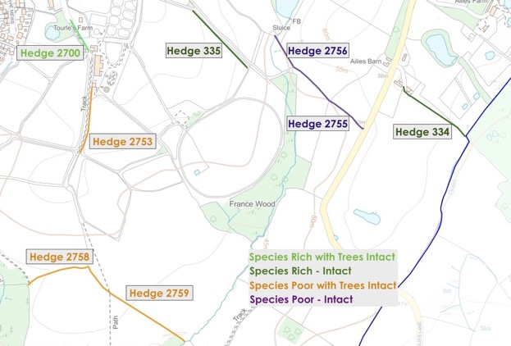

Figure 27 - Surveyed Hedgerows to South East of East Hoathly

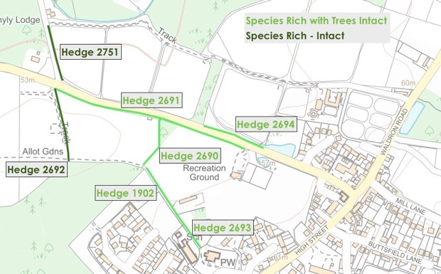

Figure 28 - Surveyed Hedgerows to West of East Hoathly

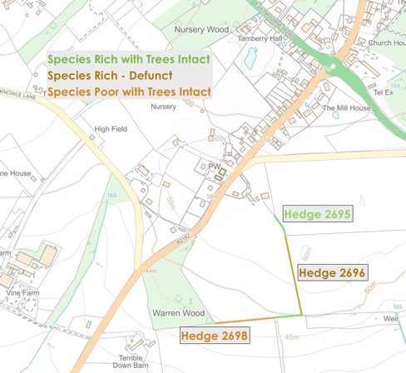

Figure 29 - Surveyed Hedgerows to South West of Halland

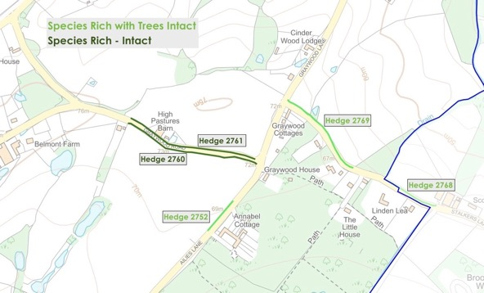

Figure 30 - Surveyed Hedgerows to East of East Hoathly
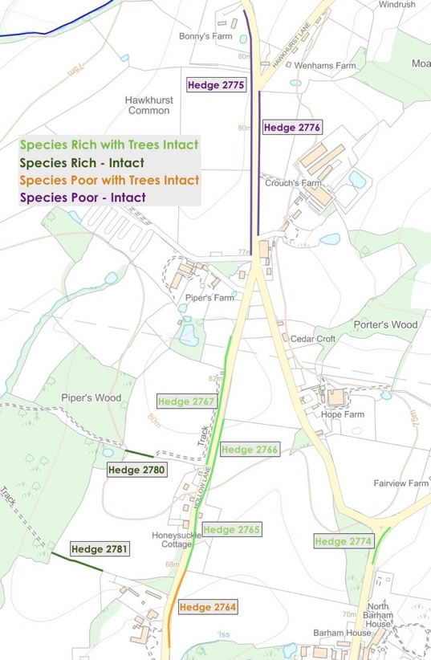

Figure 31 - Surveyed Hedgerows to North of East Hoathly

Annex L

ASSESSMENT OF POTENTIAL LOCAL GREEN SPACES

IN EAST HOATHLY WITH HALLAND PARISH

Methodology

1. The consultation process of the Neighbourhood Plan identified a wide range of suggestions for consideration as Local Green Spaces in the Parish. These were prioritised in Consultation Events and a shortlist of 20 potential sites was prepared.

2. The NPPF 2021, Paragraph 102, requires that “Local Green Space designation should only be used where the green space is:

a. In reasonably close proximity to the community it serves;

b. Demonstrably special to a local community and holds a particular local significance, for example because of its beauty, historic significance, recreational value (including as a playing field), tranquility or richness of its wildlife; and

c. Local in character and is not an extensive tract of land”.

3. A shortlist of potential Local Green Space options was established:

a. Potential Option 1 - East Hoathly War Memorial Sports Ground.

b. Potential Option 2 - East Hoathly Garden Plots (Allotments).

c. Potential Option 3 - Moat Wood and Decoy Pond.

d. Potential Option 4 - Long Pond.

e. Potential Option 5 - Circle of Oaks Green Gap.

f. Potential Option 6 - Juziers Play Area.

g. Potential Option 7 - Juziers Drains/Swales.

h. Potential Option 8 - Church Marks Lane Lawn.

i. Potential Option 9 - Nightingales Play Area.

j. Potential Option 10 - Nightingales Lawn.

k. Potential Option 11 - East Hoathly Church Yard.

l. Potential Option 12 - School Field.

m. Potential Option 13 - Church Marks Green.

n. Potential Option 14 - Croom Cottage Meadow.

o. Potential Option 15 - Approach to East Hoathly on London Road.

p. Potential Option 16 - South Downs View.
q. Potential Option 17 - Buttsfield Lane.

r. Potential Option 18 - Nursery Wood.

s. Potential Option 19 - Land to the rear of the Blacksmith’s Arms.

t. Potential Option 20 - Halland Chapel Burial Ground.

4. These potential options were assessed against the criteria of Paragraph 102 of the NPPF 2021. The results are detailed in a table following the assessment of each option. A summary of the results is presented in Table 33 and the outcome of the assessment indicated. Five sites were rejected and as a result 15 sites are being proposed as Local Green Spaces. Two of the potential sites in Halland (potential sites 18 and 19) received poor public support during consultation events and were rejected. Three of the potential sites in East Hoathly (potential sites 15, 16 and 17) were not supported by WDC on the grounds that they were too large in area and were not of sufficient merit and were rejected.

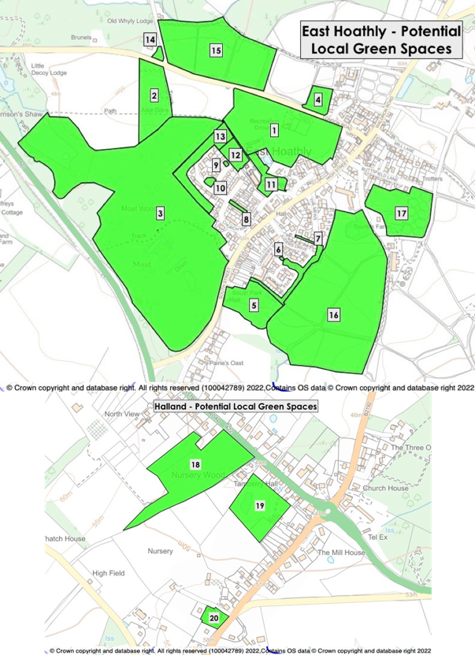

Figure 32 – Potential Local Green Spaces in Parish

5. Halland has no public open space or greenspace. One potential site (Halland Chapel - Proposed Local Green Space 20) is being proposed as a Local Green Space but this does not satisfy the need for a publicly accessible open space or greenspace for the residents of Halland. Such a site would preferably be in the North West quadrant of Halland where the greatest density of housing exists and remains an aspiration for this plan.

Potential Local Green Space 1 - East Hoathly War Memorial Sports Ground

6. The War Memorial Sports Ground Trust was established in 1947 after purchase of the 4 Hectare site with the proceeds of a War Memorial Fund. The Conveyance stipulates that the land must not be used for any other purpose than as a sports and recreation ground for the benefit and use of the Parish. The East Hoathly Parish Council became the Trustees in 1952 and the Trust was registered as a charity in 1963. The Sports Ground is central to the sporting life of our community. It is currently home to:

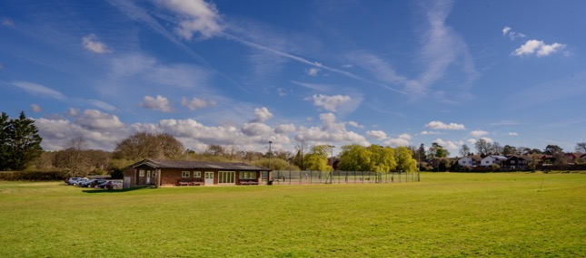

East Hoathly War Memorial Sports Ground

a. East Hoathly Cricket Club

b. East Hoathly Rifle Club

c. East Hoathly Tennis Club (Three floodlit courts)

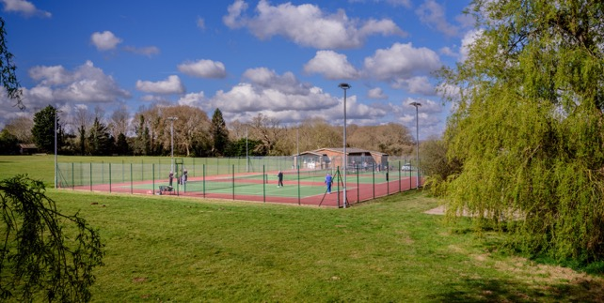

East Hoathly Tennis Courts

d. Children’s Play Area

e. Occasional use by local Cycle Racing Club

f. Basketball Hoop

7. There is a self-contained wooden building owned and administered by the Rifle Club.

8. The single storey Pavilion was built in 1980 and is of simple brick construction within a steel agricultural style framework with an asbestos roof. It has a tarmac car parking area with access onto London Road. It is now in poor condition, energy inefficient, with inadequate shower and changing facilities. It has one changing room large enough for a football team with showers and one toilet. The second changing room is only large enough for half a football team with a very small shower and no toilet. If mixed gender teams are playing there is no capacity to have separate changing facilities. There are no changing facilities for officials. The building was not designed to cater for disabled people or wheelchair access. Disabled facilities are limited to one toilet.

9. The Pavilion has a kitchen, a store for machinery and sports equipment and a function room that is used for cricket and tennis refreshments. It is available for other sporting or recreational uses and private hire for social events. It is occasionally used by local cycling groups as the base for races and time trials.

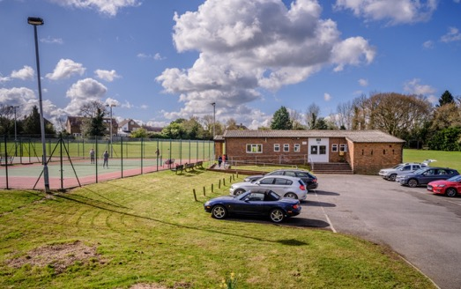

East Hoathly Sports Ground Pavilion and Car Park

10. The whole of the grassed area of the Sports Ground is poorly drained and sits towards the bottom of a slope of higher ground to the North and East. Surface water drains across the Sports Ground to the watercourses to the West, which feeds into the River Uck and River Cuckmere catchments. The result is that in wet weather most of the Sports Ground is waterlogged and in particular, the area of the Football Pitch is unplayable for large periods of the football season. The lack of playable conditions led to the demise of the East Hoathly Football Club and it is unlikely that this will start again without improvements to the drainage. The Parish Council wish to improve this by providing adequate drainage for this area. The possibility of the level of the football pitch area being raised by infilling the area with waste soil has been examined.

11. The Sports Ground is also the site for various Parish events. The annual Carnival in November is part of the wider Sussex tradition of Carnivals and Bonfires but the East Hoathly Carnival Society formed in 1918 is unique in commemorating those from the Parish who died in War. The event includes a formal act of remembrance and culminates in a large firework display. It attracts thousands of visitors and raises considerable sums for charity and local causes. Other events include the Midsummer Music Festival, Dog Shows and occasional Fetes.

12. It is the primary area for public recreation in the Parish. In addition to formal sports, it is a much-loved place to walk, exercise dogs, sit, picnic and for informal games. Its status as a War Memorial is special to many parishioners, its recreational value is unquestionable and it provides an invaluable benefit to the physical and mental wellbeing of residents.

13. The Sports Ground was proposed as a Multi-Functional Green Space in Background Paper 6 Green Infrastructure to the WDC 2013 Core Strategy. It was recognized as a Key Open Space in the WDC Draft Conservation Area Character Appraisal Jan 2021.

Table 13 – Potential Local Green Space 1 – East Hoathly War Memorial Sports Ground

NPPF 2021  Local Green Space Criteria | Assessment
1. In reasonably close proximity to the community it serves. | Yes, within 200 metres of centre of East Hoathly village, therefore within easy walking distance.
2. Local in character and not an extensive tract of land. | Yes, very local in character, a sports ground of open greenspace with facilities for football, cricket, tennis, basketball, children’s play area, pavilion and rifle club. The area also has a large pond surrounded by mature trees and scrub providing a wildlife haven and is an important part of the surface water drainage network in the Parish. The sports ground is surrounded by mature woodland, hedgerows, Churchyard, open fields and village housing. Size - 4.33 hectares.
3. Demonstrably special to the local community and holds a particular significance, for example because of its beauty, historic significance, tranquillity, recreational value (including as a playing field), or richness of wildlife or historical significance. | Yes, the Sports Ground is a War Memorial (gifted into Trust following WW2) and holds a special place in the minds of the community. This is remembered every year as part of the East Hoathly Carnival commemorations.  In addition to being the sporting centre of the Parish it hosts an annual music festival – Midsummer Magic and occasional village fetes. An essential amenity for the local community, used for sport, games, picnics and recreation. The East Hoathly Cricket Club and East Hoathly Tennis Club are active users of the facilities and Pavilion.  The open green nature of this site means that it is used frequently by children playing ball sports. The provision of children’s play equipment and a Basketball Hoop means that it is used by older and younger residents alike. Benches within the site provide an important space for residents to meet and relax. The space is much used by dogwalkers. The space contributes to the open character of this area.  Mature hedgerows and trees that line the perimeter are important habitats for nesting birds and other wildlife. The pond and surrounding mature trees are a particularly important wildlife habitat. The pond forms an important part of the surface water drainage network in the Parish. This network is a rich environment for plants and animals that depend on aquatic habitats.

Potential Local Green Space 2 - East Hoathly Garden Plots (Allotments)

14. East Hoathly Garden Plots are located on the South side of the London Road opposite the turning to Old Whyly. They were created in 2013 to replace the original much loved allotments at Church Marks Lane that were turned into housing in the 1950s. They are highly valued by Parish residents.

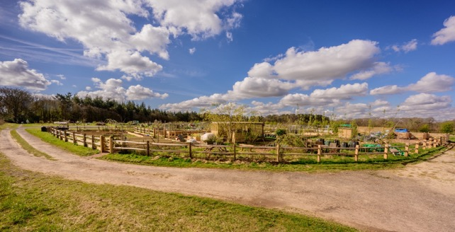

East Hoathly Garden Plots

15. The Garden Plots provide recreational benefits and the opportunity for people to grow their own food. The people doing so have formed their own supportive community aiding their health and wellbeing. There is also a separate organisation, which runs a Community Garden and Community Orchard. The Community Garden is a Community Interest Company that started in 2015 to provide a safe and nurturing space for local people, who are challenged by mental health and physical disabilities. Further details can be found by typing the following into your internet browser:

https://www.ourcommunitygarden.org.uk/

or select the following link: Link to Community Garden Website

16. The Garden Plots are often bustling with activity, yet they also provide a quiet place to enjoy healthy activity surrounded by the natural world.

Table 14 – Potential Local Green Space 2 – East Hoathly Garden Plots (Allotments)

NPPF 2021  Local Green Space Criteria | Assessment
1. In reasonably close proximity to the community it serves. | Yes, within 560 metres of centre of East Hoathly village, therefore within walking distance.
2. Local in character and not an extensive tract of land. | Yes, very local in character, an open greenspace containing allotments used to grow vegetables, fruit and flowers. The space also has a community orchard and a Community Garden providing a safe and nurturing space for local people, who are challenged by mental health and physical disabilities. The Garden Plots are surrounded by mature woodland, hedgerows and open fields. Size – 1.61 hectares.
3. Demonstrably special to the local community and holds a particular significance, for example because of its beauty, historic significance, tranquillity, recreational value (including as a playing field), or richness of wildlife or historical significance. | Yes, the Garden Plots (allotments) are the only ones available in the Parish. Many homes in the Parish have small garden spaces, no garden, or have used their garden space for vehicle parking. The Garden Plots are therefore an essential asset and much loved by those using them. The allotments provide excellent recreational value for tenants and their families, to grow vegetables, fruit and flowers for personal consumption, and healthy physical exercise. The allotments provide an atmosphere of tranquility and comradeship – an escape for those with busy family or working lives. The Garden Plots connect with local footpaths and are often visited by parishioners on walks who enjoy interacting with the gardeners. The Community Garden has been a wonderful initiative providing an opportunity for people with mental and physical disabilities to work in a safe and natural environment and benefit from the pleasures and wonder of gardening.

Potential Local Green Space 3 - Moat Wood and Decoy Pond

17. Moat Wood is designated Ancient Woodland and contains a Scheduled Monument. It is also protected by a TPO. It is located on the West side of East Hoathly and provides an important screen to the village from the A22. The public footpaths within it are well used by residents and are an important part of the network of footpaths in the village. The area is also an important catchment area with a series of ponds and waterways into which the higher land to the North East of the Parish drain.

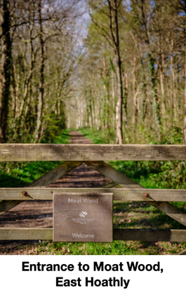

18. The woodland, which in total extends to almost 19 Hectares and has several different owners as shown on the map below. The fringe of woodland alongside the A22 is owned by ESCC. The Woodland Trust own the main section that is accessed by the public and contains the Scheduled Monument. The section on the Eastern edge of the woodland abutting South Street is owned by a property company and is regularly advertised for sale as potential development land.

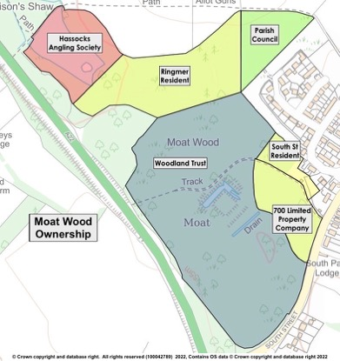

Figure 33 - Ownership of Moat Wood

19. The area represents a highly important area of biodiversity and habitat. Some of the rare and protected species that live in this area are the black adder, nightingales, many species of bats, badgers, water voles, smooth and great crested newts, pearl-bordered fritillary butterfly, colonies of wasp spiders, green tiger beetle, dormice, grass snakes and slow worms. It is home to many deer which move around the surrounding fields seeking forage and occasionally visit resident’s gardens.

20. The area includes several ponds and water courses the largest of which is Decoy Pond. This is a popular fishing destination and is run by the Hassocks Angling Society. They offer 5 pegs with disabled wheelchair access.

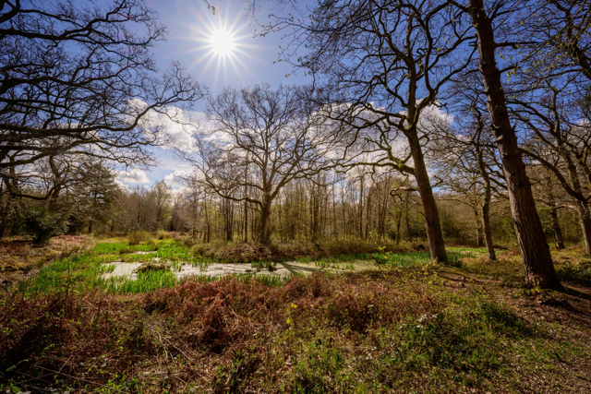
Area of Scheduled Ancient Monument in Moat Wood, East Hoathly

21. Moat Wood and Decoy Pond are the most popular destinations for walking in the Parish. The natural beauty of the mature ancient woodlands across all seasons makes it a constant tonic. The recreational value of this area is unquestionable and it provides an invaluable benefit to the physical and mental wellbeing of residents. The walks and resting places provide the opportunity for tranquility and quiet reflection.

22. The WDC Draft Conservation Area Character Appraisal Jan 2021 states, at Paragraphs 5.1.1 and 5.1.2, that “Trees, hedges, open spaces and other natural elements form a significant part of the character and appearance of the Conservation Area. The landscape around East Hoathly still has a very rural character of fields, hedges, treed boundaries, and woodland, which provides an important backdrop to the settlement”. Moat Wood is specifically identified as having an important impact on the Conservation Area.

Table 15 – Potential Local Green Space 3 – Moat Wood and Decoy Pond

NPPF 2021  Local Green Space Criteria | Assessment
1. In reasonably close proximity to the community it serves. | Yes, within 460 metres of centre of East Hoathly village, therefore within walking distance.
2. Local in character and not an extensive tract of land. | Yes, very local in character, an area of Ancient Woodland containing a large number of important mature trees and significant wildlife haven. The woodland contains many ponds and watercourses and forms a significant part of the surface water drainage network in the Parish. Part of the site is a fishing pond which provides access for anglers using wheelchairs. Another part contains the remains of a medieval moated site which is a scheduled Ancient Monument. The Ancient Woodland is surrounded by additional mature woodland, hedgerows, open fields and village housing. Size – 18.82 hectares.  The NPPF does not specify what constitutes an extensive tract of land. Government guidance on open space, sports and recreation facilities, public rights of way and local green space, states: “There are no hard and fast rules about how big a Local Green Space can be because places are different and a degree of judgment will inevitably be needed”. In other places, sites in the order of 20 Hectares have been granted Local Green Space designation. Moat Wood is owned by different parties but as a woodland it is a single entity. Our assessment is that the size of the woodland is in proportion to the size of the parish and the scale of the village.
3. Demonstrably special to the local community and holds a particular significance, for example because of its beauty, historic significance, tranquillity, recreational value (including as a playing field), or richness of wildlife or historical significance. | Yes, Moat Wood is a very important area of Ancient Woodland in the Parish. It is adjacent to East Hoathly village and has a section that is accessible to the public (the only such publicly accessible Ancient Woodland in the Parish).  It has significant historic interest with the remains of a medieval moated site (Scheduled Ancient Monument). The name Hoathly is thought to have derived from the Old English hath leah, a heathy woodland clearing where heather grows. It has been linked to the name of De Hodleigh, landowners in the 12th century. It is therefore the only remaining section of Ancient Woodland adjacent to the village created in that woodland clearing.  The woodlands excellent recreational value for all age-groups and is very popular with dog walkers. It provides children with a natural playground in the fresh air, space to play hide and seek and shade to play under in the hot summer months. It provides a sense of calm and tranquility with an opportunity to be close to nature and wildlife. This opportunity to embrace the natural world is important for mental wellbeing and quiet reflection.  The space provides an extremely rich series of habitats with abundant biodiversity. Ancient Woodland acts as an extremely important seedbank of plant life in addition to the existing vegetation. Mature trees from saplings to decaying fallen trunks all provide vital habitats and food sources for birds, mammals, insects and invertebrates. The area is carpeted in wildflowers and woodland foliage all providing cover and food for the many animals that live in the woodland or use it to transit through the area.  Decoy Pond is owned and stocked by a Fishing Club which provides access for disabled anglers. The pond is the largest of several ponds, ditches and waterways that drain the woodland and form an important part of the surface water drainage network in the Parish. This network is a rich environment for plants and animals that depend on aquatic habitats.  Some of the rare and protected species that live in this area are the black adder, nightingales, many species of bats, badgers, deer, water voles, smooth and great crested newts, pearl-bordered fritillary butterfly, colonies of wasp spiders, green tiger beetle, dormice, grass snakes and slow worms.

Potential Local Green Space 4 - Long Pond

23. Long Pond has been an important water feature in the Parish appearing on the Tithe Map of 1840. It is one of the few remaining ponds in the area of East Hoathly from that period, many of which have been built over or infilled. Long Pond is recorded by the Sussex Biodiversity Records Centre as a Great Crested Newt breeding site.

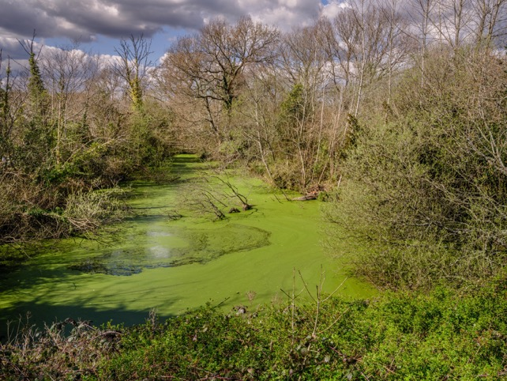

Long Pond, East Hoathly

24. The trees and shrubs that surround the pond are an important part of the setting for the nearby Heritage assets and the Conservation Area.

25. The land was owned by Trills Builders that operated on adjacent land until 1988 when it sold to Rydon Homes for housing that is now Thomas Turner Drive. The area containing Long Pond was transferred to the ownership of the Parish Council in 1994 as part of a Section 106 Agreement with Rydon Homes when a final “in-fill” part of the development was completed. It had been intended that the area would be a public open space but health and safety concerns and objections by the Parish Council insurers meant that only supervised access was allowed. The Parish Council attempted to drain the pond in September 2000 in an attempt to make the land more accessible but the excavation work caused the bank of the pond and part of the garden of one of the houses in Thomas Turner Drive to collapse. The bank was restored and public access remained prohibited.

26. In 2009 an attempt was made to apply for a change of use permission to allow allotments to be created on the site. WDC indicated that they were likely to grant the consent but required an ecological survey to be done. The significant amount of wildlife on the site and in particular the presence of a breeding population of Great Crested Newts meant that the Parish Council withdrew its application.

27. The land was transferred to Hesmond’s Stud in 2012 as part of a land swap for a piece of Hesmond’s Stud land on Harrison’s Field where the Garden Plots are now situated. The site is now closed to public access but remains a very important wildlife sanctuary.

28. The land is part of a proposed development site (WD/2016/2796/MAO and WD/2022/0341/MAJ. However, in neither planning application is the land identified as Long Pond proposed for anything other than a greenspace, retaining the pond and all its wildlife.

Table 16 – Potential Local Green Space 4 – Long Pond

NPPF 2021  Local Green Space Criteria | Assessment
1. In reasonably close proximity to the community it serves. | Yes, within 280 metres of centre of East Hoathly village, therefore within easy walking distance.
2. Local in character and not an extensive tract of land. | Yes, very local in character, a large pond and surrounding land with mature trees and scrub providing a wildlife haven and an important part of the surface water drainage network in the Parish. The pond is recorded as a breeding site for Great Crested Newts. The site is surrounded by mature woodland, hedgerows, open fields and village housing. Size – 0.45 hectares.
3. Demonstrably special to the local community and holds a particular significance, for example because of its beauty, historic significance, tranquillity, recreational value (including as a playing field), or richness of wildlife or historical significance. | Yes, Long Pond has an important part in the history of East Hoathly village. It appears on the 1840 Tithe Map and is one of the few remaining ponds in the Parish from that period.  Long Pond is large and deep and forms an important part of the surface water drainage network in the Parish. This network is a rich environment for plants and animals that depend on aquatic habitats and Long Pond has been recorded as a Great Crested Newt Breeding Pond.  The land adjacent to the pond is natural scrub with some mature and important trees. Its wild nature and lack of public access has led to it becoming an important sanctuary for wildlife and plants. It is home to squirrels, rabbits, foxes, ducks, snakes, nesting birds and is used as a resting place by deer. The wide range of plants, wildflowers and decaying wood provide forage for many animals and habitats for insects.

Potential Local Green Space 5 - Circle of Oaks Green Gap

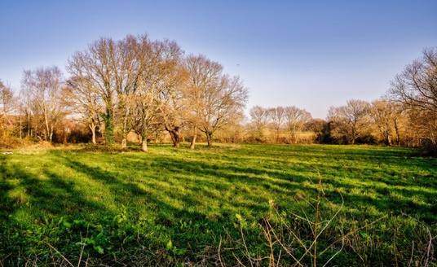

Circle of Oaks Green Gap

29. The Green Gap on South Street is known locally as Circle of Oaks owing to the characteristic circle of oak trees growing in the centre of the site. It provides a corridor of access linking the wildlife of the Ancient Woodland to the West in Moat Wood to the open countryside to the East and South of the Village. This is important because the wildlife in Moat Wood and its surrounding areas is enclosed to the West by the significant barrier of the A22. The Green Gap on South Street is the only connection that wildlife has to the open countryside to the East. This is recognized as one of the community and environmental benefits identified in the Locality Guide to Making Local Green Space Designations by “Providing habitats for wildlife and natural corridors and spaces through urban areas”. Any development here would affect a variety of wildlife:

Bats

a. Large numbers of bats, of varying species, have been detected flying in the area. It is mostly used as a transit route with the bats emerging from Moat Wood and crossing South Street at the Green Gap and heading East to the tree-line at the Eastern edge of the site. They then follow the tree line South to the Sewage Works where they feed on the abundant insects flying above the Works.

Deer

b. It is also known that deer use the cover of Moat Wood and emerge from it to cross South Street through the Green Gap to connect to the countryside beyond for grazing.

Reptiles

c. Slow worms and grass snakes have been found in this area. They use the habitats in the margins of the area and the open spaces for foraging. The rare Black Adder that has been located in Moat Wood may also be present in the area.

30. The circle of oak trees in the centre of the area is a well-known local feature and attractive reminder of the rural nature of this village. These mature trees are protected with a Tree Preservation Order in acknowledgement of their importance.

31. The importance of green gaps providing separation between housing in settlements is identified in the WDC Landscape Character Assessment. One of its guidelines for the Ouse Catchment (Zone 6D), in which the Circle of Oaks sits, is to: “Limit the amount and scale of development in rural areas, protecting the existing low-density settlement pattern of dispersed rural villages, hamlets, and scattered farms, and the separation between these different settlement types”. The importance of this open greenspace is also recognized in the WDC Draft Conservation Area Character Appraisal 2021:

a. “Open spaces within and on the edge of the conservation area are important as they help to define the built environment and create a sense of place”.

b. “The most important views looking into, out of and through the conservation area are shown on the character appraisal map in Appendix 1. These contribute to the character and setting of the conservation area and care needs to be taken to ensure that they are not lost or compromised by future development or poorly sited services”.

32. The site has been subject to repeated attempts to obtain planning consent for housing. These began in 1961 and there have been 15 applications since then all of which were refused permission or withdrawn and two of which then had appeals rejected. A further planning application was made in 2018 which was refused in 2021, the decision appealed and that appeal has now been withdrawn. WDC has assessed the site as suitable for housing in their SHELAA report (SHELAA ref:154/1950) but 14 refusals of permission, two rejected appeals and four applications/appeals withdrawn indicates strongly that this site is unsuitable for development. It is therefore still considered to meet the criteria for a Local Green Space.

Table 17 – Potential Local Green Space 5 – Circle of Oaks

NPPF 2021  Local Green Space Criteria | Assessment
1. In reasonably close proximity to the community it serves. | Yes, within 300 metres of centre of East Hoathly village, therefore within easy walking distance.
2. Local in character and not an extensive tract of land. | Yes, very local in character, an open agricultural field bordered by hedgerows and containing a group of mature trees (mostly oak) broadly in a circular pattern in the centre of the field. It provides habitat for many species, a green gap between the housing on South Street, East Hoathly and an important transit route for wildlife transiting between Moat Wood and the open countryside to the East. A building in the corner of the field is part of the East Hoathly Conservation Area. The field is surrounded by mature woodland, hedgerows, open fields and village housing. Size – 1.31 hectares.
3. Demonstrably special to the local community and holds a particular significance, for example because of its beauty, historic significance, tranquillity, recreational value (including as a playing field), or richness of wildlife or historical significance. | Yes, Circle of Oaks is a well-known landmark within the community and provides an important green gap between the main part of East Hoathly village and the end of South Street. The buildings at the end of South Street grew up around the original position of Watford’s Farm which is possibly shown on two maps dating from 1770/80s. The property appears on the East Hoathly Tithe Map of 1840 and is occupied by hop farmer, David Paine and the property remains known as Paines Farm. The nature of this section of the village changed significantly when the A22 bypass made this southern section of the village a more tranquil and pleasant environment. The existence of the green gap is something that adds significantly to the character of the village.  The space is an open field bounded by hedgerows containing many mature trees. A brick built, clay tiled, gabled roofed stable block sits in the corner of the field adjacent to South Street and forms part of the East Hoathly Conservation Area. The circle of mature oak trees in the middle of the field (protected by a Tree Preservation Order) is a very pleasing landmark viewable on entry to East Hoathly village from the South.  The space provides important habitats for nesting birds and many other animals, plants and insects. More importantly, the space provides a transit route for wildlife including many bats and deer that move from Moat Wood and the West of the village to the open land to the East and South of the village for grazing and forage. Many bats move through this area to get to the East Hoathly Sewage Works where they feed on the insects above the Works.

Potential Local Green Space 6 - Juziers Play Area

33. This open greenspace is a children’s play area and amenity space. The recreational value of this area is self-evident and it provides an invaluable benefit to the physical and mental wellbeing of children and, by extension, all residents.

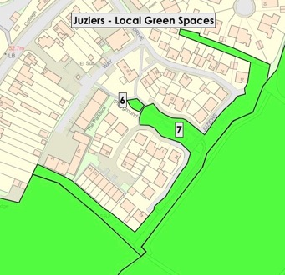

Figure 34 – Potential Juziers Local Green Spaces

34. Identified in WDC - The Open Space, Sports and Recreation Assessment (2016) as Children’s Play Area. Also identified in WDC Green Infrastructure Study 2017 as being an important part of the Green Infrastructure Network.

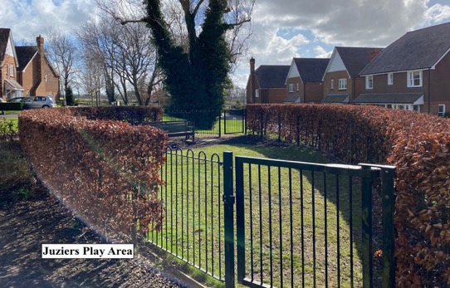
Juziers Play Area

35. This open greenspace is demonstrably special to the local community. It gives the housing development a sense of place and openness with views onto a safe play area, greenery and trees. It makes the environment a more beautiful and attractive place to live. This reflects several of the community and environmental benefits identified by Locality Guide to Making Local Green Space Designations as follows:

a. “Being part of the public realm, where informal social interaction can take place”.

b. “Forming part of a network of paths and spaces, enabling movement through an area”.

c. “Providing flexible space for recreation, local cultural events and performance”.

d. “Adding to local amenity, providing an attractive setting and outlook for surrounding residential and commercial properties”.
Table 18 – Potential Local Green Space 6 – Juziers Play Area

NPPF 2021  Local Green Space Criteria | Assessment
1. In reasonably close proximity to the community it serves. | Yes, within 190 metres of centre of East Hoathly village, therefore within easy walking distance.
2. Local in character and not an extensive tract of land. | Yes, very local in character, it provides a small fenced, grassed play area within a housing estate. It is surrounded by mature trees, open space and housing. Combined with Potential Local Green Space 7 this creates a significantly more healthy and attractive setting for the housing and its residents. Size – 0.01 hectares.
3. Demonstrably special to the local community and holds a particular significance, for example because of its beauty, historic significance, tranquillity, recreational value (including as a playing field), or richness of wildlife or historical significance. | Yes, the proposed Local Green Spaces 6 and 7 are closely linked and combine to provide a special atmosphere to this area of housing.  Proposed Local Green Space 6 provides a tranquil open area of greenspace for recreation and the enjoyment of nature.  Contributes to the open character of this area. An important amenity for the residents, providing an area for children to play safely and a meeting point.  The benefit of this natural space within the built environment is of great importance for the mental health and well-being of children and other residents.

Potential Local Green Space 7 - Juziers Drains/Swales

36. This open greenspace was established partly as an amenity space and partly as a buffer zone for the housing development. The buffer zone incorporates the drains and swales for the housing development. This area is planted with trees and shrubs (to supplement those originally on the site) and provides an attractive backdrop for the housing linking it with the surrounding countryside.

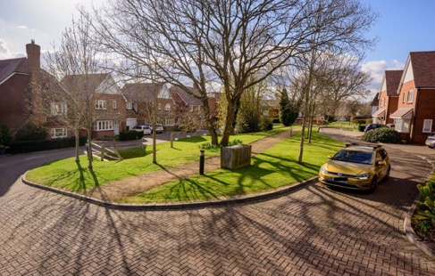
Juziers Drains/Swales

37. The importance of such tree planting is recognized in the WDC Draft Conservation Area Character Appraisal Jan 2021. Identified in Planning Decision Notice as a Green Buffer Zone containing Drainage Swales and planted with native trees and shrubs to add to the existing vegetation. This reflects several of the community and environmental benefits identified by Locality Guide to Making Local Green Space Designations as follows:

a. “Being part of the public realm, where informal social interaction can take place”.

b. “Forming part of a network of paths and spaces, enabling movement through an area”.

c. “Providing flexible space for recreation, local cultural events and performance”.

d. “Providing habitats for wildlife and natural corridors and spaces through urban areas”.

e. “Adding to local amenity, providing an attractive setting and outlook for surrounding residential and commercial properties”.

f. “Forming part of flood mitigation, such as SUDS”.

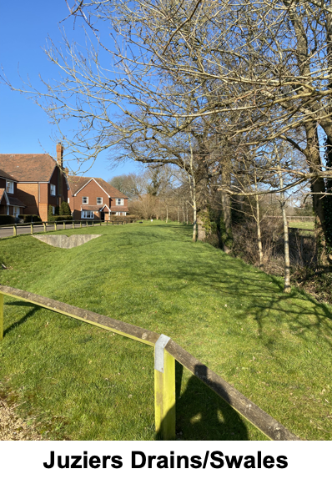

38. This open greenspace is demonstrably special to the local community. It gives the housing development a sense of place and openness with views onto greenery and trees. It makes the environment a more beautiful and attractive place to live. It also provides an important habitat for biodiversity connecting the countryside into the housing development.

Table 19 – Potential Local Green Space 7 – Juziers Drains/Swales

NPPF 2021  Local Green Space Criteria | Assessment
1. In reasonably close proximity to the community it serves. | Yes, within 190 metres of centre of East Hoathly village, therefore within easy walking distance.
2. Local in character and not an extensive tract of land. | Yes, very local in character, green open space with mature trees and water features providing separation and open space within the surrounding housing estate. Combined with Potential Local Green Space 6 this creates a significantly more healthy and attractive setting for the housing and its residents. Size – 0.5 hectares.
3. Demonstrably special to the local community and holds a particular significance, for example because of its beauty, historic significance, tranquillity, recreational value (including as a playing field), or richness of wildlife or historical significance. | Yes, the proposed Local Green Spaces 6 and 7 are closely linked and combine to provide a special atmosphere to this area of housing.  Proposed Local Green Space 7 provides a tranquil open area of greenspace for recreation and the enjoyment of nature.  Contributes to the open character of this area. An important amenity for the residents, providing an area for children to play and space for neighbours to meet and interact. The water features, mature trees and planting within the area provide habitats for nesting birds and other wildlife making the environment natural and welcoming. The views out to the East onto open countryside with the South Downs in the distance create a sense of place and character for the development.  The benefits of this natural space within the built environment and the views are of great importance for the mental health and well-being of residents.

Potential Local Green Space 8 - Church Marks Lane Lawn

39. This is an open, amenity greenspace. Greenspaces such as this provide a place for limited recreation, but more importantly they provide openness within the built environment and a natural space to balance the hard landscaping of the urban setting. These are of benefit to the physical and mental wellbeing of all residents in addition to making the built environment a more attractive place to live.

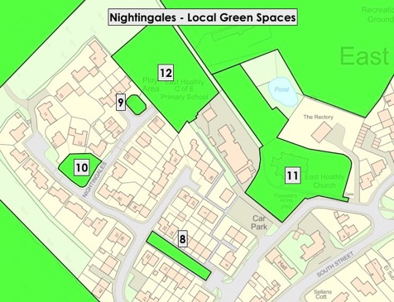

Figure 35 – Potential Nightingales Local Green Spaces

40. Identified in WDC - The Open Space, Sports and Recreation Assessment (2016) as an Amenity Green Space. This open greenspace is demonstrably special to the local community. It gives the housing development a sense of place and openness with views onto greenery and trees. It makes the environment a more beautiful and attractive place to live. It also provides an important habitat for biodiversity connecting the countryside into the housing development. This reflects several of the community and environmental benefits identified by Locality Guide to Making Local Green Space Designations as follows:

a. “Being part of the public realm, where informal social interaction can take place”.

b. “Forming part of a network of paths and spaces, enabling movement through an area”.

c. “Providing flexible space for recreation, local cultural events and performance”.

d. “Adding to local amenity, providing an attractive setting and outlook for surrounding residential and commercial properties”.

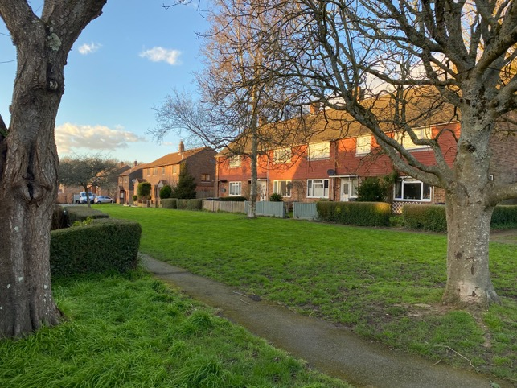
Church Marks Lawn

Table 20 – Potential Local Green Space 8 – Church Marks Lane Lawn

NPPF 2021  Local Green Space Criteria | Assessment
1. In reasonably close proximity to the community it serves. | Yes, within 220 metres of centre of East Hoathly village, therefore within easy walking distance.
2. Local in character and not an extensive tract of land. | Yes, very local in character, it provides an open greenspace within a housing estate. The site is grassed with some trees. It is surrounded on 2 sides by houses and provides a pedestrian route through the housing estate. Combined with Potential Local Green Spaces 9, 10 and 13 this creates a significantly more healthy and attractive setting for the housing and its residents. Size – 0.05 hectares.
3. Demonstrably special to the local community and holds a particular significance, for example because of its beauty, historic significance, tranquillity, recreational value (including as a playing field), or richness of wildlife or historical significance. | Yes. The proposed Local Green Spaces 8, 9, 10 and 13 are closely linked and combine to provide a special atmosphere to this area of housing.  Proposed Local Green Space 8 provides a tranquil open area of greenspace for recreation and the enjoyment of nature.  Contributes to the open character of this area. An important amenity for the residents, providing an area for children to play and space for neighbours to meet and interact. The trees within the area provide habitats for nesting birds and other wildlife making the environment natural and welcoming.  The benefit of this natural space within the built environment is of great importance for the mental health and well-being of residents.

Potential Local Green Space 9 - Nightingales Play Area

41. This open greenspace is a children’s play area and amenity space. The recreational value of this area is self-evident and it provides an invaluable benefit to the physical and mental wellbeing of children and, by extension, all residents.

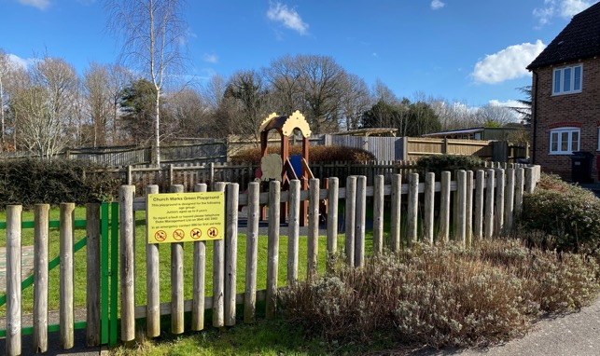

Nightingales Play Area

42. Identified in WDC - The Open Space, Sports and Recreation Assessment (2016) as Children’s Play Area. Also identified in WDC Green Infrastructure Study 2017 as being an important part of the Green Infrastructure Network. This reflects several of the community and environmental benefits identified by Locality Guide to Making Local Green Space Designations as follows:

a. “Being part of the public realm, where informal social interaction can take place”.

b. “Forming part of a network of paths and spaces, enabling movement through an area”.

c. “Providing flexible space for recreation, local cultural events and performance”.

d. “Adding to local amenity, providing an attractive setting and outlook for surrounding residential and commercial properties”.

43. This open green space is demonstrably special to the local community. It gives the housing development a sense of place and openness with views onto a safe play area and greenery. It makes the environment a more beautiful and attractive place to live.

Table 21 – Potential Local Green Space 9 – Nightingales Play Area

NPPF 2021  Local Green Space Criteria | Assessment
1. In reasonably close proximity to the community it serves. | Yes, within 250 metres of centre of East Hoathly village, therefore within easy walking distance.
2. Local in character and not an extensive tract of land. | Yes, very local in character, it provides a small fenced, grassed play area with play equipment within a housing estate. It is surrounded by the school field and housing. Combined with Potential Local Green Spaces 8, 10 and 13 this creates a significantly more healthy and attractive setting for the housing and its residents. Size – 0.02 hectares.
3. Demonstrably special to the local community and holds a particular significance, for example because of its beauty, historic significance, tranquillity, recreational value (including as a playing field), or richness of wildlife or historical significance. | Yes. The proposed Local Green Spaces 8, 9, 10 and 13 are closely linked and combine to provide a special atmosphere to this area of housing.  Proposed Local Green Space 9 provides an important amenity for the residents, providing an area for children to play safely and a meeting point for neighbours to interact. The provision of play equipment makes it a popular location for children of all ages.  Contributes to the open character of this area. The planting within the area provides habitats for wildlife making the environment natural and welcoming.  The benefit of this natural space within the built environment is of great importance for the mental health and well-being of children and other residents.

Potential Local Green Space 10 - Nightingales Lawn

44. This is an open amenity greenspace. Greenspaces such as this provide a place for limited recreation but more importantly they provide openness within the built environment and a natural space to balance the hard landscaping of the urban setting. These are of benefit to the physical and mental wellbeing of all residents.

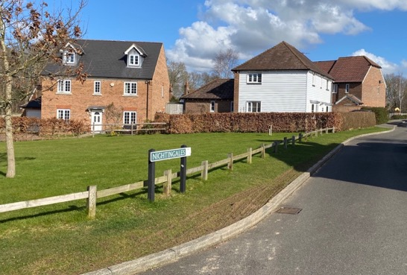

Nightingales Lawn

45. Identified in WDC - The Open Space, Sports and Recreation Assessment (2016) as an Amenity Green Space. This reflects several of the community and environmental benefits identified by Locality Guide to Making Local Green Space Designations as follows:

a. “Being part of the public realm, where informal social interaction can take place”.

b. “Forming part of a network of paths and spaces, enabling movement through an area”.

c. “Providing flexible space for recreation, local cultural events and performance”.

d. “Adding to local amenity, providing an attractive setting and outlook for surrounding residential and commercial properties”.

46. This open greenspace is demonstrably special to the local community. It gives the housing development a sense of place and openness with views onto greenery and trees. It makes the environment a more beautiful and attractive place to live.

Table 22 – Potential Local Green Space 10 – Nightingales Lawn

NPPF 2021  Local Green Space Criteria | Assessment
1. In reasonably close proximity to the community it serves. | Yes, within 290 metres of centre of East Hoathly village, therefore within easy walking distance.
2. Local in character and not an extensive tract of land. | Yes, it provides an open greenspace within a housing estate. The site is grassed with some trees. It is surrounded by houses. Combined with Potential Local Green Spaces 8, 9 and 13 this creates a significantly more healthy and attractive setting for the housing and its residents. Size – 0.06 hectares.
3. Demonstrably special to the local community and holds a particular significance, for example because of its beauty, historic significance, tranquillity, recreational value (including as a playing field), or richness of wildlife or historical significance. | Yes. The proposed Local Green Spaces 8, 9, 10 and 13 are closely linked and combine to provide a special atmosphere to this area of housing.  Proposed Local Green Space 10 provides a tranquil open area of greenspace for recreation and the enjoyment of nature.  Contributes to the open character of this area. An important amenity for the residents, providing an area for children to play and space for neighbours to meet and interact. The trees within the area provide habitats for nesting birds and other wildlife making the environment natural and welcoming.  The benefit of this natural space within the built environment is of great importance for the mental health and well-being of residents.

Potential Local Green Space 11 - East Hoathly Churchyard

47. The East Hoathly Churchyard is an area of tranquility and contemplation with the graves of many local people, historic characters and includes the war memorial. The War Memorial was dedicated in 1921 to commemorate the 20 East Hoathly servicemen who died in the First World War. The names of a further seven servicemen and four civilians were added following the Second World War. The graves are surrounded by a wonderful display of natural wildflowers, orchids and plants. The area had a wooden fence from at least 1726 which was paid for by parish landowners. They were responsible for a length of fencing based on their land ownership and their initials were carved onto their fence posts which is why the adjacent road is called Church Marks Lane.

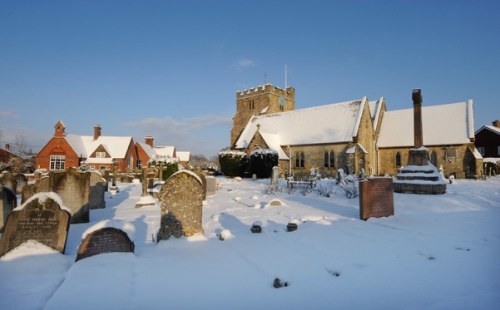

East Hoathly Churchyard

48. The area was recognized as Key Open Space in the WDC Draft Conservation Area Character Appraisal Jan 2021. Cemeteries and Churchyards are identified in WDC Green Infrastructure Study 2017 as being an important part of the Green Infrastructure Network. Also Identified in WDC - The Open Space, Sports and Recreation Assessment (2016) as an Open Space.

Table 23 – Potential Local Green Space 11 – East Hoathly Churchyard

NPPF 2021  Local Green Space Criteria | Assessment
1. In reasonably close proximity to the community it serves. | Yes, within 200 metres of centre of East Hoathly village, therefore within easy walking distance.
2. Local in character and not an extensive tract of land. | Yes, very local in character, a churchyard containing over one thousand memorials and many more thousands of burials amongst land that is managed as a wildflower area. The churchyard is adjacent to the Rectory and East Hoathly Primary School and surrounded by trees, open space, Village Hall and village housing. Size – 0.5 hectares.
3. Demonstrably special to the local community and holds a particular significance, for example because of its beauty, historic significance, tranquillity, recreational value (including as a playing field), or richness of wildlife or historical significance. | Yes, the East Hoathly Churchyard is a very special place for this community. It is the final resting place for many former residents and their families. It is a very popular place to find some tranquillity for quiet reflection. Its monuments and the inscriptions are a physical catalogue of the history of many of this community’s residents.  The area contains many mature trees that provide habitats for nesting birds and many insects. The management of the area for native wildflowers has changed the character from that of a sombre graveyard and provided a more natural and welcoming space. The planting has made the area a haven for wildlife and in particular birds and insects.  Contributes to the open character of this area.

Potential Local Green Space 12 - School Field

49. The School Field was given to the East Hoathly Church of England Primary School as part of the Nightingales development legal agreement. It provides an open green amenity space for the children’s play and sport. The space adds to the general attractiveness of the School setting and of the nearby Heritage Assets. The recreational value of this area is self-evident and it provides an invaluable benefit to the physical and mental wellbeing of children attending the School and, by extension, the children’s parents.

50. Identified in WDC - The Open Space, Sports and Recreation Assessment (2016) as Educational Open Space.

Table 24 – Potential Local Green Space 12 – School Field

NPPF 2021  Local Green Space Criteria | Assessment
1. In reasonably close proximity to the community it serves. | Yes, within 270 metres of centre of East Hoathly village, therefore within easy walking distance.
2. Local in character and not an extensive tract of land. | Yes, very local in character, a green open space and play area for the East Hoathly Church of England Primary School. It abuts the School and is surrounded by trees, open space and village housing. Size – 0.39 hectares.
3. Demonstrably special to the local community and holds a particular significance, for example because of its beauty, historic significance, tranquillity, recreational value (including as a playing field), or richness of wildlife or historical significance. | Yes, the School Field is very special to the children who attend the school and by extension to the whole community.  It provides a space for the children to play and be creative in the open air and in a natural environment. It also provides a space for sporting activities which has a significant benefit for their physical development and health. The benefits to their education and mental wellbeing are significant.  Contributes to the open character of this area.

Potential Local Green Space 13 - Church Marks Green

51. This is an open amenity greenspace. Greenspaces such as this provide a place for limited recreation but more importantly, they provide openness within the built environment and a natural space to balance the hard landscaping of the urban setting. These are of benefit to the physical and mental wellbeing of all residents in addition to making the built environment a more attractive place to live. This Lawn was created as a buffer zone surrounding the Nightingales development to protect the ancient woodland to the West and South West.

52. This open greenspace is demonstrably special to the local community. It gives the housing development a sense of place and openness with views onto greenery and trees. It provides a buffer to protect the Ancient Woodland yet also adds foraging and transit space for biodiversity to flourish. This reflects several of the community and environmental benefits identified by Locality Guide to Making Local Green Space Designations as follows:

a. “Being part of the public realm, where informal social interaction can take place”.

b. “Forming part of a network of paths and spaces, enabling movement through an area”.

c. “Providing flexible space for recreation, local cultural events and performance”.

d. “Adding to local amenity, providing an attractive setting and outlook for surrounding residential and commercial properties”.

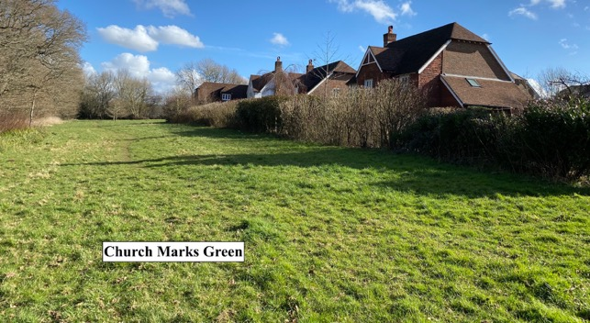

Church Marks Green

Table 25 – Potential Local Green Space 13 – Church Marks Green

NPPF 2021  Local Green Space Criteria | Assessment
1. In reasonably close proximity to the community it serves. | Yes, within 300 metres of centre of East Hoathly village, therefore within easy walking distance.
2. Local in character and not an extensive tract of land. | Yes, very local in character, a buffer zone of grass created to protect the Ancient Woodland of Moat Wood from the surrounding housing estate. surrounded by Ancient Woodland, open space and village housing. Size – 0.94 hectares.
3. Demonstrably special to the local community and holds a particular significance, for example because of its beauty, historic significance, tranquillity, recreational value (including as a playing field), or richness of wildlife or historical significance. | Yes. The proposed Local Green Spaces 8, 9, 10 and 13 are closely linked and combine to provide a special atmosphere to this area of housing.  Proposed Local Green Space 13 provides a tranquil open area of greenspace for recreation and the enjoyment of nature. This area which acts as a buffer zone for the Ancient Woodland is regularly visited by the rich biodiversity of Moat Wood.  Contributes to the open character of this area. An important amenity for the residents, providing an area for children to play and space for neighbours to meet and interact. The grassed area provides habitats for many insects and forage for deer, rabbits and and other wildlife making the environment natural and welcoming.  The benefit of this natural space within the built environment is of great importance for the mental health and well-being of residents.

Potential Local Green Space 14 - Croom Cottage Meadow

53. Croom Cottage Meadow is designated as a Local Wildlife Site (LWS) with rare wild flowers and orchids. It is the beginning of the open rural approach to East Hoathly on the London Road and adds significantly to the landscape setting of the village of open fields backed by woodland. Identified in WDC Green Infrastructure Study 2017 as being an important part of the Green Infrastructure Network.

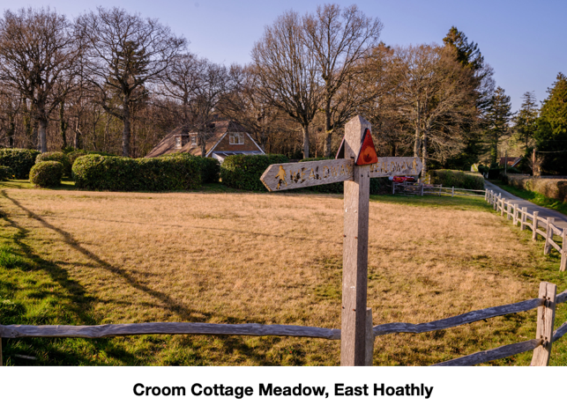

Table 26 – Potential Local Green Space 14 – Croom Cottage Meadow

NPPF 2021  Local Green Space Criteria | Assessment
1. In reasonably close proximity to the community it serves. | Yes, within 560 metres of centre of East Hoathly village, therefore within walking distance.
2. Local in character and not an extensive tract of land. | Yes, very local in character, a wildflower meadow designated as a Local Wildlife Site. It is part of the garden of Croom Cottage and is surrounded by Ancient Woodland, the Garden Plots and land designated for village housing. Size – 0.08 hectares.
3. Demonstrably special to the local community and holds a particular significance, for example because of its beauty, historic significance, tranquillity, recreational value (including as a playing field), or richness of wildlife or historical significance. | Yes, Croom Cottage Meadow is a rare remnant of a wildflower meadow and designated as a Local Wildlife Site. It is an important sanctuary for insects and plants that can only thrive in this type of habitat.  Contributes to the open character of this area. It is a visually attractive space that is much appreciated by residents and visitors passing on the Wealdway footpath.

Potential Local Green Space 15 - Approach to East Hoathly on London Road

54. The three roads entering East Hoathly are generally tree/hedge lined with green verges and open vistas across pasture and into woodland. This is a particularly striking feature of this village and adds significantly to its attractiveness.

55. The London Road approach has especially wide green verges and is very open in its views into the village and Conservation Area. This is noted in the WDC Draft Conservation Area Character Appraisal Jan 2021:

a. “Views across the wider countryside are also important, with views in and out of the conservation area providing a strong sense of place and affording strong inter-visibility with historic buildings in the historic core”.

b. “Views through the character area are along the roads and back to the village core, and across the fields to the west and views to the large houses set back to the eastern side of the road, which are often glimpsed through trees. Views across the wider countryside are important and the fields to the west allow views in and out of the conservation area and to the large area of woodland beyond”.

c. “The landscape around East Hoathly still has a very rural character of fields, hedges, treed boundaries, and woodland, which provides an important backdrop to the settlement. Views across the wider countryside are also important, with views in and out of the conservation area providing a strong sense of place and affording strong inter-visibility with historic buildings in the historic core. There are views across surrounding fields and to area of woodland beyond, as well as views southwards towards the South Downs”.

d. “Open spaces within and on the edge of the conservation area are important as they help to define the built environment and create a sense of place”.

56. Potential Local Green Space 15 is not supported by WDC. It is subject to a Planning Application. WDC have granted outline Planning Permission and it no longer meets the Local Green Space criteria. It is therefore rejected.

Table 27 – Potential Local Green Space 15 – Approach to East Hoathly on London Road

NPPF 2021  Local Green Space Criteria | Assessment
1. In reasonably close proximity to the community it serves. | Yes, within 360 metres of centre of East Hoathly village, therefore within walking distance.
2. Local in character and not an extensive tract of land. | Yes, very local in character, an area of open fields bounded by hedgerows marking the entrance to East Hoathly village. The area is surrounded by Ancient Woodland, Croom Cottage Local Wildlife Site, East Hoathly War Memorial Sports Ground and open space. Size – 4.37 hectares.
3. Demonstrably special to the local community and holds a particular significance, for example because of its beauty, historic significance, tranquillity, recreational value (including as a playing field), or richness of wildlife or historical significance. | Yes, the approach to East Hoathly village on the London Road is special to this community. The open fields and wide hedgerows marked by mature trees provide an attractive and appropriate entry to a rural Sussex village. The glimpses of the village and the church tower establishes the setting for this historic community. This has been greatly enhanced following the creation of the A22 bypass and has allowed some peace and tranquillity to return to East Hoathly. The field patterns and this setting for the village has remained the same for at least 250 years.  Contributes to the open character of this area. The open fields bounded by hedgerows containing many mature trees provide significant habitats for nesting birds and wildlife. The fields provide forage for animals emerging from the surrounding ancient woodland.

Potential Local Green Space 16 - South Downs View

57. The public footpath from Old Lane towards South Street and eventually Blackberry Farm, passes adjacent to these fields along an avenue of mature oak trees. There are unspoilt views across these fields to the South Downs on the horizon. For those walking to the village from the far end of South Street it is a charming way to approach the village as there is virtually no built-up hinterland before one enters the village centre.

58. The importance of the views southwards towards the South Downs are recognized in the WDC Draft Conservation Area Character Appraisal Jan 2021:

a. “Views across the wider countryside are also important, with views across the fields adjacent to the conservation area to the west and southwards towards the South Downs”.

b. “Open spaces within and on the edge of the conservation area are important as they help to define the built environment and create a sense of place”.

c. “The open landscape makes an important contribution to the traditional open setting of the conservation area. The rural location of the village within the gently sloping agricultural landscape of the Low Weald and in close proximity to the South Downs means that there is open fields and woodland surrounding the conservation area”.

d. “The most important views looking into, out of and through the conservation area are shown on the character appraisal map in Appendix 1. These contribute to the character and setting of the conservation area and care needs to be taken to ensure that they are not lost or compromised by future development or poorly sited services”.

59. Potential Local Green Space 16 is not supported by WDC. It is deemed not to meet the strict definition of a Local Green Space criteria. It is therefore rejected.

Table 28 – Potential Local Green Space 16 – South Downs View

NPPF 2021  Local Green Space Criteria | Assessment
1. In reasonably close proximity to the community it serves. | Yes, within 180 metres of centre of East Hoathly village, therefore within easy walking distance.
2. Local in character and not an extensive tract of land. | Yes, very local in character, an area of open fields bounded by hedgerows with views of the South Downs. The area is surrounded by trees, open space and village housing. Size – 9.94 hectares.
3. Demonstrably special to the local community and holds a particular significance, for example because of its beauty, historic significance, tranquillity, recreational value (including as a playing field), or richness of wildlife or historical significance. | Yes, views to the South Downs are special to this community. The open fields and the views beyond provide an attractive natural setting for East Hoathly. It reminds people that this is an historic rural community and provides a sense of tranquillity and calm.  Contributes to the open character of this area. The open fields bounded by hedgerows provide habitats for nesting birds and wildlife. The fields provide forage for animals emerging from the surrounding woodland.

Potential Local Green Space 17 - Buttsfield Lane

60. Buttsfield Lane sits at the highest point of East Hoathly and is part of the Wealdway public footpath route which passes through the village. There are commanding views from it across the adjacent countryside to the South and East, in particular towards the South Downs.

61. The importance of the views southwards towards the South Downs are recognized in the WDC Draft Conservation Area Character Appraisal Jan 2021:

a. “Views across the wider countryside are also important, with views across the fields adjacent to the conservation area to the west and southwards towards the South Downs”.

b. “Open spaces within and on the edge of the conservation area are important as they help to define the built environment and create a sense of place”.

c. “The open landscape makes an important contribution to the traditional open setting of the conservation area. The rural location of the village within the gently sloping agricultural landscape of the Low Weald and in close proximity to the South Downs means that there is open fields and woodland surrounding the conservation area”.
d. “The most important views looking into, out of and through the conservation area are shown on the character appraisal map in Appendix 1. These contribute to the character and setting of the conservation area and care needs to be taken to ensure that they are not lost or compromised by future development or poorly sited services”.

62. Potential Local Green Space 17 is not supported by WDC. It is deemed not to meet the strict definition of a Local Green Space criteria. It is therefore rejected.

Table 29 – Potential Local Green Space 17 – Buttsfield Lane

NPPF 2021  Local Green Space Criteria | Assessment
1. In reasonably close proximity to the community it serves. | Yes, within 260 metres of centre of East Hoathly village, therefore within easy walking distance.
2. Local in character and not an extensive tract of land. | Yes, very local in character, an area of open fields bounded by hedgerows with views of the South Downs. The area is surrounded by trees, open space and village housing. Size – 1.99 hectares.
3. Demonstrably special to the local community and holds a particular significance, for example because of its beauty, historic significance, tranquillity, recreational value (including as a playing field), or richness of wildlife or historical significance. | Yes, this area at the top of Buttsfield Lane with views to the South Downs is special to this community. The open fields and the views beyond provide an attractive natural setting for East Hoathly. It reminds people that this is an historic rural community and provides a sense of tranquillity and calm.  Contributes to the open character of this area. The open fields bounded by hedgerows provide habitats for nesting birds and wildlife. The fields provide forage for animals emerging from the surrounding woodland.  It is much appreciated by residents and visitors passing on the Wealdway footpath.

Potential Local Green Space 18 - Nursery Wood, Halland

63. This potential Local Green Space received poor public support at consultation events and has been rejected.

Table 30 – Potential Local Green Space 18 – Nursery Wood, Halland

NPPF 2021  Local Green Space Criteria | Assessment
1. In reasonably close proximity to the community it serves. | Yes, this is the centre of the built area of Halland, therefore within easy walking distance.
2. Local in character and not an extensive tract of land. | Yes, very local in character, an area of Ancient Woodland in Halland. The area is surrounded by open space and village housing. Size – 2.6 hectares.
3. Demonstrably special to the local community and holds a particular significance, for example because of its beauty, historic significance, tranquillity, recreational value (including as a playing field), or richness of wildlife or historical significance. | No, this potential Local Green Space received poor public support at Consultation Events and was not considered to be demonstrably special to the local community.  Nursery Wood is an important area of Ancient Woodland in Halland.  The space provides an extremely rich series of habitats with abundant biodiversity. Ancient Woodland acts as an extremely important seedbank of plant life in addition to the existing vegetation. Mature trees from saplings to decaying fallen trunks all provide vital habitats and food sources for birds, mammals, insects and invertebrates. The area is carpeted in wildflowers and woodland foliage all providing cover and food for the animals that live in the woodland or use it to transit through the area.

Potential Local Green Space 19 - Land to rear of The Blacksmith’s Arms, Halland

64. This potential Local Green Space received poor public support at consultation events and has been rejected.

Table 31 – Potential Local Green Space 19 – Land to rear of The Blacksmith’s Arms, Halland

NPPF 2021  Local Green Space Criteria | Assessment
1. In reasonably close proximity to the community it serves. | Yes, within 170 metres of centre of the built area of Halland, therefore within easy walking distance.
2. Local in character and not an extensive tract of land. | Yes, very local in character, an area of paddocks and open space to the rear of housing and a public house. The area is surrounded by open space, village housing and a public house. Size – 1.2 hectares.
3. Demonstrably special to the local community and holds a particular significance, for example because of its beauty, historic significance, tranquillity, recreational value (including as a playing field), or richness of wildlife or historical significance. | No, this potential Local Green Space received poor public support at Consultation Events and was not considered to be demonstrably special to the local community.

Potential Local Green Space 20 - Halland Chapel Burial Ground

65. The Halland Chapel Burial Ground is an area of tranquility and contemplation with the graves of many local people. Cemeteries and Churchyards are identified in WDC Green Infrastructure Study 2017 as being an important part of the Green Infrastructure Network. Also Identified in WDC - The Open Space, Sports and Recreation Assessment (2016) as an Open Space.

Table 32 – Potential Local Green Space 20 – Halland Chapel Burial Ground

NPPF 2021  Local Green Space Criteria | Assessment
1. In reasonably close proximity to the community it serves. | Yes, within 270 metres of centre of the built area of Halland, therefore within easy walking distance.
2. Local in character and not an extensive tract of land. | Yes, very local in character, a Burial Ground that is part of the Halland Chapel. The area is surrounded by open space and village housing. Size – 0.21 hectares.
3. Demonstrably special to the local community and holds a particular significance, for example because of its beauty, historic significance, tranquillity, recreational value (including as a playing field), or richness of wildlife or historical significance. | Yes, the Halland Chapel Burial Ground is a special place for this community. It is the final resting place for former residents and their families. Visitors to the Burial Ground find tranquillity for quiet reflection. Its monuments and the inscriptions are a physical catalogue of the history of many of the community’s residents.

Table 33 – Summary Assessment of Potential Local Green Spaces against NPPF 2021 Criteria

Potential Local Green Space | Proximity to Community  (m) Note 1 | Pass  /Fail | Demonstrably Special  Note 2 | Pass  /Fail | Local and not Extensive  (area - hectares) | Pass  /Fail | Overall Decision
1 | 200 | ✓ | The Sports Ground is a War Memorial (gifted into Trust following WW2) and holds a special place in the minds of the community. This is remembered every year as part of the East Hoathly Carnival commemorations.  In addition to being the sporting centre of the Parish it hosts an annual music festival – Midsummer Magic and occasional village fetes. An essential amenity for the local community, used for sport, games, picnics and recreation. The East Hoathly Cricket Club and East Hoathly Tennis Club are active users of the facilities and Pavilion.  The open green nature of this site means that it is used frequently by children playing ball sports. The provision of children’s play equipment and a Basketball Hoop means that it is much valued by younger residents. Benches within the site provide an important space for residents to meet and relax. The space is much used by dogwalkers. The space contributes to the open character of this area.  Mature hedgerows and trees that line the perimeter are important habitats for nesting birds and other wildlife. The pond and surrounding mature trees are a particularly important wildlife habitat. The pond forms an important part of the surface water drainage network in the Parish. This network is a rich environment for plants and animals that depend on aquatic habitats. | ✓ | 4.33 | ✓ | ✓
2 | 560 | ✓ | The Garden Plots (allotments) are the only ones available in the Parish. Many homes in the Parish have small garden spaces, no garden, or have used their garden space for vehicle parking. The Garden Plots are therefore an essential asset and much loved by those using them. The allotments provide excellent recreational value for tenants and their families, to grow vegetables, fruit and flowers for personal consumption, and healthy physical exercise. The allotments provide an atmosphere of tranquility and comradeship – an escape for those with busy family or working lives. The Garden Plots connect with local footpaths and are often visited by parishioners on walks who enjoy interacting with the gardeners. The Community Garden has been a wonderful initiative providing an opportunity for people with mental and physical disabilities to work in a safe and natural environment and benefit from the pleasures and wonder of gardening. | ✓ | 1.61 | ✓ | ✓
3 | 460 | ✓ | Moat Wood is a very important area of Ancient Woodland in the Parish. It is adjacent to East Hoathly village and has a section that is accessible to the public (the only such publicly accessible Ancient Woodland in the Parish).  It has significant historic interest with the remains of a medieval moated site (Scheduled Ancient Monument). The name Hoathly is thought to have derived from the Old English hath leah, a heathy woodland clearing where heather grows. It has been linked to the name of De Hodleigh, landowners in the 12th century. It is therefore the only remaining section of Ancient Woodland adjacent to the village created in that woodland clearing.  The woodlands excellent recreational value for all age-groups and is very popular with dog walkers. It provides children with a natural playground in the fresh air, space to play hide and seek and shade to play under in the hot summer months. It provides a sense of calm and tranquility with an opportunity to be close to nature and wildlife. This opportunity to embrace the natural world is important for mental wellbeing and quiet reflection.  The space provides an extremely rich series of habitats with abundant biodiversity. Ancient Woodland acts as an extremely important seedbank of plant life in addition to the existing vegetation. Mature trees from saplings to decaying fallen trunks all provide vital habitats and food sources for birds, mammals, insects and invertebrates. The area is carpeted in wildflowers and woodland foliage all providing cover and food for the many animals that live in the woodland or use it to transit through the area.  Decoy Pond is owned and stocked by a Fishing Club which provides access for disabled anglers. The pond is the largest of several ponds, ditches and waterways that drain the woodland and form an important part of the surface water drainage network in the Parish. This network is a rich environment for plants and animals that depend on aquatic habitats.  Some of the rare and protected species that live in this area are the black adder, nightingales, many species of bats, badgers, deer, water voles, smooth and great crested newts, pearl-bordered fritillary butterfly, colonies of wasp spiders, green tiger beetle, dormice, grass snakes and slow worms. | ✓ | 18.82 (Note 3) | ✓ | ✓
4 | 280 | ✓ | Long Pond has an important part in the history of East Hoathly village. It appears on the 1840 Tithe Map and is one of the few remaining ponds in the Parish from that period.  Long Pond is large, deep and forms an important part of the surface water drainage network in the Parish. This network is a rich environment for plants and animals that depend on aquatic habitats and Long Pond has been recorded as a Great Crested Newt Breeding Pond.  The land adjacent to the pond is natural scrub with some mature and important trees. Its wild nature and lack of public access has led to it becoming an important sanctuary for wildlife and plants. It is home to squirrels, rabbits, foxes, ducks, snakes, nesting birds and is used as a resting place by deer. The wide range of plants, wildflowers and decaying wood provide forage for many animals and habitats for insects. | ✓ | 0.45 | ✓ | ✓
5 | 300 | ✓ | Circle of Oaks is a well-known landmark within the community and provides an important green gap between the main part of East Hoathly village and the end of South Street. The buildings at the end of South Street grew up around the original position of Watford’s Farm which is possibly shown on two maps dating from 1770/80s. The property appears on the East Hoathly Tithe Map of 1840 and is occupied by hop farmer, David Paine and the property remains known as Paines Farm. The nature of this section of the village changed significantly when the A22 bypass made this southern section of the village a more tranquil and pleasant environment. The existence of the green gap is something that adds significantly to the character of the village.  The space is an open field bounded by hedgerows containing many mature trees. A brick built, clay tiled, gabled roofed stable block sits in the corner of the field adjacent to South Street and forms part of the East Hoathly Conservation Area. The circle of mature oak trees in the middle of the field (protected by a Tree Preservation Order) is a very pleasing landmark viewable on entry to East Hoathly village from the South.  The space provides important habitats for nesting birds and many other animals, plants and insects. More importantly, the space provides a transit route for wildlife including many bats and deer that move from Moat Wood and the West of the village to the open land to the East and South of the village for grazing and forage. Many bats move through this area to get to the East Hoathly Sewage Works where they feed on the insects above the Works. | ✓ | 1.31 | ✓ | ✓
6 | 190 | ✓ | The proposed Local Green Spaces 6 and 7 are closely linked and combine to provide a special atmosphere to this area of housing.  Proposed Local Green Space 6 provides a tranquil open area of greenspace for recreation and the enjoyment of nature.  Contributes to the open character of this area. An important amenity for the residents, providing an area for children to play safely and a meeting point.  The benefit of this natural space within the built environment is of great importance for the mental health and well-being of children and other residents. | ✓ | 0.01 | ✓ | ✓
7 | 190 | ✓ | The proposed Local Green Spaces 6 and 7 are closely linked and combine to provide a special atmosphere to this area of housing.  Proposed Local Green Space 7 provides a tranquil open area of greenspace for recreation and the enjoyment of nature.  Contributes to the open character of this area. An important amenity for the residents, providing an area for children to play and space for neighbours to meet and interact. The water features, mature trees and planting within the area provide habitats for nesting birds and other wildlife making the environment natural and welcoming. The views out to the East onto open countryside with the South Downs in the distance create a sense of place and character.  The benefits of this natural space within the built environment and the views are of great importance for the mental health and well-being of residents. | ✓ | 0.50 | ✓ | ✓
8 | 220 | ✓ | The proposed Local Green Spaces 8, 9, 10 and 13 are closely linked and combine to provide a special atmosphere to this area of housing.  Proposed Local Green Space 8 provides a tranquil open area of greenspace for recreation and the enjoyment of nature.  Contributes to the open character of this area. An important amenity for the residents, providing an area for children to play and space for neighbours to meet and interact. The trees within the area provide habitats for nesting birds and other wildlife making the environment natural and welcoming.  The benefit of this natural space within the built environment is of great importance for the mental health and well-being of residents. | ✓ | 0.05 | ✓ | ✓
9 | 250 | ✓ | The proposed Local Green Spaces 8, 9, 10 and 13 are closely linked and combine to provide a special atmosphere to this area of housing.  Proposed Local Green Space 9 provides an important amenity for the residents, providing an area for children to play safely and a meeting point for neighbours to interact. The provision of play equipment makes it a popular location for children of all ages.  Contributes to the open character of this area. The planting within the area provides habitats for wildlife making the environment natural and welcoming.  The benefit of this natural space within the built environment is of great importance for the mental health and well-being of children and other residents. | ✓ | 0.02 | ✓ | ✓
10 | 290 | ✓ | The proposed Local Green Spaces 8, 9, 10 and 13 are closely linked and combine to provide a special atmosphere to this area of housing.  Proposed Local Green Space 10 provides a tranquil open area of greenspace for recreation and the enjoyment of nature.  Contributes to the open character of this area. An important amenity for the residents, providing an area for children to play and space for neighbours to meet and interact. The trees within the area provide habitats for nesting birds and other wildlife making the environment natural and welcoming.  The benefit of this natural space within the built environment is of great importance for the mental health and well-being of residents. | ✓ | 0.06 | ✓ | ✓
11 | 200 | ✓ | The East Hoathly Churchyard is a very special place for this community. It is the final resting place for many former residents and their families. It is a very popular place to find some tranquillity for quiet reflection. Its monuments and the inscriptions are a physical catalogue of the history of many of this community’s residents.  The area contains many mature trees that provide habitats for nesting birds and many insects. The management of the area for native wildflowers has changed the character from that of a sombre graveyard and provided a more natural and welcoming space. The planting has made the area a haven for wildlife and in particular birds and insects.  Contributes to the open character of this area. | ✓ | 0.50 | ✓ | ✓
12 | 270 | ✓ | The School Field is very special to the children who attend the school and by extension to the whole community.  It provides a space for the children to play and be creative in the open air and in a natural environment. It also provides a space for sporting activities which has a significant benefit for their physical development and health. The benefits to their education and mental wellbeing are significant.  Contributes to the open character of this area. | ✓ | 0.39 | ✓ | ✓
13 | 300 | ✓ | The proposed Local Green Spaces 8, 9, 10 and 13 are closely linked and combine to provide a special atmosphere to this area of housing.  Proposed Local Green Space 13 provides a tranquil open area of greenspace for recreation and the enjoyment of nature. This area which acts as a buffer zone for the Ancient Woodland is regularly visited by the rich biodiversity of Moat Wood.  Contributes to the open character of this area. An important amenity for the residents, providing an area for children to play and space for neighbours to meet and interact. The grassed area provides habitats for many insects and forage for deer, rabbits and other wildlife making the environment natural and welcoming.  The benefit of this natural space within the built environment is of great importance for the mental health and well-being of residents. | ✓ | 0.94 | ✓ | ✓
14 | 560 | ✓ | Croom Cottage Meadow is a rare remnant of a wildflower meadow and designated as a Local Wildlife Site. It is an important sanctuary for insects and plants that can only thrive in this type of habitat.  Contributes to the open character of this area. It is a visually attractive space that is much appreciated by residents and visitors passing on the Wealdway footpath. | ✓ | 0.08 | ✓ | ✓
15 | 360 | ✓ | The approach to East Hoathly village on the London Road is special to this community. The open fields and wide hedgerows marked by mature trees provide an attractive and appropriate entry to a rural Sussex village. The glimpses of the village and the church tower establishes the setting for this historic community. This has been greatly enhanced following the creation of the A22 bypass and has allowed some peace and tranquillity to return to East Hoathly. The field patterns and this setting for the village has remained the same for at least 250 years.  Contributes to the open character of this area. The open fields bounded by hedgerows containing many mature trees provide significant habitats for nesting birds and wildlife. The fields provide forage for animals emerging from the surrounding ancient woodland. | ✓ | 4.37 | ✓ | ✖️
16 | 180 | ✓ | The views to the South Downs are special to this community. The open fields and the views beyond provide an attractive natural setting for East Hoathly. It reminds people that this is an historic rural community and provides a sense of tranquillity and calm.  Contributes to the open character of this area. The open fields bounded by hedgerows provide habitats for nesting birds and wildlife. The fields provide forage for animals emerging from the surrounding woodland. | ✓ | 9.94 | ✓ | ✖️  (See Para 59)
17 | 260 | ✓ | The area at the top of Buttsfield Lane with views to the South Downs is special to this community. The open fields and the views beyond provide an attractive natural setting for East Hoathly. It reminds people that this is an historic rural community and provides a sense of tranquillity and calm.  Contributes to the open character of this area. The open fields bounded by hedgerows provide habitats for nesting birds and wildlife. The fields provide forage for animals emerging from the surrounding woodland.  It is much appreciated by residents and visitors passing on the Wealdway footpath. | ✓ | 1.99 | ✓ | ✖️  (See Para 62)
18 | 0 | ✓ | This potential Local Green Space received poor public support at Consultation Events and was not considered to be demonstrably special to the local community.  Nursery Wood is an important area of Ancient Woodland in Halland.  The space provides an extremely rich series of habitats with abundant biodiversity. Ancient Woodland acts as an extremely important seedbank of plant life in addition to the existing vegetation. Mature trees from saplings to decaying fallen trunks all provide vital habitats and food sources for birds, mammals, insects and invertebrates. The area is carpeted in wildflowers and woodland foliage all providing cover and food for the animals that live in the woodland or use it to transit through the area. | ✖️ | 2.60 | ✓ | ✖️  (See Para 63)
19 | 170 | ✓ | This potential Local Green Space received poor public support at Consultation Events and was not considered to be demonstrably special to the local community. | ✖️ | 1.20 | ✓ | ✖️  (See Para 64)
20 | 270 | ✓ | The Halland Chapel Burial Ground is a special place for this community. It is the final resting place for former residents and their families. Visitors to the Burial Ground find tranquillity for quiet reflection. Its monuments and the inscriptions are a physical catalogue of the history of many of the community’s residents. | ✓ | 0.21 | ✓ | ✓

Notes for Table 33

1. An acceptable distance to the Potential Local Green Space has been taken as 600 metres which complies with the buffer applied in WDC The Open Space, Sports and Recreation Assessment (2016). Proximity to Community has been based on the distance from the centre of the Local Green Space to:

For East Hoathly - Lydfords Care Home (which represents roughly the centre of the built area of East Hoathly)

For Halland - Nursery Wood (which represents roughly the centre of the built area of Halland.

2. The Potential Local Green Space should be demonstrably special to the local community and hold a particular local significance, for example because of its beauty, historic significance, recreational value (including as a playing field), tranquility or richness of its wildlife. Continuing consultation has been taking place as part of the process of determining the relationship of the local community to potential Local Green Spaces. During a public consultation event in September 2019 people were asked to rate the importance of the 9 Potential sites identified at that stage. The results are shown in the Table 36 below. The figures shown are the level of support for each site expressed as a percentage:

Table 34 – Level of public support for Potential Local Green Spaces in September 2019 Consultation Event

Potential Local Green Space | Level of Support
1 – East Hoathly War Memorial Sports Ground | 86%
2 – East Hoathly Garden Plots (Allotments) | 72%
3 – Moat Wood and Decoy Pond | 97%
5 – Circle of Oaks Green Gap | 71%
15 – Approach to East Hoathly on London Road | 84%
16 – South Downs View | 71%
17 – Buttsfield Lane | 67%
18 – Nursery Wood, Halland | 26%
19 – Land to rear of The Blacksmith’s Arms, Halland | 26%

3. The NPPF does not specify what an extensive tract of land is. In other places, sites in the order of 20 Hectares have been granted Local Green Space designation. For the purpose of this assessment, the judgement has been taken in proportion to the size of the built area and the size of the greenspaces in the area.

Annex M

PUBLIC RIGHTS OF WAY AND BRIDLEWAYS

IN EAST HOATHLY WITH HALLAND PARISH

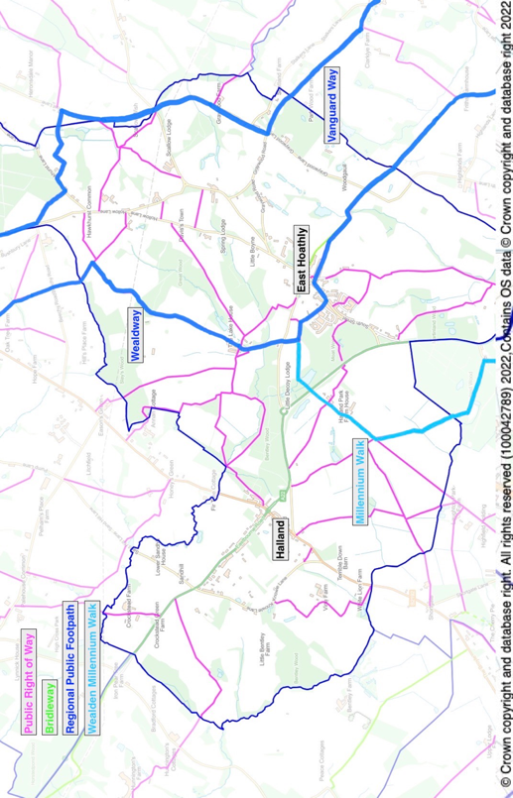

Annex N

Not Part of Statutory NP or Independent Examination

EAST HOATHLY WITH HALLAND PARISH COUNCIL

CIL EXPENDITURE PRIORITIES

The Parish Council CIL Expenditure Priorities in descending order of priority are:

a. Community Land Trust Aspiration 1

b. Pelham Buckle Mileposts Aspiration 2

c. ACVs Aspiration 3

d. Provision of Open/Greenspace in Halland Aspiration 4

e. Improvements to Sports Ground Aspiration 5

f. Upgrading Pavilion Aspiration 5

g. Extra Defibrillators Aspiration 5

h. Community Fibre Project Aspiration 6

i. East Hoathly to Halland Path/Cycleway Aspiration 7

j. Visitor Information Point Aspiration 7

Not Part of Statutory NP or Independent Examination

neighbourhoodplanning.org
WDC SEA Screening Opinion - Feb 2022.
WDC HRA Screening Report - Feb 2022.
Wealden Landscape Study 2014 - The Low Weald Landscape.
Sussex Biodiversity Record Centre - Report SxBRC/21/1019 dated 21 Mar 2022.
A Vision of Britain Website - https://www.visionofbritain.org.uk/unit/10105304
EHHNP Website - Parish Statistics.
ESHER Reference: MES 15563 and MES 21353.
ESHER Reference: MES 15564, MES 15565, MES 3113, MES 23121, MES 23122 and MES 21352.
ESHER Reference: MES 3114.
The History, Antiquities and Topography of the County of Sussex Thomas Walker Horsfield FSA, page 358.
WDC Draft East Hoathly Conservation Area Character Appraisal 2021, Paragraph 2.3.8.
WDC Draft East Hoathly Conservation Area Character Appraisal 2021, Paragraph 2.5.22.
https://historicengland.org.uk/sitesearch?searchType=site&search=East+Hoathly+with+Halland+Parish (also shown in Annex D).
WDC Draft East Hoathly Conservation Area Character Appraisal 2021.
https://www.wealden.gov.uk/planning-and-building-control/planning-policy/adopted-local-plan-documents/adopted-wealden-local-plan-1998/
https://www.wealden.gov.uk/UploadedFiles/Index_of_Saved_Policies.pdf
https://www.wealden.gov.uk/planning-and-building-control/planning-policy/adopted-local-plan-documents/core-strategy-local-plan/
https://www.wealden.gov.uk/planning-and-building-control/planning-policy/adopted-local-plan-documents/affordable-housing-delivery-local-plan/
Wealden Core Strategy LP 2013, Table 1, Pages 9-10.
ESCC School Organisation Plan 2020 – 2024, Page 81.
ESCC School Organisation Plan 2021 - 2025.
WDC Playing Pitch and Outdoor Sports Strategy Report 2022, Paragraph 496.
Survey of Bus Usage - EHHNP Website - Parish Statistics.
ESCC Shared Traffic Data from Parish Online Mapping.
East Hoathly with Halland Parish Survey 2016 Results Summary and Feria Interim Report - see EHHNP Website.
Department For Transport Tables Veh0105 and CGN0405 – See EHHNP Website – Parish Statistics. The reduction in vehicles on roads during the Covid-19 Pandemic is now reversing and congestion is almost back to pre-pandemic levels.
UK Power Network Data - see EHHNP Website - Parish Statistics.
South East Power Network - Long Term Development Statement November 2021.
Government Ten Point Plan for a Green Industrial Revolution -https://www.gov.uk/government/publications/the-ten-point-plan-for-a-green-industrial-revolution
Building Regulations 2010 - Part S - Infrastructure for the Charging of Electric Vehicles 2021.
UK Power Network Website - Future Energy - Electric Vehicles - https://innovation.ukpowernetworks.co.uk/wp-content/uploads/2023/03/UK-Power-Networks-Electric-Vehicle-Strategy-2023_FINAL.pdf.
UK Power Networks Website - Electric Vehicle Strategy - https://innovation.ukpowernetworks.co.uk/wp-content/uploads/2019/11/UK-Power-Networks-Electric-Vehicle-Strategy-November-19.pdf.
WDC Climate Emergency Plan 2019.
WDC Press Release 10 November 2020 - WDC Website.
WDC Press Release 25 November 2021 - WDC Website.
ZapMap Website - recommended by WDC to see current charging point availability - see EHHNP Website - Parish Statistics.
ONS 2011 Census Data Table KS401EW.
ONS 2011 Census Data Table QS411EW.
ONS 2011 Census Data Table CT0545.
ONS 2011 Census Data Table KS402EW.
WDC Housing Needs Assessment 2021, Table on Page 3.
WDC Housing Needs Assessment 2021, Page 3.
EHHNP Website - Parish Statistics.
Planning Application WD/2016/2796/MAO Decision Notice dated 11 Jun 2021.
Planning Application WD/2019/1674/MAO Appeal Decision Notice dated 27 Jul 2021.
EHHNP Website - Parish Statistics.
EHHNP Website - Parish Statistics.
EHHNP Website - Parish Statistics.
EHHNP Website - Parish Statistics.
EHHNP Website - Parish Statistics.
WDC Housing Needs Assessment 2021, Page 93.
https://www.wealden.gov.uk/housing-health-and-advice/housing/housing-allocations-policy/
ONS 2011 Census Data Table QS416EW.
EHHNP Website - Parish Statistics.
EHHNP Website - Parish Statistics.
ONS 2011 Census Data Table QS701EW.
https://www.statista.com/statistics/448040/influence-of-covid-19-on-online-grocery-shopping-uk/
ESCC Guidance for Parking at New Residential Development 2017.
WDC Design Guide, Part 1, Figure 10.21.
EHHNP Website - Parish Statistics.
EHHNP Website - Parish Statistics.
https://www.eastsussexinfigures.org.uk.
Page 3, WDC Local Housing Needs Assessment 2021.
Pages 19/20, Government response to the Planning for the right homes in the right places consultation 2018.
East Hoathly with Halland Parish Plan 2008, East Hoathly with Halland Parish Survey 2016. See EHHNP Website.
https://www.rtpi.org.uk/practice/2020/september/dementia-and-town-planning/
https://www.eastsussexjsna.org.uk/about-us/jsna-summary-east-sussex/
https://www.housinglin.org.uk/Topics/browse/Design-building/HAPPI/
East Hoathly with Halland Character Area Appraisal, March 2022.
https://escc.maps.arcgis.com/apps/webappviewer/index.html?id=78ce56f03ccf42b3810b30a5023d4989
ESHER Reference: MES 15563 and MES 21353.
ESHER Reference: MES 15564, MES 15565, MES 3113, MES 23121, MES 23122 and MES 21352.
ESHER Reference: MES 3114.
The History, Antiquities and Topography of the County of Sussex Thomas Walker Horsfield FSA, page 358.
WDC Draft East Hoathly Conservation Area Character Appraisal 2021, Paragraph 2.3.8.
Planning (Listed Buildings and Conservation Areas) Act 1990.
Historic England List Entry Number 1252622.
Historic England Local Heritage Listing – Historic England Advice Note 7 (Second Edition), Paragraph 1 and Paragraph 40.
WDC Draft Conservation Area Character Appraisal Jan 2021, Paragraph 3.3.6.
WDC Draft Conservation Area Character Appraisal Jan 2021, Paragraph 3.4.6.
WDC Draft Conservation Area Character Appraisal Jan 2021, Paragraph 5.1.2 and 5.2.
WDC Draft Conservation Area Character Appraisal Jan 2021, Paragraph 3.5.5.
WDC Draft Conservation Area Character Appraisal Jan 2021, Paragraph 5.4.1.
WDC Draft Conservation Area Character Appraisal Jan 2021, Paragraph 5.4.3.
WDC Draft Conservation Area Character Appraisal Jan 2021, Paragraph 5.5.1.
https://www.lshtm.ac.uk/newsevents/news/2015/reduced_street_lighting_does_not_increase_crime.html
England’s Light Pollution and Dark Skies - CPRE Website.
https://theilp.org.uk/publication/guidance-note-1-for-the-reduction-of-obtrusive-light-2021/
WDC Green Infrastructure Study 2017, Paragraph 5.2.5.
GI Network Plan provides a strategic framework for the delivery of GI. It is only illustrative and does not necessarily indicate a constraint on development
WDC Landscape Character Assessment 2022: https://www.wealden.gov.uk/UploadedFiles/Wealden-LCA.pdf
WDC Landscape Character Assessment 2022 pages 84, 172 and 185.
Rivers Trust Website - https://experience.arcgis.com/experience/e834e261b53740eba2fe6736e37bbc7b/page/Map/?data_id=dataSource_4-1788e0d0481-layer-54%3A16460&org=theriverstrust
Stantec/Water UK - Storm Overflow Evidence Project - Nov 2021.
Met Office – Southern England: Climate - https://www.metoffice.gov.uk/binaries/content/assets/metofficegovuk/pdf/weather/learn-about/uk-past-events/regional-climates/southern-england_-climate---met-office.pdf
Met Office Data - https://www.metoffice.gov.uk/hadobs/hadukp/data/daily/HadSEEP_daily_totals.txt
Met Office Data - https://www.metoffice.gov.uk/pub/data/weather/uk/climate/datasets/Raindays1mm/date/England_SE_and_Central_S.txt
Met Office Data - https://www.metoffice.gov.uk/hadobs/hadukp/data/daily/HadSEEP_daily_totals.txt
Sussex Biodiversity Record Centre - Report SxBRC/21/1019 dated 21 Mar 2022.
Sussex Biodiversity Record Centre - Report SxBRC/16/740 dated 9 Feb 2017.
Parish Online Mapping – ESCC Shared Data, Wildlife Verges.
Locality Guide – Neighbourhood Plan – Local Green Spaces – 2021, Paragraph 1.
Locality Guide – Neighbourhood Plan – Local Green Spaces – 2021, Paragraph 1.
EHHNP Website - Parish Statistics.
https://www.planningportal.co.uk/permission/common-projects/change-of-use/use-classes
Ofcom UK Home Broadband Performance Report 2021.
Government manifesto commitment for nationwide gigabit broadband by 2025 (revised in 2022 to a minimum of 85% of premises by 2025). Levelling Up White Paper 2022 set a new target for gigabit broadband by 2030 for 99% of premises.
Ofcom Website mobile phone availability checker for O2 indoor 4G calls.
https://www.eastsussex.gov.uk/roads-transport/public/bus-service-improvement-plan/bus-service-improvement-plan-for-east-sussex-county-council
https://www.wealden.gov.uk/planning-and-building-control/planning-advice/community-infrastructure-levy/paying-cil/
https://redrowconsults.co.uk/library/sites/13/east_hoathly_exhibition_boards_reduced_size_compressed_1.pdf
https://www.gov.uk/guidance/community-infrastructure-levy
https://www.legislation.gov.uk/uksi/2019/1103/contents/made
EHHNP Website - Parish Statistics.
East SussexHistoric Environment Record reference.
Sussex Biodiversity Records Centre (Contact Andrew Lawson).
https://www.gov.uk/guidance/open-space-sports-and-recreation-facilities-public-rights-of-way-and-local-green-space
Mills AD 2011, A Dictionary of British Place Names.
Lower, M A. A Compendious History of Sussex 1870.
Locality - Guide to Making Local Green Space Designations in your NP – 2021, Paragraph 1, Page 6.
WDC Landscape Character Assessment 2022: https://www.wealden.gov.uk/UploadedFiles/Wealden-LCA.pdf
WDC Draft Conservation Area Character Appraisal Jan 2021, Paragraph 5.4.1.
WDC Draft Conservation Area Character Appraisal Jan 2021, Paragraph 5.5.1.
Yeakell and Gardner Map 1778 – 1783. Ordnance Survey Drawing – Eridge Park dated 1789.
East Hoathly Tithe Map Apportionment 1841 - Numbers 454 to 459 - Occupier David Paine for property of Late Watfords.
Locality - Guide to Making Local Green Space Designations in your NP – 2021, Paragraph 1, Page 6.
Locality - Guide to Making Local Green Space Designations in your NP – 2021, Paragraph 1, Page 6.
Locality - Guide to Making Local Green Space Designations in your NP – 2021, Paragraph 1, Page 6.
Locality - Guide to Making Local Green Space Designations in your NP – 2021, Paragraph 1, Page 6.
Locality - Guide to Making Local Green Space Designations in your NP – 2021, Paragraph 1, Page 6.
In Loving Memory – Gravestone Inscriptions and Memorials in East Hoathly Churchyard, Jane Seabrook 1999.
Locality - Guide to Making Local Green Space Designations in your NP – 2021, Paragraph 1, Page 6.
WDC Draft Conservation Area Character Appraisal Jan 2021, Paragraph 3.3.6.
WDC Draft Conservation Area Character Appraisal Jan 2021, Paragraph 3.4.6.
WDC Draft Conservation Area Character Appraisal Jan 2021, Paragraph 5.1.2 and 5.2.
WDC Draft Conservation Area Character Appraisal Jan 2021, Paragraph 5.4.1.
Yeakell and Gardner Map 1778 – 1783.
WDC Draft Conservation Area Character Appraisal Jan 2021, Paragraph 3.5.5.
WDC Draft Conservation Area Character Appraisal Jan 2021, Paragraph 5.4.1.
WDC Draft Conservation Area Character Appraisal Jan 2021, Paragraph 5.4.3.
WDC Draft Conservation Area Character Appraisal Jan 2021, Paragraph 5.5.1.
WDC Draft Conservation Area Character Appraisal Jan 2021, Paragraph 3.5.5.
WDC Draft Conservation Area Character Appraisal Jan 2021, Paragraph 5.4.1.
WDC Draft Conservation Area Character Appraisal Jan 2021, Paragraph 5.4.3.
WDC Draft Conservation Area Character Appraisal Jan 2021, Paragraph 5.5.1.
Mills AD 2011, A Dictionary of British Place Names.
Lower, M A. A Compendious History of Sussex 1870.
Yeakell and Gardner Map 1778 – 1783. Ordnance Survey Drawing – Eridge Park dated 1789.
East Hoathly Tithe Map Apportionment 1841 - Numbers 454 to 459 - Occupier David Paine for property of Late Watfords.
Yeakell and Gardner Map 1778 – 1783.

